

**Dry Fruits management**

**system**

**ARCADE BUSINESS**

**COLLEGE**

|  |  |
| --- | --- |
| PROJECTNAME**:-** | DRY FRUITS STORE MANAGEMENT SYSTEM |
| GROUP CODE**:-** | 33F |
| COURSE :- | BCA |
| BATCH/YEAR**:-** | 3-3/3RD YEAR |
| SUBMISSION DATE**:-** | 18 September 2019 |
| **MEMBER DETAIL’S : -** |  |

***2016 - 2019***

|  |  |  |  |  |
| --- | --- | --- | --- | --- |
| **NAME** | **CLASS R0LL NO.** | **COLLEGE R0LL NO** | **REG.**  **NO** | **CONTACT. NO** |
| SOMI KESHRI | 45 | 16036 | 1607004020 | 9097322799 |
| SURAJ KUMAR | 55 | 16012 | 1607004044 | 7764946860 |
| SANTOSH KUMAR | 11 | 16015 | 1607003948 | 6206638195 |
| SHIVAM KUMAR | 28 | 16060 | 1607003988 | 8936893089 |

**Contents**

I. ACKNOWLEDGEMENT 7

II. PREFACE 8

III. INTRODUCTION 9

IV. OBJECTIVE 9

• Paper Work- 9

• Maintain ace/Storage - 9

• Cost- 9

• Speed- 9

• Accuracy - 10

• Reliability - 10

• Diligence 10

• Automation 10

• Versatility 10

V. SYSTEM ANALYSIS 11

• Introduction of existing system 12

• Limitation or Problem In Existing System 13

1. Paper Work- 13

2. Maintain ace/Storage 13

3. Cost- 13

4. Speed- 13

5. Accuracy - 13

6. Time 13

7. Reliability- 13

8. Less communicable- 13

• Identification of need 13

• Primary investigation 14

• Feasibility Studies 14

1 . Technical Feasibility: - 17

2. Estimation of cost 18

• Project planning- 18

• Project scheduling- 18

• Software requirement specification 20

• Software Engineering (paradigm applied) 21

• Data modules 22

• Administrative module 22

• Purchasing module 22

• Stock module 23

• Accounting module 23

• Selling module 23

1. Erd :- 24

2. Dfd:- 24

VI. Components of system 24

ADMIN – 24

1. Capital Management:- 24

2. Expense Management:- 24

3. Income Management:- 24

4. Profit/Loss Management:- 25

5. Department Management:- 25

6. Employee Management:- 25

7. Reporting:- 25

8. Supplier Management:- 25

9. Product management:- 26

10. Customer management:- 26

• ORDER- 27

ORDER DETAIL 27

• PURCHASE- 27

SALE- 27

• Stock- 27

1 AVAILABILITY MANAGEMENT:- 27

2 DAMAGE :- 28

STOCK DETAIL 28

Return- 28

• Report- 28

VII. System design 28

• Moralization details- 28

Data integrity & constraints 28

Database design 30

User interface 33

VIII. Coding 33

• Complete Coding- 34

• Comments & description- 34

IX. Testing 35

A. OBJECTIVES :- 35

B. PRINCIPLES:- 35

C. TESTING STRATEGY UES:- 35

D. BLACK BOX TESTING 36

WHITE BOX TESTING:- 36

E. VERIFICATION AND VALIDATION 37

F. UNIT TESTING 37

G. COMMON ERROR IN COMPUTATIONS ARE:- 37

H. UNIT TEST CASES UNCOVERED ERROR LIKE: 37

I. INTEGRATION TESTING 38

J. INTEGRATION TESTING STRATEGY ARE: 38

3. REGRESSION TESTING: 41

ALPHA AND BETA TESTING: 41

SYSTEM TESTING: 41

LEVEL OF SYSTEM TESTING: 42

X. System security measure 43

• Database security- 43

• Creation of User profile- 44

XI. Cost Estimation 45

XII. Reports 45

XIII. Future Scope 45

XIV. Bibliography 45

XV. Glossary 46

# ACKNOWLEDGEMENT

This success and final outcome of this project required a lot of guidance and assistance from many people and we are extremely privileged to have got this all along the completion of our project.All that we have done is only due to such supervision and assistance and we would not forget to thank them.

We respect and thank Mr. Inder Keshri, owner of  **Laxmi Narayana Traders** organization for providing us the opportunity to do the project work for their organization and giving us all their support and guidance which made us complete the project duly.

We owe our deep gratitude to our project guide **Mrs. Anupam Singh** HOD of Arcade Business College, who took keen interest on our project work and guided us all along , till the completion of our project work by providing all the necessary information for developing a good system.

We are thankful to and fortunate enough to get constant encouragement , support and guidance from all teaching faculty of BCA department which helped us in successfully completing our project work. Also, we would like to extend our sincere esteems to all teaching faculty for their timely support.



# PREFACE

This project training is the development of software under the demand of “Bachelor of Computer Applications” course in final year.

The main objective of the training is that, we should experience the practical work and gain the knowledge to develop the quality of working environment. Also, this training helps in understanding the real life project.

# INTRODUCTION

The dry fruits store management system for laxmi Narayan Traders is a software developed for helping in managing the marketing of dry fruits product.

The main objective of the software is to store the details of product , suppliers ,customers and generate reports like sales , purchase, stock. It also generate monthly report like all customer report, customer order report , customer payment report , all supplier report , supplier order report , supplier payment report , product report ,monthly sale report , yearly sale report , monthly purchase report , yearly purchase report and accounts reports.

It also maintains accounts report like capital, income , expenditure , profit and loss. No end users are allowed to make changes in the master form.



**INFORMATION TECHNOLOGY LAW IN INDIA**

The Information Technology Act, 2000 is an act of Indian parliament notified on 17 October 2000. It is primary law in India dealing with cybercrime and electronic commerce.

It is based on United Nation Model on electronic commerce 1996 recommended by the general assembly of united nation by a resolution dated 30 January 1997.The act provide legal recognition for transaction carried out by electronic data interchange and other mean of electronic communication, Commonly referred to as “electronic commerce”. Which involve the use of alternative way to paper based method of communication and storage of information.

The original act contained 94 sections, divided in 13 chapters and 4 schedules. The laws apply to the whole of India. Persons of others nationality can also be indicted under the law, if the crime involves a computer or computer network located in India.

The act provides a legal framework for electronic governance by giving recognition to electronic records and digital signature. The formations

Of controller of certifying Authorities was directed by the Act, to regulate issuing of digital signature, it also defines cyber crimes and prescribed penalties for them. It also establishes a Cyber appellate

Tribunal to resolve disputes arising from this new law. The act also amended various sections of Indian penal code, 1860, Indian Evidence Act, 1872, bankers book evidence act,1891,and Reserve bank of India,1934 to make them complaint with new technology.

# OBJECTIVE

* Paper Work- The use of computers for data processing in an organization leads to reduction in paper work and results in speeding up a process. As data in electronic files can be retrieved as and when required, the problem of maintenance of large number of paper files gets reduced.
* Maintain ace/Storage - Memory is a very important characteristic of computers. A computer has much more storage capacity than human beings. It can store large amount of data. It can store any type of data such as images, videos, text, audio and many others. A computer can store for later retrieval as and when required.
* Cost-Though the initial investment for installing a computer is high but it substantially reduces the cost of each of its transaction.
* Speed- Computer is a very fast device. It is capable of performing calculation of very large amount of data. The computer has units of speed in microsecond, nanosecond, and even the picoseconds. It can perform millions of calculations in a few seconds as compared to man who will spend many months for doing the same task. It’s speed may vary from 10-6sec to 10-9sec.
* Accuracy - In addition to being very fast, computers are very accurate. The calculations are 100% error free. Computers perform all jobs with 100% accuracy provided that correct input has been given.
* Reliability - A computer is a reliable machine. Modern electronic components have long lives. Computers are designed to make maintenance easy.
* Diligence -Unlike human beings, a computer is free from monotony, tiredness and lack of concentration. It can work continuously without any error and boredom. It can do repeated work with same speed and accuracy. A computer system can be used for long spam of time due to which it is said as diligent and non-exhausting.
* Automation - Computer is an automatic machine. Automation means ability to perform the given task automatically. Once a program is given to computer i.e., stored in computer memory, the program and instruction can control the program execution without human interaction.
* Versatility **-** A computer is a very versatile machine. A computer is very flexible in performing the jobs to be done. This machine can be used to solve the problems related to various fields. At one instance, it may be solving a complex scientific problem and the very next moment it may be playing a card game.

# SYSTEM ANALYSIS

System analysis is a process of gathering and interpreting facts, diagnosing problems and the information about the dry fruits store management system to recommend improvement on the system. It is a problem solving activity that requires intensive communication between the system, user and developer . System analysis or study is an important phase of any system development process. The system is studied to the minutes details and analyzed. The system analyst plays the role of the interrogator and dwells deep into the working of the present system. The system is viewed as a whole and the input to the system are identified. The output from the organization are traced to the various process. System analysis is concerned with becoming aware of the problem , identifying the relevant and decisional variables , analyzing and synthesizing the various factors and determining the optimal or atleast a satisfactory solution or program of action. A detail study of process must be made by various techniques like interviews and questionaries etc. The data collected by these resources must be scrutinized to arrive a conclusion . The conclusion is an understanding of how the system functions. This system is called the existing system. Now the existing system is subjected to close study and problem areas are identified. The designer now functions as a problem solver and tries to sort out the difficulties that the enterprise faces . The solution is given as proposals. The proposal is then weighted with the existing system analytically and the best one is selected. The proposal is presented to the user for an endorsement by the user. The proposal is reviewed on user request and suitable changes are made . This is loop that ends as soon as the user is satisfied with proposal.

* Introduction of existing system

Dry fruits are sweet, delicious nutritious and accessible to everyone. we have then around us all the time to satisfy our sweet tooth and provide a boost to the morale.

The “**LAXMI NARAYAN TRADERS**" play a vital role to available you a best quality of dry fruits. Our store is the best organization in dry fruits business. It a **Trading units** and provide various types of dry fruits and those are best quality and best brand. All types of dry fruits passed by government of India, and each product have a particular GST rate. This store provides good costumer services and always gives the priority to the costumer. Laxmi narayan traders are officially registered by the government.

**Store detail**

|  |  |  |  |
| --- | --- | --- | --- |
| Shop name -  Ownername-  Address -  email add.-  Pin code - | Laxmi narayan traders  Mr. Inder Keshri  Marufganj, Patna.  Laxminarayan@gmail.com  800008 | phone no -  Reg. no -  GST IN -  State code -  A/c number - | +91 9386633501  10BJKPK9685D125  10 |

Laxmi Narayan traders is a wholesaler and retailer organization. It is a single ownership organization. The main Moto of this organization is to provide excellent quality of dry fruits to the costumer in simple way with no trouble .To achieve this, the organization maintains manual register.

* Limitation or Problem In Existing System

1. Paper Work- We need large registers to keep the data and records in the existing system. on which the data or records are manually inserted, due to the large data we need a large register.
2. Maintain ace/Storage- In manual system we need much more physical space like Elmira, storage room etc., to store much more data or records in registers.
3. Cost- It involves expenses on stationary product and extra expense on the individuals who are maintaining those data. Which is huge as compared to the automatic system?
4. Speed- The speed for maintaining data manually is very low, the average speed of a normal human while writing is 25-94alphabet per unit time.
5. Accuracy -Accuracy decreases while doing the same type of calculation repeatedly because mental irritation, which leads to generation of error.
6. Time-In large registers, data or records are manually recorded. It takes long time to insert data, due to the large data
7. Reliability- It is not always possible to rely on human calculation and writing.
8. Less communicable- Way of doing a particular job differ person to person so it always necessary for a person to dictate its work, because of a person uses notation to do his work fast.

* Identification of need
* Primary investigation

After knowing the working of the company in detail, we came upon the following conclusion:

The underlying problem that was initially presented in system request and later reinforced during a series of interviews with our employer is the lack of digitalized version of the circulation system that is easy to use by any random person who does not have any experience in programming field ,scalable for future web interaction and efficient in tracking information of suppliers,product,customer along with the main working of the system.



* Feasibility Studies

In the case system proposal is accepted by the management, the next phase is to examine the feasibility of the system. The feasibility study is basically the test of the proposed system in the light of its work ability, meeting users requirements, effective use of resources and of course the cost effectiveness. Feasibility is a study to compare to different environment.

**Developer Environment**

### 

**Client Environment**

# 

**Types of Feasibility**

1 . Technical Feasibility: -Technical feasibility is a study of environment specification for development and execution. A software always executed on specific hardware and software configuration must be available on both developer and client system.

As per our project our team visit to the client side, where we identified that, they are ready to install specified following specification which are used by our team.

**Hardware Specification**

**Operational Feasibility: -** This feasibility is study of operational staff. There qualification, knowledge, skill etc. and user of software. As per our study we observe that there staff members are well qualified to execute software. No need to change staff.

### Estimation of cost

Total function Point =45

Language Used = VB

Average line of code per function point = 60

Total line of code = (60*45) = 2700/-

Efforts = 75 line of code per person per hour.

Cost = 75/-

Total cost of Man-power = (cost*total line of code)\Efforts. = (75*2700)/75 =>2700

Direct cost = 1000/-

Testing cost = 50% of total cost = 1350/-

Indirect cost = 1000/-

Total cost of software = Man power cost + Direct cost + Testing cost + Indirect cost

* 2700+1000+1350+1000
* 6050/-

Project planning

[**gantt.docx**](gantt.docx)

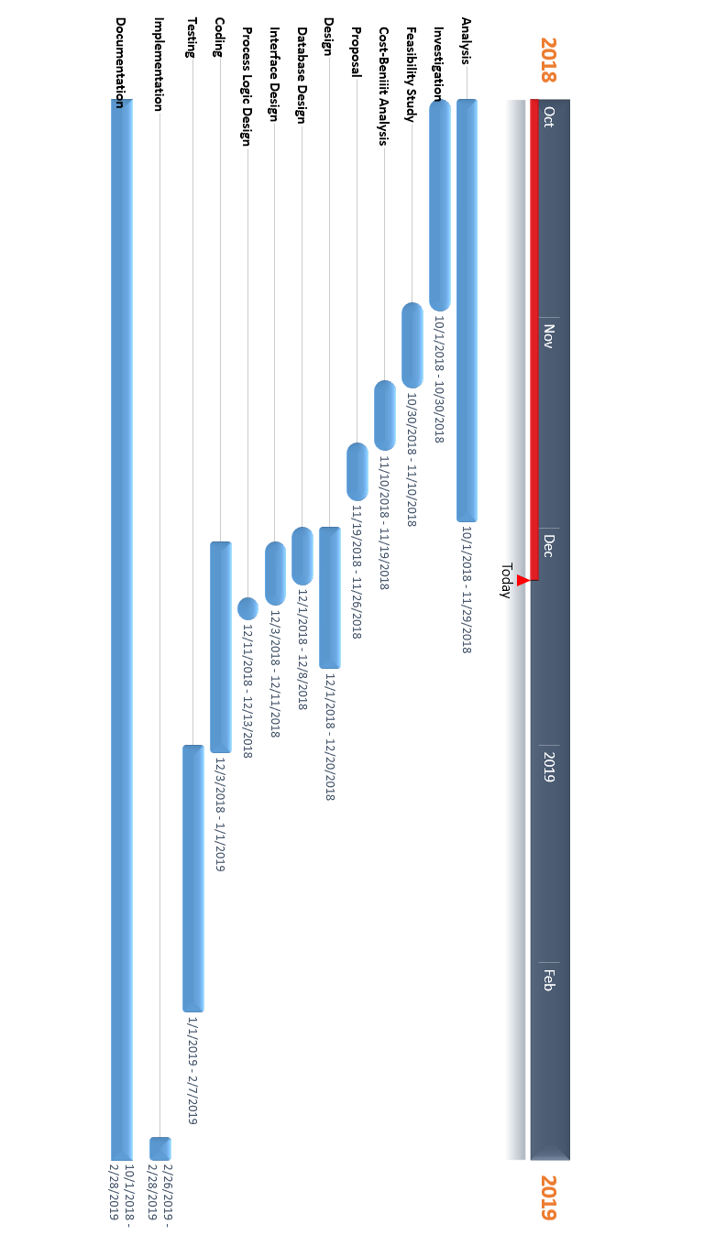



* Software requirement specification

**VISUAL BASIC**

Visual basic is very powerful programming language that helps one develop graphical application that can be run on Microsoft windows environment. VB is actually basic language. In 1960 by professor john kemeny and Thomas Kurts. Microsoft windows GUI in the late 1980 and early 1990. The natural evolution of basic was VB which was created by Microsoft Corporation in 1991 and VISUAL BASIC 6.0 was created in 1998 visual basic support 3 types of programming style.

**Features of visual Basic:**-

* GUI interface
* Modularization
* Object orientation
* High-level programming language
* good debugging



Oracle is one of the largest vendors in the enterprise IT market and the shorthand name of its flagship product, a relational database management system (RDBMS) that's formally called Oracle Database. The database software sits at the center of many corporate IT environments, supporting a mix of transaction processing, business intelligence and analytics applications.

**Features of Oracle:**-

* Application Development
* Availability
* Business Intelligence
* Clustering
* Content Management
* Database Overall
* Database Security
* Grid Computing
* Grid Management
* Information Integration
* Performance and Scalability
* Server Manageability
* Workspace Manager
* Software Engineering (paradigm applied)



* Data modules

Each unit of project has been explained above and by understanding each unit in an organization we have converted them into module for programming convenience. These modules are as follows.

### Administrative module –

In this module an administrator inputs his money and resources in business and waits for an output after functioning of its sub units on his input.

INPUT PROCESSING OUTPUT

### Purchasing module –

In this module input involves the availability of product in the stock and as output it maintains the details of purchased product, by doing some management works.

INPUT PROCESSING OUTPUT

### Stock module –

In this module input is to record availability of good and out is to report good unavailability of goods for this certain managing functions are performed.

INPUT PROCESSING OUTPUT

# Accounting module -This module input is various transaction in business and output is the financial statement of one financial year. Output is achieved by various intermediately processes.

INPUT PROCESSING OUTPOT

# Selling module - This module takes input as availability of goods in shop and outputs its unavailability. To achieve this it does certain processes.

INPUT PROCESS OUTPUT

### Erd

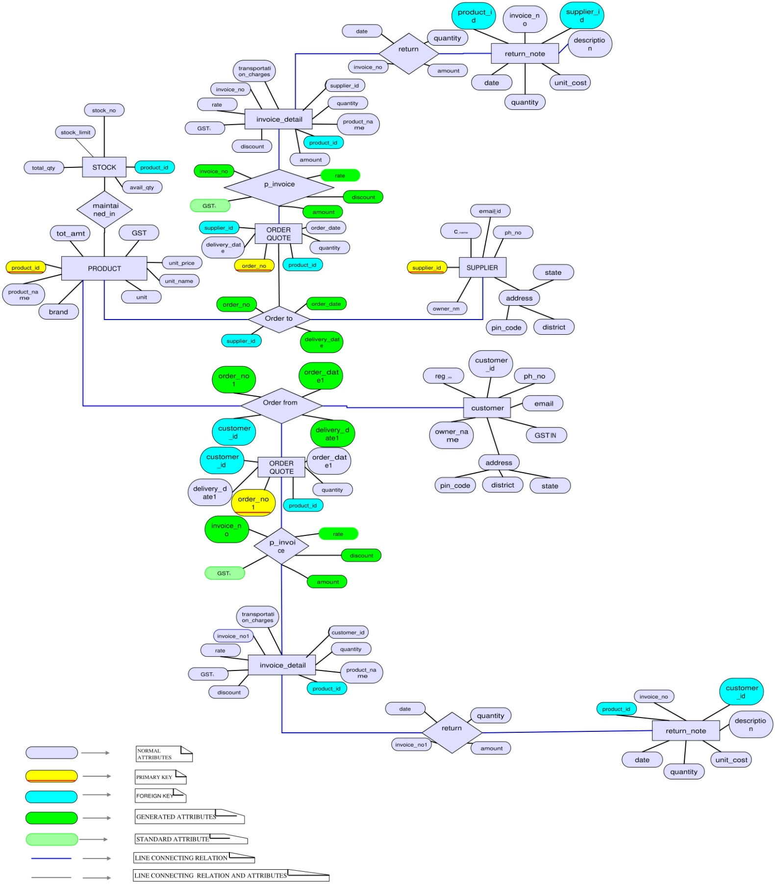[Er diagram.pdf](Er%20diagram.pdf)

### DFD

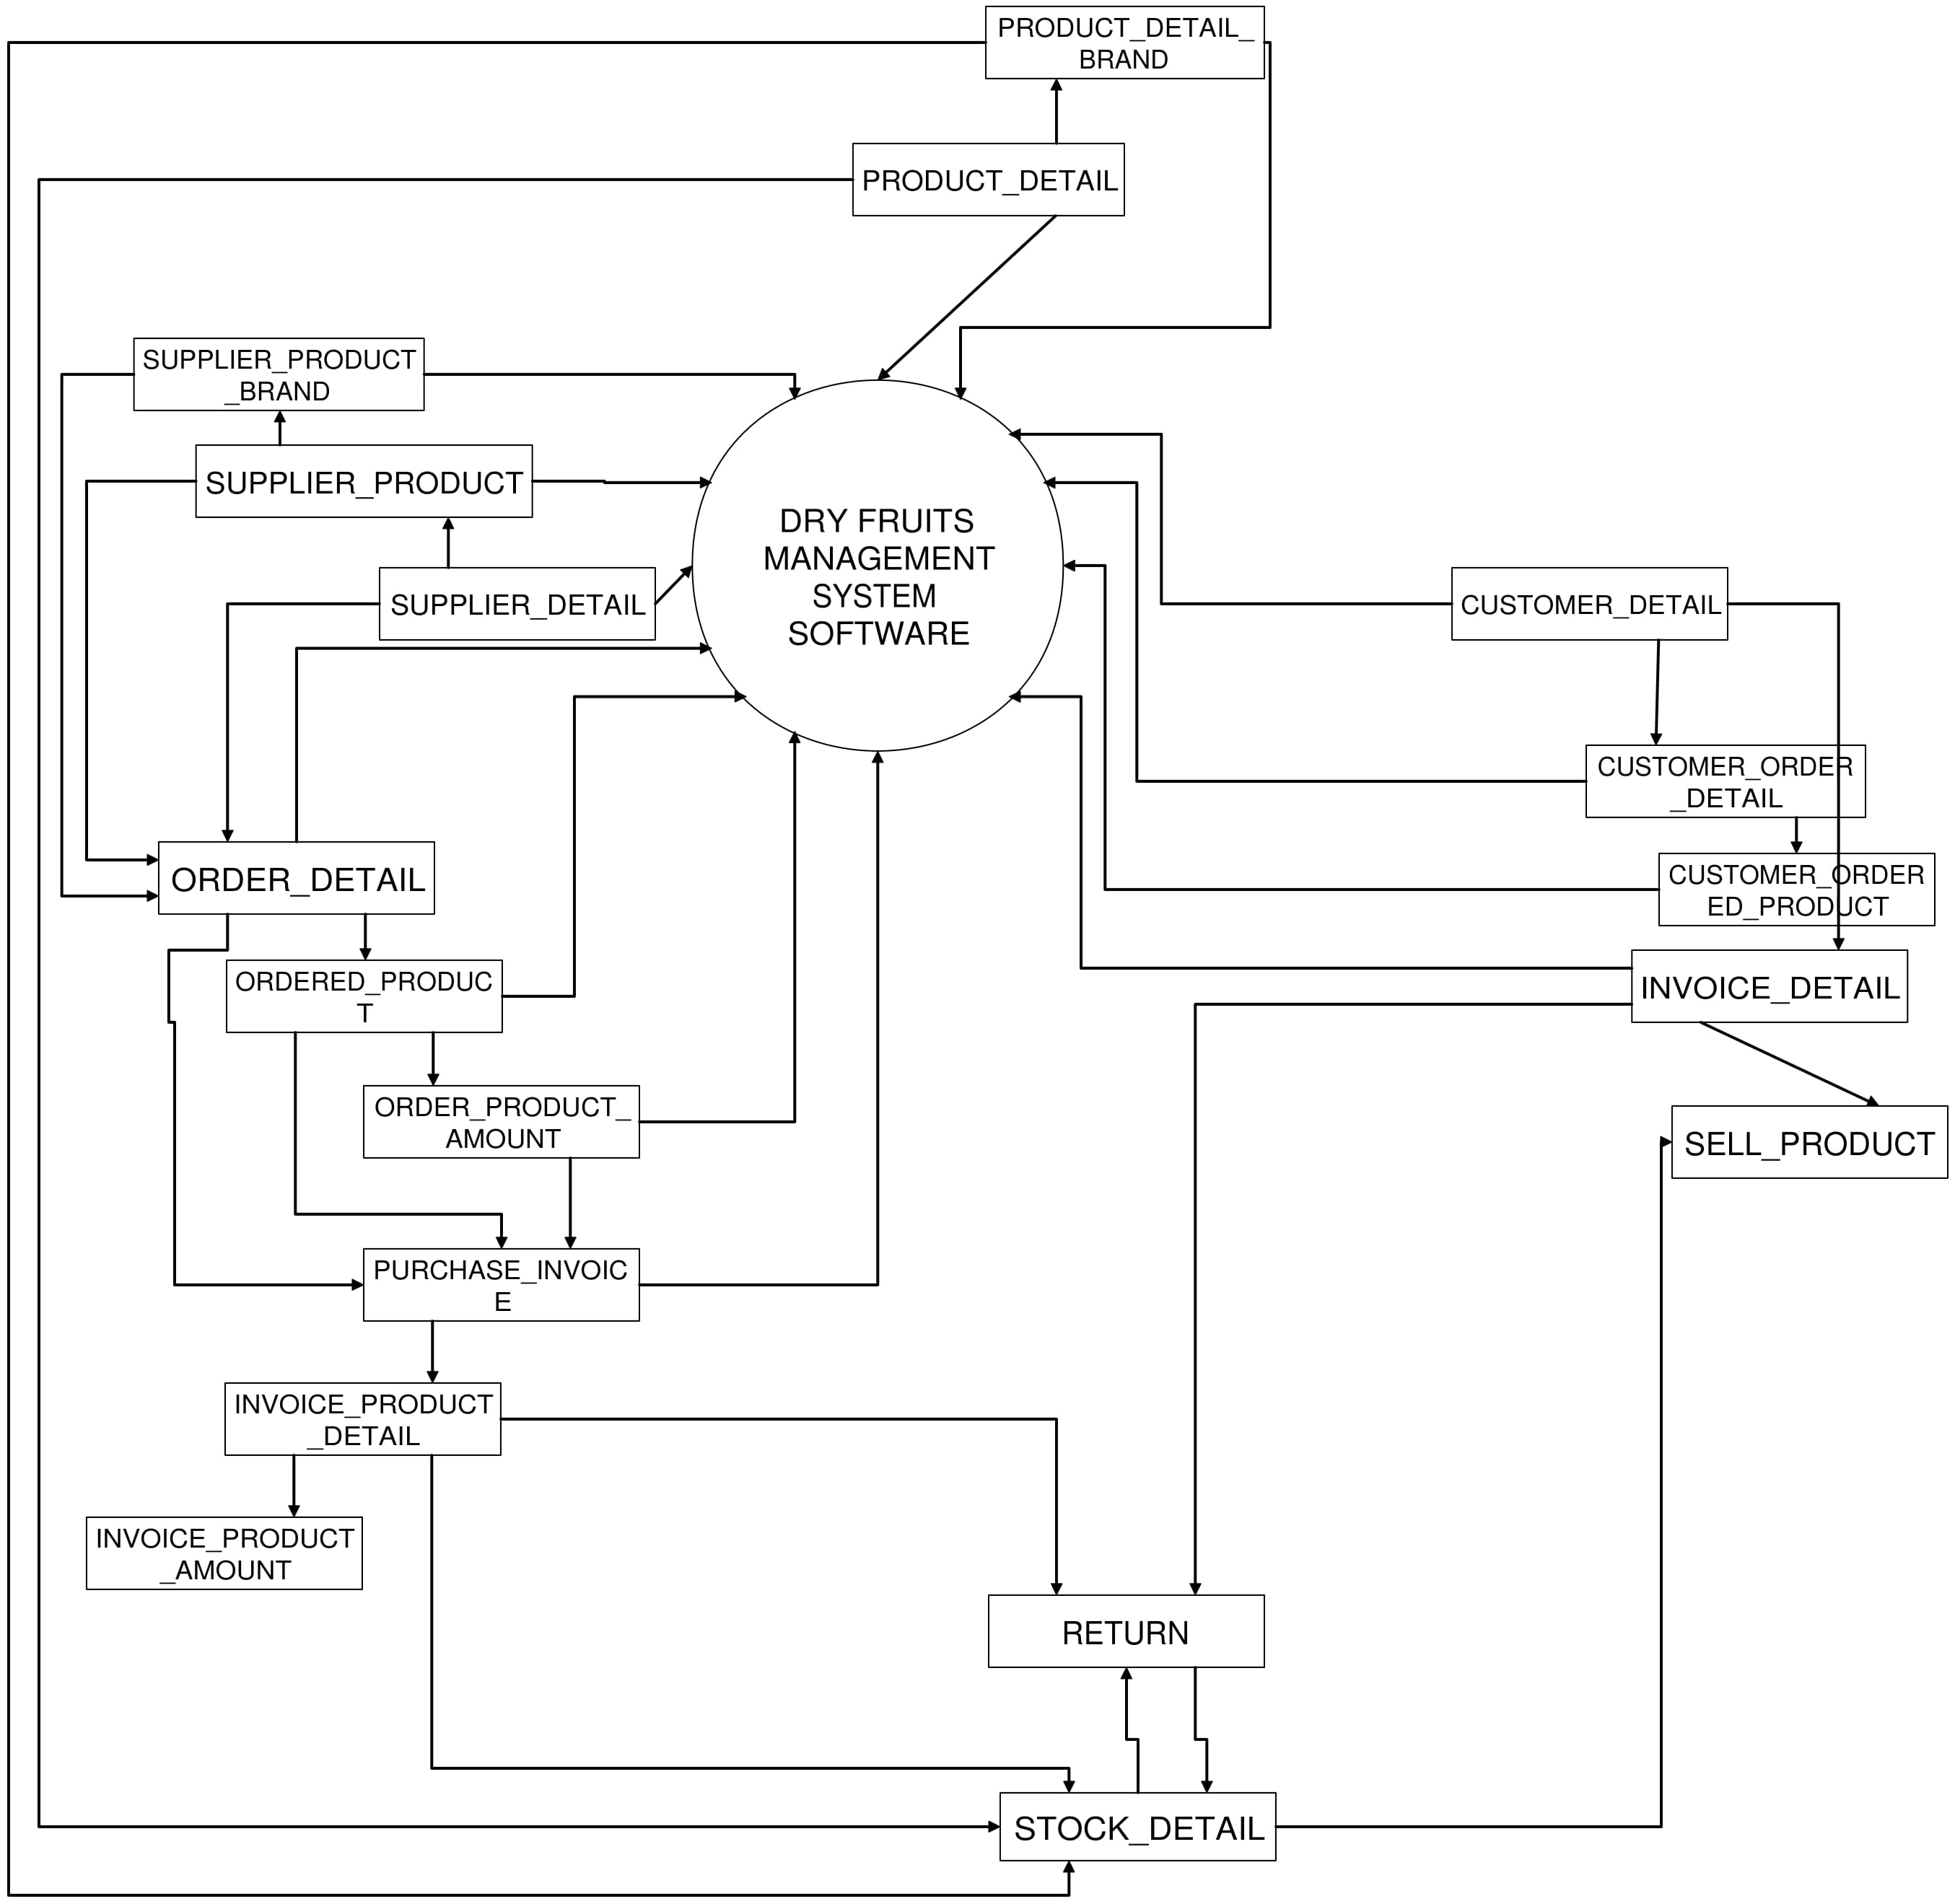

**ZERO LEVEL DFD**

**FIRST LEVEL DFD**

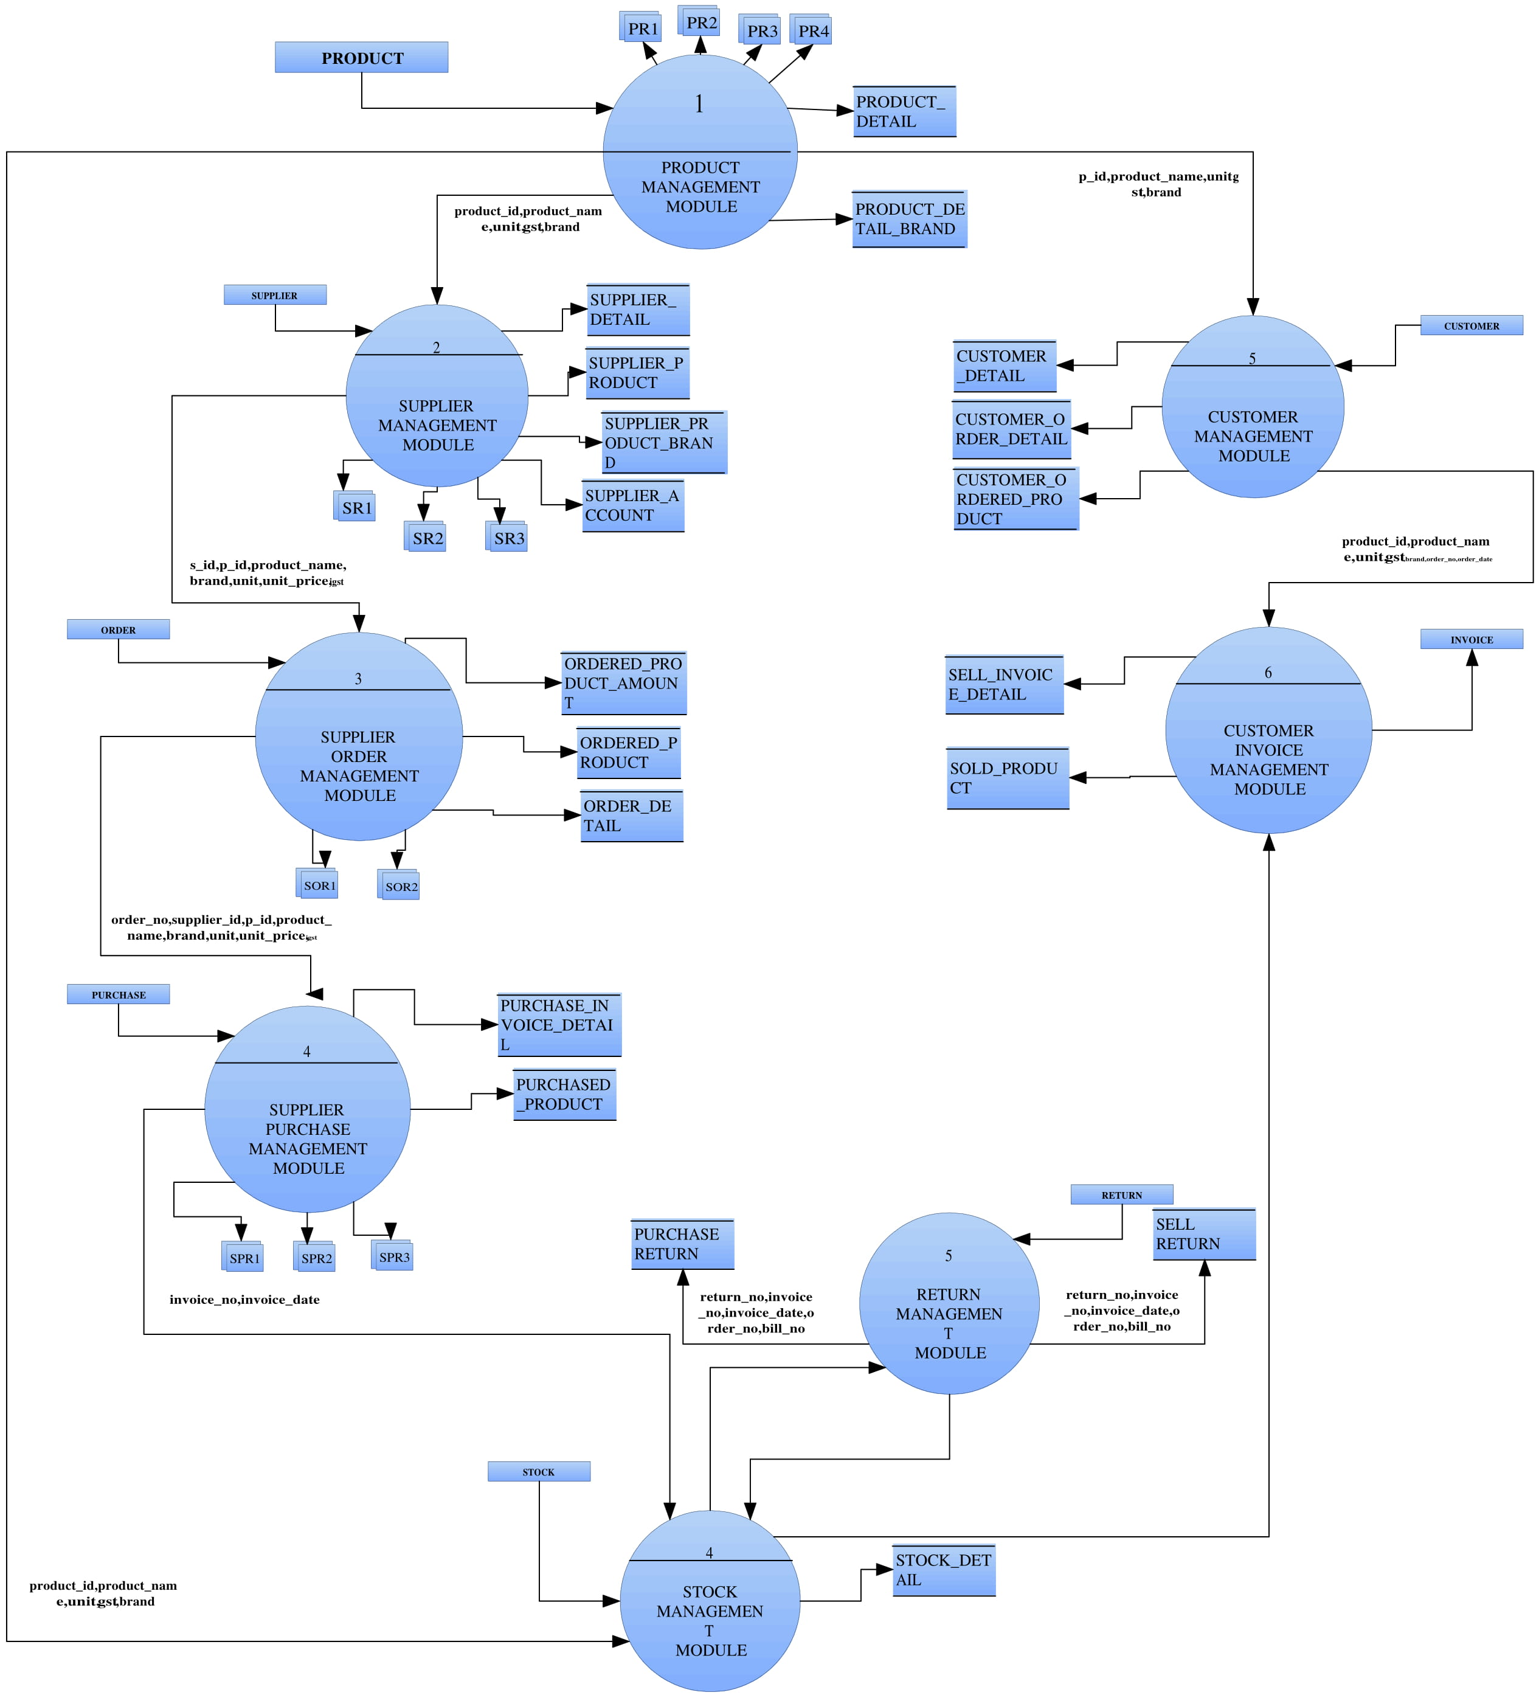

**SECOND LEVEL DFD**

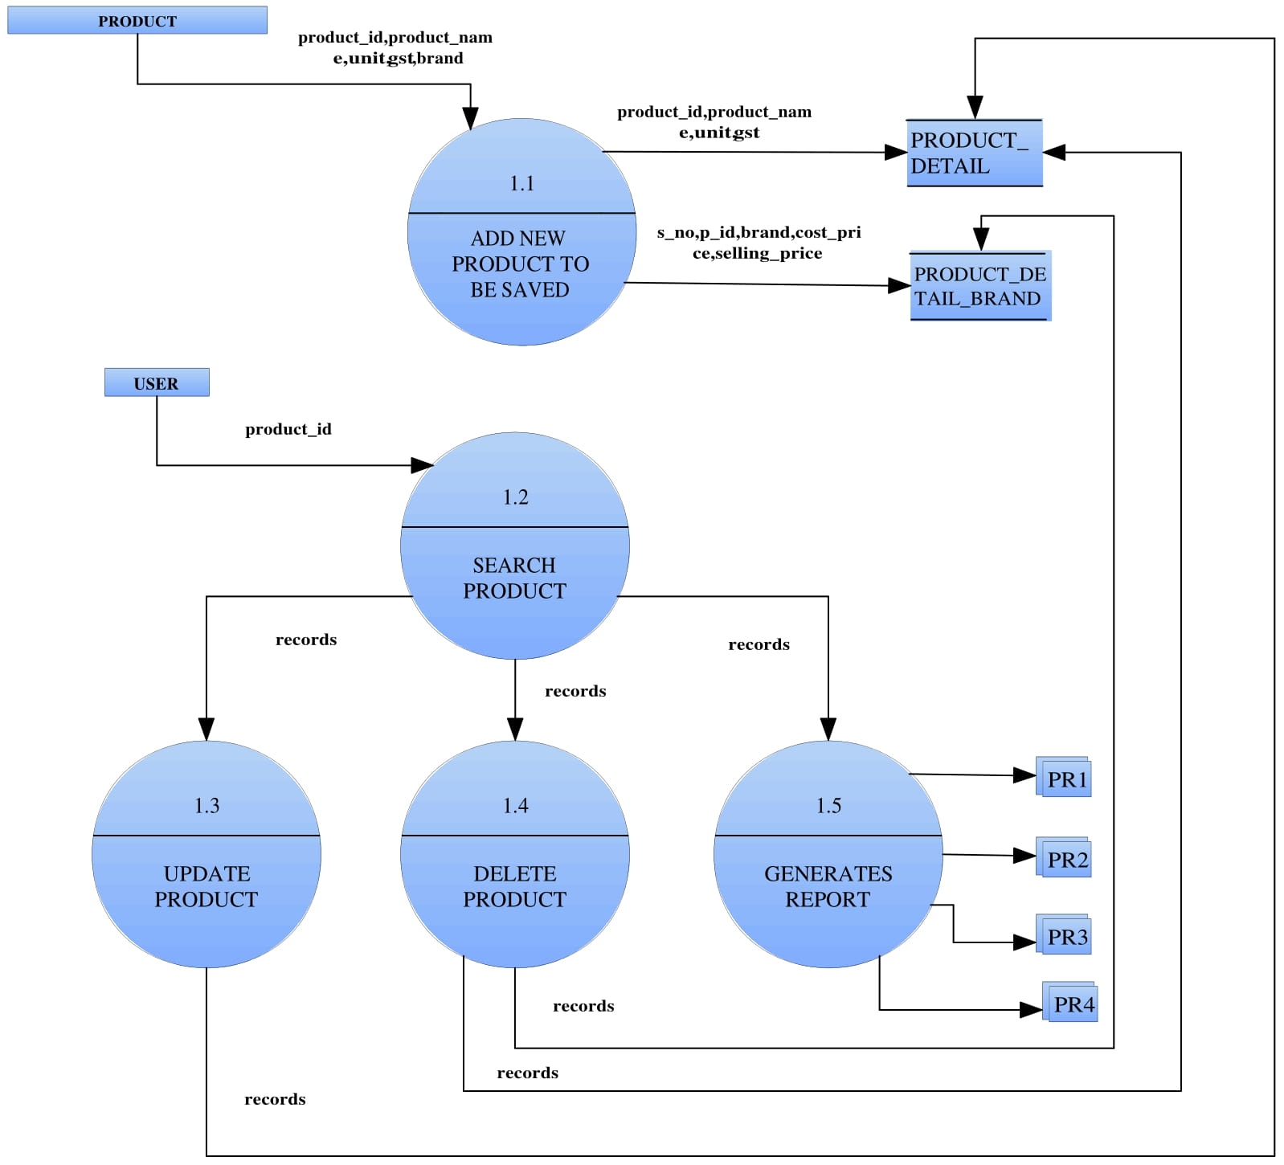

**Product**

***Customer***

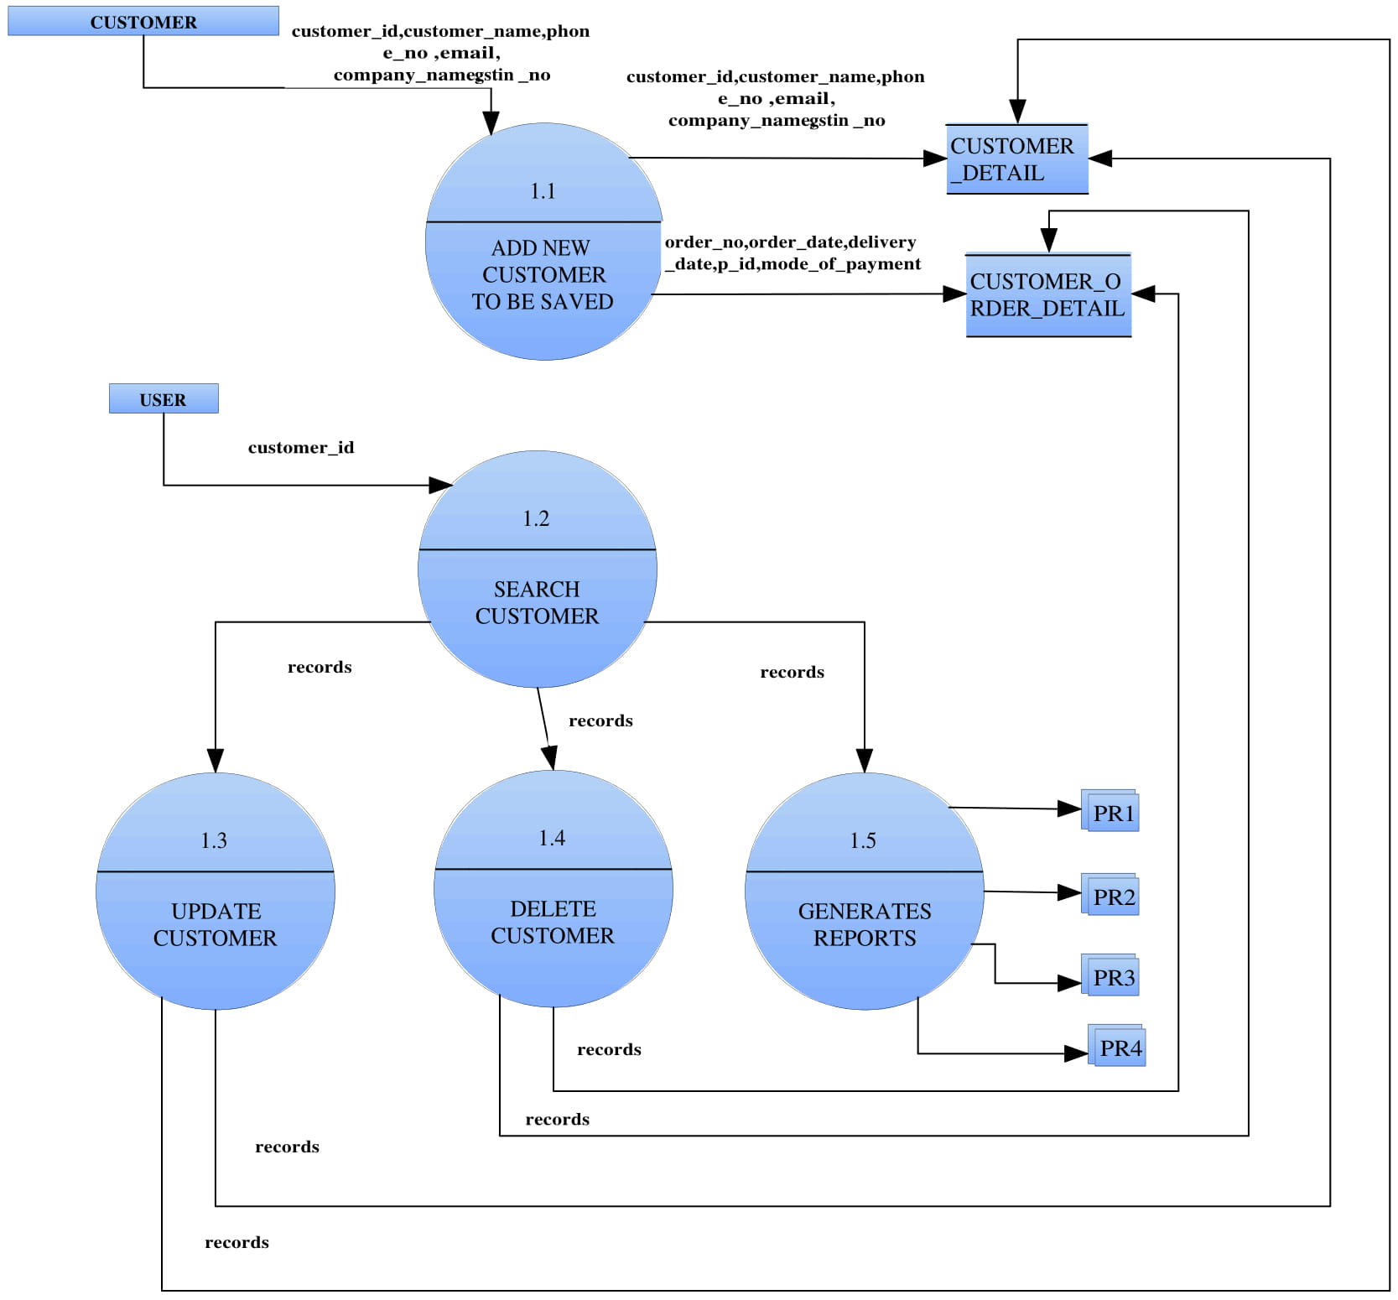

***Supplier***

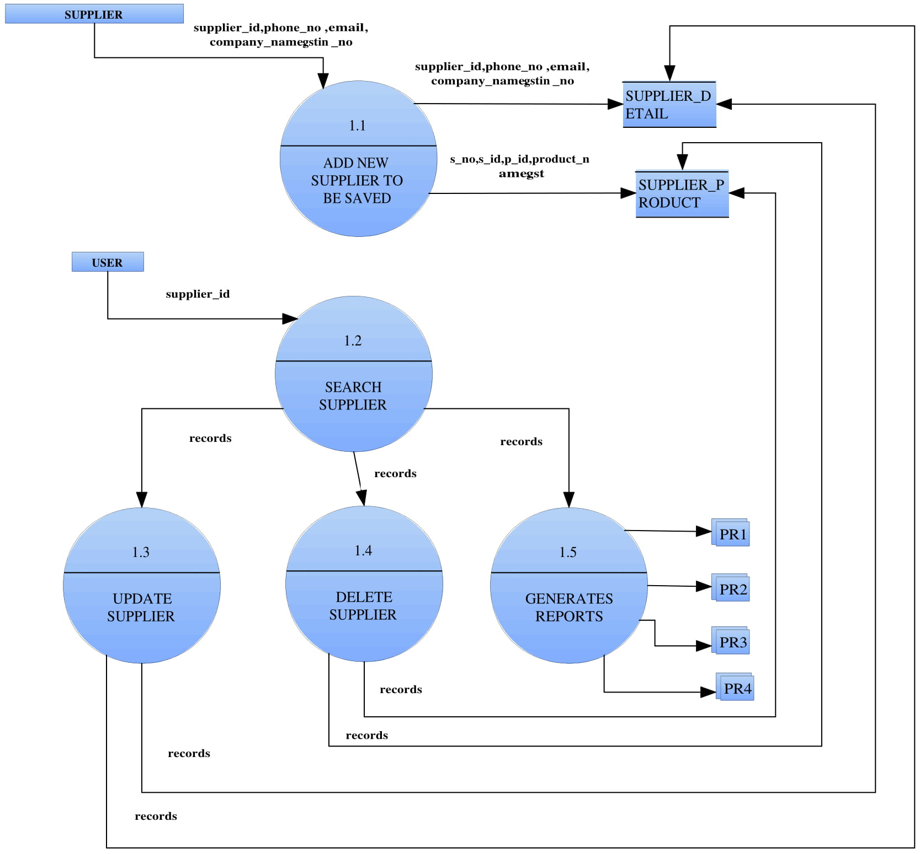

***Supplier Order***

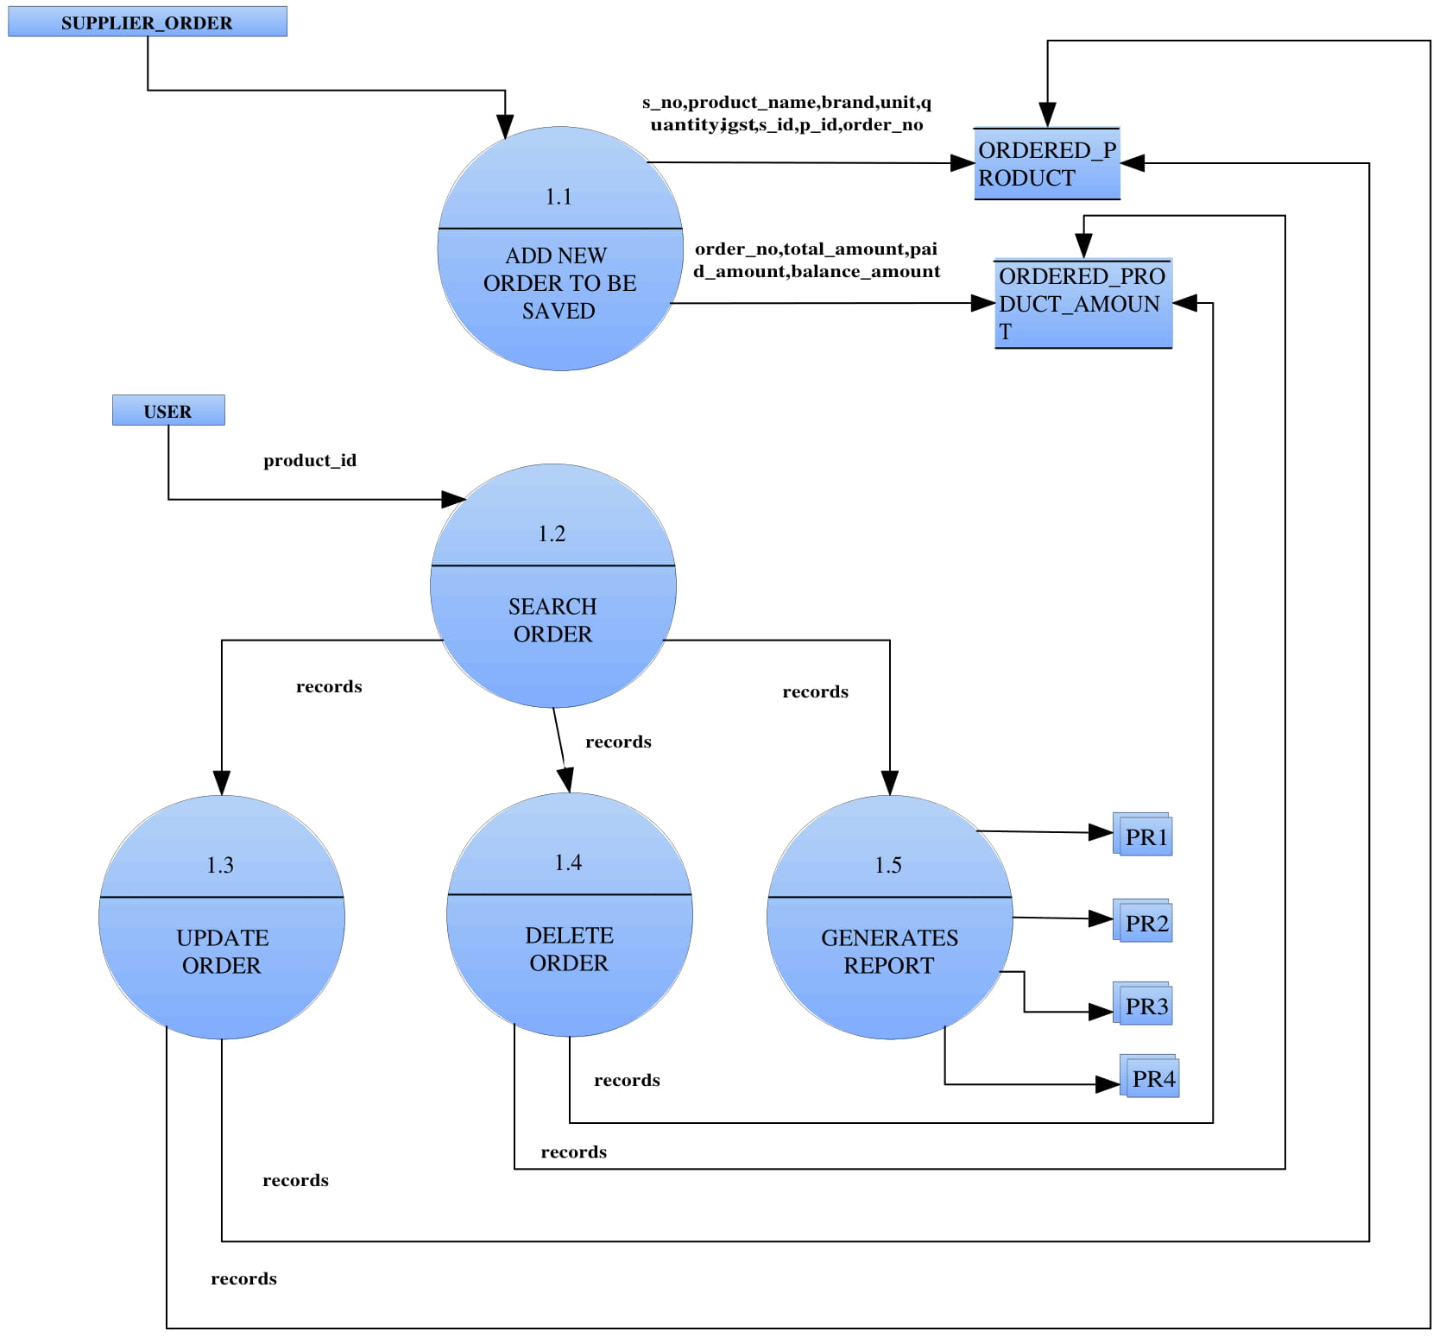

***Customer Order***

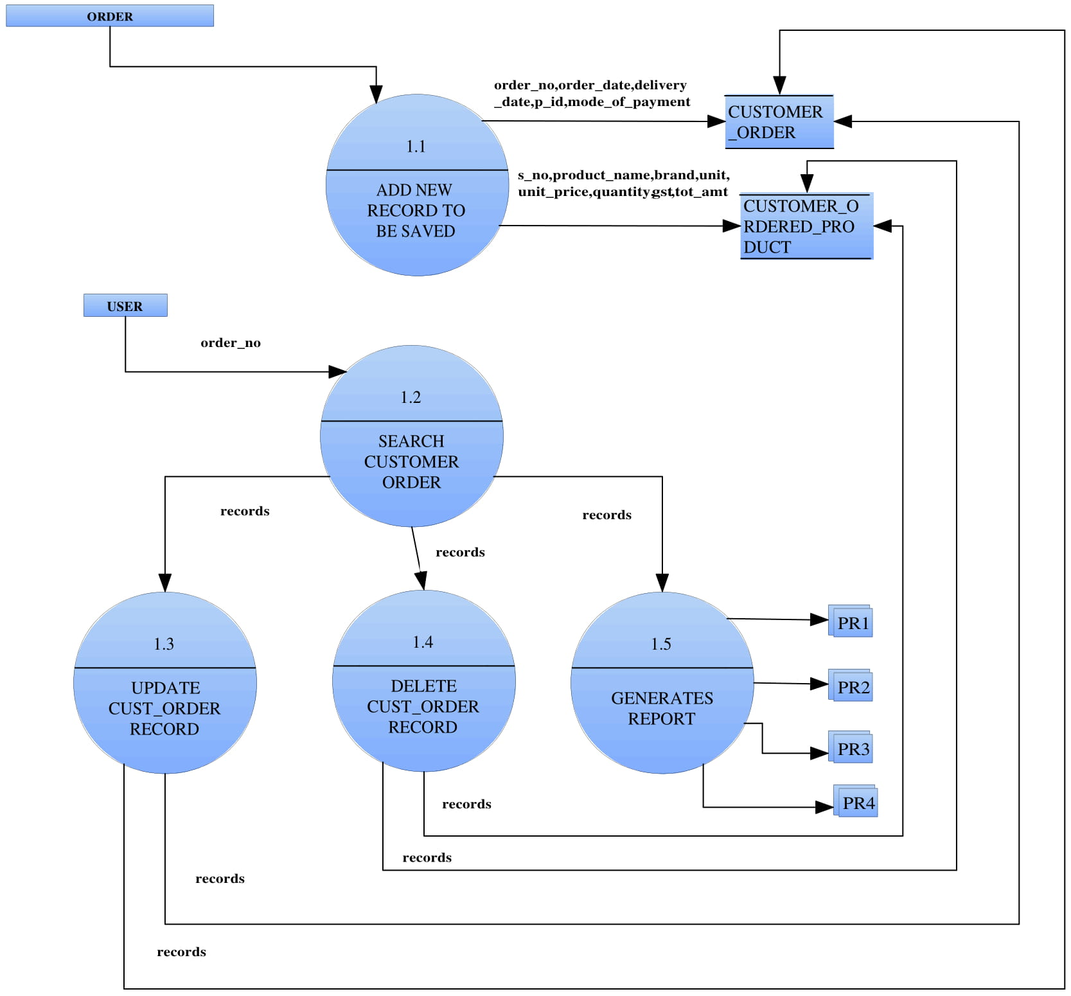

***Purchase***

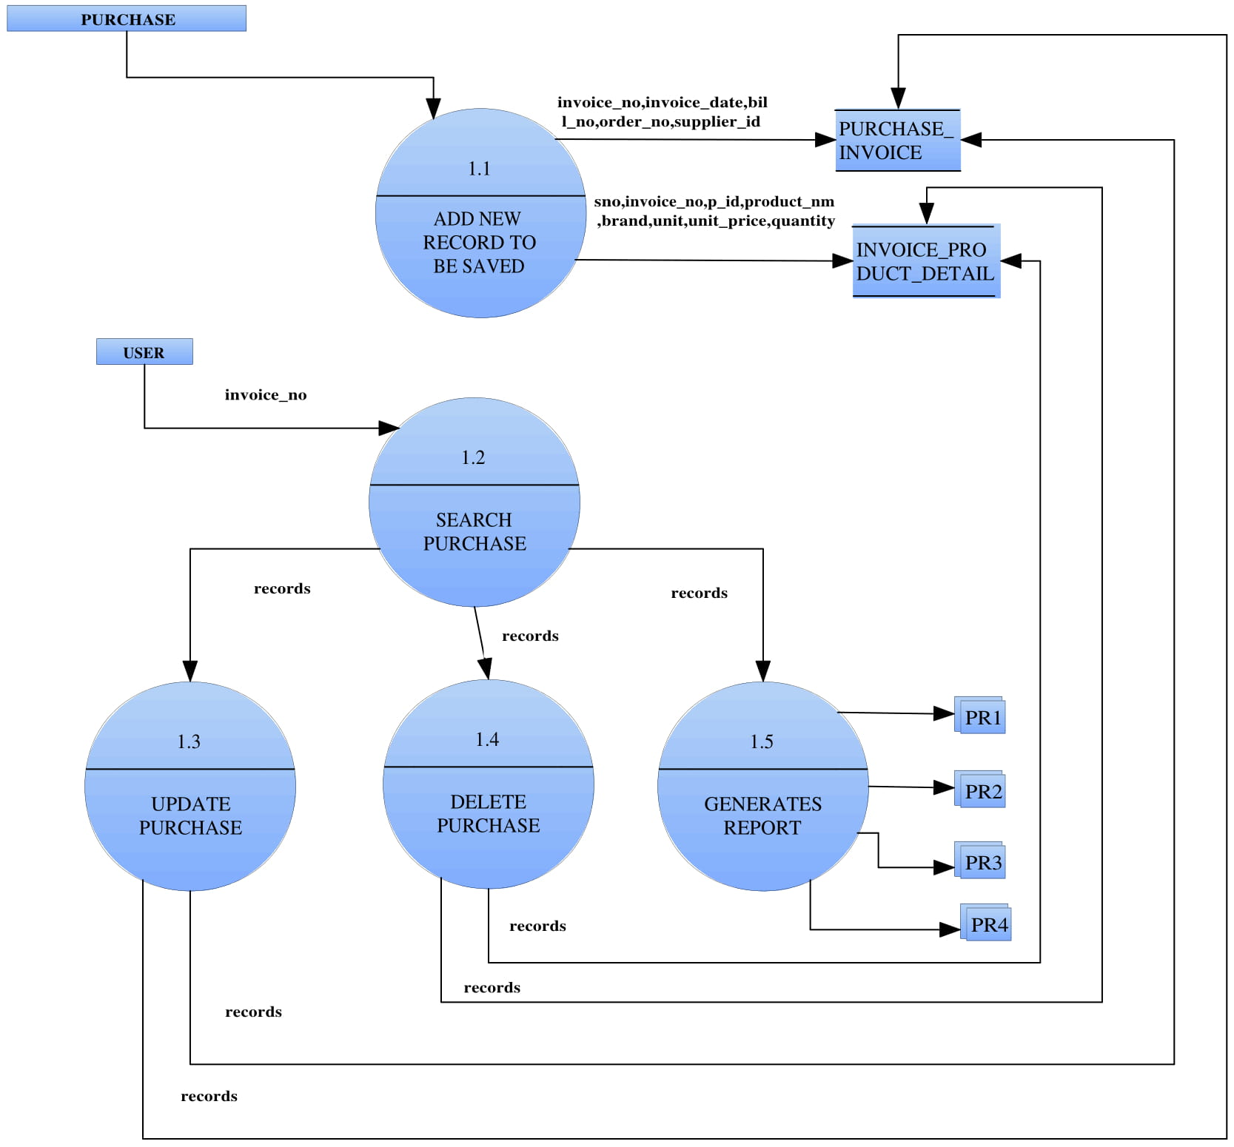

***Stock***

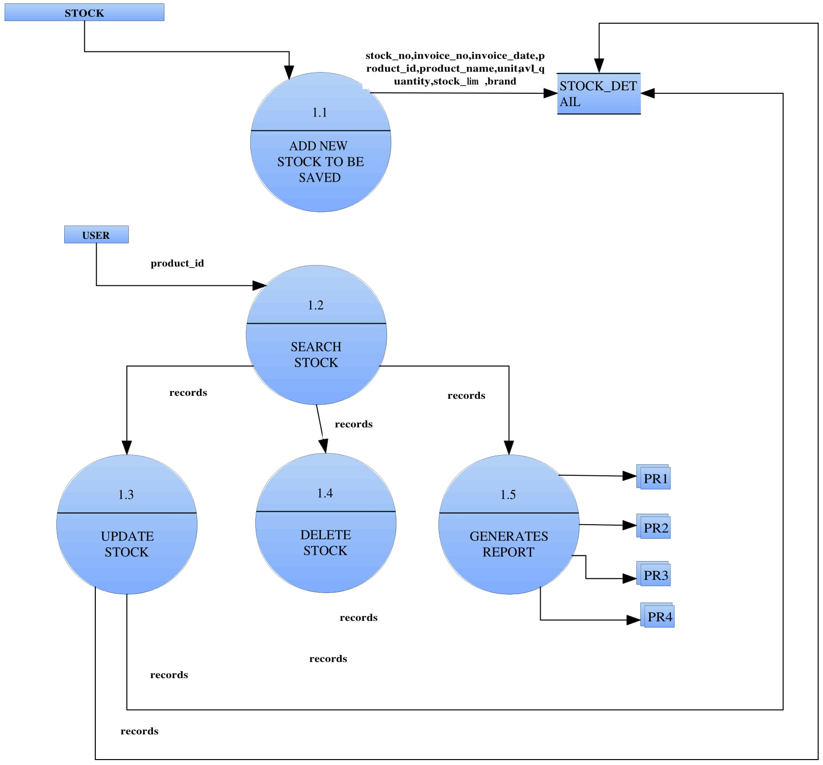

***Sells***

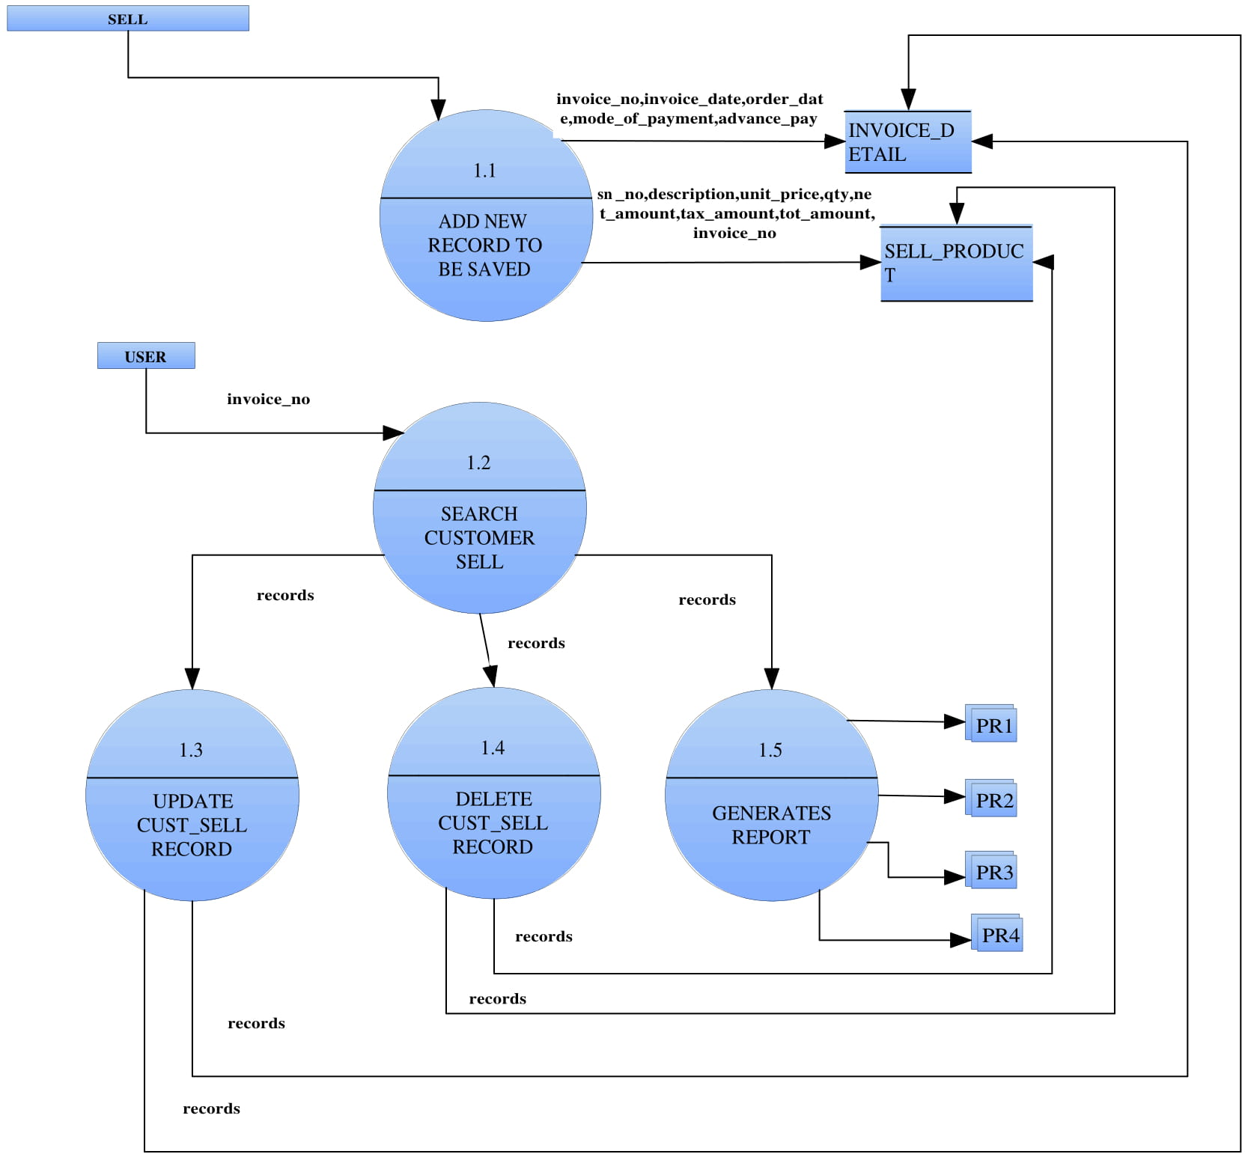

***Purchase Return***

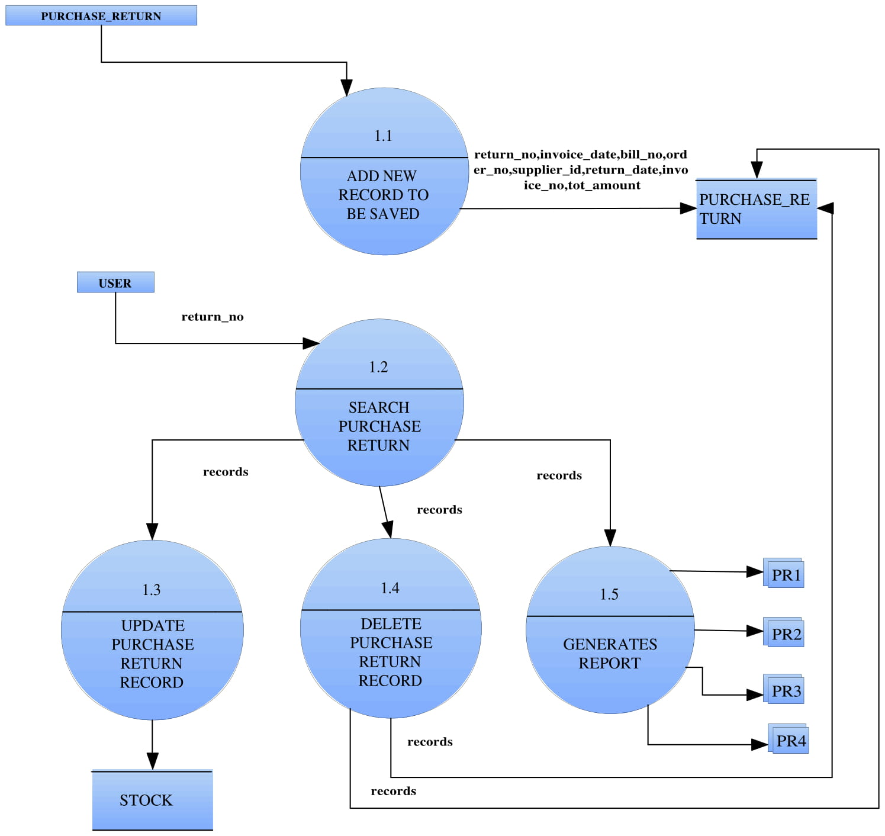

***Sell Return***

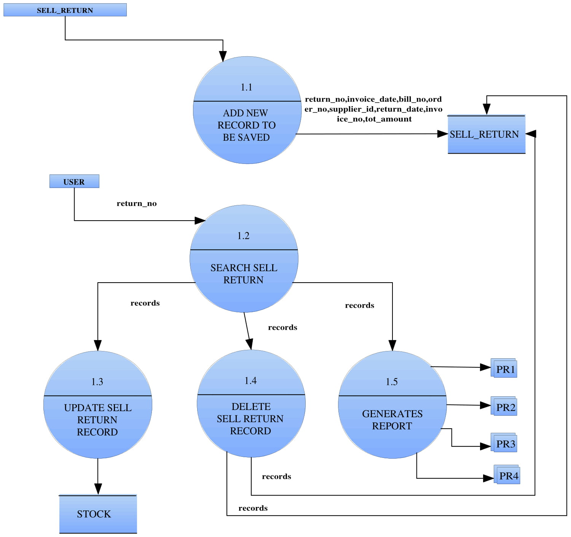

# Components of system

ADMIN – Admin is the backbone of an organization who ensures the efficient performance of all department in an organization. Admin invest his money in an organization and keep an information related with capital management, expense management, income management , profit / loss management, department management , advertisement management , employee management, reporting , etc . It’s sub units are interdependent of each other.

### Capital Management:-

Capital management is the sub unit of admin . It is the financial strategy aimed at ensuring maximum efficiency in an organization’s cash flow. Its aim is to have adequate means to meet its day to day expenses, as well as financial obligations in the short- term.

### Expense Management:-

Expense management is the sub unit of admin . It refers to the systems deployed by a business to process, pay and audit expenses . It maintain details of purchase product details , transportation details , rent details , electricity details and other expenses details in an organization .

### Income Management:-

Income management is the sub unit of admin . It refers to the all the incoming money in an organization.

### Profit/Loss Management:-

Profit/loss management is the sub unit of admin . it refers to the managing income (incoming money) and expenses (outgoing money) to ensure that an organization earns a net operating profit. Usually, profit and loss management deals with profit and loss report.

### Department Management:-

Department management is the sub unit of admin.It refers to the managing of various department in an organization like accounting ,marketing , stock control , forecasting future sales , etc . Every department has its own functions and chain of commands .

### Employee Management:-

Employee management is the sub unit of admin. It refers to allocate specific work to each employee and generate a best output from them. Admin oversee the works of employee. Employee is one of the major aspect of an organization.

### Reporting:-

Reporting is the sub unit of admin. It refers to maintain monthly publish report which includes monthly ledger, monthly sale details , stock details, monthly purchase details etc.

### Supplier Management:-

Supplier management is also sub unit of purchase unit , it mainly deals with the supply of goods which includes the number of consignment ,transportation cost, total cost, delivery address, billing address , etc. It maintains particular details as record which is as follows.

**SUPPLIER DETAIL**

|  |  |  |  |  |  |
| --- | --- | --- | --- | --- | --- |
| **supplier id** | **supplier name** | **supplier add.** | **city** | **phone no** | **email id** |
|  |  |  |  |  |  |

### Product management:-

Product management is sub unit of purchase unit it collects information from market related to purchasing a quality goods with low cost and on time delivery and report to the respective units . To achieve this it takes help of details such as distributor details, availability of product at distributors, quality check, delivery dates etc and informs order management. It maintains particular details as record which are as follows.

**PRODUCT DETAILS**

|  |  |  |  |  |  |
| --- | --- | --- | --- | --- | --- |
| **s.n** | **product name** | **gst** | **brand** | **Price** | **unit** |
| 1 | Cashew | 5% | Balaji | 770/kg | 10kg/Packets |
| 2 | Walnuts | 12% | Dekux | 950/kg | 10kg/Packets |
| 3 | Dates | 12% | Alkhali | 120/kg | 8kg/Packets |
| 4 | Almonds | 12% | 69Almond | 720/kg | 25kg/bag |
| 5 | Pista | 12% | Gauri | 1000/kg | 10kg/Packets |
| 6 | Angeer | 12% | Tulsi | 1040/kg | 10kg/Packets |
| 7 | Makhana | 0% | Rajbhog | 600/kg | 10kg/Packets |
| 8 | Chuhara | 12% | Mahagulla | 170/kg | 70kg/bag |
| 9 | Dried coconut | 5% | Coconut | 200/kg | 25kg/bag |
| 10 | Munakka | 12% | Tulsi | 320/kg | 10kg/Packets |

**3. SOLD PRODUCT:-**

It is the sub unit of sales . It maintain the details of all product that had been sold.

### Customer management:-

* ORDER- Order management is also sub unit of purchase unit . It automates and streamlines order processing for business. It mainly stores information about purchasing of product from company and take order from distributor .

# ORDER DETAIL

|  |  |  |  |
| --- | --- | --- | --- |
| **order no** | **order date** | **delivery date** | **distributer id** |
|  |  |  |  |
|  |  |  |  |

* PURCHASE- Purchase unit is a function module in an organization .It mainly deals with managing product management, supplier management, order management , supply management , return management etc. To achieve this it maintains respective registers. It sub units are interdependent on each other.

SALE- Sale unit is a function module in an organization . It’s responsibility is to store all the information related to sales of product. Mainly it deals with availability of products , customers management , sold product information , billing , return management , etc .

* Stock- Stock is one of the main module in an organization. It is the product or goods kept on the premises of a shop or warehouse and available for sale or distribution.

### 1 AVAILABILITY MANAGEMENT:-

Availability management is the sub unit of stock . It deals with the availability of product which are kept as a stock in the organization for sale .After the entire day sale , stock is checked (it maintain the record of how much product is left after one day sale) daily.

### 2 DAMAGE :-

It is basically maintain to determine whether the stock in warehouse(godown) is destroyed or damaged by any physical means

## 

## STOCK DETAIL

|  |  |  |  |
| --- | --- | --- | --- |
| **company id** | **product id** | **daily sell quantity** | **total quantity** |
|  |  |  |  |
|  |  |  |  |
|  |  |  |  |

### 

Return- It is the sub unit of sales . It maintains the details of those product which has been returned back due to product damage or any other reason.

* Report-

# System design



**Splash Screen**

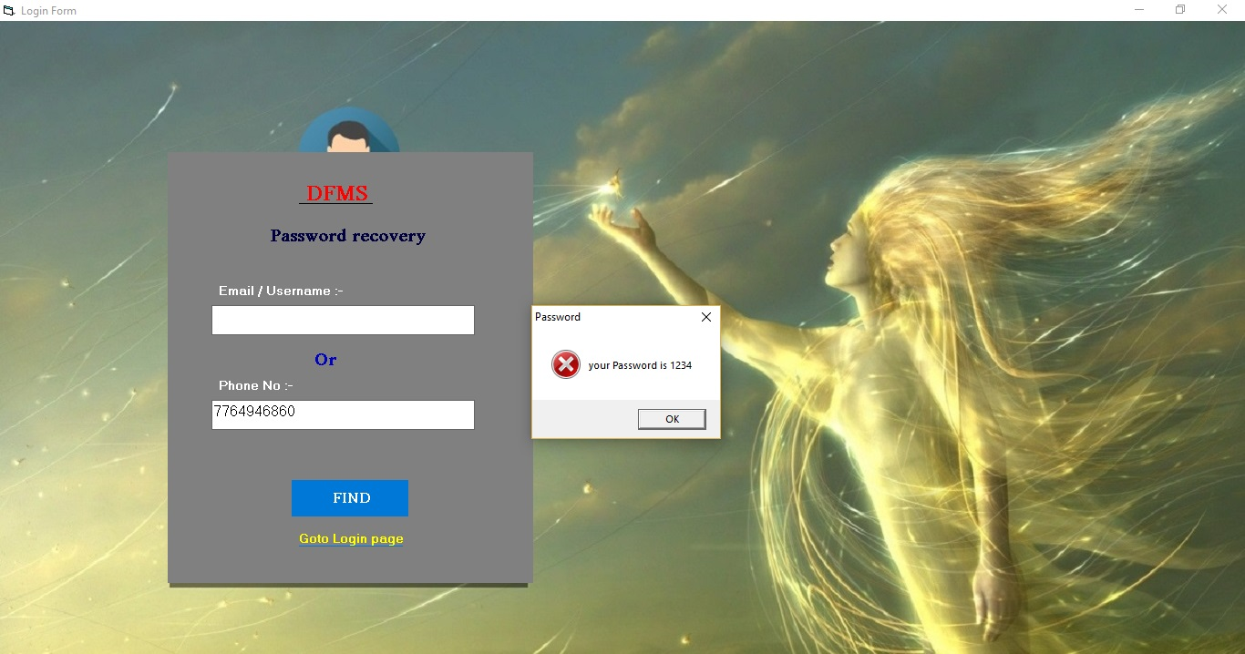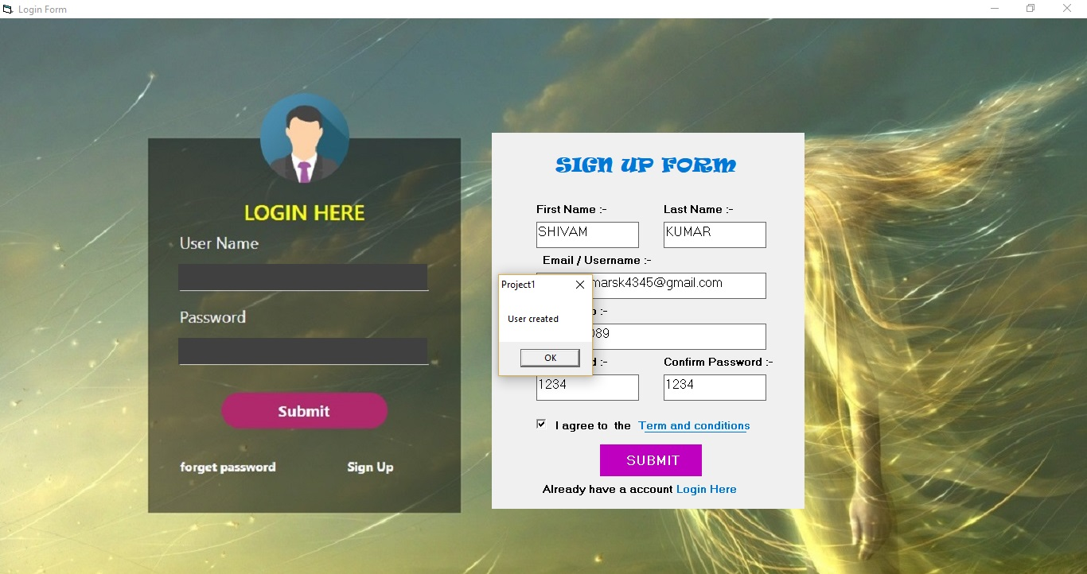

**Forgot Password**

**Sign up Form**

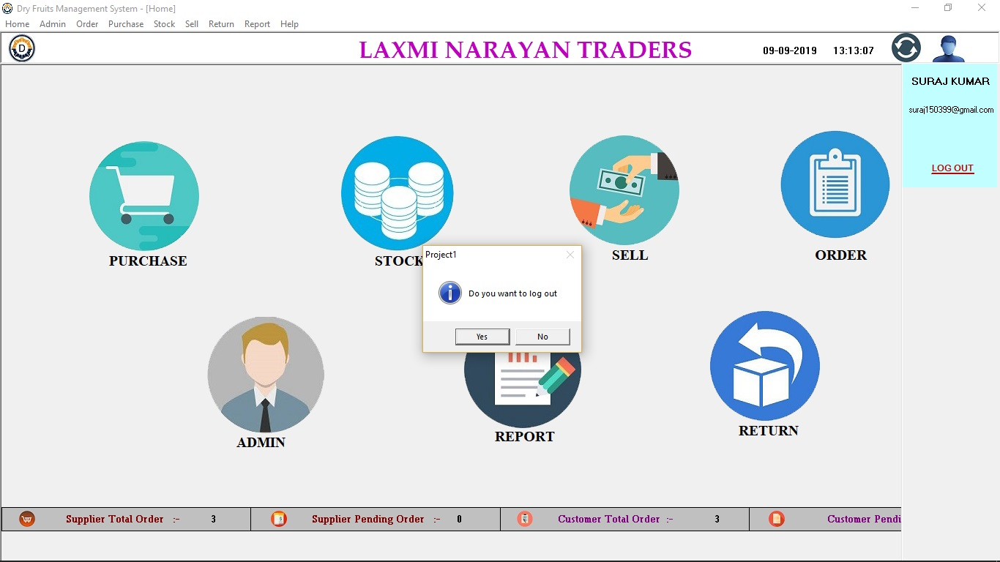

**Forgot Password**

**MDI Form**

**Password recovery Form**

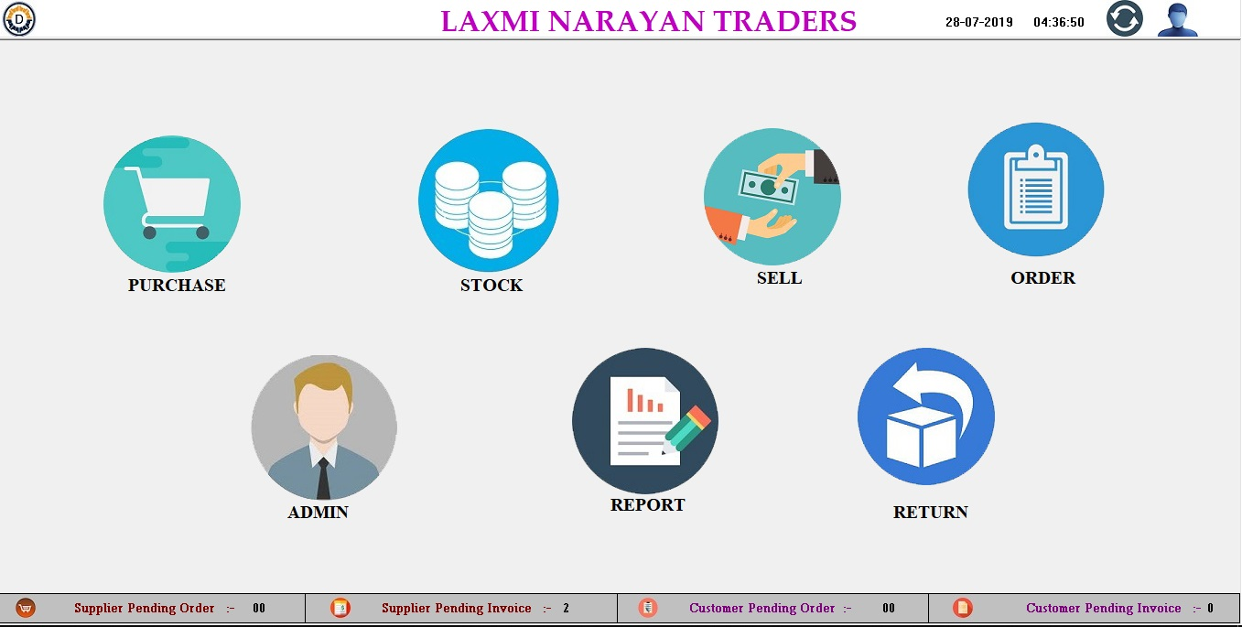

**MDI Form**

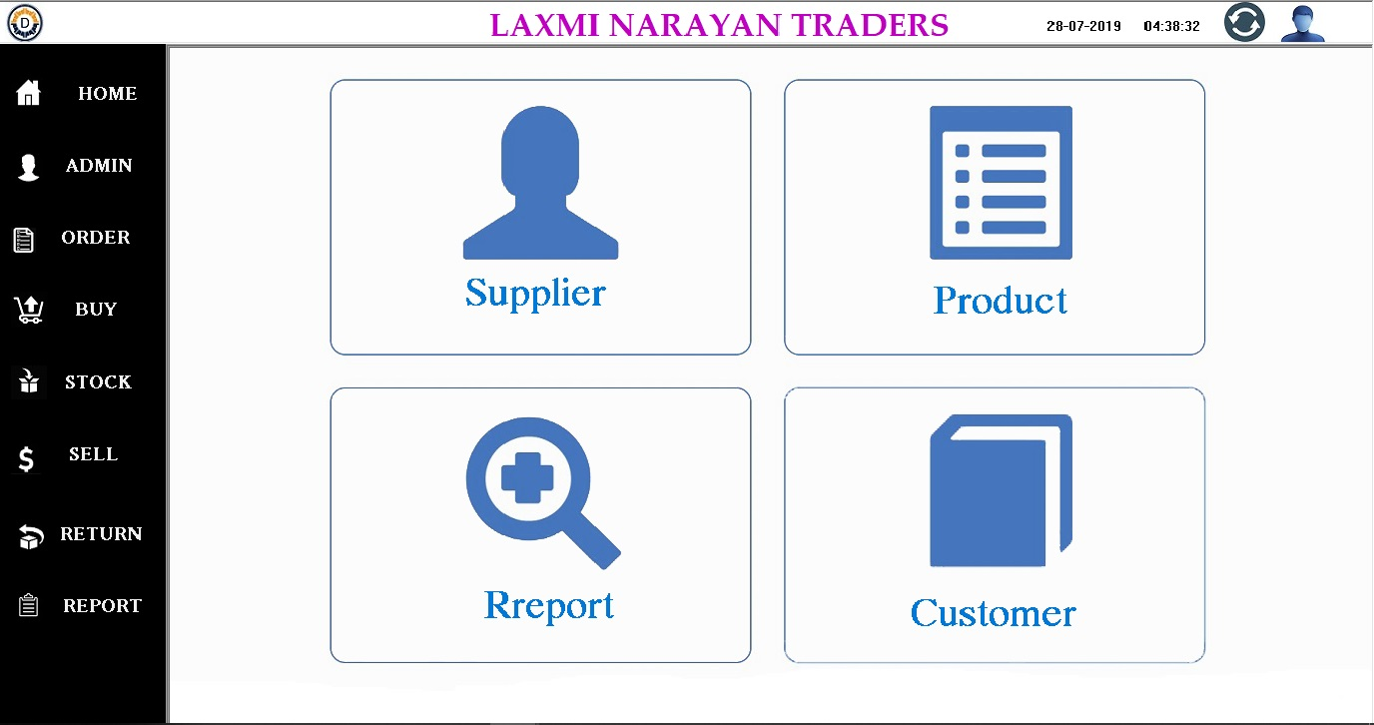

**Admin Form**

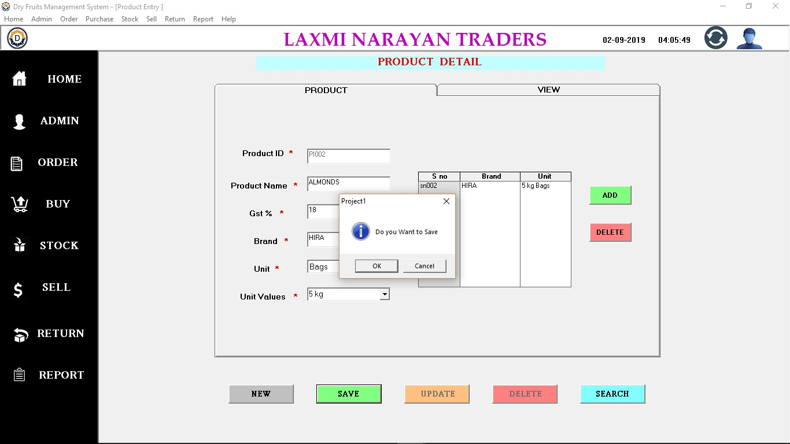

**Product Form**

**Product View**

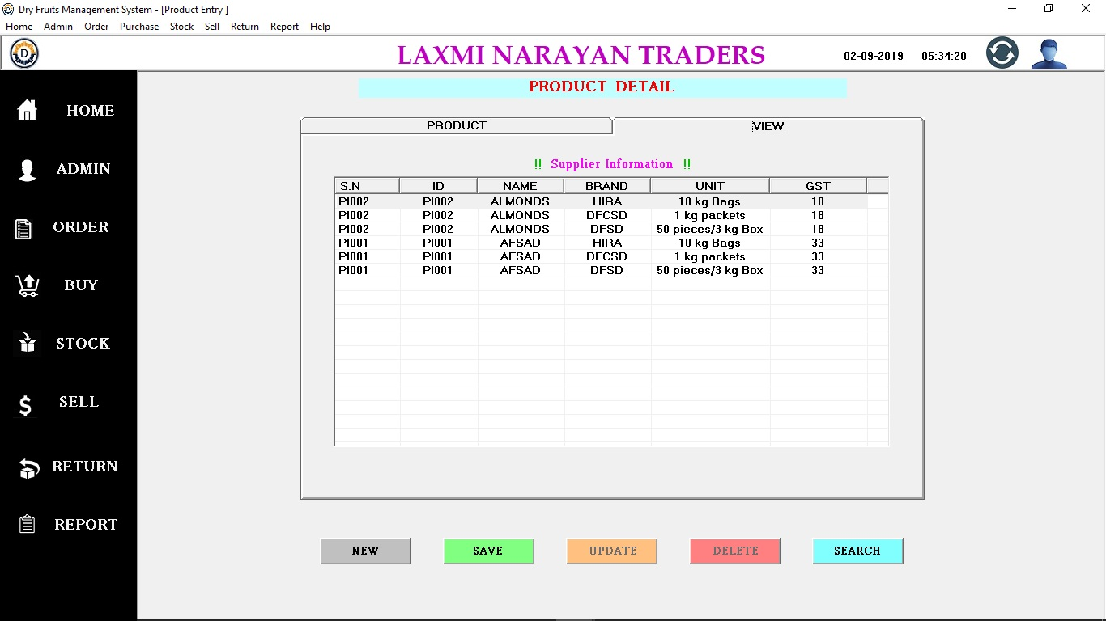

**Customer Form**

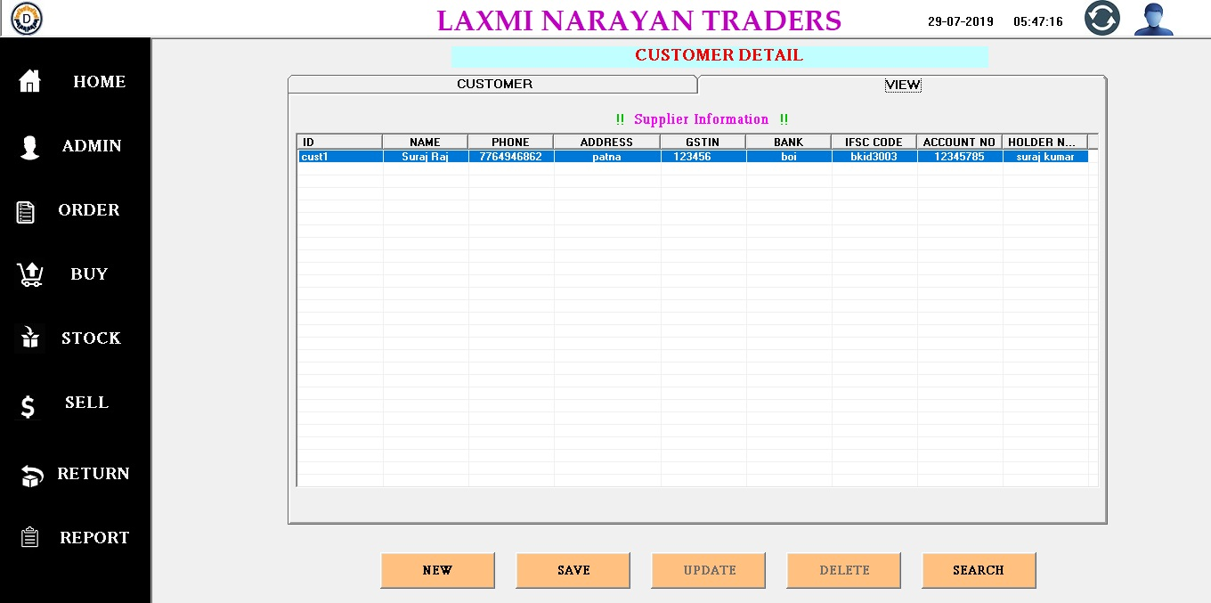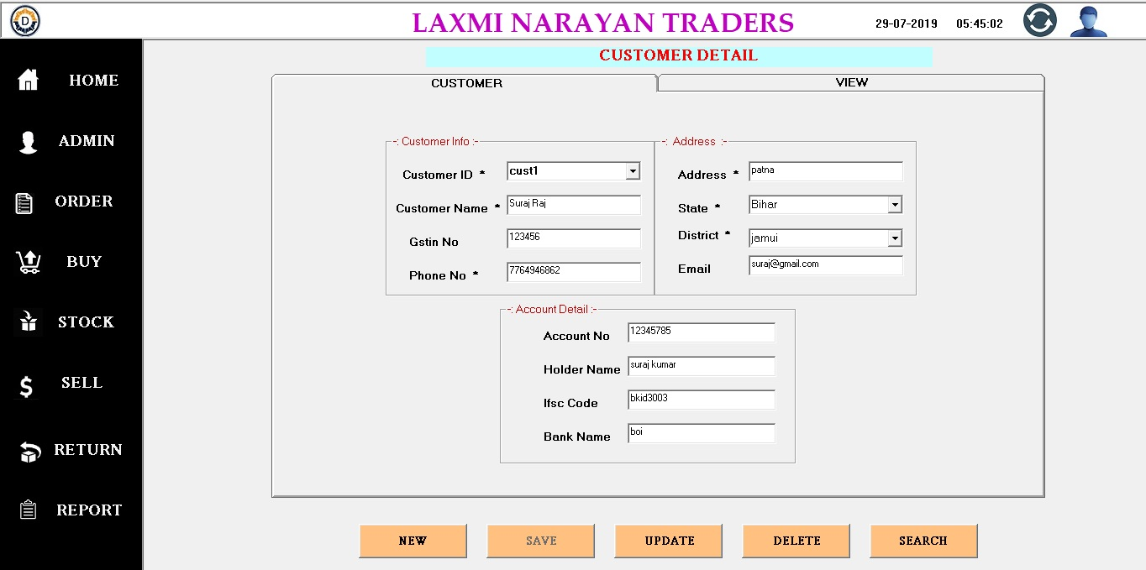

**Customer View**

**Supplier Detail**

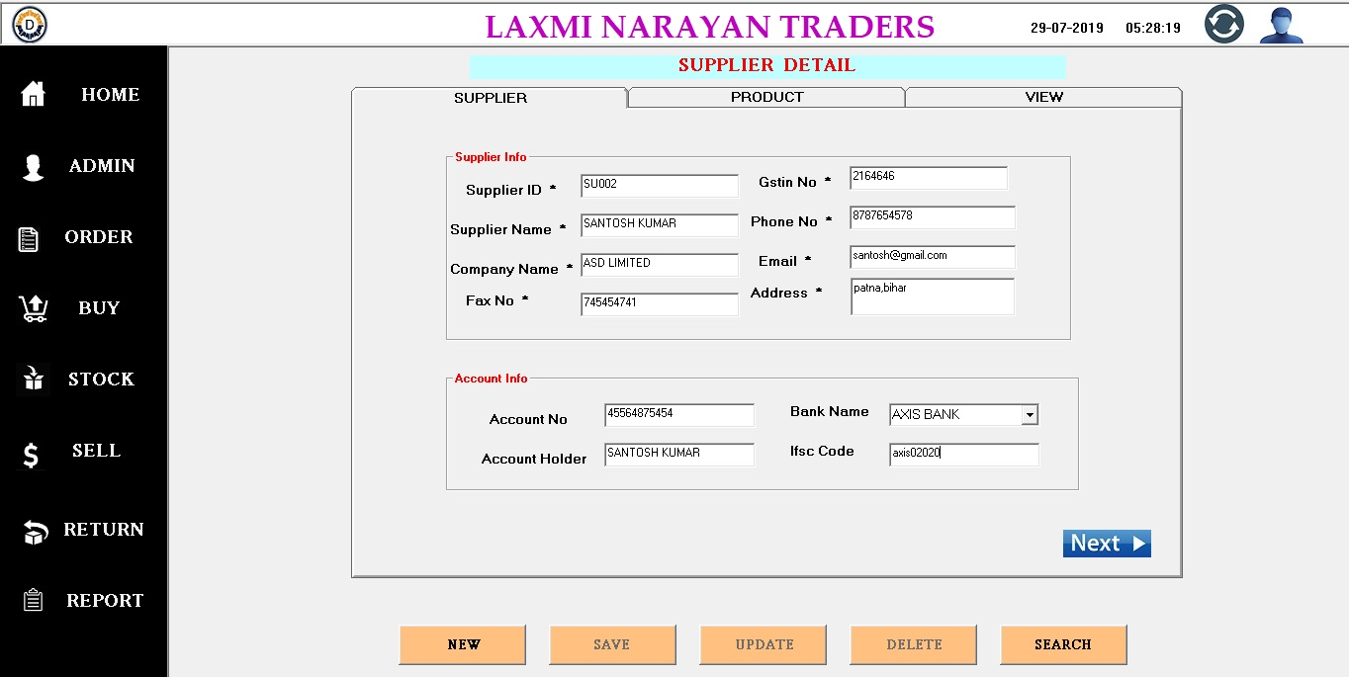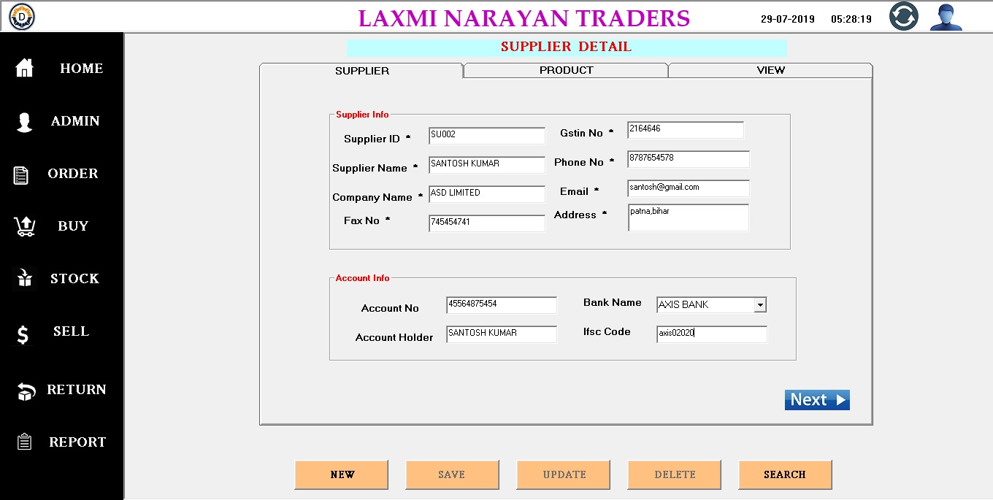

**Supplier Product**

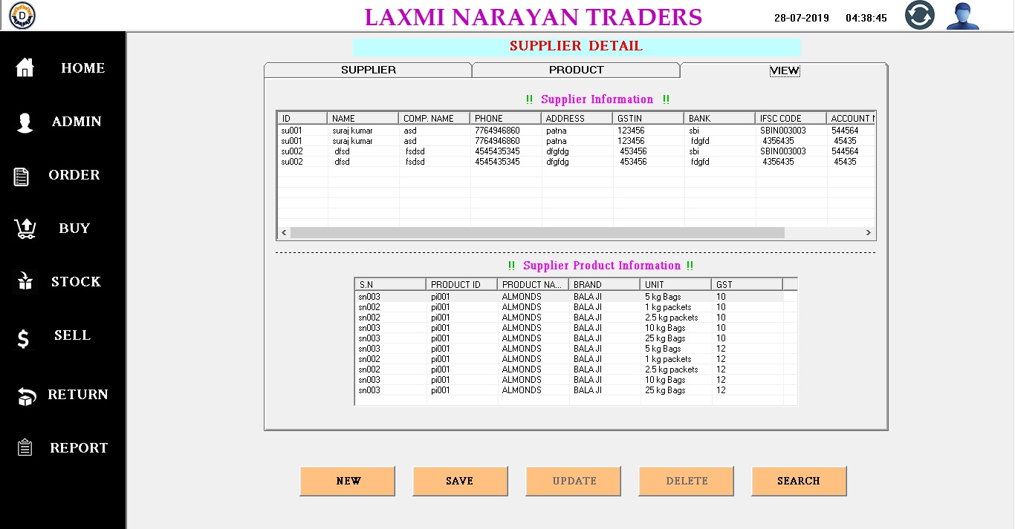

**Supplier view**

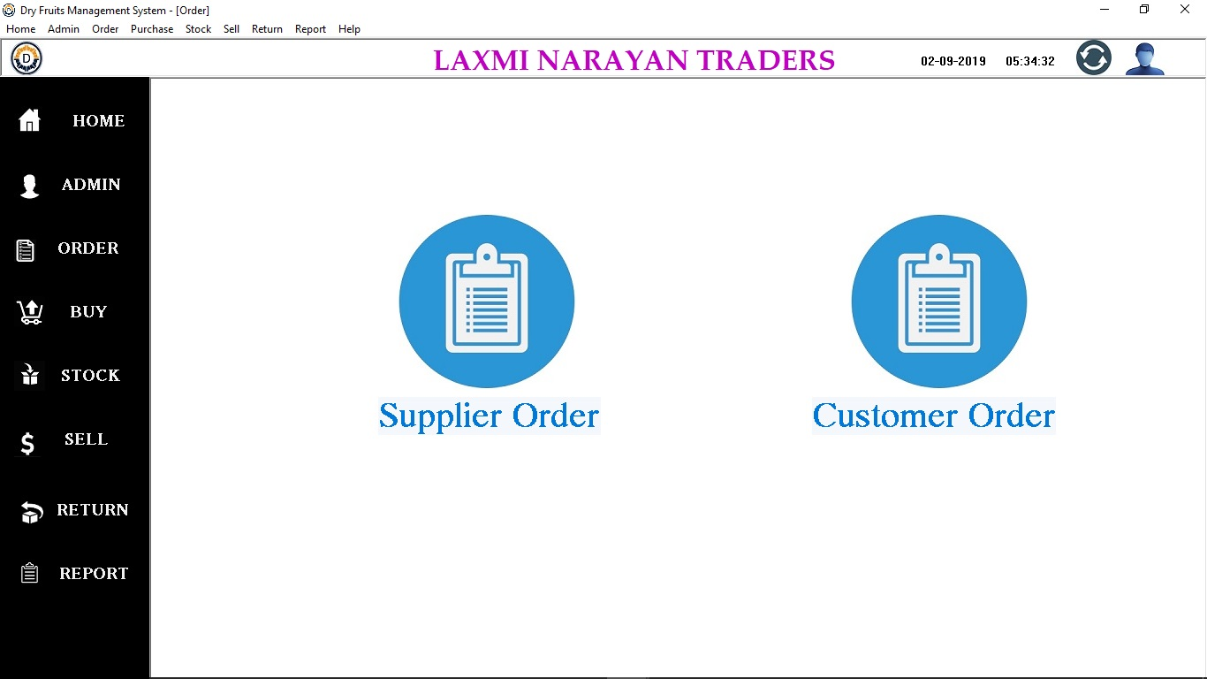

**Order Form**

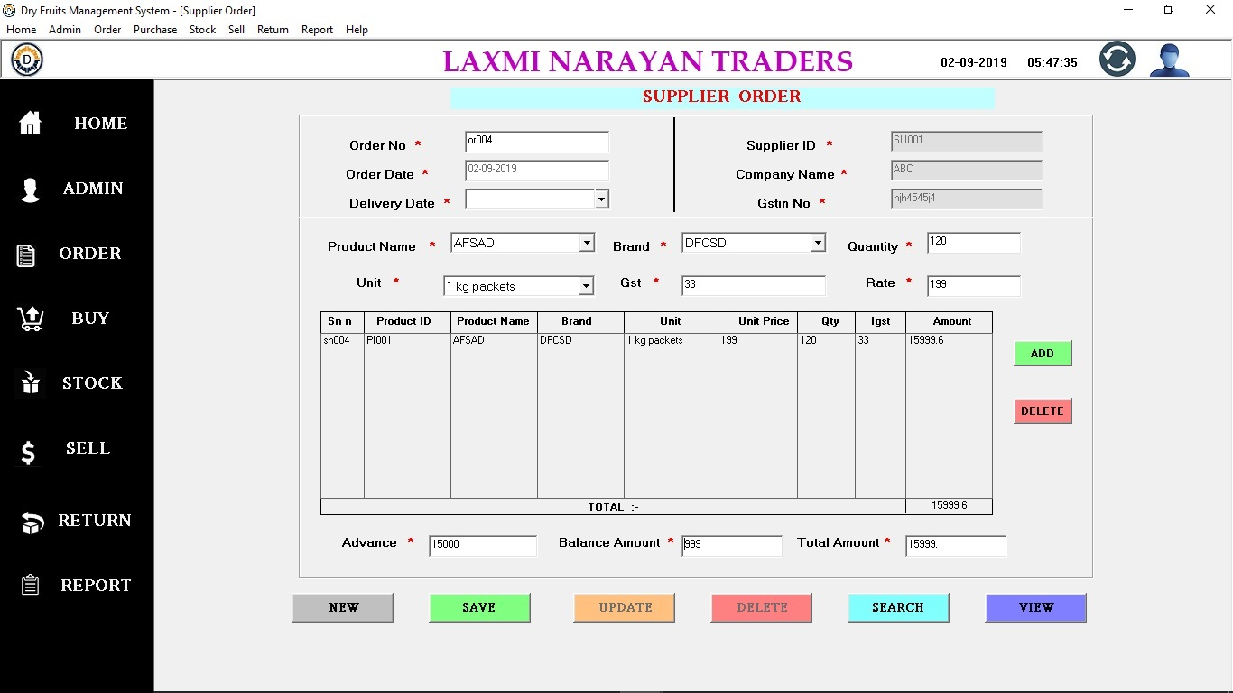

**Supplier Order**

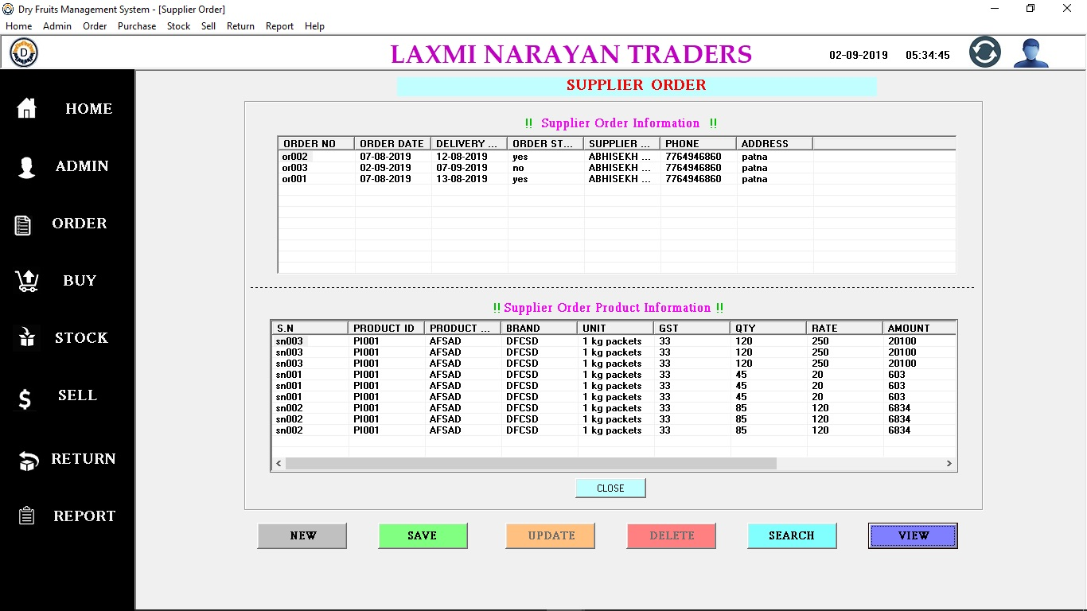

**Supplier Order View**

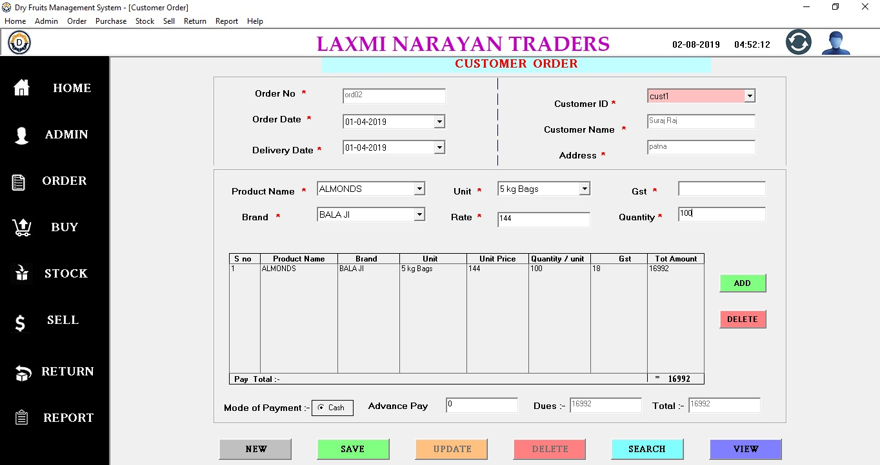

**Customer Order View**

**Customer Order**

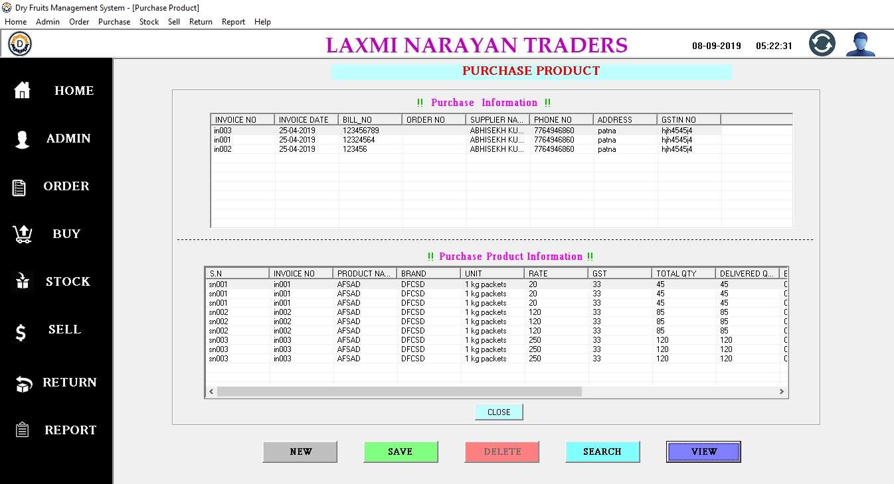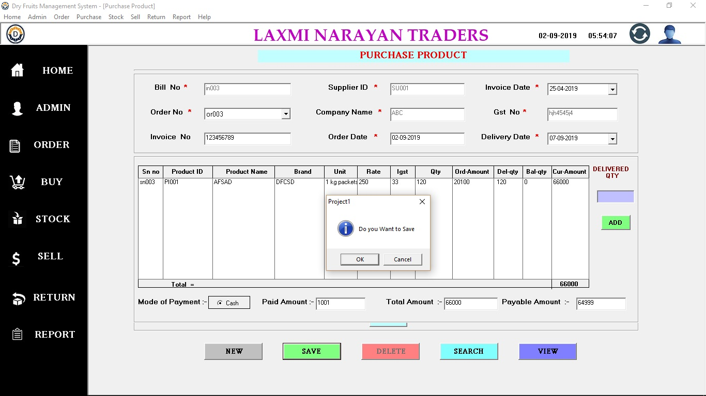

**Purchase View**

**Purchase Product**

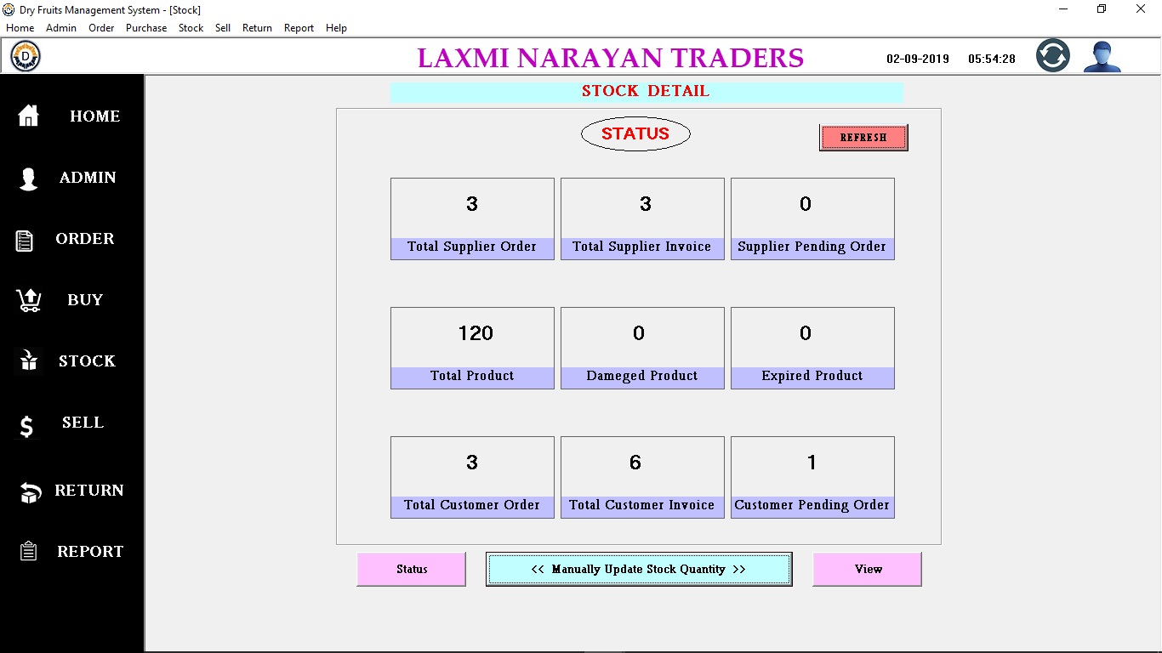

**Stock Status**

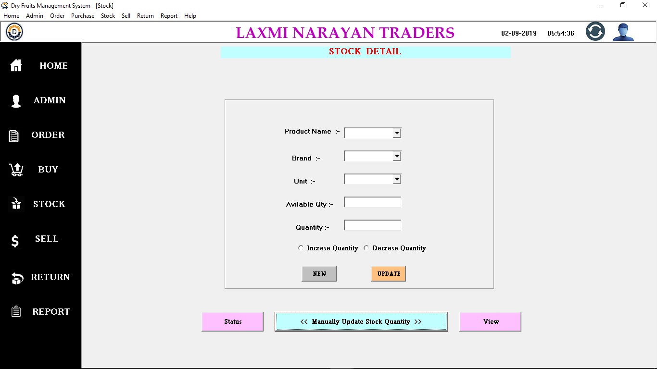

**Stock Update Manually**

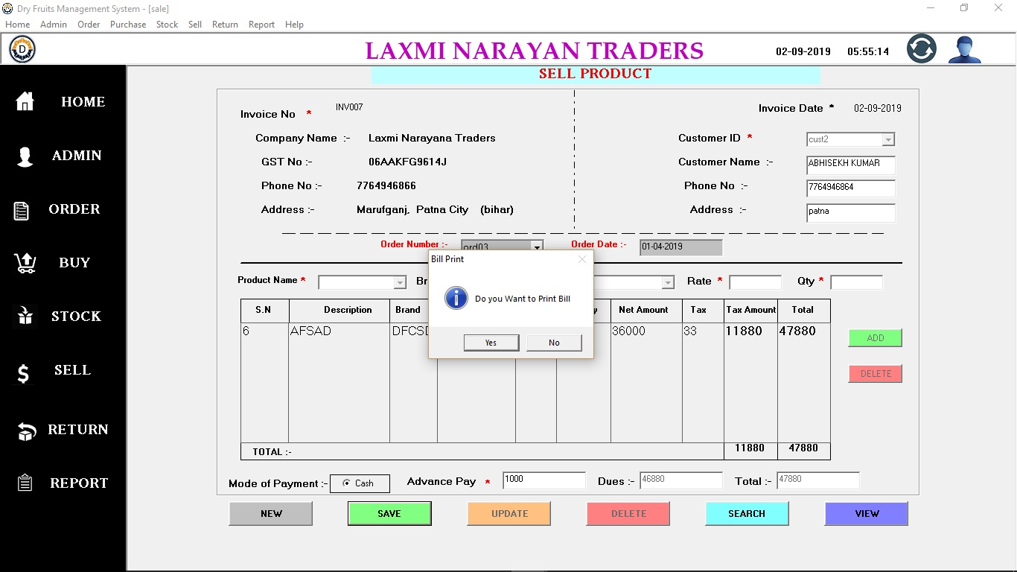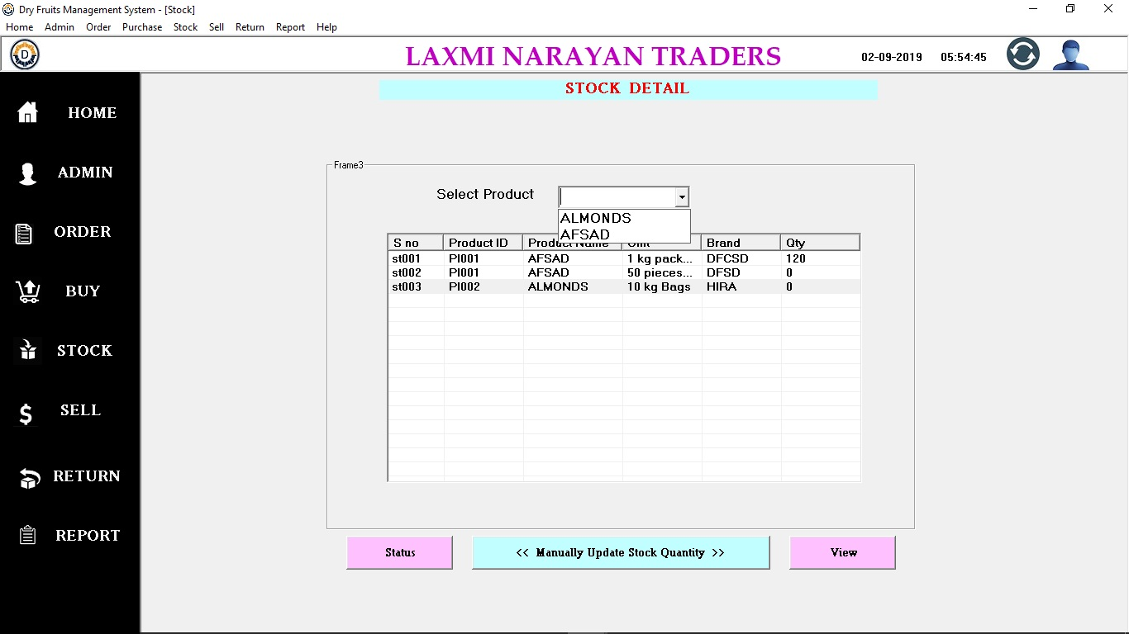

**Sell Form**

**Stock view**

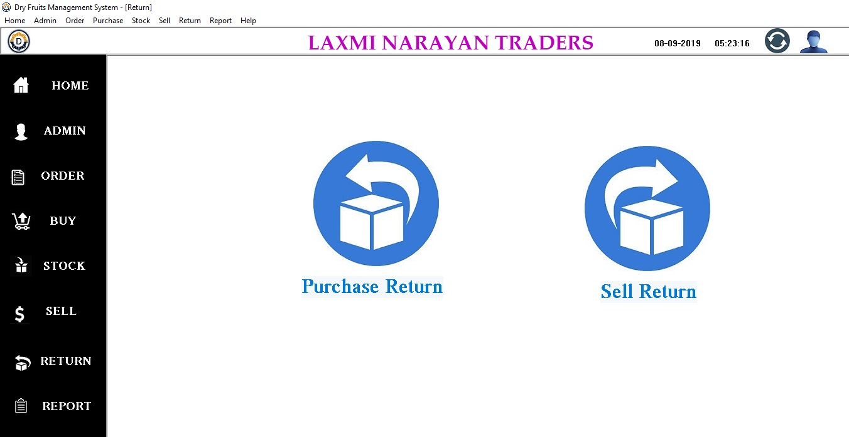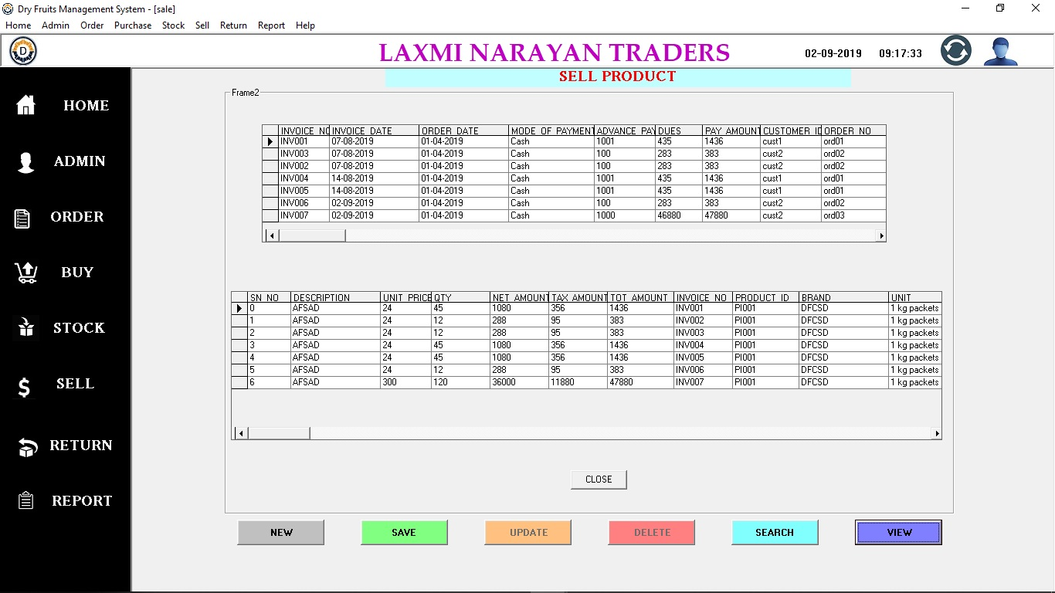

**Return Form**

**Sell View**

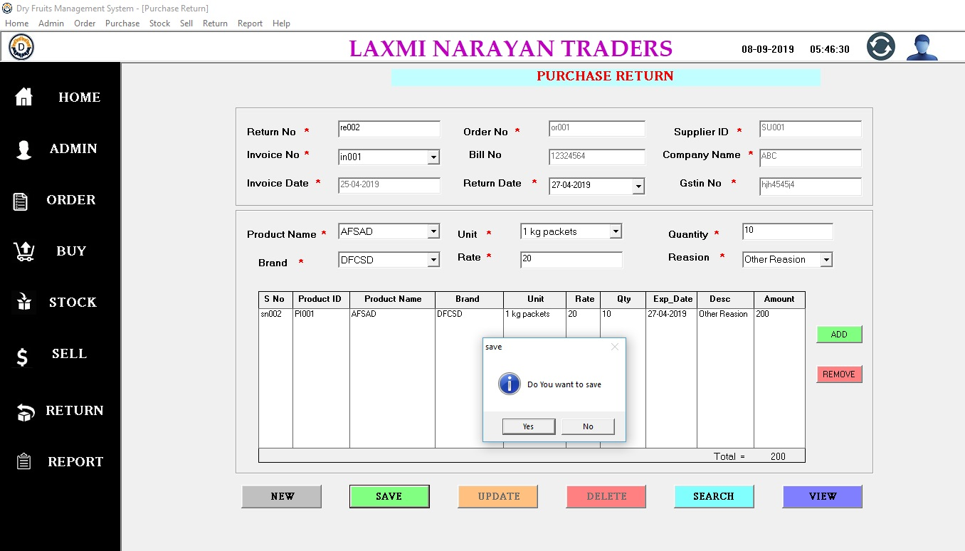

**Purchase Return**

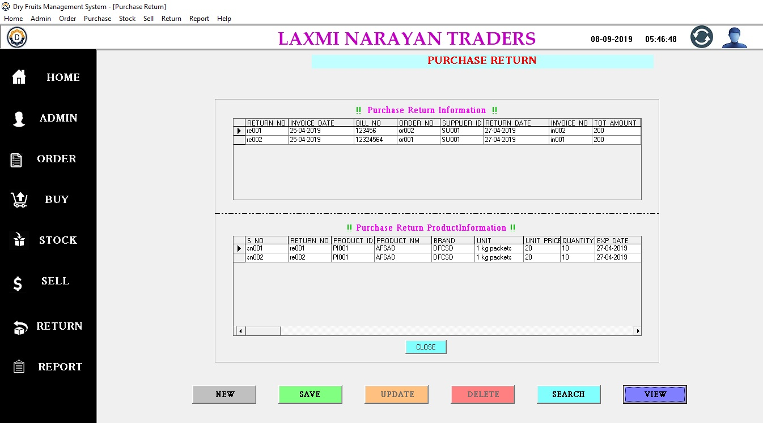

**Purchase Return view**

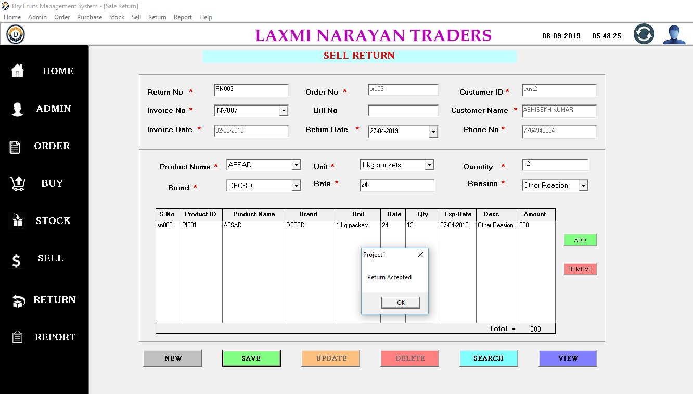

**Sell Return**

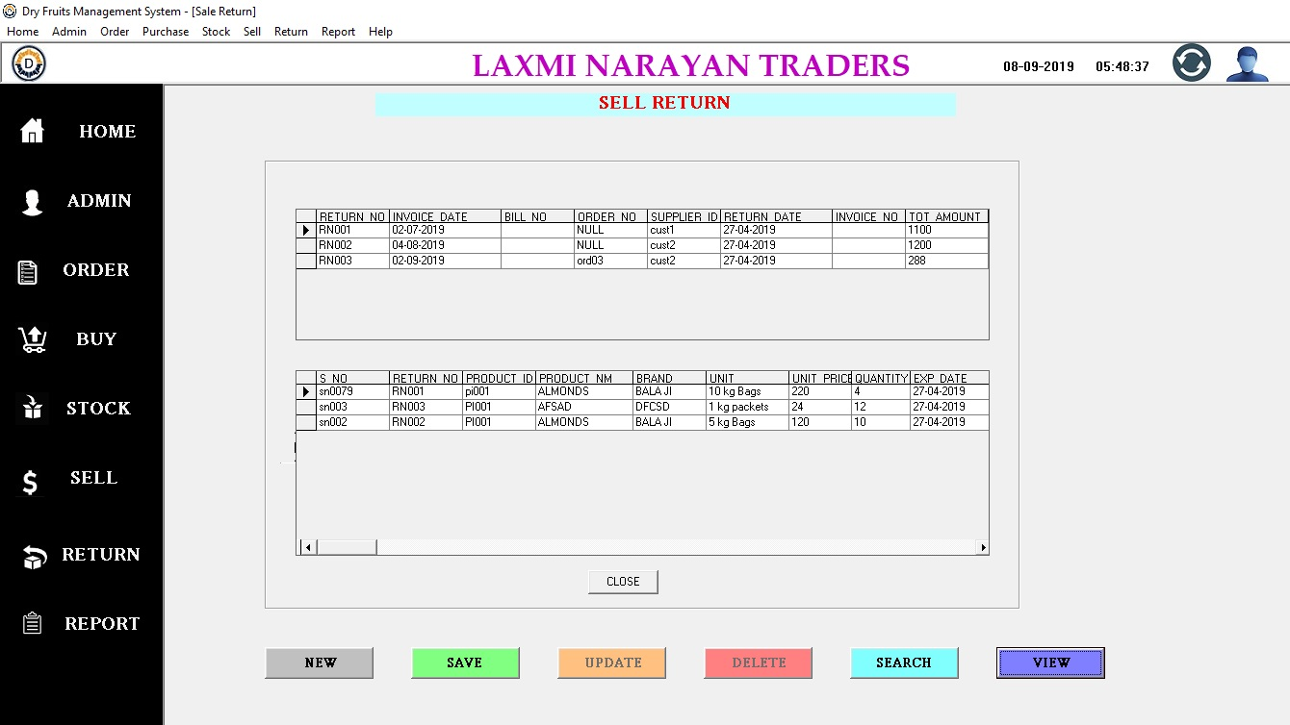

**Sell Return View**

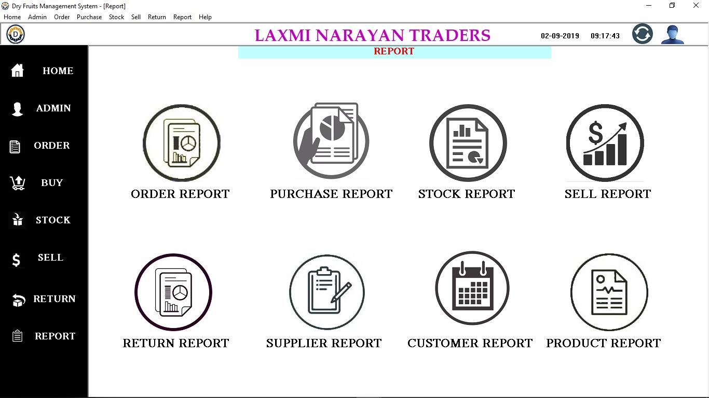

**Report Form**

**Supplier Order Report**

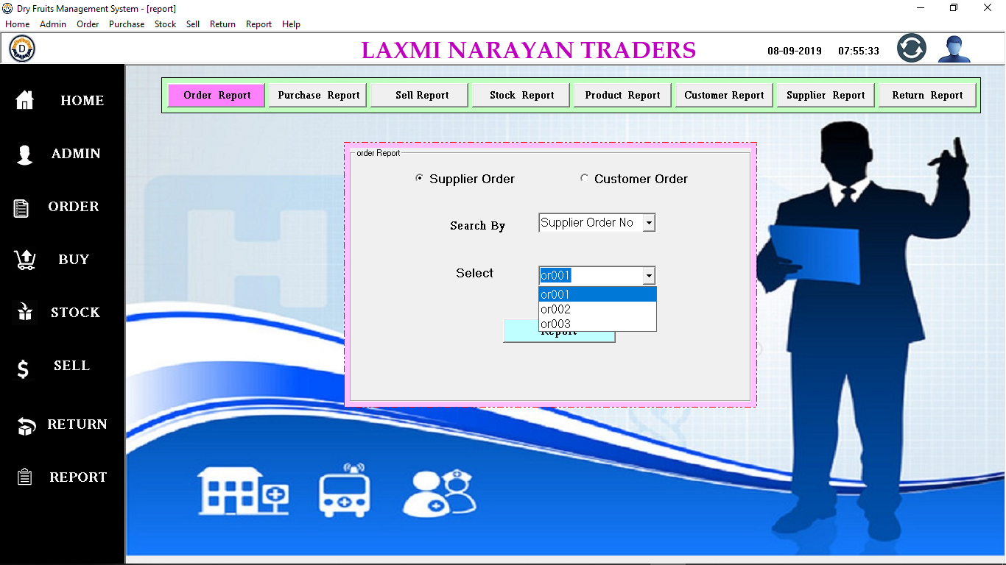

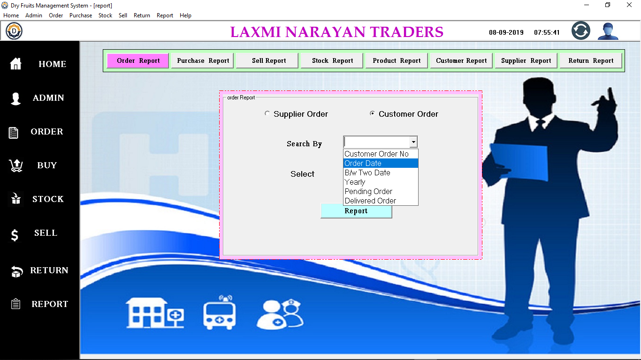

**Customer Order Report**

**Purchase Report**

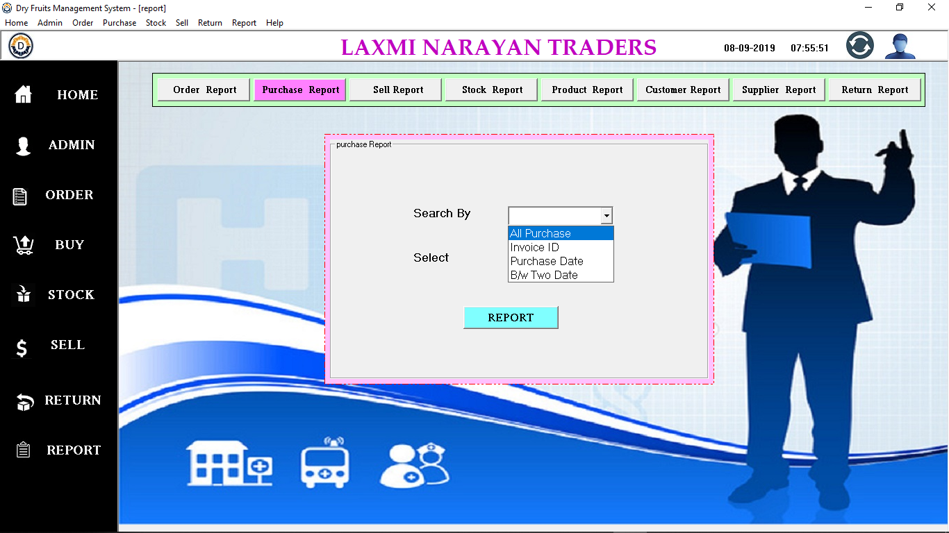

**Sell Report**

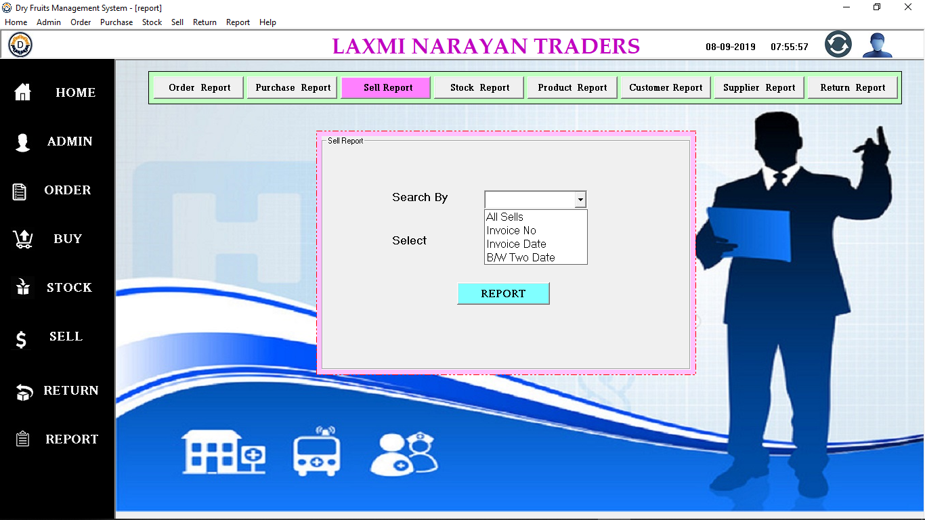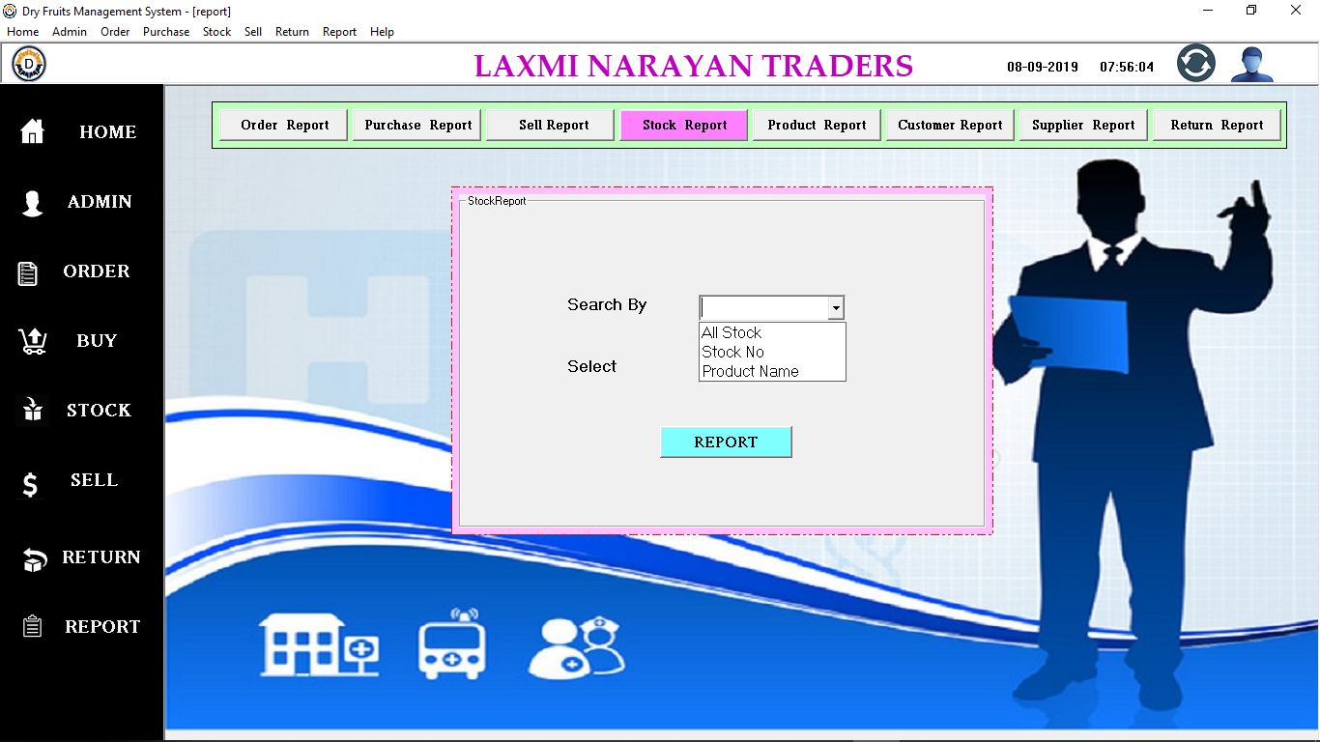

**Stock Report**

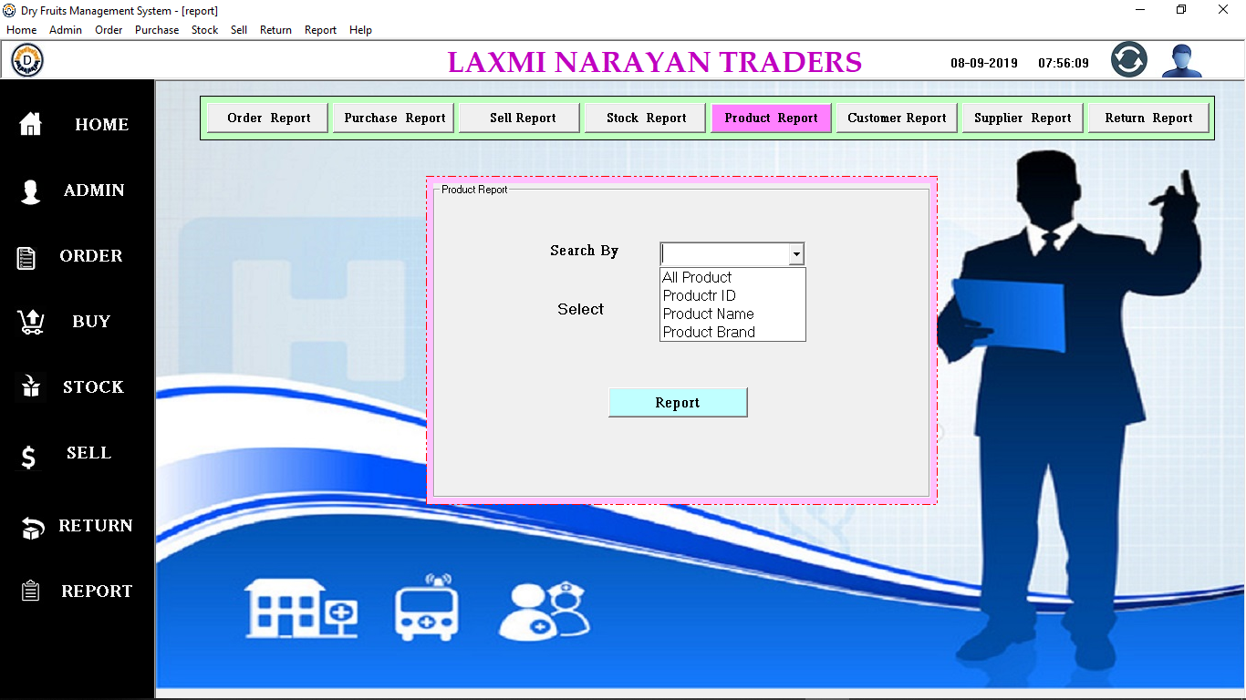

**Product Report**

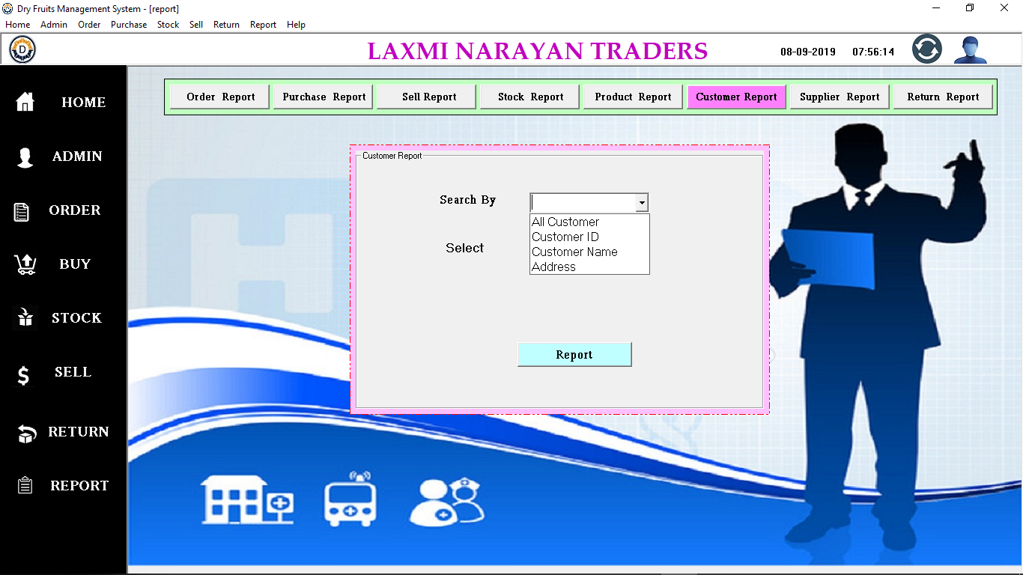

**Customer Report**

**Supplier Report**

**Purchase Return Report**

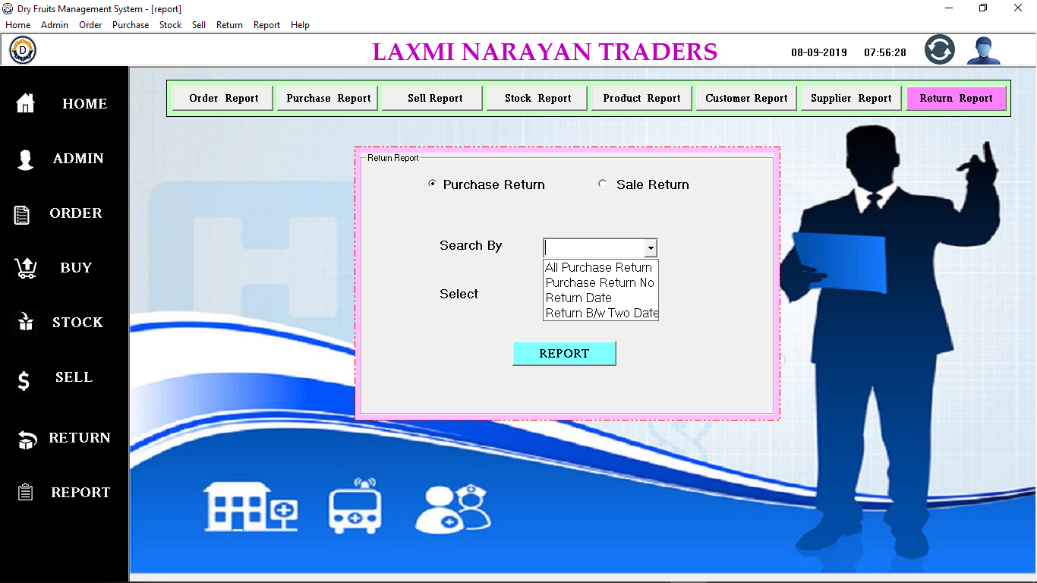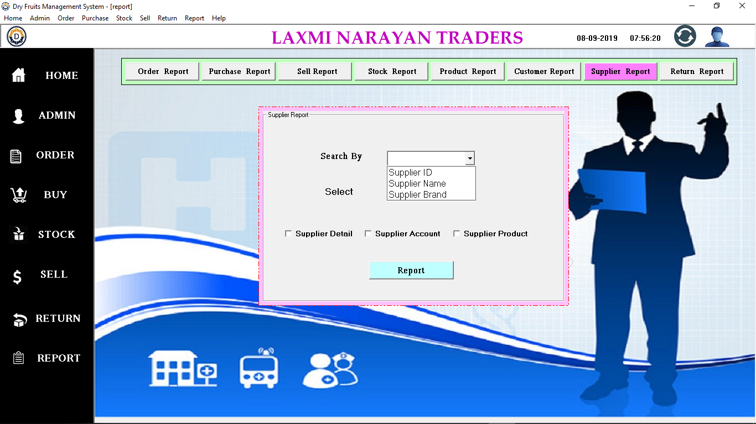

**Sell Return Report**

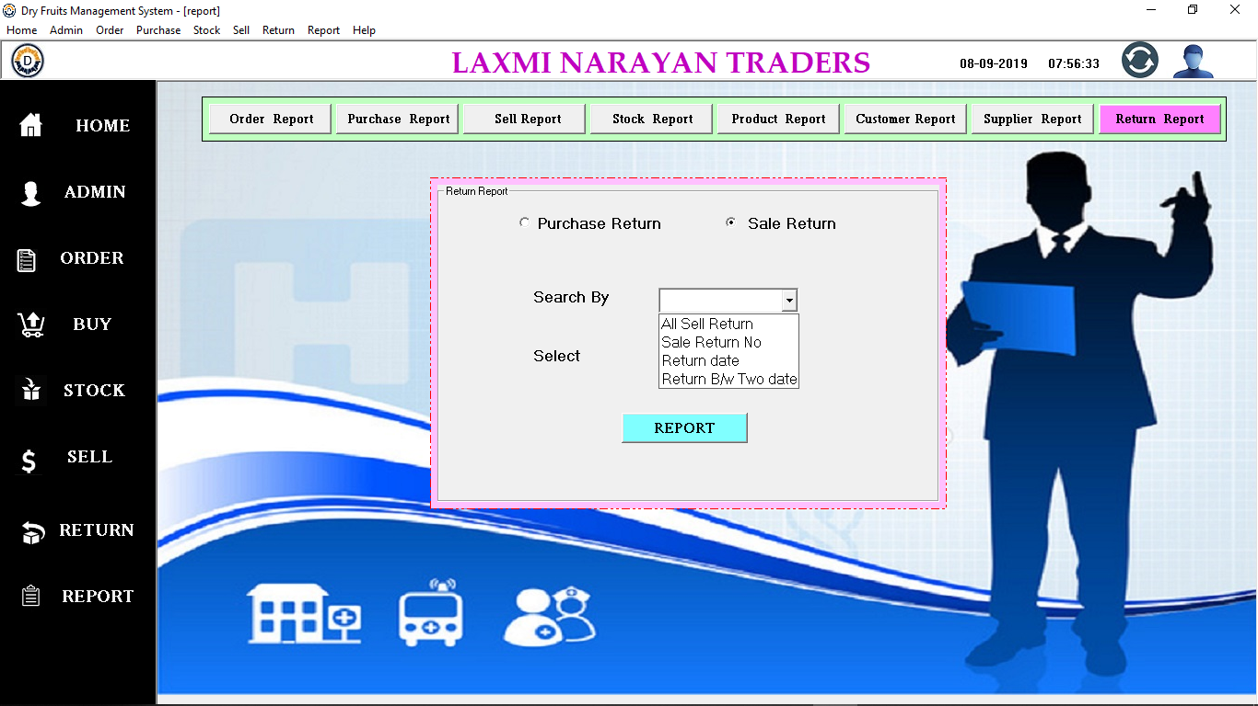

**Supplier Order number Report**

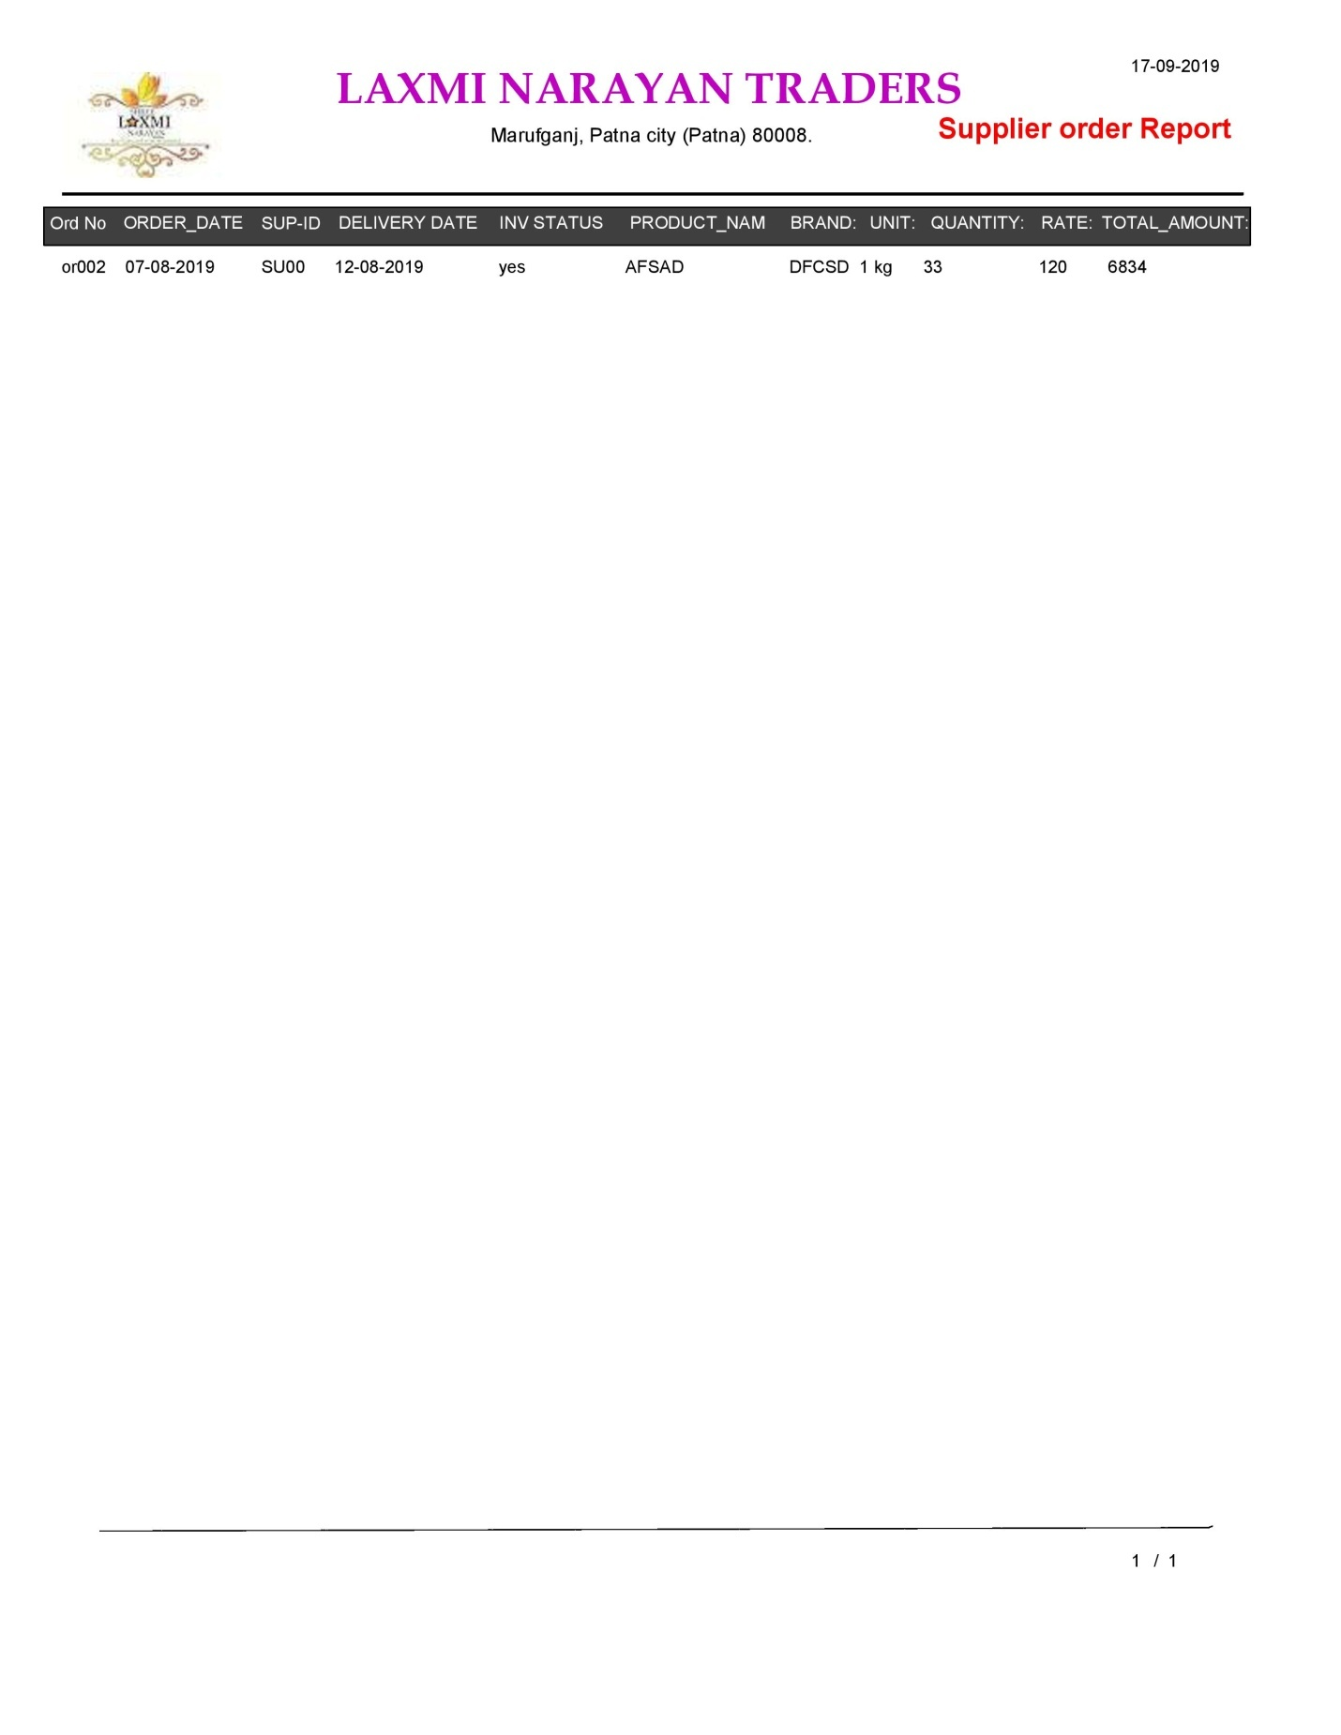

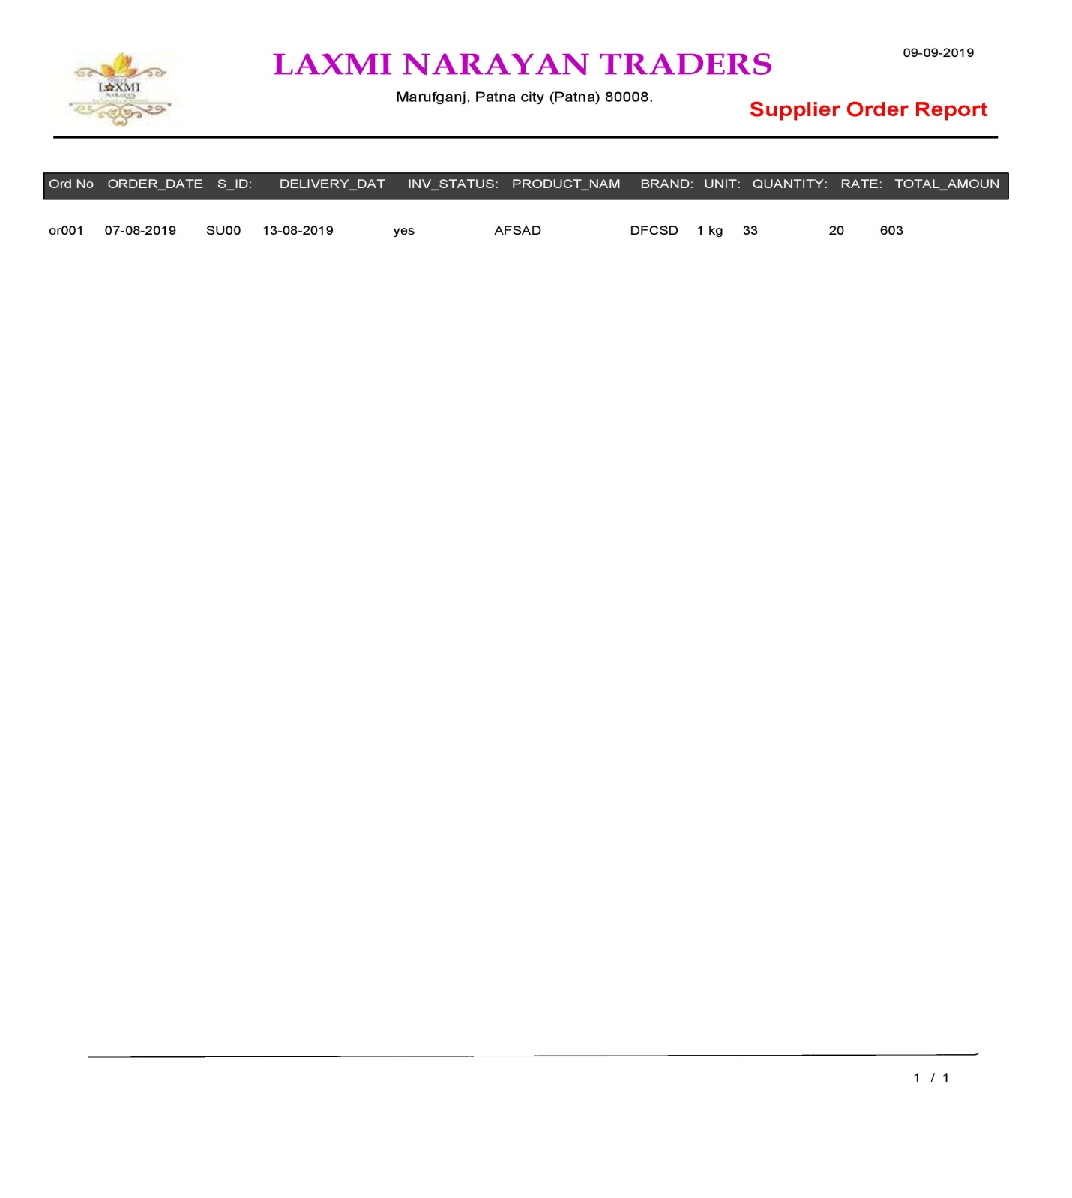

**Supplier Order Date Report**

**Supplier Order Pending Report**

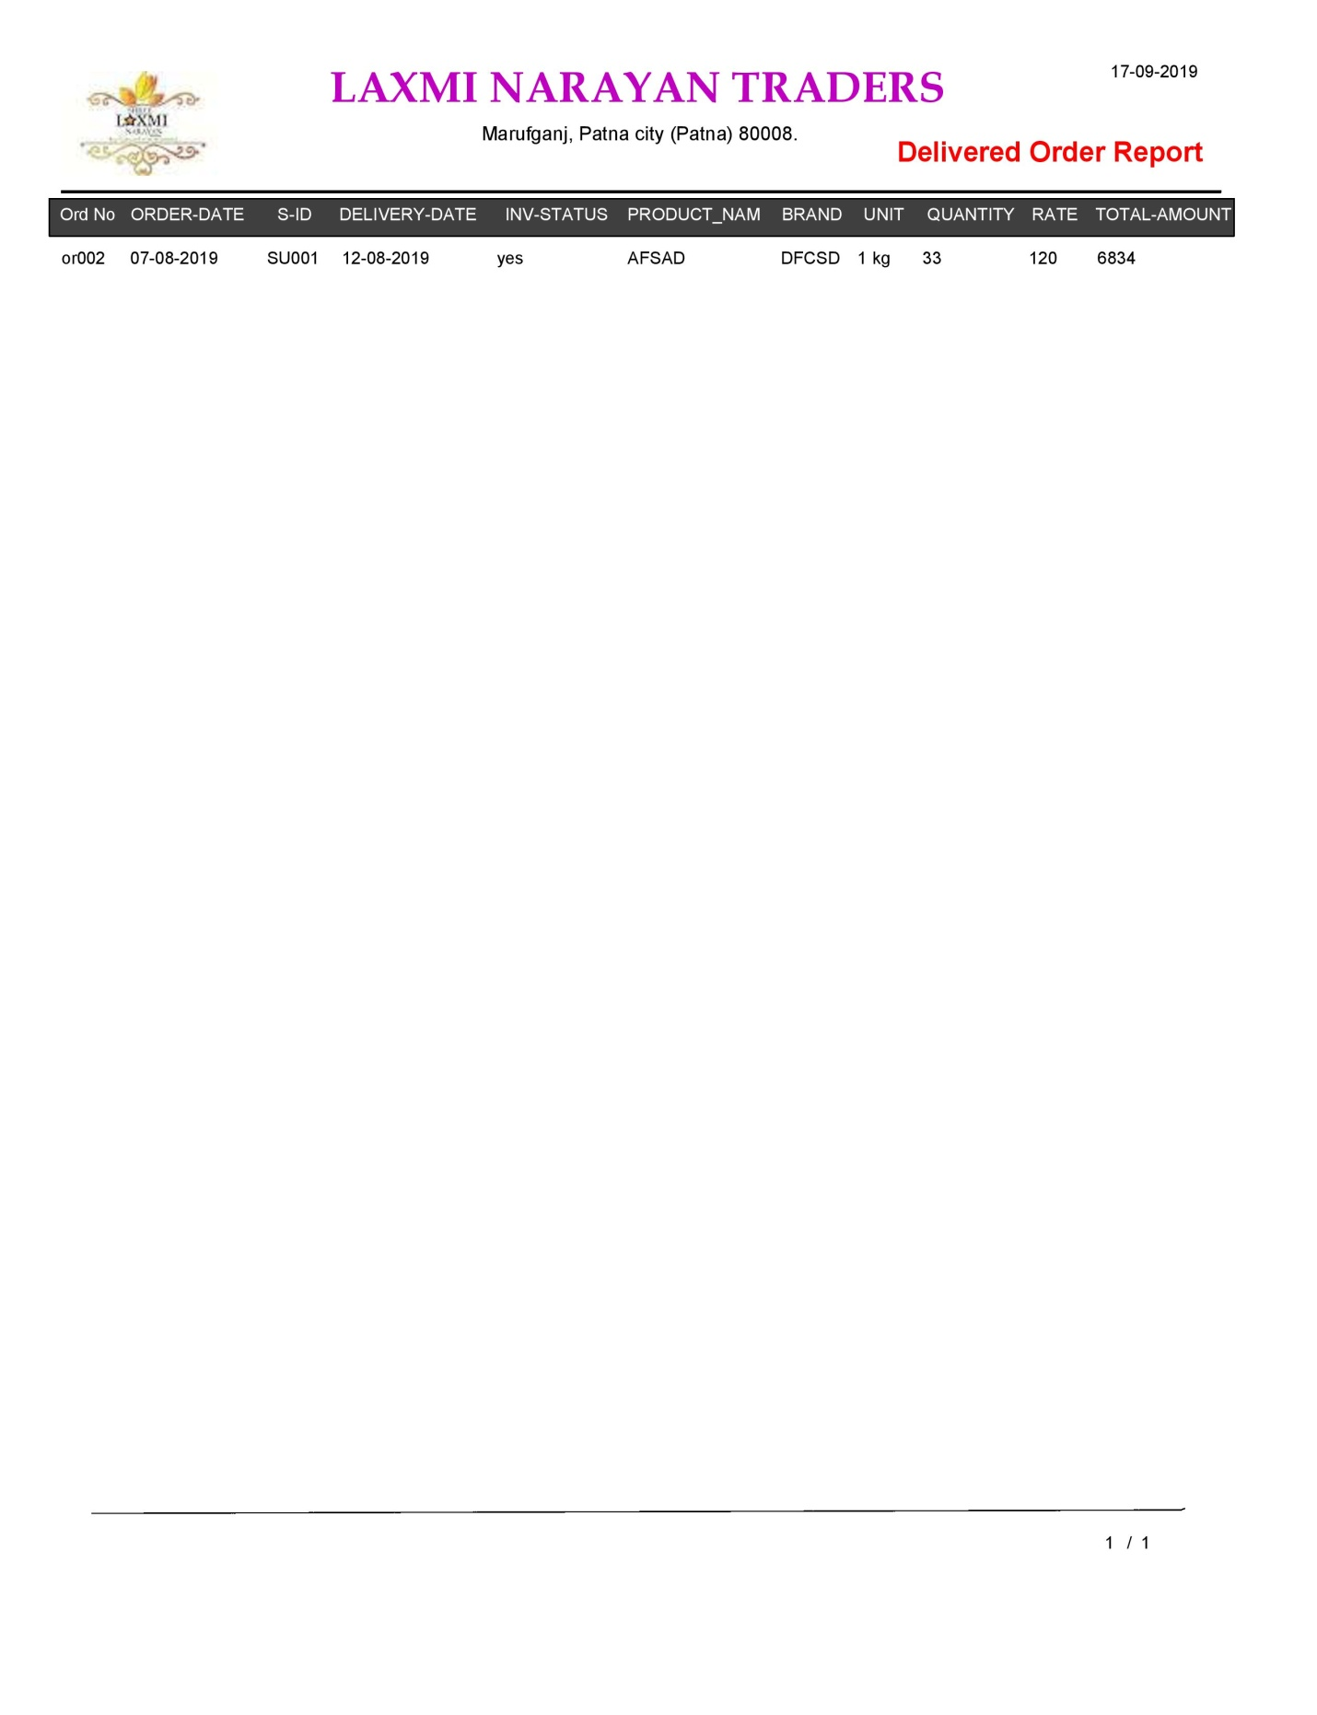

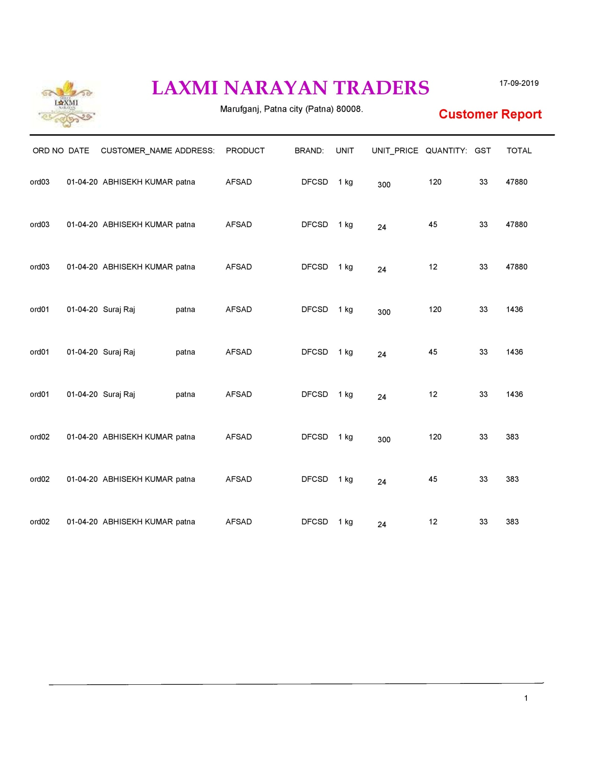

**Customer Order numer Report**

**Customer Order Date Report**

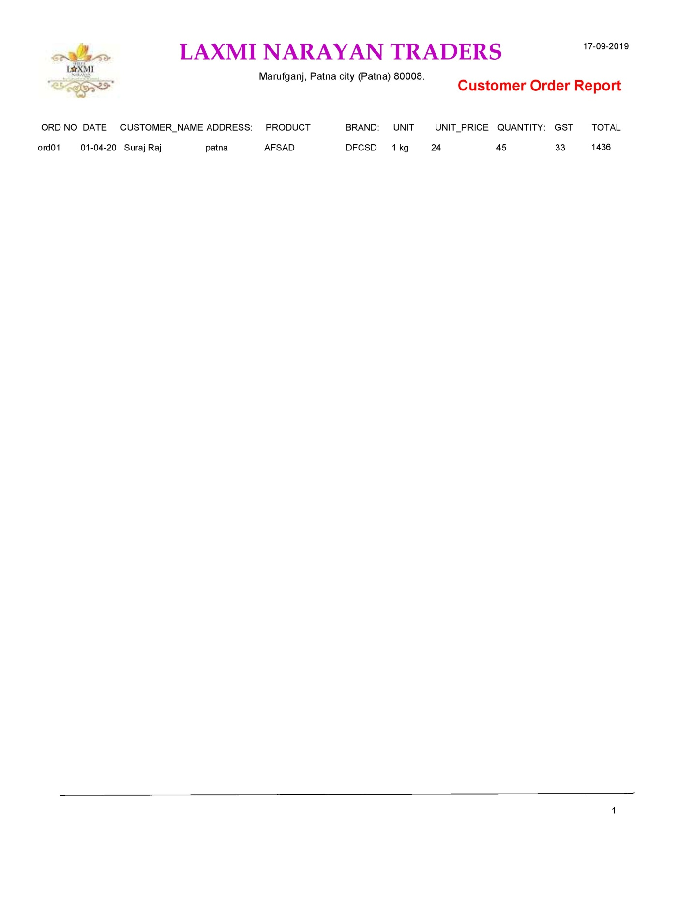

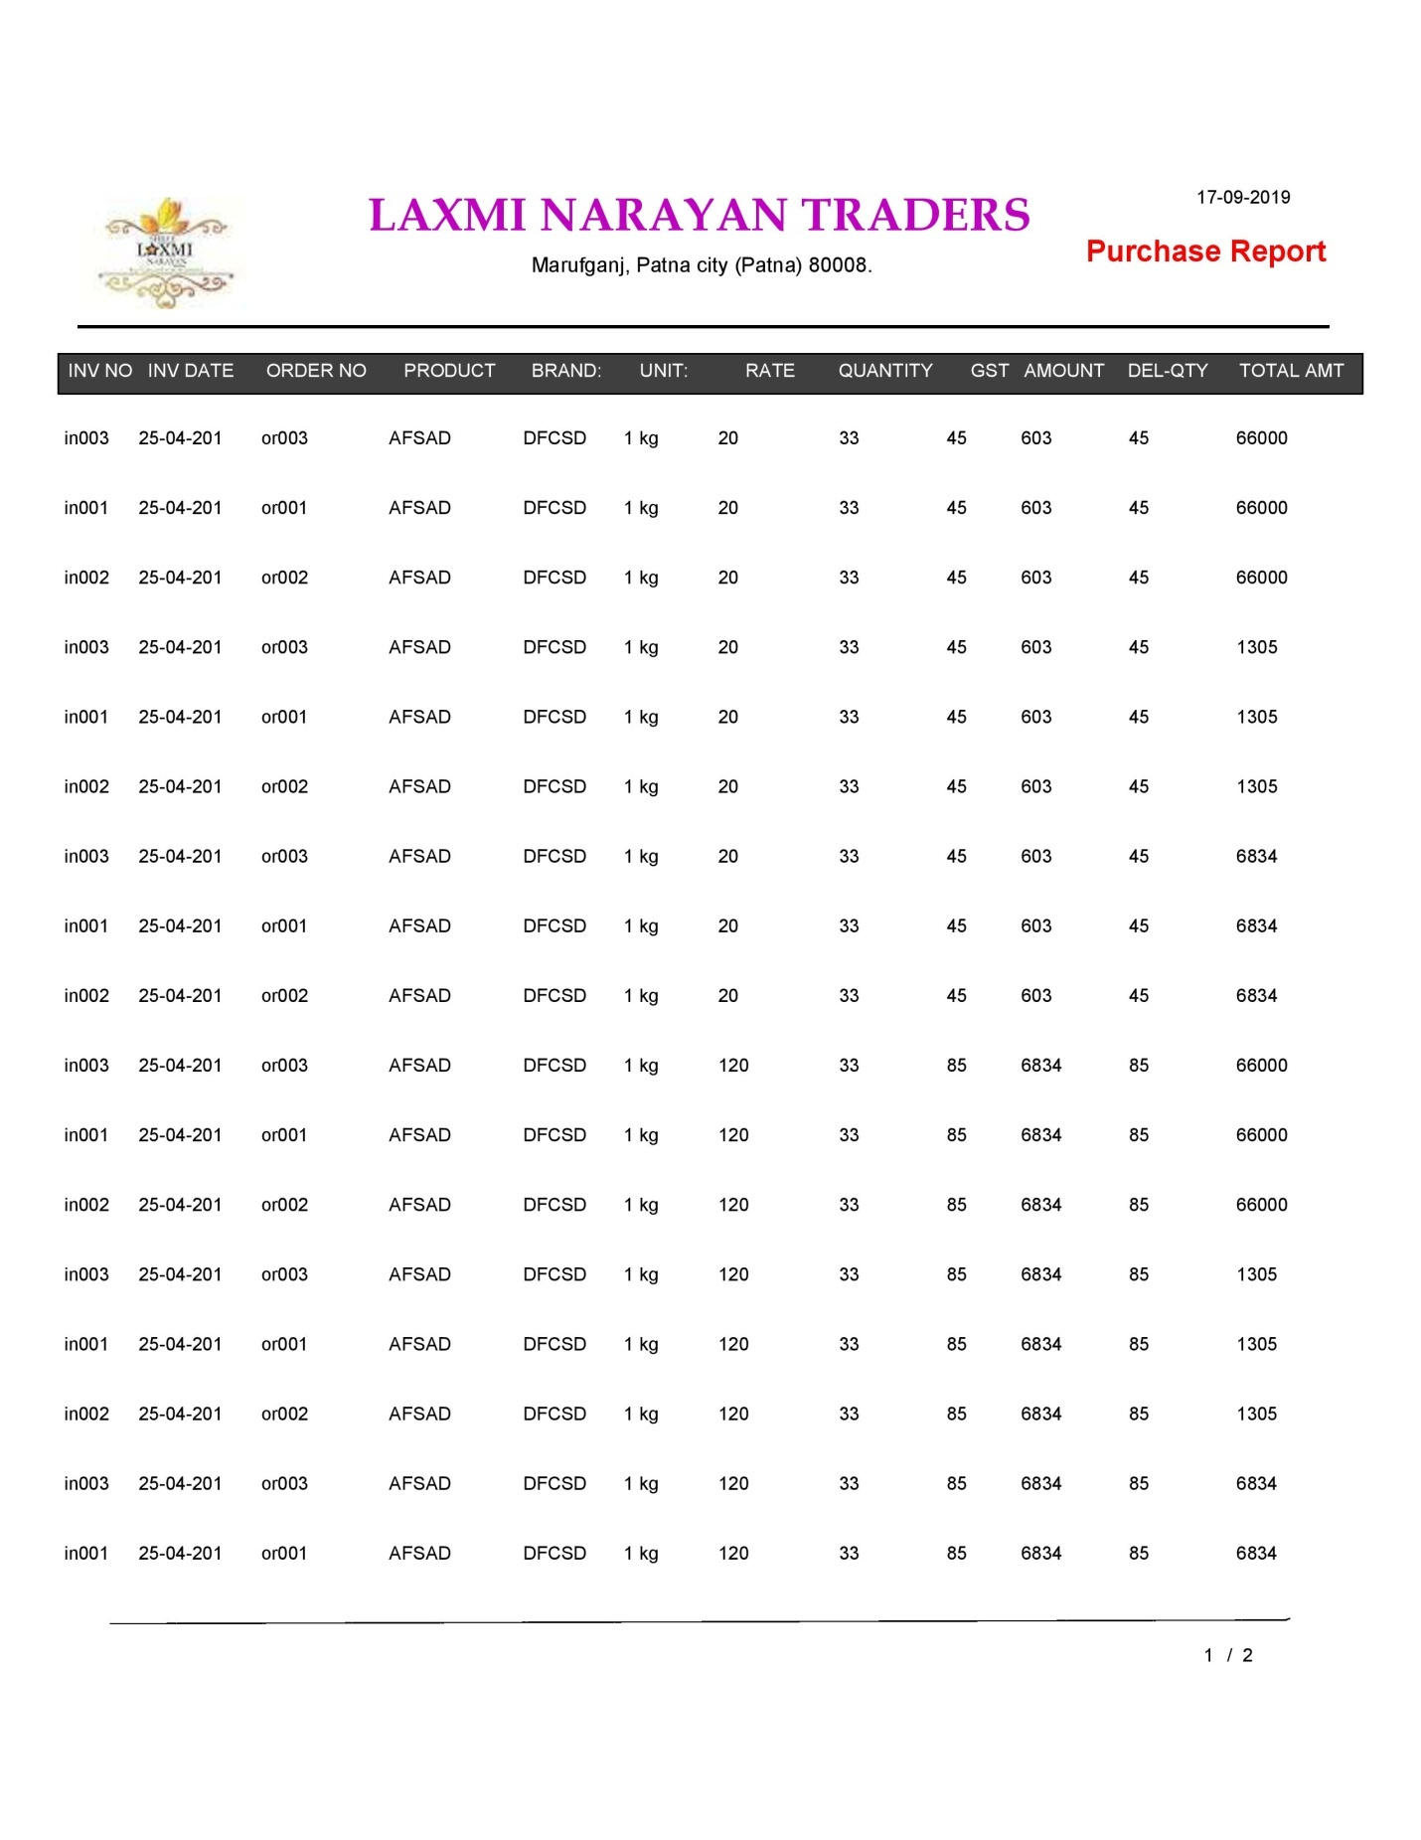

**All Purchase Report**

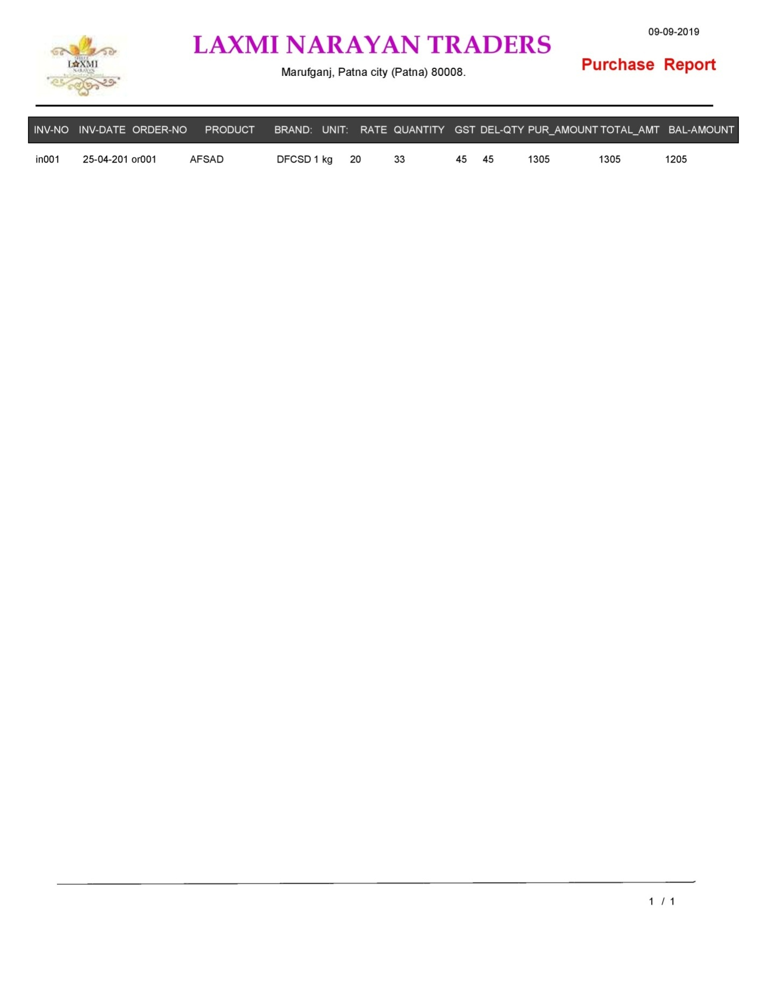

**Purchase ID Report**

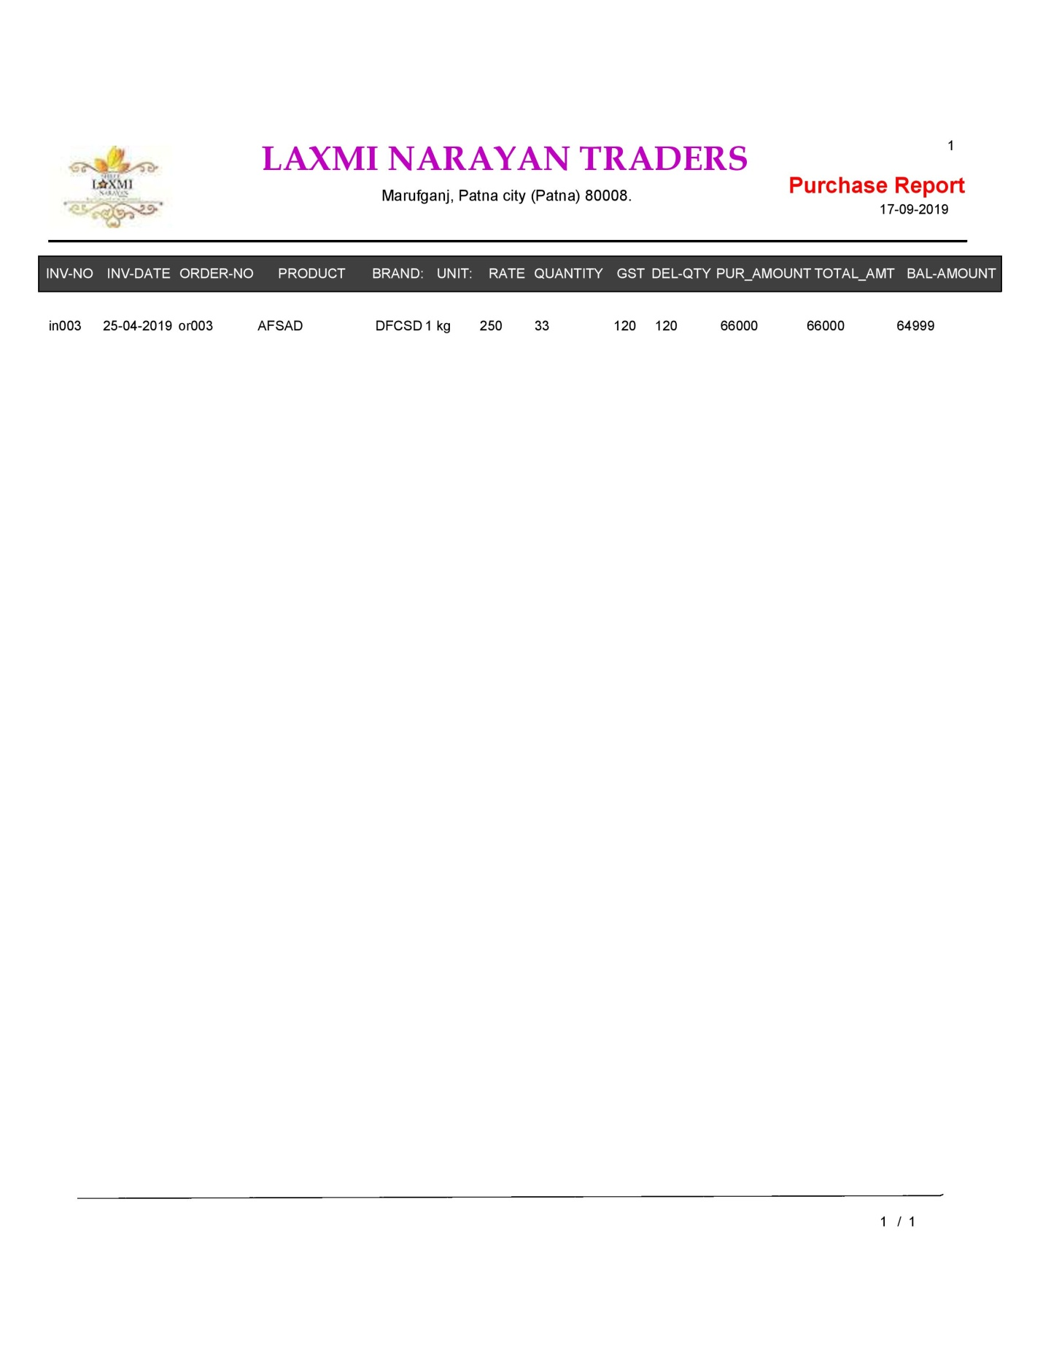

**Purchase Date Report**

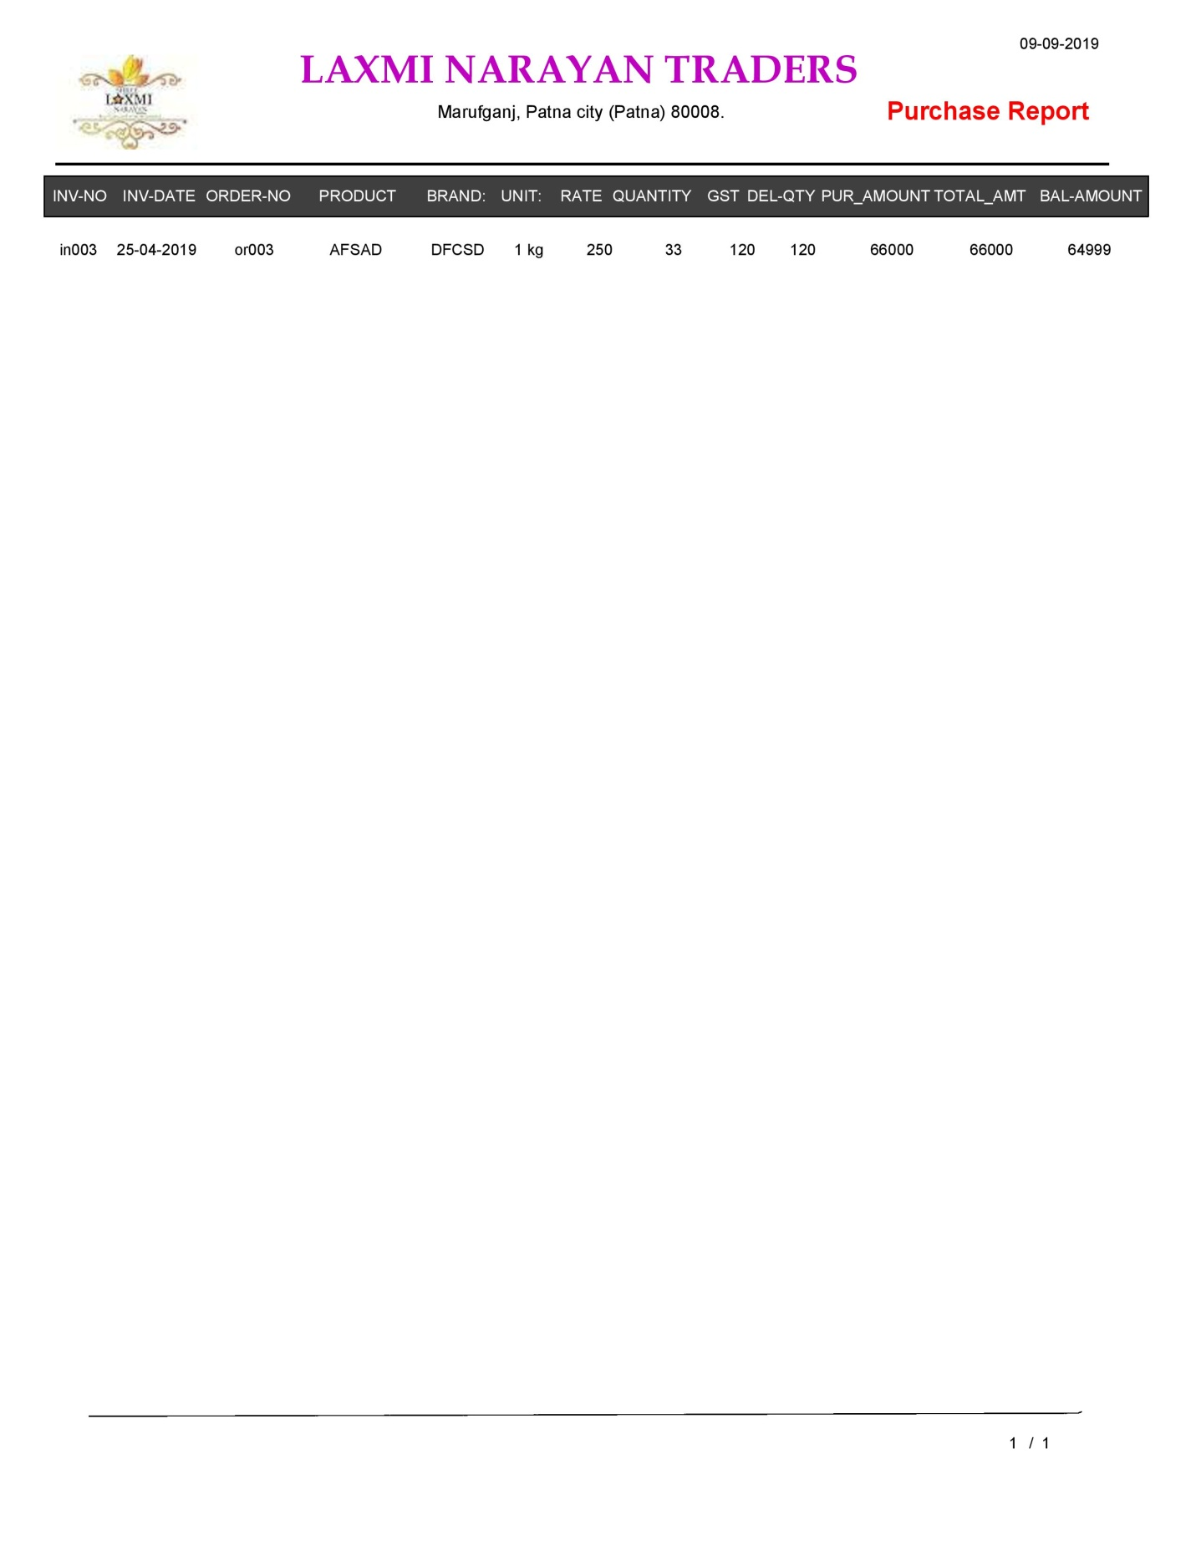

**Purchase B/w To Date Report**

**All Sale Report**

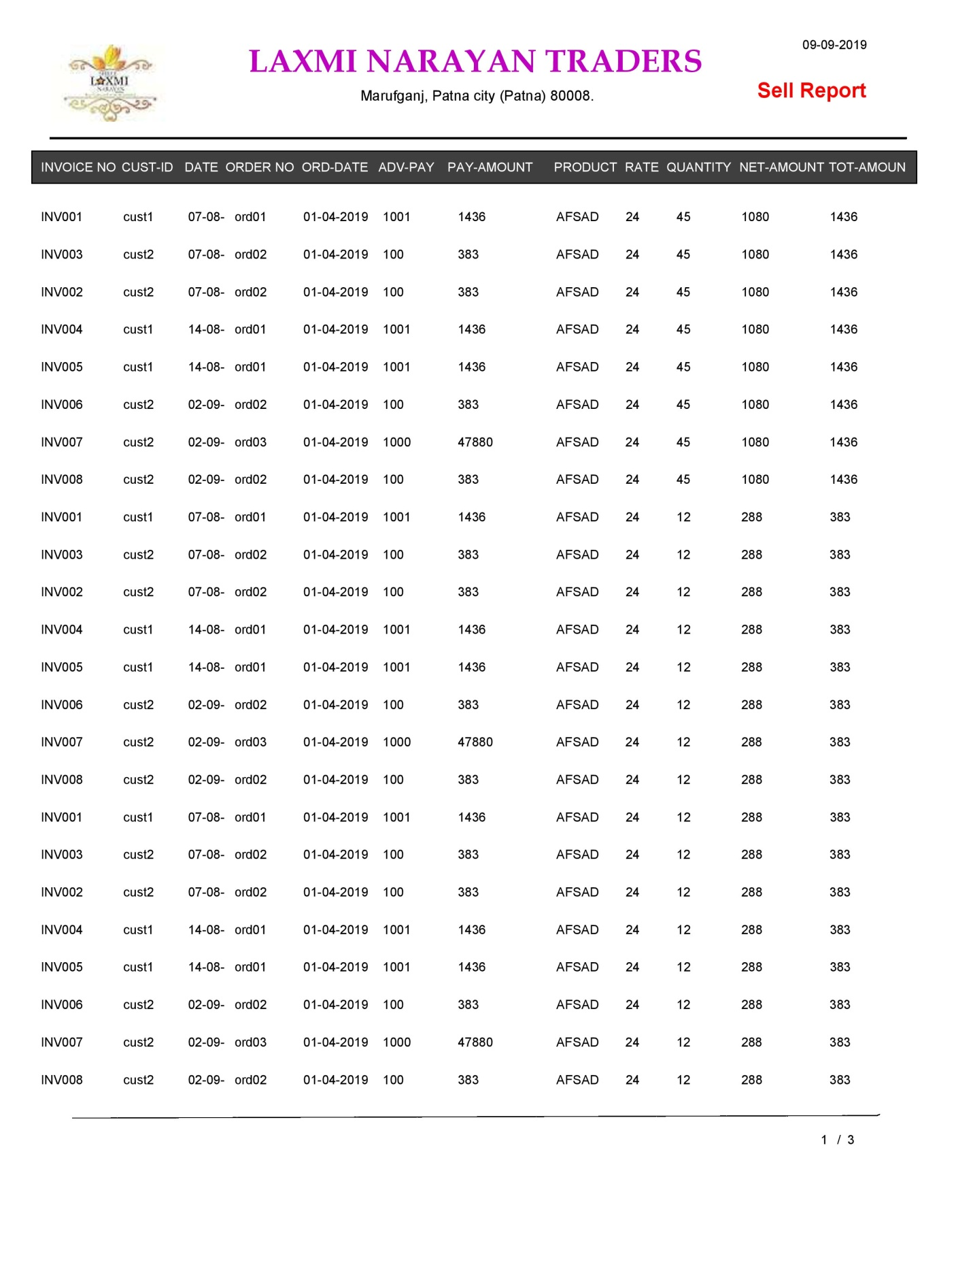

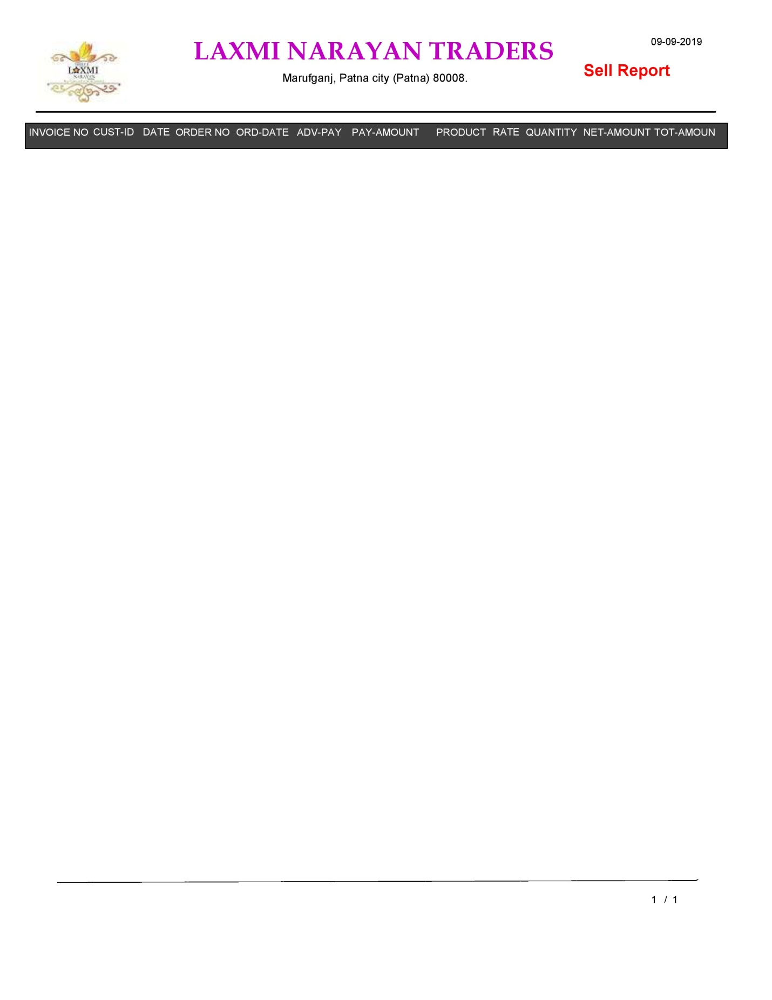

**Sale ID Report**

**Sale Date Report**

**Sale B/w to Date Report**

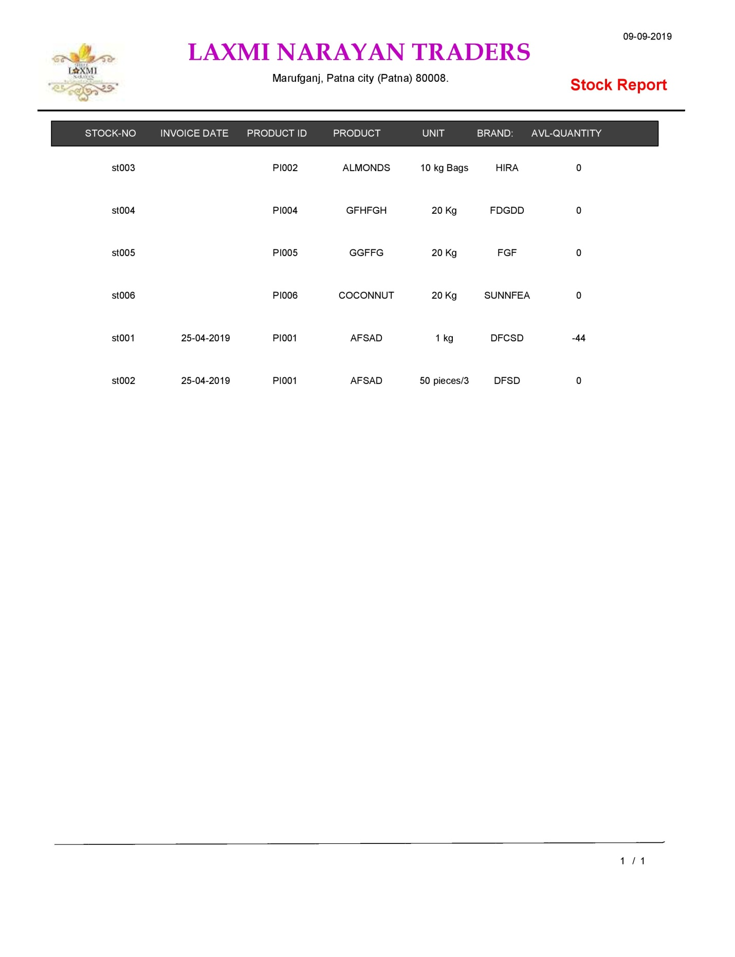

**All Stock Report**

**Stock No Report**

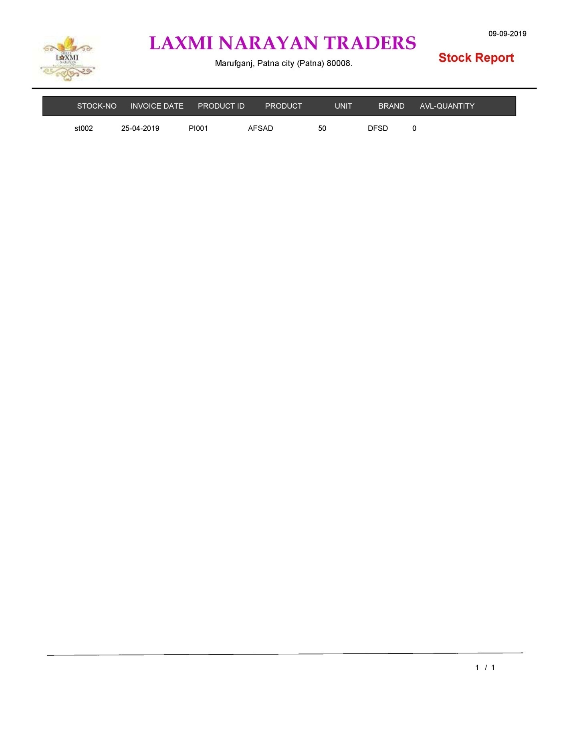

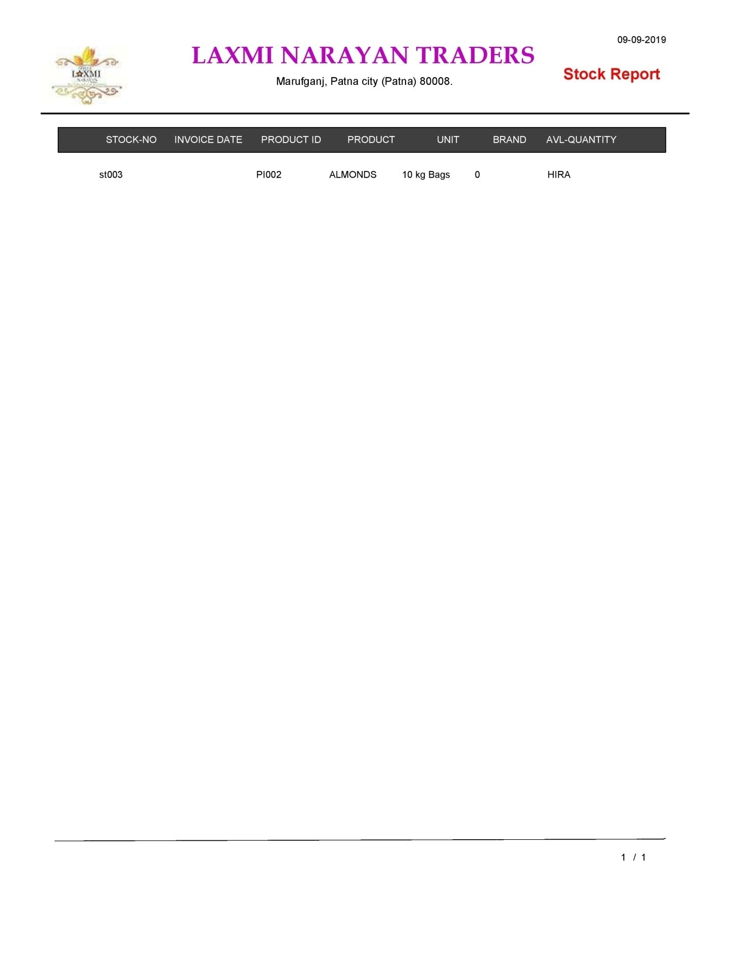

**Stock Report By Product Name**

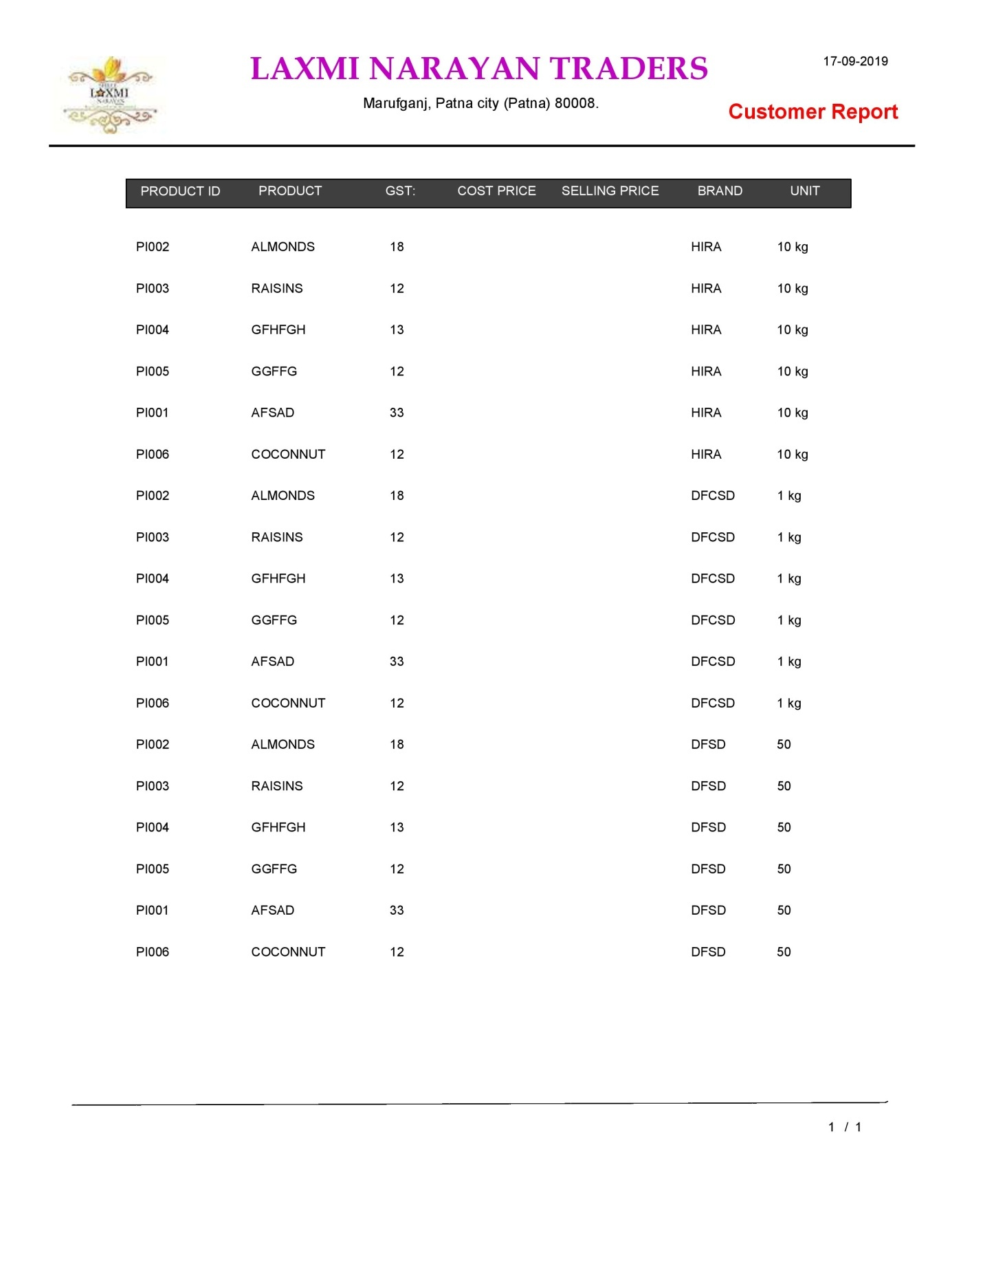

**All Product Report**

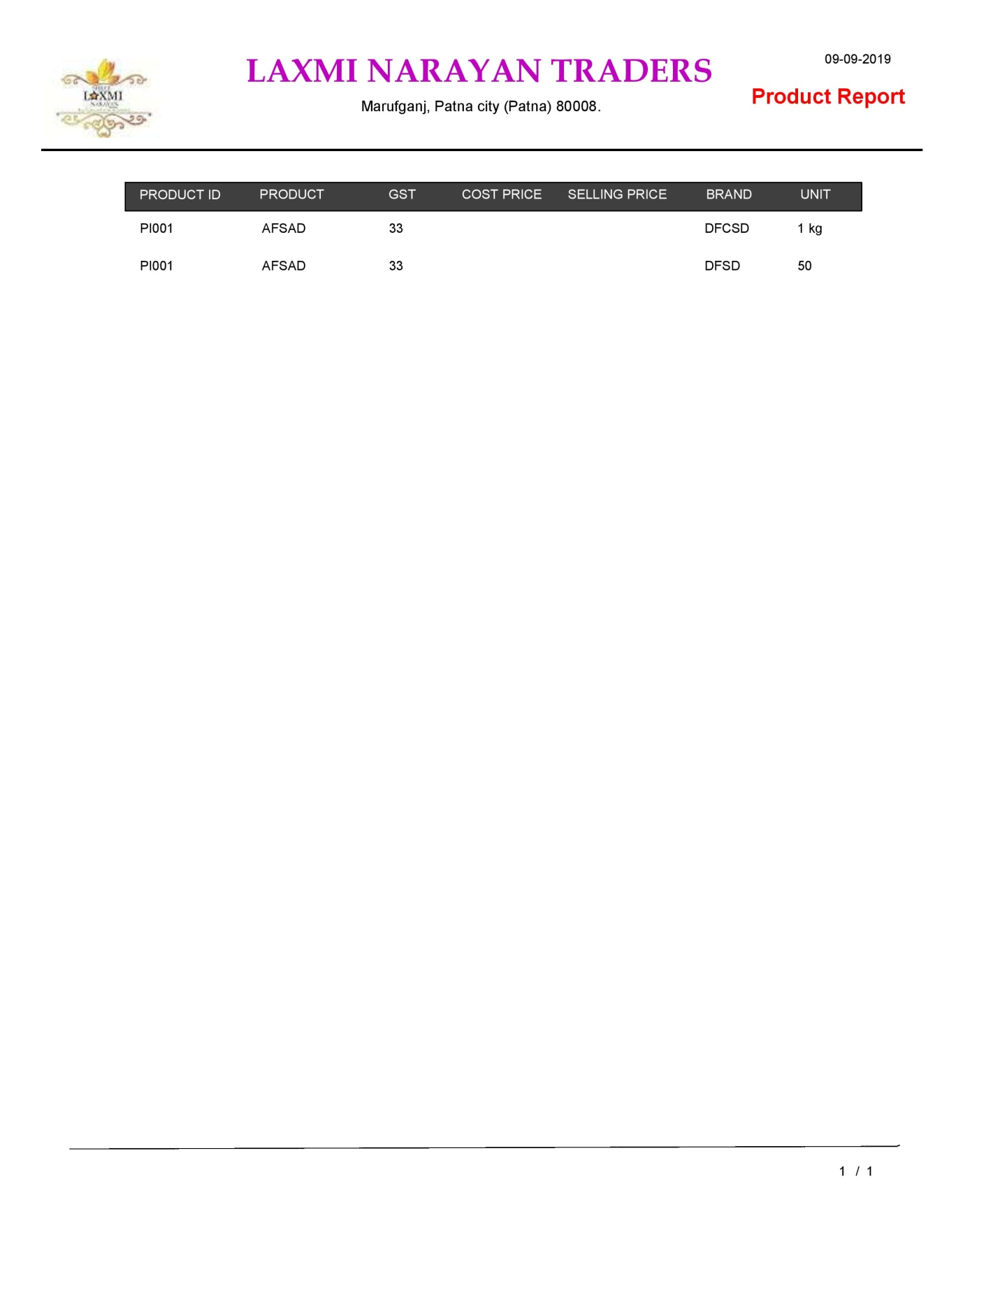

**Product ID Report**

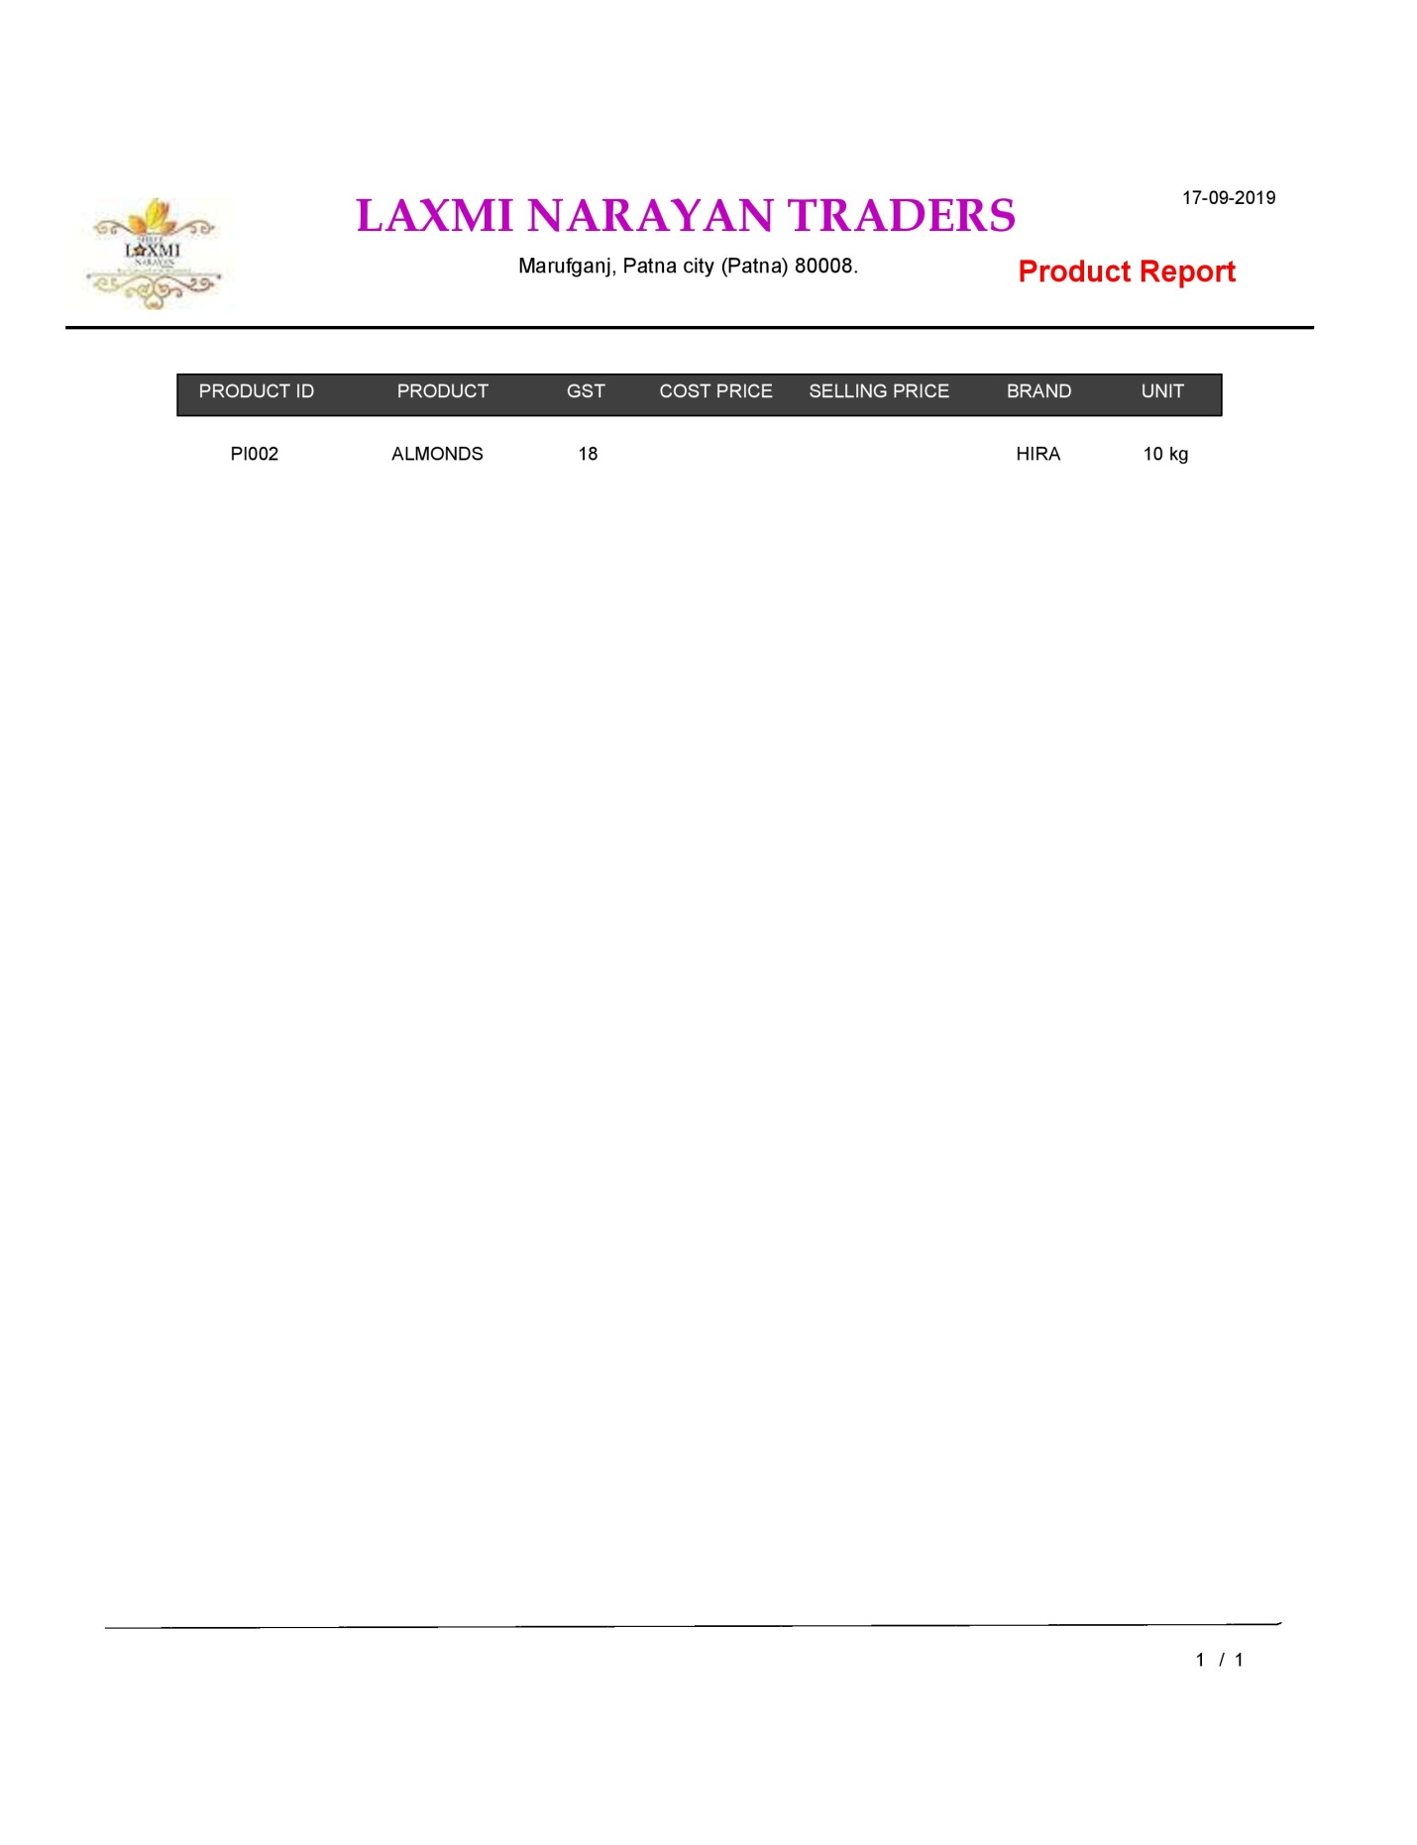

**Product Name Report**

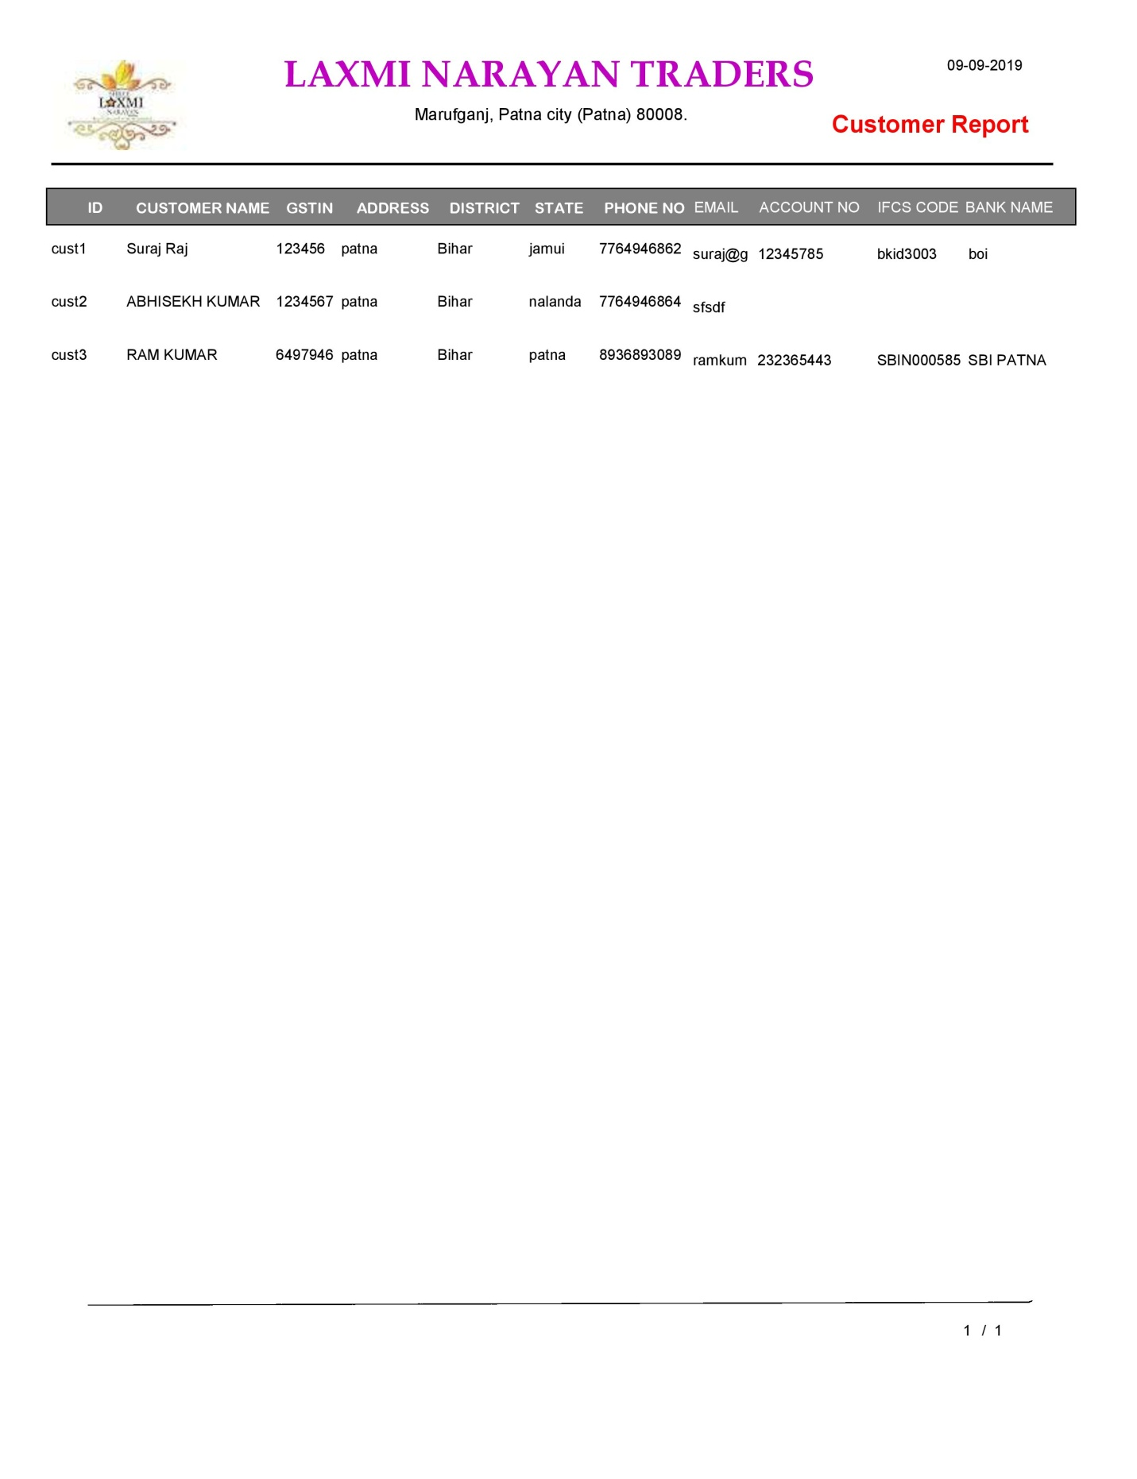

**All Customer Report**

**Customer ID Report**

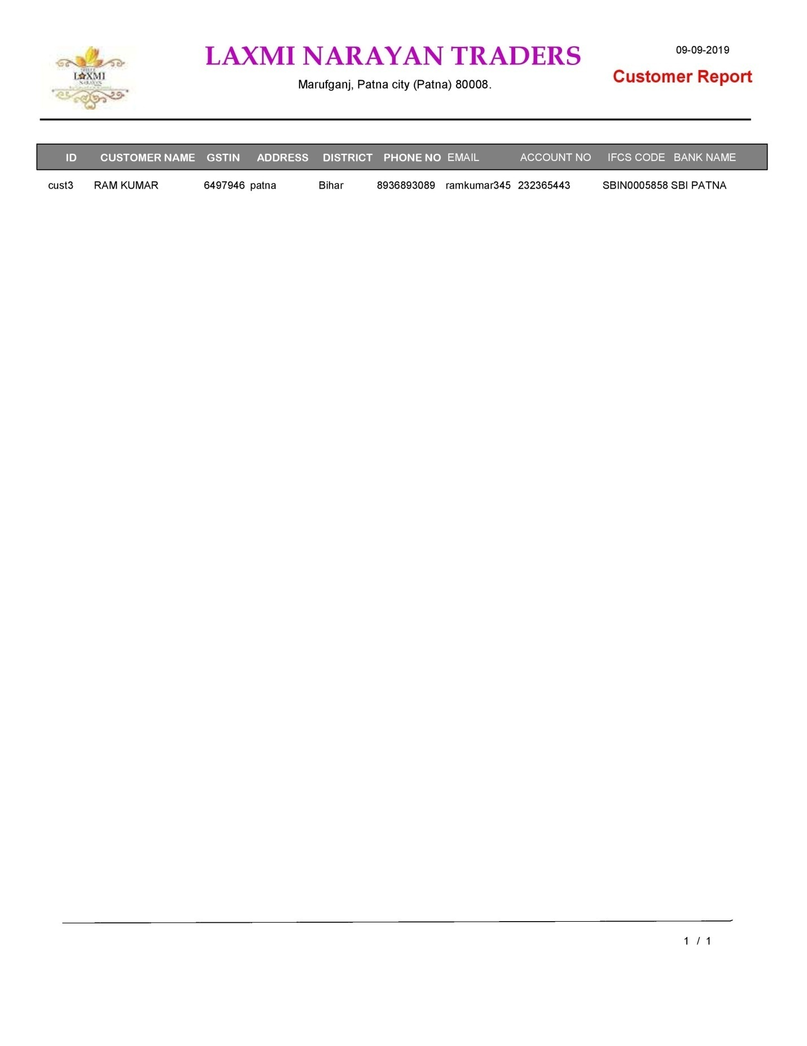

**Customer Name Report**

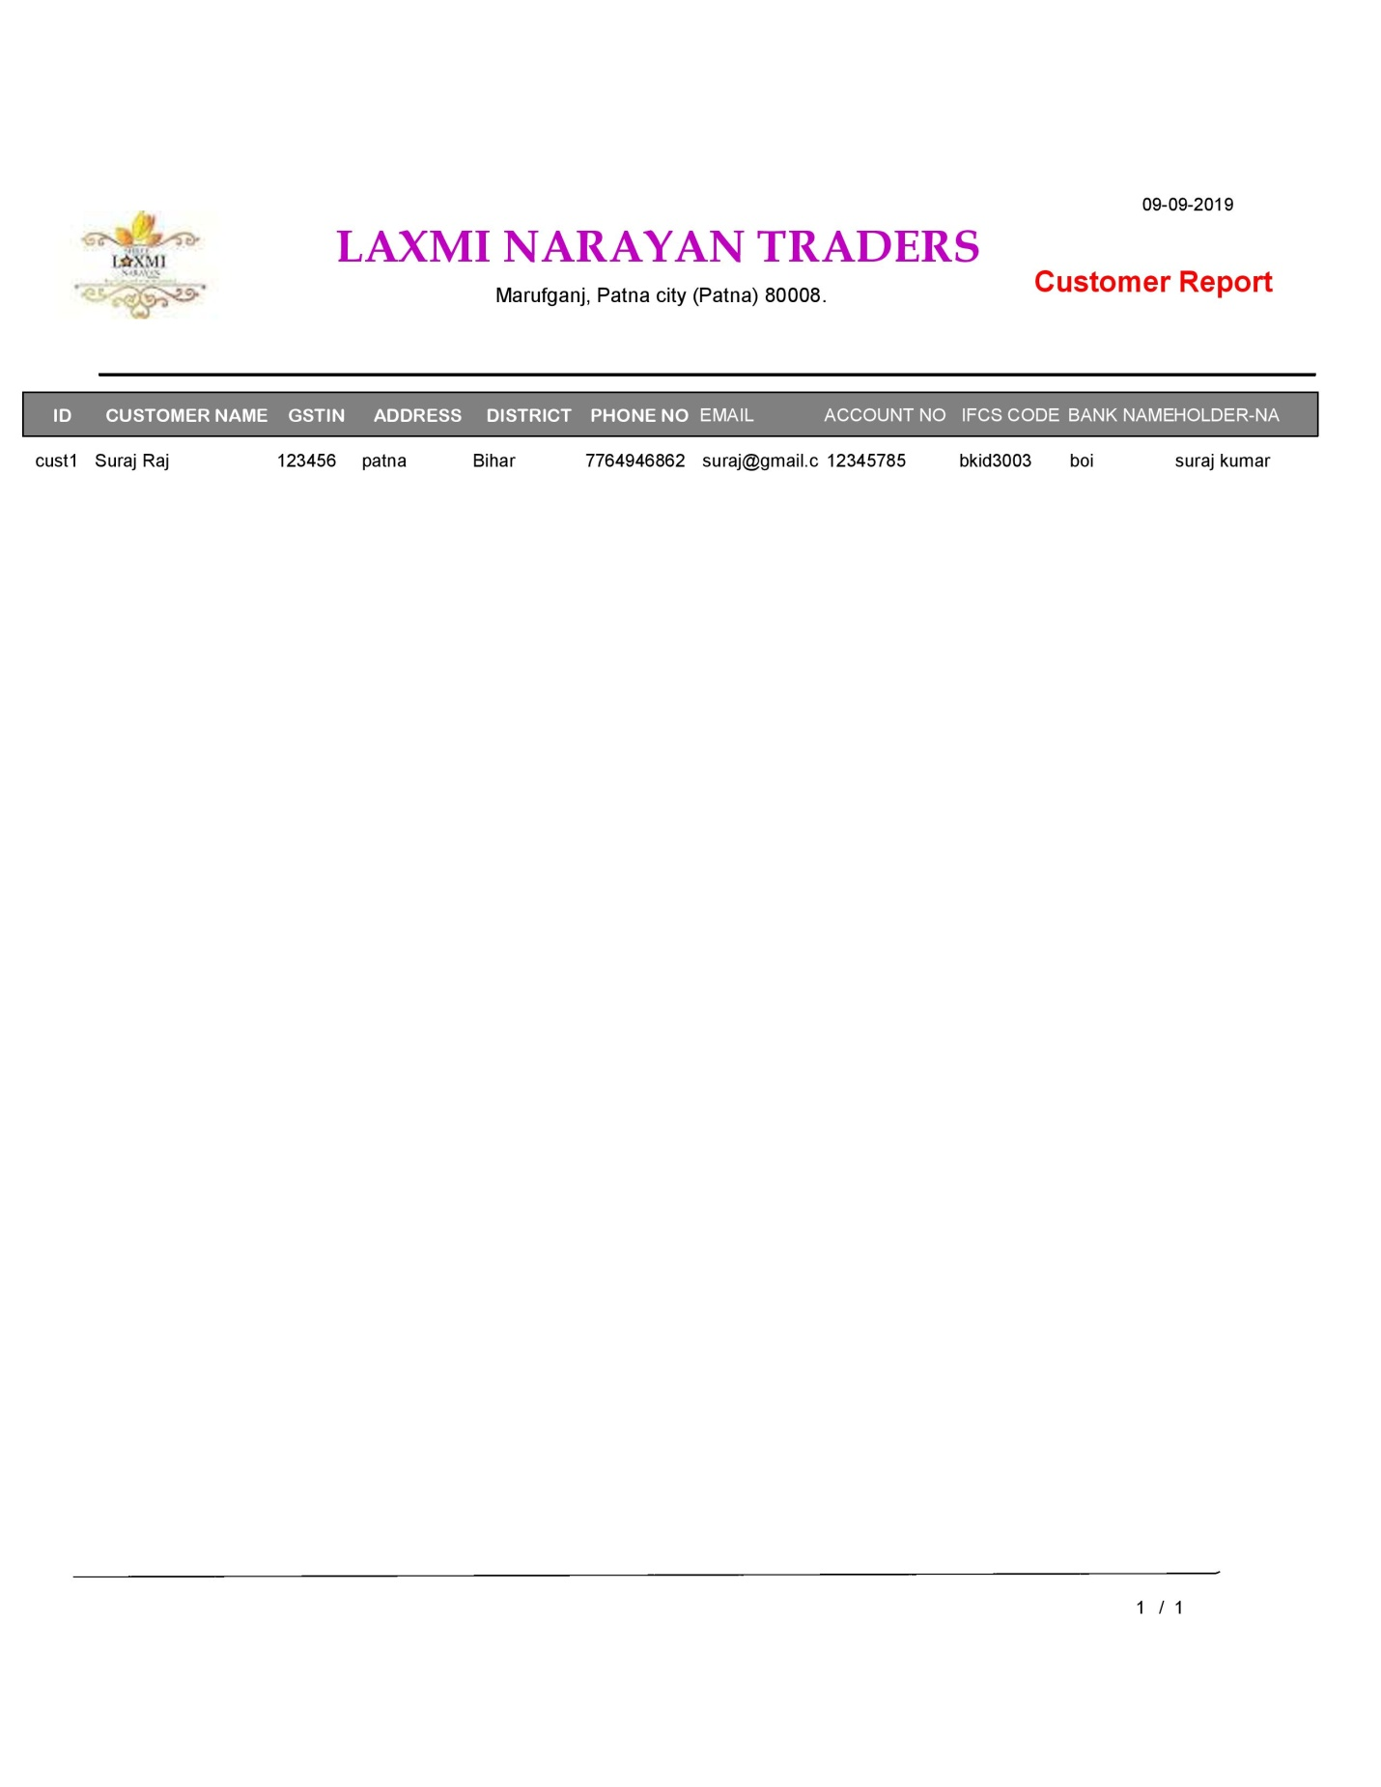

**Customer Address Report**

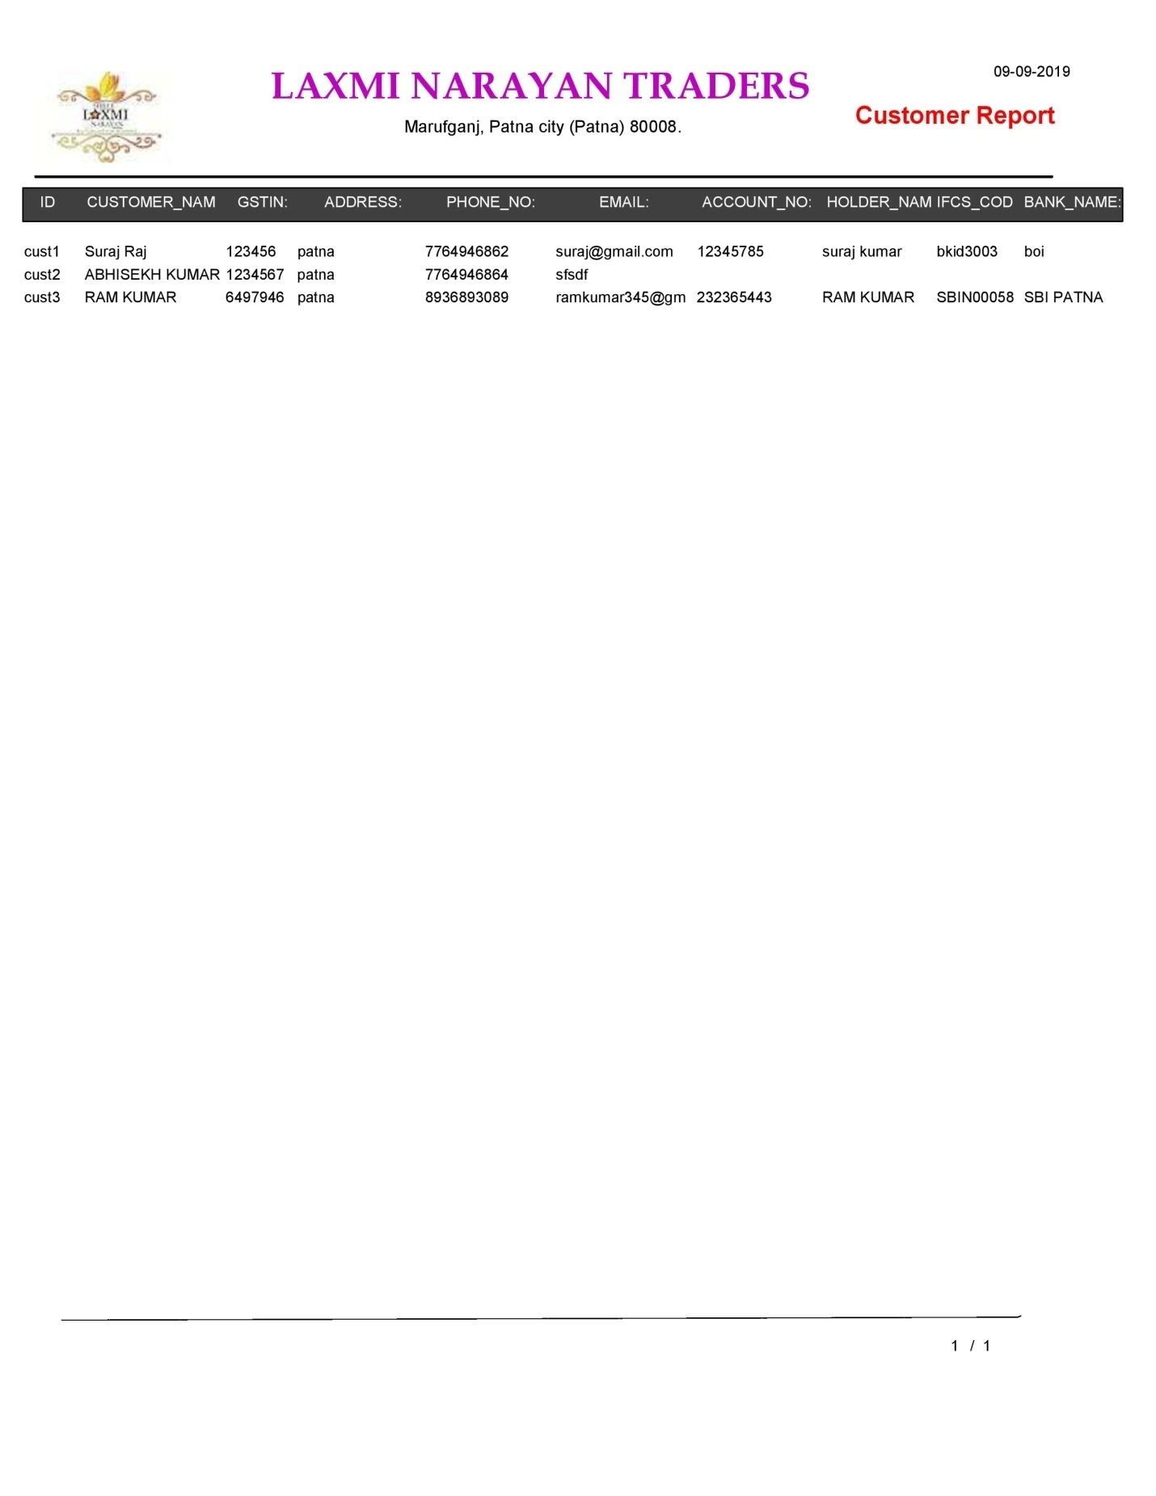

**Supplier Detail Report**

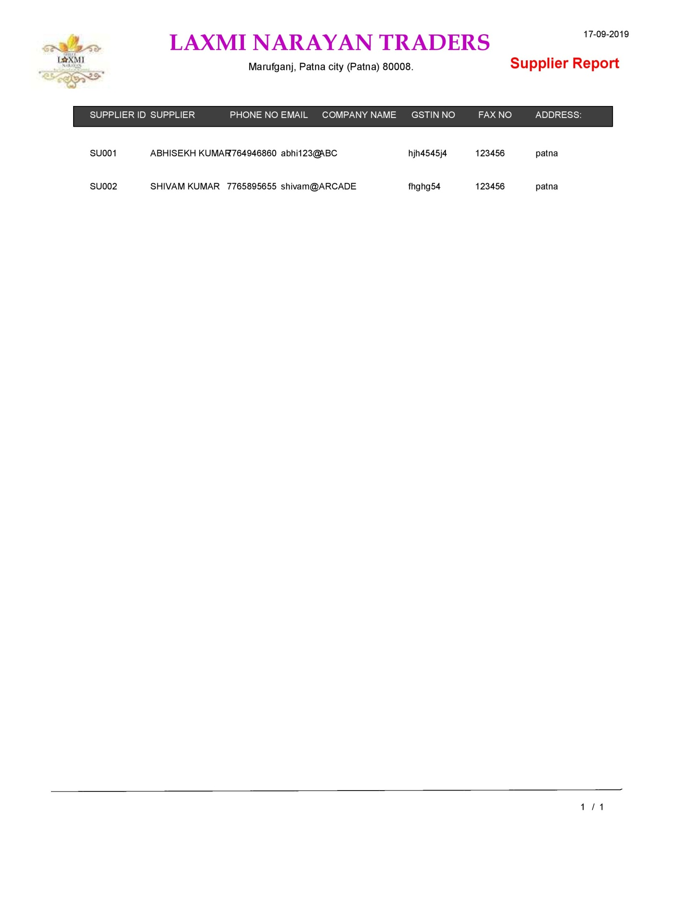

**Supplier Account Report**

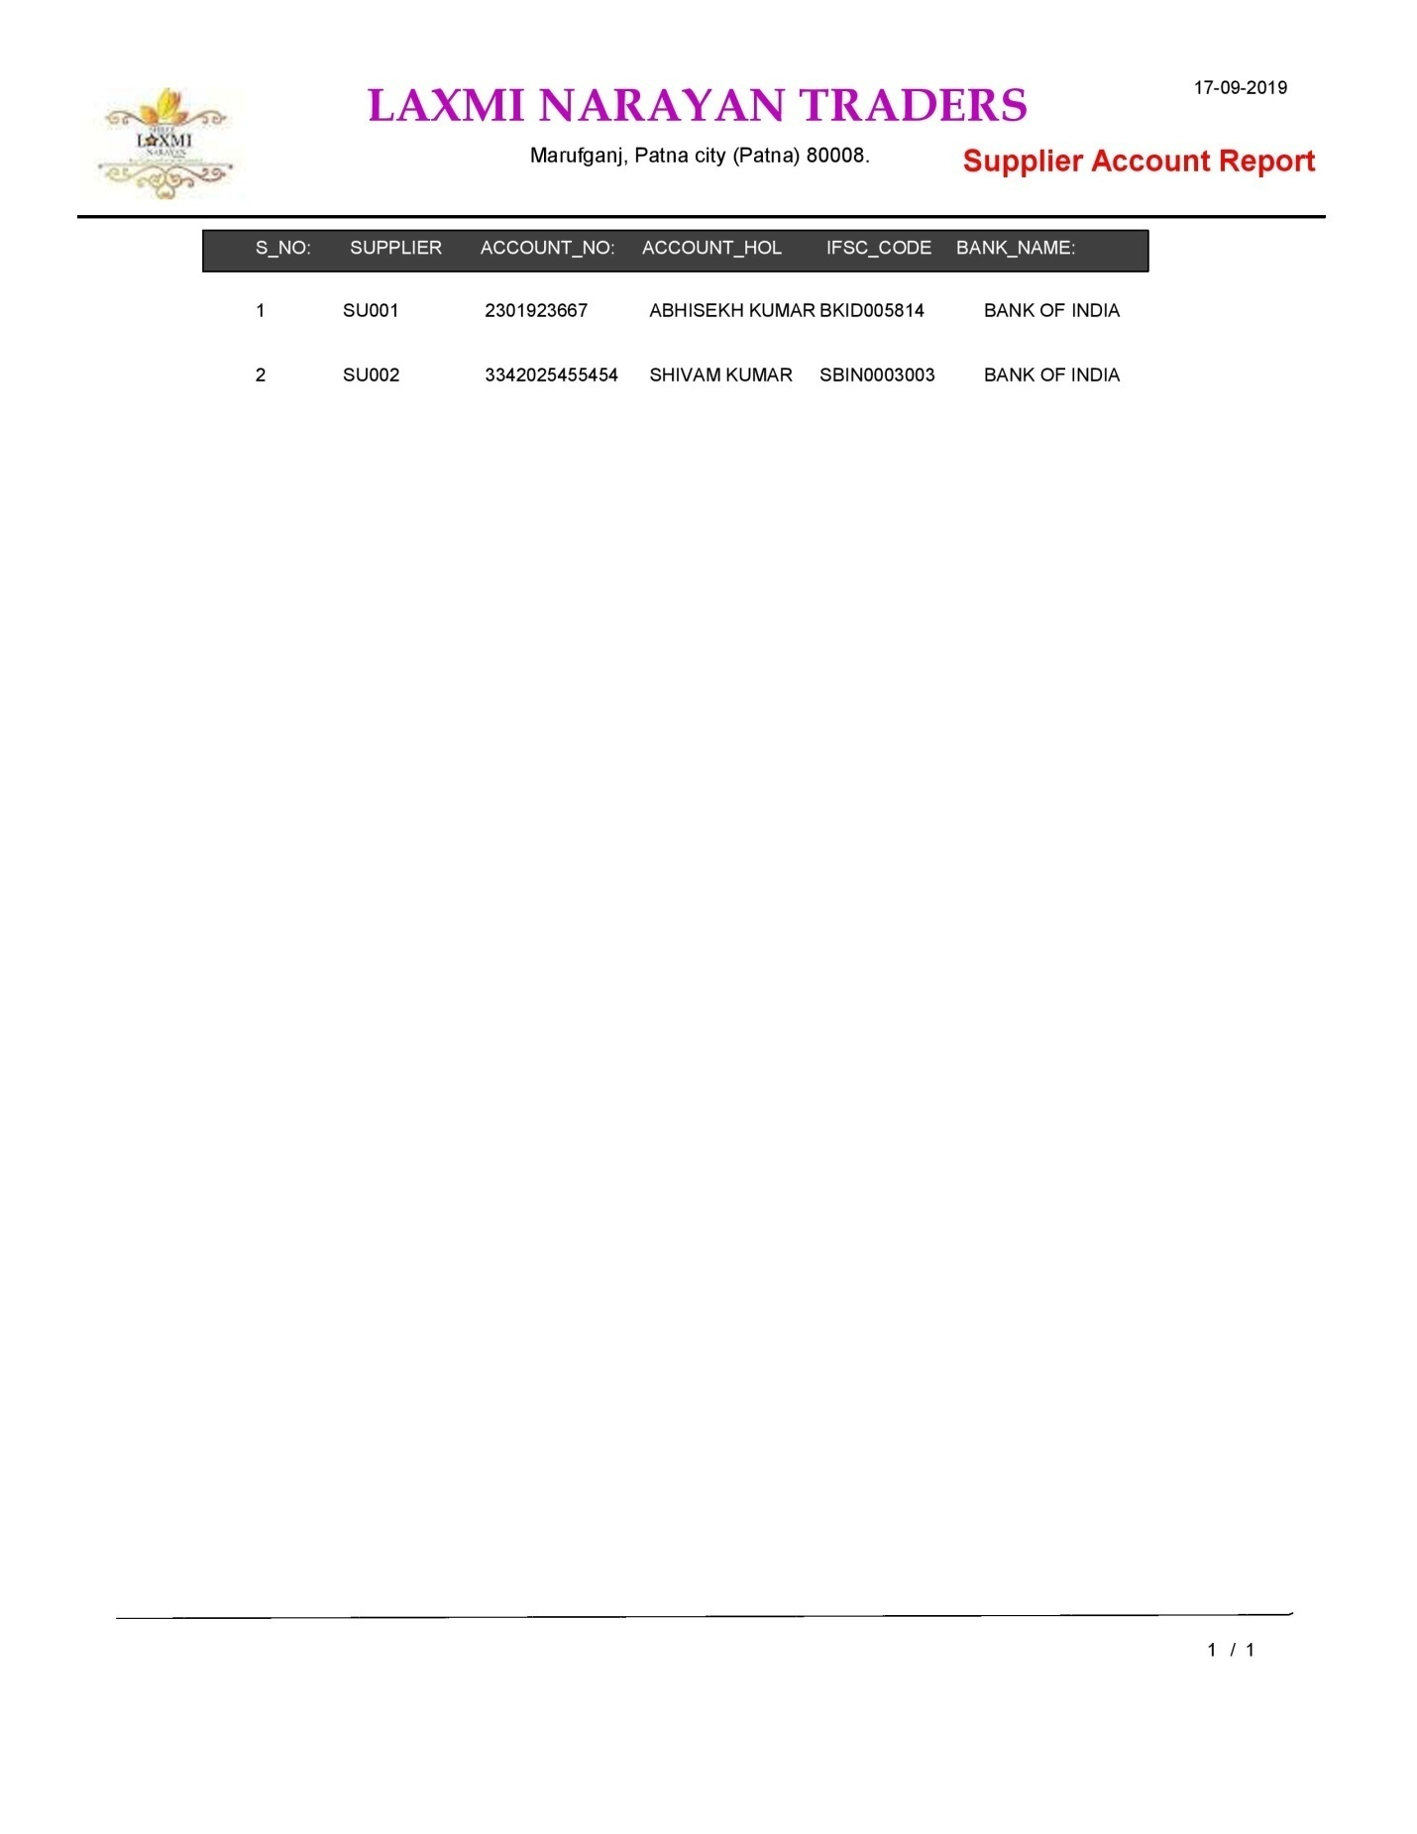

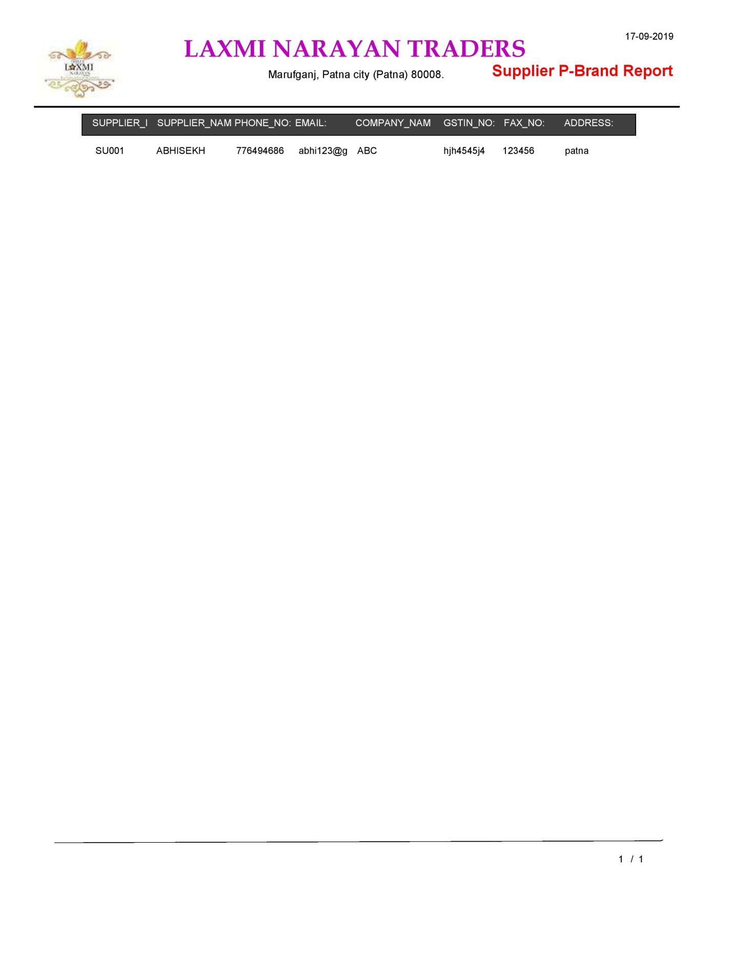

**Supplier Product Report**

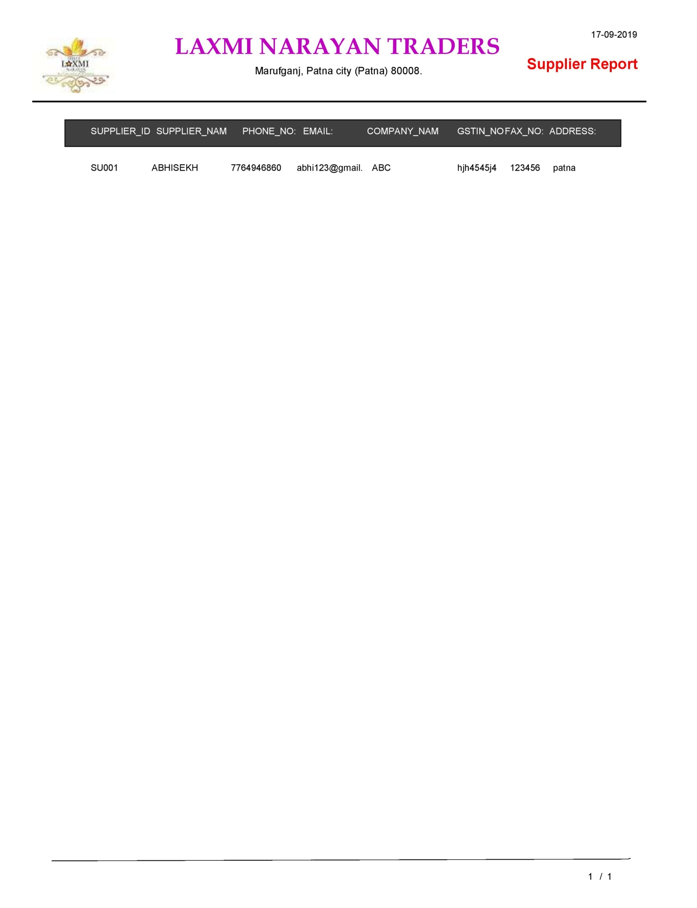

**Supplier ID Report**

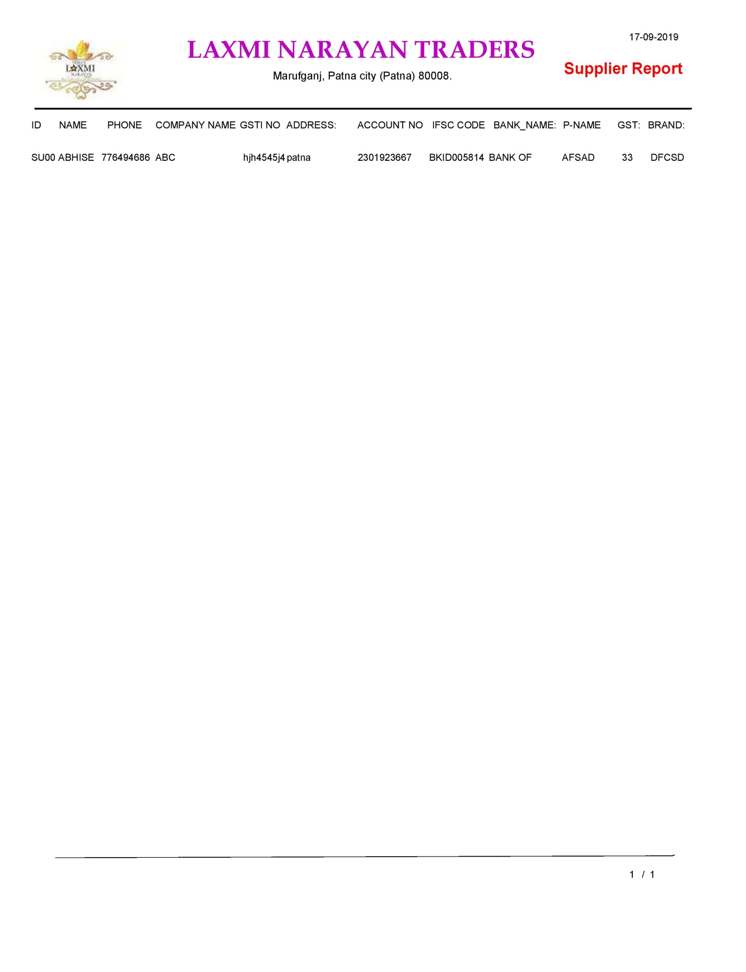

**Supplier Name Report**



**Supplier Brand Report**

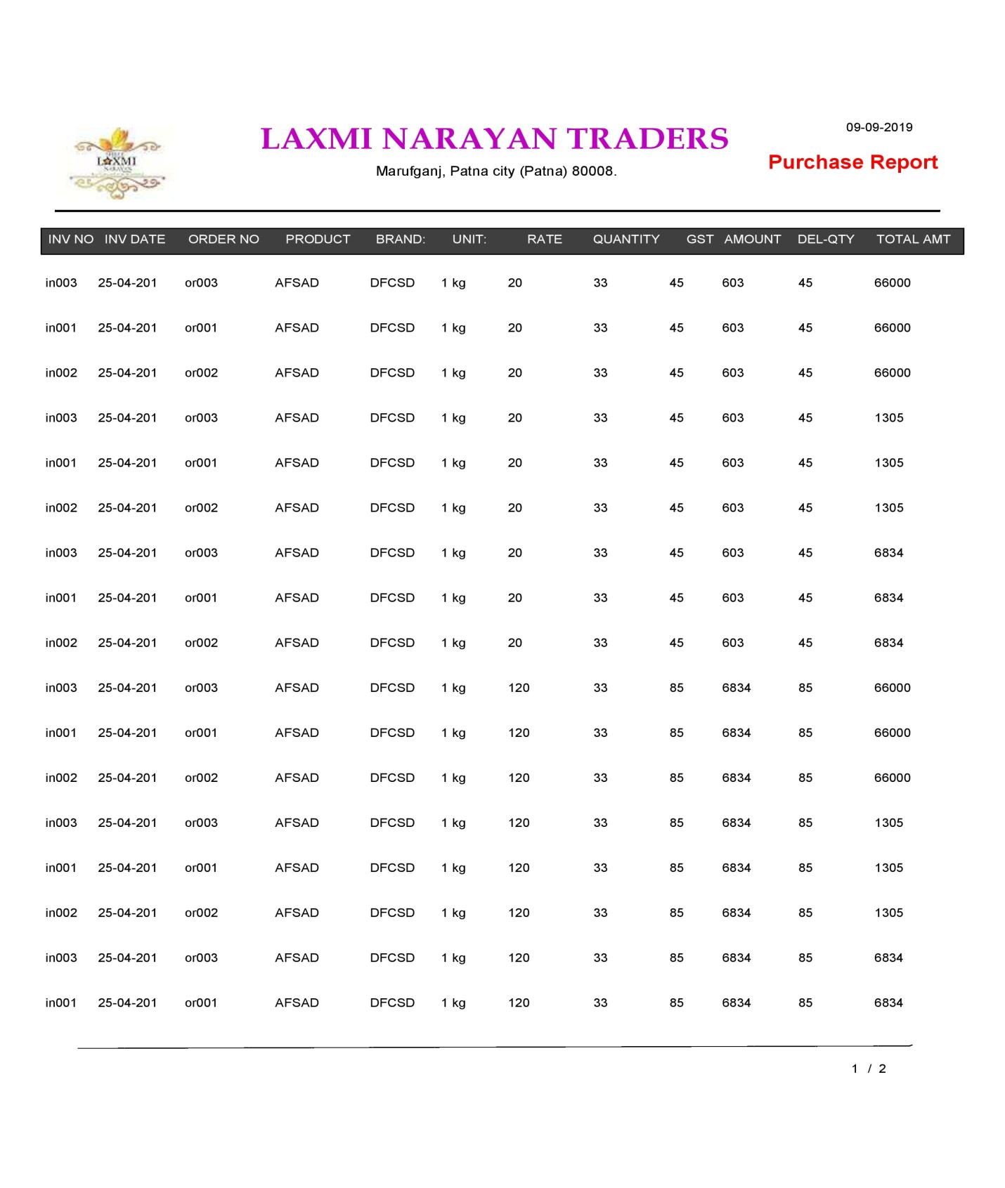

**All Purchase Return Report**

**Purchase Return No Report**

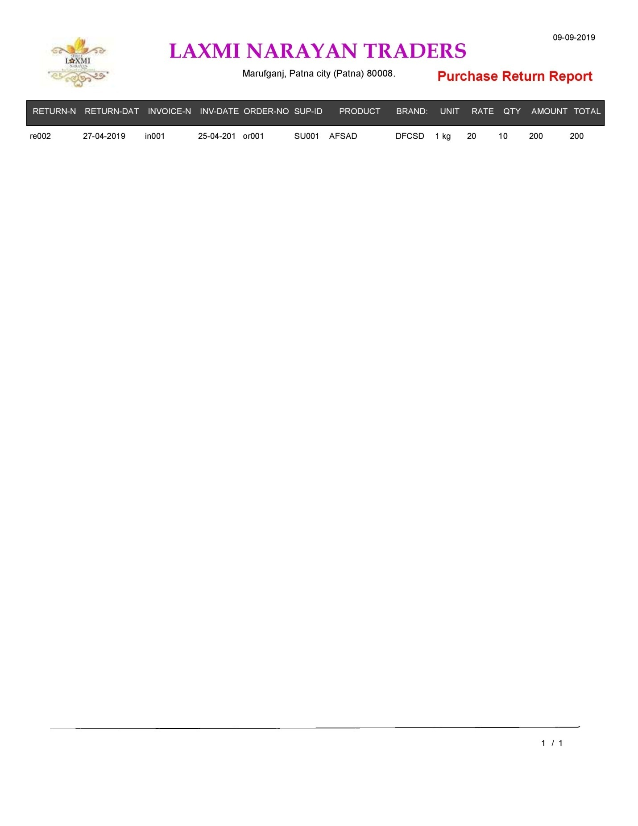

**Purchase Return Date Report**

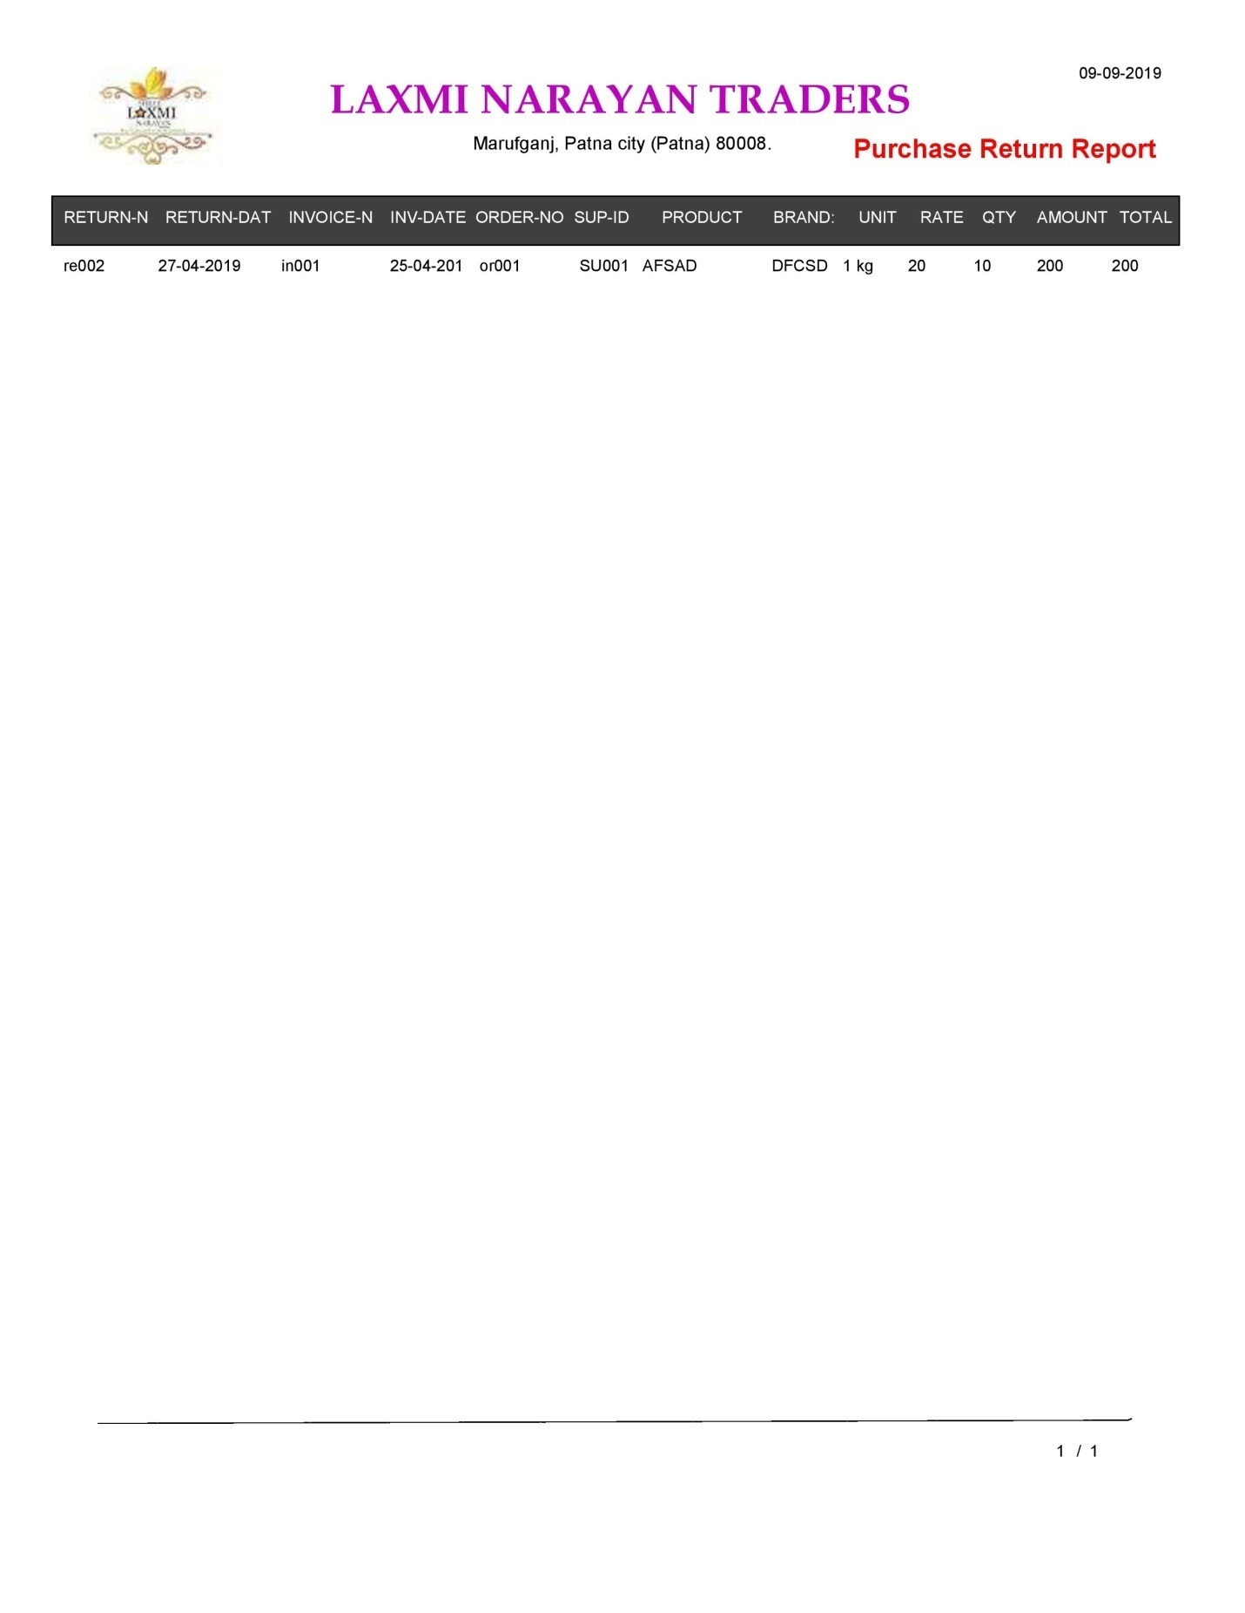

**All Sell Return Report**

**Sell Return No Report**

**Sell Return Date Report**

Data integrity & constraints

**DATA BASE:-**Database is the collection of similar or related data element specific to or organization which can be centralized or distributed and it is available for different people of organization.

**CONSTRAINTS**:- These are data validation and restriction . it works during insertion of record as tuple.

* **UNIQUE :-**  this constraint allows distinct value entry in an attribute.
* **NOT NULL :**- This constraint does not allow null value in particular attribute . so it is used for compulsory field.
* **CHECK :**- this constraint is used to check a range of value or particular list of value.
* **DEFAULT :**- this constraint is used to initialize a particular attribute with default value.
* **NULL :**- for a computer system zero(0) and blank space is a character or a value so if a value is not pass to database it should be initialized to null.
* **KEY: - A** relation has a multiple attribute, some of them are specialized for specific operation , these attributes are known as keys. It works as constraints.

**Following are the key constraint:-**

* **PRIMARY KEY :-**  it is used to implement “Entity Integrity Rule “ defined by EF Codd . according to which each and every record or tuple in a relation should be unique and not null. It helps in unique data access. Primary key attributes follow unique and not null constraint at a time. A relation should have only one primary key that can not be altered or drop
* **FOREIGN KEY:**- this constraint is used to enforce “Referencial Entigrity Rule “ to implement relationship between two or more relation . foreign key is an attribute of relation which refer another to accvess their data . it does not allow unique property of primary key bjut it should be null.
* **COMPOSITE KEY :**- when a relation does not contain any unique and not null attribute then according to RDBMS(Relational database Management System) two or more field combined together as a composite key which is used as a primary key.

Database design

**Company**

|  |  |  |  |  |
| --- | --- | --- | --- | --- |
| **Attribute** | **Data type** | **Size** | **Constraint** | **Description** |
| Reg_no | Varchar2 | 10 | Primary key | Registration no |
| C _nm | Varchar2 | 20 | Not null | Company name |
| O_nm | Varchar2 | 20 | Not null | Owner name |
| Email_id | Varchar2 | 20 | Null | Email id |
| GST_no | Char | 12 | Not null | GST number |
| a/c_no | Char | 10 | Not null | Account number |
| P_no | Char | 12 | Not null | Phone number |
| Add | Varchar2 | 30 | Not null | Address |

**Supplier**

|  |  |  |  |  |
| --- | --- | --- | --- | --- |
| **Attribute** | **Data type** | **Size** | **Constraint** | **Description** |
| sid | Char | 6 | Primary key | Supplier id |
| snm | Varchar2 | 20 | Not null | Supplier name |
| Pid | Char | 4 | Not null | Product id |
| add | Varchar2 | 30 | Not null | Address |
| P_no | Char | 10 | Not null | Phone number |

**Product**

|  |  |  |  |  |
| --- | --- | --- | --- | --- |
| **Attribute** | **Data type** | **Size** | **Constraint** | **Description** |
| Pid | Char | 4 | **Primary key** | **Product id** |
| pnm | Varchar2 | 10 | Not null | Product name |
| brand | Varchar2 | 10 | Not null | Brand name |
| amt | Number | 10,2 | Not null | Amount |
| GST | Char | 4 | Not null | GST |
| unit | Number | 5 | Not null | Unit |
| Unit _price | Number | 14,2 | Not null | Unit price |
| Tot_amt | Number | 14,2 | Not null | Total amount |

**Product challan**

|  |  |  |  |  |
| --- | --- | --- | --- | --- |
| **Attribute** | **Data type** | **Size** | **Constraint** | **Description** |
| S_order_no | Number | 5 | Primary key | Supplier order number |
| Sid | Char | 6 | Reference to supplier(sid) | Supplier id |
| Pid | Char | 4 | Reference to product(pid) | Product id |
| Qty | Number | 10 | Not null | Quantity |
| Payment mode | Varchar2 | 20 | Not null | Mode of payment |
| Order date | Date | - | Not null | Order date of product |
| Delivery date | Date | - | Not null | Delivery date of product |

**Invoice**

|  |  |  |  |  |
| --- | --- | --- | --- | --- |
| **Attribute** | **Data type** | **Size** | **Constraint** | **Description** |
| Invoice _no | Number | 6 | Primary key | Invoice number |
| S_Order_no | Number | 5 | Reference to product challan (s_order_no) | Supplier order number |
| Pid | Char | 4 | Reference to product(Pid) | Product id |
| Qty | Number | 10 | Not null | Quantity |
| Invoice_date | Date | 8 | Not null | Invoice date |
| Amt | Number | 14,2 | Not null | Amount |
| GST | Char | 4 | Not null | GST |
| Tot_amt | Number | 14,2 | Not null | Total amount |

**Return note**

|  |  |  |  |  |
| --- | --- | --- | --- | --- |
| **Attribute** | **Data type** | **Size** | **Constraint** | **Description** |
| R_no | Char | 6 | Primary key | Return number |
| Invoice_no | Number | 6 | Reference to invoice(invoice_no) | Invoice number |
| Pid | Char | 4 | Reference to product(pid) | Product id |
| Qty | Number | 10 | Not null | Quantity |
| T_sell | Number | 10 | Not null | Total sell |
| R_value | Number | 10 | Not null | Return value |
| Grand_amt | Number | 14,2 | Not null | Grand amount |
| date | Date | - | Not null | Date |

**Stock**

|  |  |  |  |  |
| --- | --- | --- | --- | --- |
| **Attribute** | **Data type** | **Size** | **Constraint** | **Description** |
| Sno | Number | 10 | Primary key | Serial number |
| Pid | Char | 6 | Reference to product(pid) | Product id |
| Avail_qty | Number | 10 | Not null | Available quantity |
| Stock_limit | Number | 10 | Not null | Stock limit |
| Tot_qty | Number | 10 | Not null | Total quantity |

**Customer**

|  |  |  |  |  |
| --- | --- | --- | --- | --- |
| **Attribute** | **Data type** | **Size** | **Constraint** | **Description** |
| C_id | Char | 6 | Primary key | Customer id |
| Cnm | Varchar2 | 10 | Not null | Customer name |
| GST_no | Char | 12 | Not null | Gst number |
| Add | Varchar2 | 20 | Not null | Address |
| Phn_no | Number | 10 | Not null | Phone number |

**Sell order challan**

|  |  |  |  |  |
| --- | --- | --- | --- | --- |
| **Attribute** | **Data type** | **Size** | **Constraint** | **Description** |
| C_order_no | Number | 5 | Primary key | Customer order number |
| C_id | Char | 6 | Reference to customer(c_id) | Customer id |
| P_id | Char | 4 | Reference to product(pid) | Product id |
| Qty | Number | 10 | Not null | Quantity |
| Payment mode | Varchar2 | 20 | Not null | Mode of payment |
| Order _date | Date | - | Not null | Order date of product |
| Delivery_date | Date | - | Not null | Delivery date of product |

**Sell invoice**

|  |  |  |  |  |
| --- | --- | --- | --- | --- |
| **Attribute** | **Data type** | **Size** | **Constraint** | **Description** |
| S_invoice_no | Number | 6 | Primary key | Sell invoice number |
| Invoice_date | Date | - | Not null | Invoice date |
| C_order_no | Number | 5 | Reference to sell order challan(c_order_no) | Customer order number |
| C_id | Char | 6 | Reference to customer(c_id) | Customer id |
| Pid | Char | 4 | Reference to product (pid) | Product id |
| Qty | Number | 10 | Not null | Quantity |
| Amt | Number | 14,2 | Not null | Amount |
| GST | Char | 4 | Not null | GST |
| Tot_amt | Number | 14,2 | Not null | Total amount |

**Sell return note**

|  |  |  |  |  |
| --- | --- | --- | --- | --- |
| **Attribute** | **Data type** | **Size** | **constraint** | **Description** |
| S_R_no | Char | 6 | Primary key | Sell return number |
| S_invoice_no | Number | 6 | Reference to sell invoice(s_invoice_no) | Sell invoice number |
| Pid | Char | 4 | Reference to product(pid) | Product id |
| Qty | Number | 10 | Not null | Quantity |
| Tot_sell | Number | 10 | Not null | Total sell |
| R_value | Number | 10 | Not null | Return value |
| Grand_amt | Number | 14,2 | Not null | Grand amount |
| Date | Date | - | Not null | Date |

User interface

User interface design is concerned with the dialogue between a user and the computer. It is concerned with everything from starting the system or logging into the system to the eventually presentation of desired inputs or outputs. The overall flow of screens and messages is called a dialogue.

**The following steps are various guidelines for user interface design:**

* The system user should always be aware of what to do next.
* The screen should be formatted so that various types of information’s, instruction, and messages always appear in the same general display area.
* Message, instruction and information should be displayed long enough to allow the system user to read them.
* Use display attributes sparingly.
* Default values for fields and answers to be entered by the user should be specified.
* A user should not be allowed to proceed without correcting an error.
* The system user should never get an operating system message or fatal error.

# Coding

**Splash Screen**

Private Sub Form_Load()

Timer1.Enabled = True

End Sub

Private Sub Timer1_Timer()

Timer1.Interval = Rnd * 300 + 10

ProgressBar1.Value = ProgressBar1.Value + 2

Label3.Caption = ProgressBar1.Value & "%"

If Label3.Caption = 100 & "%" Then

Unload Me

Form2.Show

End If

End Sub

Public user As String

**Login form**

Private Sub f_name_LostFocus()

f_name.Text = UCase(f_name.Text)

End Sub

Private Sub forget_Click()

Frame1.Visible = False

Frame2.Visible = True

End Sub

Private Sub Form_Load()

Connection

End Sub

Private Sub Image2_Click()

If f_name.Text = "" Or l_name.Text = "" Or Check1.Value <> Checked Or email.Text = "" Or pass.Text = "" Or c_pass.Text = "" Then

MsgBox "fields are blanks"

Else

If pass.Text <> c_pass.Text Then

MsgBox "Password not matched"

Else

user_id

ans = MsgBox("Do you want to Submit ", vbYesNo + vbInformation)

If ans = vbYes Then

Set r = c.Execute("insert into login values('" & user & "','" + f_name.Text + "','" + l_name.Text + "','" + email.Text + "','" + pass.Text + "','" + c_pass.Text + "'," + phone_no.Text + ") ")

MsgBox "User created"

clear

End If

End If

End If

End Sub

Private Sub Image3_Click()

If Text1.Text = "" And Text2.Text = "" Then

MsgBox "Enter Email or Phone no"

Else

If Text1.Text <> blank Then

Set r = c.Execute("select * from login where email='" + Text1.Text + "' ")

If Text1.Text = r.Fields(3) Then

a = MsgBox("your Password is " & r.Fields(4), vbCritical, "Password")

Else

MsgBox "Email does not Exists"

End If

ElseIf Text2.Text <> blank Then

Set r = c.Execute("select * from login where phone_no='" + Text2.Text + "' ")

If Text2.Text = r.Fields(6) Then

a = MsgBox("your Password is " & r.Fields(4), vbCritical, "Password")

Else

MsgBox "Email does not Exists"

End If

End If

End If

End Sub

Private Sub l_name_LostFocus()

l_name.Text = UCase(l_name.Text)

End Sub

Private Sub Label10_Click(Index As Integer)

Frame1.Visible = False

Frame2.Visible = False

End Sub

Private Sub log_Click()

Frame1.Visible = False

Frame2.Visible = False

End Sub

Private Sub signup_Click()

Frame1.Visible = True

End Sub

Private Sub submit_Click()

Set r = New ADODB.Recordset

Set r = c.Execute("select * from login where email='" + user_email.Text + "' and password='" + password.Text + "' ")

If r.EOF = True Then

MsgBox "invalid email or password"

Else

If user_email.Text = r.Fields(3) And password.Text = r.Fields(4) Then

Set r = c.Execute("select f_name,l_name,email from login where email='" + user_email.Text + "' and password='" + password.Text + "'")

MDIForm1.Label4.Caption = r.Fields(0) & " " & r.Fields(1)

'MDIForm1.Label5.Caption = r.Fields(2)

Unload Me

MDIForm1.Show

Else

MsgBox "invalid User Or Password"

End If

End If

End Sub

Public Function user_id()

Dim a As String

Dim i As Integer

Set r = New ADODB.Recordset

sql = "select max(to_number(substr(login_id,7,length(login_id)))) from login"

Set r = c.Execute(sql)

If IsNull(r.Fields(0)) Then

user = "USER" & "00" & 1

Else

user = "USER" & "00" & r.Fields(0) + 1

End If

a = user

If (a = "USER" & "001" & "0") Then

sql = "select max(to_number(substr(LOGIN_ID,4,length(login_id)))) from login"

Set r = c.Execute(sql)

user = "USER" & "0" & r.Fields(0) + 1

End If

End Function

Public Function clear()

f_name.Text = ""

l_name.Text = ""

email.Text = ""

pass.Text = ""

c_pass.Text = ""

Check1.Value = Unchecked

End Function

**MDI Form**

Private Sub about__Click()

about_company.Show

End Sub

Private Sub customer_entry_Click()

customer_entry_form.Show

End Sub

Private Sub customer_order__Click()

CUSTOMER_ORDER.Show

End Sub

Private Sub customer_report_Click()

customer_report_function

End Sub

Private Sub home__Click()

Unload admin

Unload purchased_product

Unload sells

Unload stock_form

Unload report_form

Load m_form

m_form.WindowState = vbMaximized

Picture2.Visible = False

m_form.Show

End Sub

Private Sub Image10_Click()

Unload admin

Unload purchased_product

Unload sells

Unload stock_form

Unload report_form

Load m_form

m_form.WindowState = vbMaximized

Picture2.Visible = False

m_form.Show

End Sub

Private Sub Image11_Click()

Unload customer_entry_form

Unload supplier_entry_form

Unload product_detail

Unload m_form

admin.Show

admin.WindowState = vbMaximized

End Sub

Private Sub Image12_Click()

Unload CUSTOMER_ORDER

Unload supplier_order

Unload stock_form

Unload report_form

Unload product_detail

Unload report_form

Unload admin

Unload purchased_product

Unload sells

Unload report

Unload sell_return

Unload purchase_return

Unload m_form

order.Show

order.WindowState = vbMaximized

End Sub

Private Sub Image13_Click()

Unload CUSTOMER_ORDER

Unload supplier_order

Unload stock_form

Unload report_form

Unload product_detail

Unload report_form

Unload admin

Unload purchased_product

Unload sells

Unload report

Unload sell_return

Unload purchase_return

Unload m_form

Load purchased_product

purchased_product.Show

End Sub

Private Sub Image14_Click()

stock_form.WindowState = vbMaximized

Unload m_form

Unload admin

Unload purchased_product

Unload sells

Unload report_form

Load stock_form

stock_form.Show

End Sub

Private Sub Image15_Click()

Unload return_form

Unload m_form

Unload admin

Unload purchased_product

Unload report_form

Unload stock_form

sells.Show

End Sub

Private Sub Image16_Click()

Unload CUSTOMER_ORDER

Unload supplier_order

Unload stock_form

Unload report_form

Unload product_detail

Unload report_form

Unload admin

Unload purchased_product

Unload sells

Unload report

Unload sell_return

Unload purchase_return

Unload sells

Unload order

return_form.Show

End Sub

Private Sub Image17_Click()

Unload m_form

Unload admin

Unload purchased_product

Unload sells

Unload stock_form

Unload CUSTOMER_ORDER

Unload supplier_order

Unload stock_form

Unload report_form

Unload product_detail

Unload admin

Unload purchased_product

Unload report

Unload sell_return

Unload purchase_return

report_form.Show

End Sub

Private Sub Image18_Click()

If Picture1.Visible = True Then

Picture1.Visible = False

Else

Picture1.Visible = True

End If

If Picture1.Visible = True Then

Timer3.Enabled = True

Else

Timer3.Enabled = False

End If

End Sub

Private Sub Image19_Click()

Unload admin

Unload purchased_product

Unload sells

Unload stock_form

Unload report_form

Load m_form

m_form.WindowState = vbMaximized

Picture2.Visible = False

m_form.Show

End Sub

Private Sub Image9_Click()

ans = MsgBox("Do you Want to Restart Program", vbOKCancel + vbInformation)

If ans = 1 Then

Unload Me

Load MDIForm1

End If

End Sub

Private Sub Label6_Click()

ans = MsgBox("Do you want to log out ", vbYesNo + vbInformation)

If ans = vbYes Then

Unload Me

Load Form2

Form2.Show

End If

End Sub

Private Sub MDIForm_Load()

Load m_form

m_form.Show

Picture1.Visible = False

Image10.MousePointer = vbCustom

Image10.MouseIcon = LoadPicture("C:\Program Files x86\Microsoft Visual Studio\COMMON\Graphics\Cursors\H_POINT.cur")

Image11.MousePointer = vbCustom

Image11.MouseIcon = LoadPicture("C:\Program Files x86\Microsoft Visual Studio\COMMON\Graphics\Cursors\H_POINT.cur")

Image12.MousePointer = vbCustom

Image12.MouseIcon = LoadPicture("C:\Program Files x86\Microsoft Visual Studio\COMMON\Graphics\Cursors\H_POINT.cur")

Image13.MousePointer = vbCustom

Image13.MouseIcon = LoadPicture("C:\Program Files x86\Microsoft Visual Studio\COMMON\Graphics\Cursors\H_POINT.cur")

Image14.MousePointer = vbCustom

Image14.MouseIcon = LoadPicture("C:\Program Files x86\Microsoft Visual Studio\COMMON\Graphics\Cursors\H_POINT.cur")

Image15.MousePointer = vbCustom

Image15.MouseIcon = LoadPicture("C:\Program Files x86\Microsoft Visual Studio\COMMON\Graphics\Cursors\H_POINT.cur")

Image16.MousePointer = vbCustom

Image16.MouseIcon = LoadPicture("C:\Program Files x86\Microsoft Visual Studio\COMMON\Graphics\Cursors\H_POINT.cur")

Image19.MousePointer = vbCustom

Image19.MouseIcon = LoadPicture("C:\Program Files x86\Microsoft Visual Studio\COMMON\Graphics\Cursors\H_POINT.cur")

Image17.MousePointer = vbCustom

Image17.MouseIcon = LoadPicture("C:\Program Files x86\Microsoft Visual Studio\COMMON\Graphics\Cursors\H_POINT.cur")

Label2.Caption = Time

Label3.Caption = Date

Picture2.Visible = False

MDIForm1.Caption = "Dry Fruits Management System"

End Sub

Private Sub order_report_Click()

order_report_function

End Sub

Private Sub product_entry_Click()

product_detail.Show

End Sub

Private Sub product_report_Click()

product_report_function

End Sub

Private Sub purchase__Click()

Unload m_form

Unload admin

Unload sells

Unload report_form

Load purchased_product

purchased_product.Show

End Sub

Private Sub purchase_report_Click()

purchase_report_function

End Sub

Private Sub purchase_return__Click()

Unload sell_return

Unload m_form

MDIForm1.Picture2.Visible = True

purchase_return.Show

purchase_return.WindowState = vbMaximized

End Sub

Private Sub return_report_Click()

return_report_function

End Sub

Private Sub sell__Click()

Unload return_form

Unload m_form

Unload admin

Unload purchased_product

Unload report_form

Unload stock_form

sells.Show

End Sub

Private Sub sell_report_Click()

sale_report_function

End Sub

Private Sub sell_return__Click()

sell_return.Show

End Sub

Private Sub stock__Click()

stock_form.WindowState = vbMaximized

Unload m_form

Unload admin

Unload purchased_product

Unload sells

Unload report_form

Load stock_form

stock_form.Show

End Sub

Private Sub stock_report_Click()

stock_report_function

End Sub

Private Sub supplier_entry_Click()

supplier_entry_form.Show

End Sub

Private Sub supplier_order__Click()

Unload CUSTOMER_ORDER

Unload stock_form

Unload report_form

Unload product_detail

Unload report_form

Unload admin

Unload purchased_product

Unload sells

Unload report

Unload sell_return

Unload purchase_return

supplier_order.Show

supplier_order.WindowState = vbMaximized

End Sub

Private Sub supplier_report_Click()

supplier_report_function

End Sub

Private Sub Timer1_Timer()

Label2.Caption = Time

End Sub

Private Sub Timer3_Timer()

Static hdd As Integer

hdd = hdd + 2

If hdd = 50 Then

Picture1.Visible = False

hdd = 0

End If

End Sub

Private Sub ts_Click()

Help_form.Show

End Sub

**Home form**

Private Sub Form_Load()

Connection

Image1.MousePointer = vbCustom

Image1.MouseIcon = LoadPicture("C:\Program Files x86\Microsoft Visual Studio\COMMON\Graphics\Cursors\H_POINT.cur")

Img.MousePointer = vbCustom

Img.MouseIcon = LoadPicture("C:\Program Files x86\Microsoft Visual Studio\COMMON\Graphics\Cursors\H_POINT.cur")

Image3.MousePointer = vbCustom

Image3.MouseIcon = LoadPicture("C:\Program Files x86\Microsoft Visual Studio\COMMON\Graphics\Cursors\H_POINT.cur")

Image4.MousePointer = vbCustom

Image4.MouseIcon = LoadPicture("C:\Program Files x86\Microsoft Visual Studio\COMMON\Graphics\Cursors\H_POINT.cur")

Image5.MousePointer = vbCustom

Image5.MouseIcon = LoadPicture("C:\Program Files x86\Microsoft Visual Studio\COMMON\Graphics\Cursors\H_POINT.cur")

Image6.MousePointer = vbCustom

Image6.MouseIcon = LoadPicture("C:\Program Files x86\Microsoft Visual Studio\COMMON\Graphics\Cursors\H_POINT.cur")

Image7.MousePointer = vbCustom

Image7.MouseIcon = LoadPicture("C:\Program Files x86\Microsoft Visual Studio\COMMON\Graphics\Cursors\H_POINT.cur")

Image2.MousePointer = vbCustom

Image2.MouseIcon = LoadPicture("C:\Program Files x86\Microsoft Visual Studio\COMMON\Graphics\Cursors\H_POINT.cur")

Image11.MousePointer = vbCustom

Image11.MouseIcon = LoadPicture("C:\Program Files x86\Microsoft Visual Studio\COMMON\Graphics\Cursors\H_POINT.cur")

Image9.MousePointer = vbCustom

Image9.MouseIcon = LoadPicture("C:\Program Files x86\Microsoft Visual Studio\COMMON\Graphics\Cursors\H_POINT.cur")

Image10.MousePointer = vbCustom

Image10.MouseIcon = LoadPicture("C:\Program Files x86\Microsoft Visual Studio\COMMON\Graphics\Cursors\H_POINT.cur")

MDIForm1.Picture2.Visible = False

m_form.Caption = "Home"

Set r = c.Execute("select count(order_number) from order_detail ")

Label12.Caption = r.Fields(0)

Set r = c.Execute("select count(order_number) from order_detail where inv_status='no'")

Label13.Caption = r.Fields(0)

Set r = c.Execute("select count(order_number) from customer_order_detail where status='no' ")

Label15.Caption = r.Fields(0)

Set r = c.Execute("select count(order_number) from customer_order_detail ")

Label14.Caption = r.Fields(0)

End Sub

Private Sub Image1_Click()

Load purchased_product

purchased_product.Show

MDIForm1.Picture2.Visible = True

End Sub

Private Sub Image10_Click()

Unload stock_form

Unload report_form

Unload product_detail

Unload report_form

Unload admin

Unload purchased_product

Unload sells

Unload sell_return

Unload purchase_return

Unload m_form

Unload supplier_order

CUSTOMER_ORDER.Show

End Sub

Private Sub Image11_Click()

Unload stock_form

Unload report_form

Unload product_detail

Unload report_form

Unload admin

Unload sell_return

Unload purchase_return

Unload m_form

Unload supplier_order

Unload CUSTOMER_ORDER

Unload purchased_product

sells.Show

End Sub

Private Sub Image2_Click()

Unload CUSTOMER_ORDER

Unload stock_form

Unload report_form

Unload product_detail

Unload report_form

Unload admin

Unload purchased_product

Unload sells

Unload sell_return

Unload purchase_return

Unload m_form

supplier_order.Show

supplier_order.Frame1.Visible = True

supplier_order.Frame2.Visible = False

supplier_order.Frame3.Visible = False

End Sub

Private Sub Image3_Click()

sells.Show

MDIForm1.Picture2.Visible = True

End Sub

Private Sub Image4_Click()

admin.Show

End Sub

Private Sub Image5_Click()

MDIForm1.Picture2.Visible = True

report_form.Show

End Sub

Private Sub Image6_Click()

order.Show

End Sub

Private Sub Image7_Click()

MDIForm1.Picture2.Visible = True

return_form.Show

End Sub

Private Sub Image9_Click()

Unload stock_form

Unload report_form

Unload product_detail

Unload report_form

Unload admin

Unload sells

Unload sell_return

Unload purchase_return

Unload m_form

Unload supplier_order

Unload CUSTOMER_ORDER

purchased_product.Show

End Sub

Private Sub Img_Click()

stock_form.Show

End Sub

**Admin form**

Private Sub Form_Load()

MDIForm1.Picture2.Visible = True

Image1.MousePointer = vbCustom

Image1.MouseIcon = LoadPicture("C:\Program Files x86\Microsoft Visual Studio\COMMON\Graphics\Cursors\H_POINT.cur")

Image4.MousePointer = vbCustom

Image4.MouseIcon = LoadPicture("C:\Program Files x86\Microsoft Visual Studio\COMMON\Graphics\Cursors\H_POINT.cur")

Image2.MousePointer = vbCustom

Image2.MouseIcon = LoadPicture("C:\Program Files x86\Microsoft Visual Studio\COMMON\Graphics\Cursors\H_POINT.cur")

Image3.MousePointer = vbCustom

Image3.MouseIcon = LoadPicture("C:\Program Files x86\Microsoft Visual Studio\COMMON\Graphics\Cursors\H_POINT.cur")

End Sub

Private Sub Image1_Click()

Load supplier_entry_form

supplier_entry_form.Show

End Sub

Private Sub Image2_Click()

Load product_detail

product_detail.Show

End Sub

Private Sub Image3_Click()

report.Show

End Sub

Private Sub Image4_Click()

Load customer_entry_form

customer_entry_form.Show

End Sub

Private Sub Label3_Click()

Load customer_entry_form

customer_entry_form.Show

End Sub

**Product form**

Dim pk As String

Dim c As ADODB.Connection

Dim r As ADODB.Recordset

Dim sql As String

Dim i As Integer

Dim item As ListItem

Public ind As Integer

Private Sub Combo2_Click()

Combo3.clear

If Combo2.Text = "packets" Then

Combo3.AddItem "250 gram"

Combo3.AddItem "500 gram"

Combo3.AddItem "1 kg"

Combo3.AddItem "2.5 kg"

ElseIf Combo2.Text = "Bags" Then

Combo3.AddItem "5 kg"

Combo3.AddItem "10 kg"

Combo3.AddItem "25 kg"

Combo3.AddItem "50 kg"

ElseIf Combo2.Text = "Box" Then

Combo3.AddItem "25 pieces/4 kg"

Combo3.AddItem "50 pieces/3 kg"

Combo3.AddItem "100 pieces /2 kg"

Combo3.AddItem "200 pieces /1 kg"

ElseIf Combo2.Text = "Kg" Then

Combo3.AddItem "1"

Combo3.AddItem "2"

Combo3.AddItem "5"

Combo3.AddItem "10"

Combo3.AddItem "20"

Combo3.AddItem "50"

End If

End Sub

Private Sub Combo2_KeyPress(KeyAscii As Integer)

Combo2.BackColor = vbWhite

End Sub

Private Sub Combo3_KeyPress(KeyAscii As Integer)

Combo3.BackColor = vbWhite

End Sub

Private Sub Command1_Click()

If Text3.Text = "" Or Combo2.Text = "" Or Combo2.Text = "combo2" Or Combo3.Text = "" Then

MsgBox "Select Brand and Unit", vbCritical, "Warning"

Else

List1.BackColor = vbWhite

List3.BackColor = vbWhite

List4.BackColor = vbWhite

List3.AddItem i + 1

List1.AddItem Text3.Text

brand_no

List4.AddItem Combo3.Text + " " + Combo2.Text

End If

i = i + 1

End Sub

Private Sub brand_KeyPress(KeyAscii As Integer)

If KeyAscii = 13 Then

Combo2.SetFocus

End If

End Sub

Private Sub Combo1_Click()

additem_combo

End Sub

Private Sub Command2_Click()

autogenerate

gst.Text = ""

text1.Text = ""

Text3.Text = ""

List1.clear

List2.clear

List3.clear

List4.clear

Combo1.Visible = False

product_id.Visible = True

saveproduct.Enabled = True

update.Enabled = False

saveproduct.Enabled = True

delete.Enabled = False

End Sub

Private Sub delete_brand_Click()

If List1.List(ind) = "" Then

Else

List1.RemoveItem (ind)

List3.RemoveItem (ind)

List4.RemoveItem (ind)

End If

End Sub

Private Sub Command3_Click()

List1.RemoveItem i

List1.AddItem Text3.Text

End Sub

Private Sub delete_Click()

Dim i As Integer

ans = MsgBox("Do you Want to Delete", vbOKCancel + vbInformation)

If ans = 1 Then

sql = "delete from product_brand where product_id='" + Combo1.Text + "'"

Set r = c.Execute(sql)

sql = "delete from product_detail where product_id='" + Combo1.Text + "'"

Set r = c.Execute(sql)

MsgBox "Product deleted"

List1.clear

List2.clear

text1.Text = ""

Combo2.Text = ""

gst.Text = ""

List1.clear

List2.clear

List3.clear

List4.clear

End If

End Sub

Private Sub Form_Load()

Connection

autogenerate

product_detail.Caption = "Product Entry "

all_product

End Sub

Private Sub gst_KeyPress(KeyAscii As Integer)

gst.BackColor = vbWhite

If (KeyAscii >= vbKey0 And KeyAscii <= vbKey9) Or KeyAscii = vbKeyBack Or KeyAscii = vbKeyReturn Then

If KeyAscii = 13 Then

saveproduct.SetFocus

End If

Else

KeyAscii = 0

MsgBox "Enter only number"

End If

End Sub

Private Sub Label26_Click()

Unload customer_entry_form

Unload supplier_entry_form

Load product_detail

product_detail.Show

End Sub

Private Sub Label27_Click()

Unload customer_entry_form

Unload product_detail

Load supplier_entry_form

supplier_entry_form.Show

End Sub

Private Sub Label9_Click()

Unload product_detail

Unload supplier_entry_form

Load customer_entry_form

customer_entry_form.Show

End Sub

Private Sub price_KeyPress(KeyAscii As Integer)

If (KeyAscii >= vbKey0 And KeyAscii <= vbKey9) Or KeyAscii = vbKeyBack Or KeyAscii = vbKeyReturn Then

If KeyAscii = 13 Then

gst.SetFocus

End If

Else

KeyAscii = 0

MsgBox "Enter only number"

End If

End Sub

Private Sub product_name_KeyPress(KeyAscii As Integer)

If KeyAscii = 13 Then

brand.SetFocus

End If

End Sub

Private Sub List1_Click()

Dim i As Integer

i = List1.ListIndex

Text3.Text = List1.Text

ind = List1.ListIndex

End Sub

Private Sub OK_Click()

Dim i As Integer

i = List1.ListIndex

List1.List(i) = Text2.Text

End Sub

Private Sub List3_Click()

i = List1.ListIndex

Text3.Text = List1.List(i)

ind = List3.ListIndex

End Sub

Private Sub List4_Click()

ind = List4.ListIndex

End Sub

Private Sub saveproduct_Click()

Dim i As Integer

ans = MsgBox("Do you Want to Save", vbOKCancel + vbInformation)

If ans = 1 Then

If text1.Text = "" Then

text1.BackColor = &HC0C0FF

MsgBox "Product Name Fields is Empty", vbCritical

ElseIf gst.Text = "" Then

gst.BackColor = &HC0C0FF

MsgBox "Gst Fields is Empty", vbCritical

ElseIf List1.List(0) = "" Then

List1.BackColor = &HC0C0FF

MsgBox "Add Brand and unit in Listbox", vbCritical

ElseIf List3.List(0) = "" Then

List3.BackColor = &HC0C0FF

MsgBox "Add Brand and unit in Listbox", vbCritical

ElseIf List4.List(0) = "" Then

List4.BackColor = &HC0C0FF

MsgBox "Add Brand and unit in Listbox", vbCritical

Else

sql = "insert into product_detail values('" + product_id.Text + "','" + text1.Text + "'," + gst.Text + ",NULL,NULL)"

Set r = c.Execute(sql)

For i = 0 To List2.ListCount - 1

Set r = New ADODB.Recordset

sql = "insert into product_brand values('" + List1.List(i) + "','" + product_id.Text + "','" + List2.List(i) + "','" + List4.List(i) + "',NULL,NULL)"

Set r = c.Execute(sql)

Next i

MsgBox "Product saved"

For i = 0 To List1.ListCount - 1

autostock

sql = "insert into stock_detail values('" + stock.Text + "',NULL,'" + product_id.Text + "','" + text1.Text + "','" + List4.List(i) + "','" + "0" + "',NULL,'" + List1.List(i) + "')"

Set r = c.Execute(sql)

Next i

text1.Text = ""

Text3.Text = ""

Combo3.Text = ""

gst.Text = ""

autogenerate

List1.clear

List2.clear

List3.clear

List4.clear

End If

End If

ListView1.ListItems.clear

all_product

End Sub

Public Function additem_combo()

Set r = New ADODB.Recordset

sql = "select * from product_detail where product_id='" + Combo1.Text + "'"

Set r = c.Execute(sql)

product_id.Text = r.Fields(0)

text1.Text = r.Fields(1)

gst.Text = r.Fields(2)

List1.clear

List2.clear

List3.clear

List4.clear

Set r = New ADODB.Recordset

sql = "select * from product_brand where product_id='" + Combo1.Text + "'"

Set r = c.Execute(sql)

Text3.Text = r.Fields(0)

Do While Not r.EOF

List1.AddItem r!brand

List2.AddItem r!s_no

List3.AddItem i + 1

List4.AddItem r.Fields(3)

r.MoveNext

i = i + 1

Loop

End Function

Public Function Connection()

Set c = New ADODB.Connection

c.Open "Provider=MSDAORA.1;Password=lnt123;User ID=LNT;Persist Security Info=True"

Set r = New ADODB.Recordset

End Function

Public Function autogenerate()

Dim a As String

product_id.Visible = True

Set r = New ADODB.Recordset

sql = "select max(to_number(substr(product_id,5,length(product_id)))) from product_detail"

Set r = c.Execute(sql)

If IsNull(r.Fields(0)) Then

product_id.Text = "PI" & "00" & 1

Else

product_id.Text = "PI" & "00" & r.Fields(0) + 1

End If

a = product_id.Text

If (a = "PI" & "001" & "0") Then

sql = "select max(to_number(substr(product_id,4,length(product_id)))) from product_detail"

Set r = c.Execute(sql)

product_id.Text = "PI" & "0" & r.Fields(0) + 1

End If

End Function

Private Sub Text1_KeyPress(KeyAscii As Integer)

text1.BackColor = vbWhite

Select Case KeyAscii

Case 32 To 64, 91 To 96, 123 To 126

MsgBox "Must be a latter", vbCritical, "Warning"

KeyAscii = 0

End Select

End Sub

Private Sub text1_LostFocus()

text1.Text = UCase(text1.Text)

End Sub

Private Sub Text3_KeyPress(KeyAscii As Integer)

Text3.BackColor = vbWhite

Select Case KeyAscii

Case 33 To 64, 91 To 96, 123 To 126

MsgBox "Must be a latter", vbCritical, "Warning"

KeyAscii = 0

End Select

End Sub

Private Sub Text3_lostfocus()

Text3.Text = UCase(Text3.Text)

End Sub

Private Sub update_Click()

Dim i As Integer

ans = MsgBox("Do you Want to Update", vbOKCancel + vbInformation)

If ans = 1 Then

For i = 0 To List3.ListCount - 1

Set r = New ADODB.Recordset

sql = "update product_brand set brand='" + List1.List(i) + "',unit='" + List4.List(i) + "' where s_no='" + List2.List(i) + "'"

Set r = c.Execute(sql)

Next i

Set r = New ADODB.Recordset

sql = "update product_detail set product_name='" + text1.Text + "',gst='" + gst.Text + "' where product_id='" + Combo1.Text + "'"

Set r = c.Execute(sql)

MsgBox "Product updated"

End If

additem_combo

End Sub

Private Sub viewproduct_Click()

update.Enabled = True

delete.Enabled = True

product_id.Visible = False

Combo1.Visible = True

Combo1.clear

sql = "select product_id from product_detail"

Set r = c.Execute(sql)

While r.EOF = False

Combo1.AddItem r.Fields(0)

r.MoveNext

Wend

saveproduct.Enabled = False

update.Enabled = True

delete.Enabled = True

End Sub

Public Function autostock()

Dim a As String

Set r = New ADODB.Recordset

sql = "select max(to_number(substr(stock_no,5,length(stock_no)))) from stock_detail"

Set r = c.Execute(sql)

If IsNull(r.Fields(0)) Then

stock.Text = "st" & "00" & 1

Else

stock.Text = "st" & "00" & r.Fields(0) + 1

End If

b = stock.Text

If (a = "st" & "001" & "0") Then

sql = "select max(to_number(substr(stock_no,4,length(stock_no)))) from stock_detail"

Set r = c.Execute(sql)

stock.Text = "st" & "0" & r.Fields(0) + 1

End If

End Function

Public Function brand_no()

j = List2.ListCount

Set r = New ADODB.Recordset

sql = "select max(to_number(substr(s_no,5,length(s_no)))) from brandsno"

Set r = c.Execute(sql)

If IsNull(r.Fields(0)) Then

List2.AddItem "sn" & "00" & 1

Else

List2.AddItem "sn" & "00" & r.Fields(0) + 1

End If

a = List2.List(j)

If (a = "sn" & "001" & "0") Then

sql = "select max(to_number(substr(s_no,4,length(s_no)))) from brandsno"

Set r = c.Execute(sql)

List2.List(j) = "sn" & "0" & r.Fields(0) + 1

End If

End Function

Public Sub all_product()

ListView1.ListItems.clear

Set r = c.Execute("select * from product_detail,product_brand")

While Not r.EOF

Set item = ListView1.ListItems.Add(, , r.Fields(0))

item.SubItems(1) = r.Fields(0)

item.SubItems(2) = r.Fields(1)

item.SubItems(3) = r.Fields(5)

item.SubItems(4) = r.Fields(8)

item.SubItems(5) = r.Fields(2)

'item.SubItems(6) = r.Fields(0)

r.MoveNext

Wend

End Sub

**Customer form**

Dim c1 As ADODB.Connection

Dim r1 As ADODB.Recordset

Dim sql As String

Dim item As ListItem

Private Sub account_no_Change()

If account_no.Text = "" Then

holder_name.Enabled = False

ifsc_code.Enabled = False

bank_name.Enabled = False

Else

holder_name.Enabled = True

ifsc_code.Enabled = True

bank_name.Enabled = True

End If

End Sub

Private Sub account_no_KeyPress(KeyAscii As Integer)

If (KeyAscii >= vbKey0 And KeyAscii <= vbKey9) Or KeyAscii = vbKeyBack Or KeyAscii = vbKeyReturn Then

If KeyAscii = 13 Then

account_no.SetFocus

End If

Else

KeyAscii = 0

MsgBox "Enter only number"

End If

End Sub

Private Sub address_KeyPress(KeyAscii As Integer)

address.BackColor = vbWhite

End Sub

Private Sub bank_name_KeyPress(KeyAscii As Integer)

Select Case KeyAscii

Case 33 To 64, 91 To 96, 123 To 126

MsgBox "Must be a latter", vbCritical, "Warning"

KeyAscii = 0

End Select

End Sub

Private Sub Combo1_KeyPress(KeyAscii As Integer)

combo1.BackColor = vbWhite

End Sub

Private Sub Combo2_KeyPress(KeyAscii As Integer)

combo2.BackColor = vbWhite

End Sub

Private Sub Combo3_Click()

additem_combo

End Sub

Private Sub customer_id_LostFocus()

If customer_id.Text = "" Then

MsgBox "customer id empty"

customer_id.SetFocus

End If

End Sub

Private Sub customer_name_KeyPress(KeyAscii As Integer)

customer_name.BackColor = vbWhite

Select Case KeyAscii

Case 33 To 64, 91 To 96, 123 To 126

MsgBox "Must be a latter", vbCritical, "Warning"

KeyAscii = 0

End Select

End Sub

Private Sub customer_name_LostFocus()

If customer_name.Text = "" Then

Else

customer_name.Text = UCase(customer_name.Text)

End If

End Sub

Private Sub delete_Click()

ans = MsgBox("Do you Want to Delete", vbOKCancel + vbInformation)

If ans = 1 Then

Set r1 = New ADODB.Recordset

sql = "delete from customer_detail where customer_id='" + Combo3.Text + "'"

Set r1 = c1.Execute(sql)

MsgBox "record deleted"

auto

Combo3.clear

combo_item

Adodc1.Refresh

End If

End Sub

Private Sub Form_Load()

Set c1 = New ADODB.Connection

c1.Open "Provider=MSDAORA.1;Password=lnt123;User ID=LNT;Persist Security Info=True"

auto

combo_item

MDIForm1.Picture2.Visible = True

customer_entry_form.Caption = "Customer Form"

ListView1.ListItems.clear

Set r1 = c1.Execute("select * from customer_detail")

If IsNull(r1.Fields(11)) Then

rf11 = None

Else

rf11 = r1.Fields(11)

End If

If IsNull(r1.Fields(9)) Then

rf9 = None

Else

rf9 = r1.Fields(9)

End If

If IsNull(r1.Fields(8)) Then

rf8 = None

Else

rf8 = r1.Fields(8)

End If

If IsNull(r1.Fields(10)) Then

rf10 = None

Else

rf10 = r1.Fields(10)

End If

While Not r1.EOF

Set item = ListView1.ListItems.Add(, , r1.Fields(0))

item.SubItems(1) = r1.Fields(1)

item.SubItems(2) = r1.Fields(6)

item.SubItems(3) = r1.Fields(3)

item.SubItems(4) = r1.Fields(2)

item.SubItems(5) = rf11

item.SubItems(6) = rf10

item.SubItems(7) = rf8

item.SubItems(8) = rf9

r1.MoveNext

Wend

SSTab1.Tab = 0

End Sub

Private Sub gstin_KeyPress(KeyAscii As Integer)

gstin.BackColor = vbWhite

End Sub

Private Sub gstin_LostFocus()

If gstin.Text = "" Then

Else

gstin.Text = UCase(gstin.Text)

End If

End Sub

Private Sub holder_name_GotFocus()

holder_name.Text = customer_name.Text

End Sub

Private Sub holder_name_KeyPress(KeyAscii As Integer)

Select Case KeyAscii

Case 33 To 64, 91 To 96, 123 To 126

MsgBox "Must be a latter", vbCritical, "Warning"

KeyAscii = 0

End Select

End Sub

Private Sub ifsc_code_LostFocus()

ifsc_code.Text = UCase(ifsc_code.Text)

End Sub

Private Sub Label26_Click()

Unload customer_entry_form

Unload supplier_entry_form

Load product_detail

product_detail.Show

End Sub

Private Sub Label27_Click()

Unload customer_entry_form

Unload product_detail

Load supplier_entry_form

supplier_entry_form.Show

End Sub

Private Sub Label9_Click()

Unload product_detail

Unload supplier_entry_form

Load customer_entry_form

customer_entry_form.Show

End Sub

Private Sub newproduct_Click()

auto

Combo3.Visible = False

update.Enabled = False

delete.Enabled = False

savecustomer.Enabled = True

End Sub

Private Sub savecustomer_Click()

ans = MsgBox("Do you Want to Save", vbOKCancel + vbInformation)

If ans = 1 Then

If customer_name.Text = "" Then

customer_name.BackColor = &HC0C0FF

MsgBox "Customer name fields is Empty", vbCritical

ElseIf gstin.Text = "" Then

gstin.BackColor = &HC0C0FF

MsgBox "Gstin fields is Empty", vbCritical

ElseIf Text4.Text = "" Then

Text4.BackColor = &HC0C0FF

MsgBox "Phone no fields is Empty", vbCritical

ElseIf address.Text = "" Then

address.BackColor = &HC0C0FF

MsgBox "Address fields is Empty", vbCritical

ElseIf combo1.Text = "" Then

combo1.BackColor = &HC0C0FF

MsgBox "State fields is Empty", vbCritical

ElseIf combo2.Text = "" Then

combo2.BackColor = &HC0C0FF

MsgBox "District fields is Empty", vbCritical

ElseIf Text6.Text = "" Then

Text6.BackColor = &HC0C0FF

MsgBox "Email fields is Empty", vbCritical

MsgBox ""

Else

Set r1 = New ADODB.Recordset

sql = "insert into customer_detail values('" + customer_id.Text + "','" + customer_name.Text + "'," + gstin.Text + ",'" + address.Text + "','" + combo1.Text + "','" + combo2.Text + "','" + Text4.Text + "','" + Text6.Text + "','" + account_no.Text + "','" + holder_name.Text + "','" + ifsc_code.Text + "','" + bank_name.Text + "')"

Set r1 = c1.Execute(sql)

MsgBox "data saved"

auto

Combo3.clear

combo_item

End If

End If

End Sub

Public Function auto()

customer_name.Text = ""

gstin.Text = ""

address.Text = ""

combo2.Text = ""

Text4.Text = ""

Text6.Text = ""

account_no.Text = ""

holder_name.Text = ""

ifsc_code.Text = ""

bank_name.Text = ""

Set r1 = New ADODB.Recordset

sql = "select count(customer_id) from customer_detail"

Set r1 = c1.Execute(sql)

customer_id = r1.Fields(0) + 1

customer_id = "cust" + customer_id

End Function

Public Function combo_item()

Set r1 = New ADODB.Recordset

sql = "select customer_id from customer_detail "

Set r1 = c1.Execute(sql)

Do While Not r1.EOF

Combo3.AddItem r1!customer_id

r1.MoveNext

Loop

End Function

Private Sub search_Click()

Combo3.Visible = True

update.Enabled = True

delete.Enabled = True

savecustomer.Enabled = False

End Sub

Private Sub SSTab1_GotFocus()

ListView1.ListItems.clear

Set r1 = c1.Execute("select * from customer_detail")

If IsNull(r1.Fields(11)) Then

rf11 = None

Else

rf11 = r1.Fields(11)

End If

If IsNull(r1.Fields(9)) Then

rf9 = None

Else

rf9 = r1.Fields(9)

End If

If IsNull(r1.Fields(8)) Then

rf8 = None

Else

rf8 = r1.Fields(8)

End If

If IsNull(r1.Fields(10)) Then

rf10 = None

Else

rf10 = r1.Fields(10)

End If

While Not r1.EOF

Set item = ListView1.ListItems.Add(, , r1.Fields(0))

item.SubItems(1) = r1.Fields(1)

item.SubItems(2) = r1.Fields(6)

item.SubItems(3) = r1.Fields(3)

item.SubItems(4) = r1.Fields(2)

item.SubItems(5) = rf11

item.SubItems(6) = rf10

item.SubItems(7) = rf8

item.SubItems(8) = rf9

r1.MoveNext

Wend

End Sub

Private Sub Text4_KeyPress(KeyAscii As Integer)

Text4.BackColor = vbWhite

If (KeyAscii >= vbKey0 And KeyAscii <= vbKey9) Or KeyAscii = vbKeyBack Or KeyAscii = vbKeyReturn Then

Else

KeyAscii = 0

MsgBox "Must be a Number", vbCritical

End If

End Sub

Private Sub Text6_KeyPress(KeyAscii As Integer)

Text6.BackColor = vbWhite

End Sub

Private Sub update_Click()

ans = MsgBox("Do you Want to Update", vbOKCancel + vbInformation)

If ans = 1 Then

Set r1 = New ADODB.Recordset

sql = "update customer_detail set customer_name='" + customer_name.Text + "',gstin=" + gstin.Text + ",address='" + address.Text + "',district='" + combo1.Text + "',state='" + combo2.Text + "',phone_no='" + Text4.Text + "',email='" + Text6.Text + "' ,account_no='" + account_no.Text + "',holder_name='" + holder_name.Text + "',ifcs_code='" + ifsc_code.Text + "',bank_name='" + bank_name.Text + "'where customer_id='" + Combo3.Text + "'"

Set r1 = c1.Execute(sql)

MsgBox "updated"

auto

Adodc1.Refresh

End If

End Sub

Public Function additem_combo()

Set r1 = New ADODB.Recordset

sql = "select * from customer_detail where customer_id='" + Combo3.Text + "'"

Set r1 = c1.Execute(sql)

customer_id.Text = r1.Fields(0)

customer_name.Text = r1.Fields(1)

gstin.Text = r1.Fields(2)

Text4.Text = r1.Fields(6)

address.Text = r1.Fields(3)

combo1.Text = r1.Fields(4)

combo2.Text = r1.Fields(5)

Text6.Text = r1.Fields(7)

If IsNull(r1.Fields(11)) Then

rf11 = None

Else

rf11 = r1.Fields(11)

End If

If IsNull(r1.Fields(9)) Then

rf9 = None

Else

rf9 = r1.Fields(9)

End If

If IsNull(r1.Fields(8)) Then

rf8 = None

Else

rf8 = r1.Fields(8)

End If

If IsNull(r1.Fields(10)) Then

rf10 = None

Else

rf10 = r1.Fields(10)

End If

account_no.Text = rf8

holder_name.Text = rf9

ifsc_code.Text = rf10

bank_name.Text = rf11

End Function

**Supplier form**

Dim s As String

Dim i, j As Integer

Public m As String

Dim X As Integer

Dim item As ListItem

Public ind As Integer

Private Sub account_holder_GotFocus()

account_holder.Text = supplier_name.Text

End Sub

Private Sub account_holder_KeyPress(KeyAscii As Integer)

account_holder.BackColor = vbWhite

Select Case KeyAscii

Case 33 To 64, 91 To 96, 123 To 126

MsgBox "Must be a latter", vbCritical, "Warning"

KeyAscii = 0

End Select

End Sub

Private Sub account_no_Change()

If account_no.Text = "" Then

account_holder.Enabled = False

ifsc_code.Enabled = False

bank_name.Enabled = False

Else

account_holder.Enabled = True

ifsc_code.Enabled = True

bank_name.Enabled = True

End If

End Sub

Private Sub account_no_KeyPress(KeyAscii As Integer)

account_no.BackColor = vbWhite

If (KeyAscii >= vbKey0 And KeyAscii <= vbKey9) Or KeyAscii = vbKeyBack Or KeyAscii = vbKeyReturn Then

If KeyAscii = 13 Then

End If

Else

KeyAscii = 0

a = MsgBox("Enter only number", vbCritical, "Warning")

End If

End Sub

Private Sub add_Click()

If Combo1.Text = "" Or Combo1.Text = "Select product ID" Or product_name.Text = "" Or gst.Text = "" Then

MsgBox "Some fields are Blank", vbCritical

Else

Combo5.clear

List1.AddItem product_name.Text

List4.AddItem gst.Text

List13.AddItem Combo1.Text

Dim a As String

Dim j, i As Integer

j = List2.ListCount

Set r = New ADODB.Recordset

sql = "select max(to_number(substr(s_no,5,length(s_no)))) from suppliersno"

Set r = c.Execute(sql)

If IsNull(r.Fields(0)) Then

List2.AddItem "sn" & "00" & 1

Else

List2.AddItem "sn" & "00" & r.Fields(0) + 1

End If

a = List2.List(j)

If (a = "SU" & "001" & "0") Then

sql = "select max(to_number(substr(s_no,4,length(s_no)))) from suppliersno"

Set r = c.Execute(sql)

List2.List(j) = "sn" & "0" & r.Fields(0) + 1

End If

Text2.Text = List2.List(j)

Set r = New ADODB.Recordset

sql = "insert into suppliersno values('" + List2.List(j) + "')"

Set r = c.Execute(sql)

sql = "select DISTINCT(BRAND) from product_brand where product_id='" + Combo1.Text + "'"

Set r = c.Execute(sql)

Combo4.clear

Do While Not r.EOF

Combo4.AddItem r!brand

r.MoveNext

Loop

List14.AddItem Combo1.Text

i = Combo1.ListIndex

Combo1.RemoveItem i

End If

product_name.Text = ""

gst.Text = ""

End Sub

Private Sub addacc1_Click()

List7.AddItem account_no.Text

List8.AddItem account_holder.Text

List9.AddItem ifsc_code.Text

List10.AddItem bank_name.Text

List11.AddItem branch.Text

Dim a As String

Dim j As Integer

j = List12.ListCount

Set r = New ADODB.Recordset

sql = "select max(to_number(substr(s_no,5,length(s_no)))) from supplieraccountsno"

Set r = c.Execute(sql)

If IsNull(r.Fields(0)) Then

List12.AddItem "sn" & "00" & 1

Else

List12.AddItem "sn" & "00" & r.Fields(0) + 1

End If

a = List12.List(j)

If (a = "SU" & "001" & "0") Then

sql = "select max(to_number(substr(s_no,4,length(s_no)))) from supplieraccountsno"

Set r = c.Execute(sql)

List12.List(j) = "sn" & "0" & r.Fields(0) + 1

End If

Set r = New ADODB.Recordset

sql = "insert into supplieraccountsno values('" & List12.List(j) & "')"

Set r = c.Execute(sql)

End Sub

Private Sub address_KeyPress(KeyAscii As Integer)

address.BackColor = vbWhite

End Sub

Private Sub bank_name_KeyPress(KeyAscii As Integer)

bank_name.BackColor = vbWhite

Select Case KeyAscii

Case 33 To 64, 91 To 96, 123 To 126

MsgBox "Must be a latter", vbCritical, "Warning"

KeyAscii = 0

End Select

End Sub

Private Sub bank_name_LostFocus()

bank_name.Text = UCase(bank_name.Text)

End Sub

Private Sub Combo1_Click()

additemcombo

End Sub

Private Sub Combo2_Change()

If Combo1.Text <> blank Then

Combo4.clear

sql = "select DISTINCT(BRAND) from product_brand where product_id='" + Combo1.Text + "'"

Set r = c.Execute(sql)

Do While Not r.EOF

Combo4.AddItem r!brand

r.MoveNext

Loop

End If

End Sub

Private Sub Combo2_Click()

Set r = New ADODB.Recordset

sql = "select *from supplier_detail where supplier_id='" + Combo2.Text + "'"

Set r = c.Execute(sql)

supplier_name.Text = r.Fields(7)

company_name.Text = r.Fields(3)

fax_no.Text = r.Fields(5)

gstin_no.Text = r.Fields(4)

phone_no.Text = r.Fields(1)

email.Text = r.Fields(2)

address.Text = r.Fields(6)

Set r = c.Execute("select * from supplier_account where supplier_id='" + Combo2.Text + "'")

account_no.Text = r.Fields(2)

account_holder.Text = r.Fields(3)

ifsc_code.Text = r.Fields(4)

bank_name.Text = r.Fields(5)

Set r = c.Execute("select * from supplier_product where s_id='" + Combo2.Text + "'")

Do While Not r.EOF

List2.AddItem r.Fields(0)

List13.AddItem r.Fields(2)

List1.AddItem r.Fields(3)

List4.AddItem r.Fields(4)

r.MoveNext

Loop

Set r = c.Execute("select * from supplier_product_brand where sup_id='" + Combo2.Text + "'")

Do While Not r.EOF

List6.AddItem r.Fields(3)

List5.AddItem r.Fields(0)

List3.AddItem r.Fields(4)

r.MoveNext

Loop

List15.Visible = False

List6.Visible = True

End Sub

Private Sub Combo4_click()

Combo5.clear

sql = "select (unit) from product_brand where brand='" + Combo4.Text + "'"

Set r = c.Execute(sql)

While r.EOF = False

Combo5.AddItem r.Fields(0)

r.MoveNext

Wend

End Sub

Private Sub Combo5_Click()

Dim X As Integer

X = List13.ListCount - 1

List3.AddItem Combo5.Text

List6.AddItem Text2.Text

sql = "select brand from product_brand where unit='" + Combo5.Text + "' and product_id='" + List13.List(X) + "'"

Set r = c.Execute(sql)

List5.AddItem r.Fields(0)

i = Combo5.ListIndex

Combo5.RemoveItem i

List15.AddItem j + 1

j = j + 1

End Sub

Private Sub account_holder_LostFocus()

If account_holder.Text = "" Then

Else

account_holder.Text = UCase(account_holder.Text)

End If

End Sub

Private Sub Command2_Click()

Dim i As Integer

Dim item As String

If List3.ListIndex = -1 Then

Else

item = List3.List(i)

Combo5.AddItem item

i = List3.ListIndex

List5.RemoveItem ind

List6.RemoveItem ind

List3.RemoveItem ind

i = i + 1

End If

End Sub

Private Sub company_name_KeyPress(KeyAscii As Integer)

company_name.BackColor = vbWhite

Select Case KeyAscii

Case 33 To 64, 91 To 96, 123 To 126

MsgBox "Must be a latter", vbCritical, "Warning"

KeyAscii = 0

End Select

End Sub

Private Sub delete_Click()

ans = MsgBox("Do you Want to Delete All Supplier Detail ?", vbOKCancel + vbInformation)

If ans = 1 Then

Set r = c.Execute("delete supplier_product_brand where sup_id='" + Combo2.Text + "'")

Set r = c.Execute("delete supplier_product where s_id='" + Combo2.Text + "'")

Set r = c.Execute("delete supplier_account where supplier_id='" + Combo2.Text + "'")

Set r = c.Execute("delete supplier_detail where supplier_id='" + Combo2.Text + "'")

MsgBox "Deleted"

clear

End If

End Sub

Private Sub delete_supplier_product_Click()

Dim i As Integer

Dim item As String

i = 0

item = List13.List(i)

Combo1.AddItem item

i = i + 1

List1.RemoveItem ind

List2.RemoveItem ind

List13.RemoveItem ind

List4.RemoveItem ind

i = 0

End Sub

Private Sub deleteacc_Click()

Dim a, b, c, d, e, f As Integer

a = List7.ListIndex

b = List8.ListIndex

c = List9.ListIndex

d = List10.ListIndex

e = List11.ListIndex

If (a >= 0) And (b >= 0) And (c >= 0) And (d >= 0) And (d >= 0) And (e >= 0) Then

List7.RemoveItem a

List8.RemoveItem b

List9.RemoveItem c

List10.RemoveItem d

List11.RemoveItem e

End If

End Sub

Private Sub company_name_LostFocus()

If company_name.Text = "" Then

Else

company_name.Text = UCase(company_name.Text)

End If

End Sub

Private Sub dist_LostFocus()

If dist.Text = "" Then

MsgBox "some foelds are empty"

dist.SetFocus

End If

End Sub

Private Sub first_name_LostFocus()

If first_name = "" Then

MsgBox "field is blank"

first_name.SetFocus

End If

End Sub

Private Sub email_KeyPress(KeyAscii As Integer)

email.BackColor = vbWhite

End Sub

Private Sub fax_no_KeyPress(KeyAscii As Integer)

fax_no.BackColor = vbWhite

End Sub

Private Sub Form_Load()

Connection

auto

supplier_idfe.Enabled = True

supplier_entry_form.Caption = "Supplier Entry"

sql = "select (product_id) from product_detail"

Set r = c.Execute(sql)

Combo1.clear

Do While Not r.EOF

Combo1.AddItem r!product_id

r.MoveNext

Loop

MDIForm1.Picture2.Visible = True

'for add all product in view tab

view_sup

SSTab1.Tab = 0

End Sub

Private Sub gstin_no_KeyPress(KeyAscii As Integer)

gstin_no.BackColor = vbWhite

End Sub

Private Sub ifsc_code_KeyPress(KeyAscii As Integer)

ifsc_code.BackColor = vbWhite

End Sub

Private Sub ifsc_code_LostFocus()

If ifsc_code.Text = "" Then

End If

ifsc_code.Text = UCase(ifsc_code.Text)

End Sub

Private Sub Image1_Click()

SSTab1.Tab = 1

End Sub

Private Sub Image2_Click()

SSTab1.Tab = 0

End Sub

Private Sub insert_Click()

ans = MsgBox("Do you Want to Save", vbOKCancel + vbInformation, "Save")

If ans = 1 Then

If supplier_idfe.Text = "" Then

ElseIf supplier_name.Text = "" Then

supplier_name.BackColor = &HC0C0FF

MsgBox "Supplier name Empty", vbCritical

ElseIf company_name.Text = "" Then

company_name.BackColor = &HC0C0FF

MsgBox "Company name Empty", vbCritical

ElseIf fax_no.Text = "" Then

fax_no.BackColor = &HC0C0FF

MsgBox "Fax no Empty", vbCritical

ElseIf gstin_no.Text = "" Then

gstin_no.BackColor = &HC0C0FF

MsgBox "Gst no Empty", vbCritical

ElseIf phone_no.Text = "" Then

phone_no.BackColor = &HC0C0FF

MsgBox "Phone no Empty", vbCritical

ElseIf email.Text = "" Then

email.BackColor = &HC0C0FF

MsgBox "Email fields is Empty", vbCritical

ElseIf address.Text = "" Then

address.BackColor = &HC0C0FF

MsgBox "Address fields is Empty", vbCritical

ElseIf account_no.Text = "" Then

account_no.BackColor = &HC0C0FF

MsgBox "Account no fields is Empty", vbCritical

ElseIf account_holder.Text = "" Then

account_holder.BackColor = &HC0C0FF

MsgBox "Account holder Name fields is Empty", vbCritical

ElseIf bank_name.Text = "" Then

bank_name.BackColor = &HC0C0FF

MsgBox "Bank name fields is Empty", vbCritical

ElseIf ifsc_code.Text = "" Then

ifsc_code.BackColor = &HC0C0FF

MsgBox "ifsc code fields is Empty", vbCritical

ElseIf List1.List(0) = "" Or List2.List(0) = "" Or List3.List(0) = "" Or List4.List(0) = "" Or List5.List(0) = "" Or List6.List(0) = "" Or List13.List(0) = "" Then

a = MsgBox("Some Fields are required", vbOKOnly + vbCritical, "warnnig")

Else

sql = "insert into supplier_detail values('" + supplier_idfe.Text + "','" + phone_no.Text + "','" + email.Text + "','" + company_name.Text + "','" + gstin_no.Text + "','" + fax_no.Text + "','" + address.Text + "','" + supplier_name.Text + "')"

Set r = c.Execute(sql)

For i = 0 To List1.ListCount - 1 Step 1

sql = "insert into supplier_product values ('" & List2.List(i) & "','" & supplier_idfe.Text & "','" & List13.List(i) & "','" & List1.List(i) & "','" & List4.List(i) & "')"

Set r = c.Execute(sql)

Next i

Set r = c.Execute("select max(s_no) from supplier_account")

If IsNull(r.Fields(0)) Then

gh = 0

Else

gh = r.Fields(0)

End If

sql = "insert into supplier_account values ('" & gh + 1 & "','" & supplier_idfe.Text & "','" & account_no.Text & "','" & account_holder.Text & "','" & ifsc_code.Text & "','" & bank_name.Text & "')"

Set r = c.Execute(sql)

For i = 0 To List5.ListCount - 1

sql = "insert into supplier_product_brand values('" & List5.List(i) & "','" & List14.List(i) & "','" & supplier_idfe.Text & "','" & List6.List(i) & "','" + List3.List(i) + "')"

Set r = c.Execute(sql)

Next i

a = MsgBox("Supplier Saved", , "Save")

insert.Enabled = False

clear

auto

End If

End If

End Sub

Private Sub landmark_LostFocus()

If landmark.Text = "" Then

a = MsgBox("Email field is empty", vbOKOnly + vbCritical, "warnning")

landmark.SetFocus

End If

End Sub

Private Sub List1_Click()

ind = List1.ListIndex

i = List1.ListIndex

Text1.Text = List13.List(i)

product_name.Text = List1.List(i)

gst.Text = List4.List(i)

End Sub

Private Sub List13_Click()

ind = List13.ListIndex

i = List13.ListIndex

Text1.Text = List13.List(i)

product_name.Text = List1.List(i)

gst.Text = List4.List(i)

End Sub

Private Sub List2_Click()

ind = List2.ListIndex

i = List2.ListIndex

Text1.Text = List13.List(i)

product_name.Text = List1.List(i)

gst.Text = List4.List(i)

End Sub

Private Sub List3_Click()

i = List3.ListIndex

ind = List3.ListIndex

Text4.Text = List5.List(i)

Text3.Text = List3.List(i)

End Sub

Private Sub List4_Click()

ind = List4.ListIndex

i = List4.ListIndex

Text1.Text = List13.List(i)

product_name.Text = List1.List(i)

gst.Text = List4.List(i)

End Sub

Private Sub List5_Click()

i = List5.ListIndex

ind = List5.ListIndex

Text4.Text = List5.List(i)

Text3.Text = List3.List(i)

End Sub

Private Sub List6_Click()

i = List6.ListIndex

ind = List6.ListIndex

Text4.Text = List5.List(i)

Text3.Text = List3.List(i)

End Sub

Private Sub new_Click()

insert.Enabled = True

clear

auto

sql = "select product_id from product_detail"

Set r = c.Execute(sql)

Do While Not r.EOF

Combo1.AddItem r!product_id

r.MoveNext

Loop

Combo2.Visible = False

supplier_idfe.Visible = True

j = 0

insert.Enabled = True

update.Enabled = False

delete.Enabled = False

List15.Visible = True

List6.Visible = False

Combo1.Visible = True

Combo4.Visible = True

Combo5.Visible = True

Text3.Visible = False

Text4.Visible = False

Text1.Visible = False

sql = "select (product_id) from product_detail"

Set r = c.Execute(sql)

Combo1.clear

Do While Not r.EOF

Combo1.AddItem r!product_id

r.MoveNext

Loop

End Sub

Private Sub product_name_LostFocus()

product_name.Text = UCase(product_name.Text)

End Sub

Private Sub supplier_name_KeyPress(KeyAscii As Integer)

supplier_name.BackColor = vbWhite

Select Case KeyAscii

Case 33 To 64, 91 To 96, 123 To 126

MsgBox "Must be a latter", vbCritical, "Warning"

KeyAscii = 0

End Select

End Sub

Private Sub supplier_name_LostFocus()

supplier_name.Text = UCase(supplier_name.Text)

End Sub

Private Sub Text1_KeyPress(KeyAscii As Integer)

If KeyAscii = 13 Then

sur_name.SetFocus

End If

End Sub

Private Sub Label26_Click()

Unload customer_entry_form

Unload supplier_entry_form

Load product_detail

product_detail.Show

End Sub

Private Sub Label27_Click()

Unload customer_entry_form

Unload product_detail

Load supplier_entry_form

supplier_entry_form.Show

End Sub

Private Sub Label9_Click()

Load customer_entry_form

customer_entry_form.Show

End Sub

Public Function check()

If Option1.Value = True Then

s = "male"

Else

s = "female"

End If

End Function

Private Sub phone_no_KeyPress(KeyAscii As Integer)

phone_no.BackColor = vbWhite

If (KeyAscii >= vbKey0 And KeyAscii <= vbKey9) Or KeyAscii = vbKeyBack Or KeyAscii = vbKeyReturn Then

If KeyAscii = 13 Then

End If

Else

KeyAscii = 0

a = MsgBox("Enter only number", vbCritical, "Warning")

End If

End Sub

Private Sub phone_no_LostFocus()

If phone_no.Text = "" Then

ElseIf Len(phone_no.Text) <> 10 Then

a = MsgBox("Phone no length not = 10", vbCritical, "Warning")

End If

End Sub

Private Sub state_lostfocus()

If State.Text = "" Then

MsgBox "some fields are empty"

State.SetFocus

End If

End Sub

Private Sub report_Click()

update.Enabled = True

delete.Enabled = True

insert.Enabled = False

Combo1.Visible = False

Combo4.Visible = False

Combo5.Visible = False

Text3.Visible = True

Text4.Visible = True

Text1.Visible = True

Combo2.Visible = True

supplier_idfe.Visible = False

SSTab1.Tab = 0

Combo2.clear

Set r = c.Execute("select supplier_id from supplier_detail")

Do While Not r.EOF

Combo2.AddItem r!supplier_id

r.MoveNext

Loop

insert.Enabled = False

End Sub

Private Sub sur_name_LostFocus()

If sur_name.Text = "" Then

MsgBox "surname field is empty"

sur_name.SetFocus

End If

End Sub

Public Function additemcombo()

Set r = New ADODB.Recordset

sql = "select * from product_detail where product_id='" + Combo1.Text + "'"

Set r = c.Execute(sql)

product_name.Text = r.Fields(1)

gst.Text = r.Fields(2)

End Function

Private Sub SSTab1_GotFocus()

view_sup

End Sub

Private Sub update_Click()

Dim i As Integer

ans = MsgBox("Do you Want to Update All detail Of Supplier", vbOKCancel + vbInformation)

If ans = 1 Then

sql = "update supplier_detail set phone_no='" + phone_no.Text + "',email='" + email.Text + "',company_name='" + company_name.Text + "',gstin_no='" + gstin_no.Text + "',fax_no='" + fax_no.Text + "',address='" + address.Text + "',supplier_name='" + supplier_name.Text + "' where supplier_id='" + Combo2.Text + "' "

Set r = c.Execute(sql)

sql = "update supplier_account set account_no='" + account_no.Text + "',account_holder_name='" + account_holder.Text + "',ifsc_code='" + ifsc_code.Text + "',bank_name='" + bank_name + "' where supplier_id='" + Combo2.Text + "'"

Set r = c.Execute(sql)

For i = 0 To List1.ListCount - 1

sql = "update supplier_product set product_name='" + List1.List(i) + "',gst='" + List4.List(i) + "'where s_id='" + Combo2.Text + "'"

Set r = c.Execute(sql)

Next i

For i = 0 To List1.ListCount - 1

sql = "update supplier_product_brand set brand='" + List5.List(i) + "',unit='" + List3.List(i) + "'where sup_id='" + Combo2.Text + "'"

Set r = c.Execute(sql)

Next i

MsgBox "Update Completed"

clear

End If

End Sub

Private Sub updateacc_Click()

List7.clear

List8.clear

List9.clear

List10.clear

List11.clear

List12.clear

Set r = New ADODB.Recordset

sql = "select (account_no) from supplier_account "

Set r = c.Execute(sql)

Do While Not r.EOF

Combo4.AddItem r!account_no

r.MoveNext

Loop

End Sub

Private Sub view_Click()

Load supplier_form_view

supplier_form_view.Show

End Sub

Public Function clear()

supplier_idfe.Text = ""

supplier_name.Text = ""

company_name.Text = ""

gstin_no.Text = ""

fax_no.Text = ""

phone_no.Text = ""

email.Text = ""

address.Text = ""

account_no.Text = ""

account_holder.Text = ""

ifsc_code.Text = ""

bank_name.Text = ""

product_name.Text = ""

'unit.Text = ""

gst.Text = ""

List2.clear

List13.clear

List1.clear

List3.clear

List4.clear

'List14.clear

List6.clear

List5.clear

List15.clear

Combo1.clear

Combo4.clear

Combo5.clear

End Function

Public Function auto()

Dim a As String

sql = "select max(to_number(substr(supplier_id,5,length(supplier_id)))) from supplier_detail"

Set r = c.Execute(sql)

If IsNull(r.Fields(0)) Then

supplier_idfe.Text = "SU" & "00" & 1

Else

supplier_idfe.Text = "SU" & "00" & r.Fields(0) + 1

End If

a = supplier_idfe.Text

If (a = "SU" & "001" & "0") Then

sql = "select max(to_number(substr(supplier_id,4,length(supplier_id)))) from supplier_detail"

Set r = c.Execute(sql)

supplier_idfe.Text = "SU" & "0" & r.Fields(0) + 1

End If

End Function

Public Function view_sup()

Set r = c.Execute("select * from supplier_detail,supplier_account")

ListView1.ListItems.clear

ListView2.ListItems.clear

While Not r.EOF

Set item = ListView1.ListItems.add(, , r.Fields(0))

item.SubItems(1) = r.Fields(7)

item.SubItems(2) = r.Fields(3)

item.SubItems(3) = r.Fields(1)

item.SubItems(4) = r.Fields(6)

item.SubItems(5) = r.Fields(4)

item.SubItems(6) = r.Fields(13)

item.SubItems(7) = r.Fields(12)

item.SubItems(8) = r.Fields(10)

item.SubItems(9) = r.Fields(11)

r.MoveNext

Wend

Set r = c.Execute("select * from supplier_product_brand,supplier_product")

While Not r.EOF

Set item = ListView2.ListItems.add(, , r.Fields(3))

item.SubItems(1) = r.Fields(7)

item.SubItems(2) = r.Fields(8)

item.SubItems(3) = r.Fields(0)

item.SubItems(4) = r.Fields(4)

item.SubItems(5) = r.Fields(9)

r.MoveNext

Wend

End Function

**Supplier-order form**

Dim item As ListItem

Public ind As Integer

Private Sub add_Click()

Dim a As String

Dim j As Integer

If Combo5.Text = "" And product_name.Text = "" Or brand.Text = "" Or gst.Text = "" Or quantity.Text = "" Or unit_price.Text = "" Then

MsgBox "Product Detail Fields are blank", vbCritical

Else

j = List1.ListCount

Set r = New ADODB.Recordset

sql = "select max(to_number(substr(s_no,5,length(s_no)))) from ordersno"

Set r = c.Execute(sql)

If IsNull(r.Fields(0)) Then

List1.AddItem "sn" & "00" & 1

Else

List1.AddItem "sn" & "00" & r.Fields(0) + 1

End If

a = List1.List(j)

If (a = "sn" & "001" & "0") Then

sql = "select max(to_number(substr(s_no,4,length(s_no)))) from ordersno"

Set r = c.Execute(sql)

List1.AddItem "sn" & "0" & r.Fields(0) + 1

End If

sql = "insert into ordersno values('" + List1.List(j) + "')"

Set r = c.Execute(sql)

List9.AddItem prod_id.Text

List2.AddItem product_name.Text

List3.AddItem brand.Text

List4.AddItem Combo5.Text

List5.AddItem unit_price.Text

List6.AddItem gst.Text

List7.AddItem quantity.Text

List8.AddItem ((Val(unit_price.Text) * Val(quantity.Text)) - ((Val(gst.Text / 100)) * ((Val(unit_price.Text) * Val(quantity.Text)))))

For i = 0 To List8.ListCount - 1

tot = Val(tot) + Val(List8.List(i))

Next

total.Caption = tot

End If

End Sub

Private Sub brand_Click()

Dim i As Integer

Dim a As String

Set r = New ADODB.Recordset

sql = "select *from supplier_product_brand where brand='" + brand.Text + "'"

Set r = c.Execute(sql)

a = r.Fields(3)

sql = "select *from supplier_product where s_no='" + a + "' "

Set r = c.Execute(sql)

supplier_id.Text = r.Fields(1)

sql = "select * from supplier_detail where supplier_id='" + supplier_id.Text + "'"

Set r = c.Execute(sql)

company_name.Text = r.Fields(3)

gstin_num.Text = r.Fields(4)

'sql = "select product_name from supplier_product where s_id='" + supplier_id.Text + "'"

'Set r = c.Execute(sql)

'Do While Not r.EOF

'product_name.AddItem r!product_name

'r.MoveNext

'Loop

End Sub

Private Sub Combo3_Click()

List1.clear

List2.clear

List3.clear

List4.clear

List5.clear

List6.clear

List7.clear

List8.clear

List9.clear

sql = "select *from order_detail"

Set r = c.Execute(sql)

order_date.Text = r.Fields(1)

supplier_id.Text = r.Fields(2)

delivery_date.Text = r.Fields(3)

Text4.Text = r.Fields(5)

Text2.Text = r.Fields(6)

Text1.Text = r.Fields(7)

sql = "select company_name,gstin_no from supplier_detail where supplier_id='" + supplier_id.Text + "'"

Set r = c.Execute(sql)

company_name.Text = r.Fields(0)

gstin_num.Text = r.Fields(1)

sql = "select *from ordered_product where order_no='" + Combo3.Text + "'"

Set r = c.Execute(sql)

While r.EOF = False

List1.AddItem r.Fields(0)

List9.AddItem r.Fields(7)

List2.AddItem r.Fields(1)

List3.AddItem r.Fields(2)

List4.AddItem r.Fields(3)

List5.AddItem r.Fields(9)

List7.AddItem r.Fields(4)

List6.AddItem r.Fields(5)

List8.AddItem r.Fields(10)

r.MoveNext

Wend

End Sub

Private Sub Combo4_click()

delivery_date.BackColor = vbWhite

delivery_date.Text = Date + Combo4.Text

End Sub

Private Sub Combo5_Click()

sql = "select distinct(brand) from supplier_product_brand where unit='" + Combo5.Text + "'"

Set r = c.Execute(sql)

brand.clear

Do While Not r.EOF

brand.AddItem r!brand

r.MoveNext

Loop

End Sub

Private Sub Command1_Click()

Frame1.Visible = False

Frame2.Visible = True

Frame3.Visible = True

End Sub

Private Sub Command3_Click()

If List2.List(ind) = "" Then

Else

List1.RemoveItem ind

List2.RemoveItem ind

List3.RemoveItem ind

List4.RemoveItem ind

List5.RemoveItem ind

List6.RemoveItem ind

List7.RemoveItem ind

List8.RemoveItem ind

List9.RemoveItem ind

End If

End Sub

Private Sub delete_Click()

ans = MsgBox("Do you Want to Delete", vbOKCancel + vbInformation)

If ans = 1 Then

Set r = c.Execute("delete ordered_product where order_no='" + Combo3.Text + "'")

Set r = c.Execute("delete ordered_product_amount where order_number='" + Combo3.Text + "'")

Set r = c.Execute("delete order_detail where order_number='" + Combo3.Text + "'")

MsgBox "order_deleted"

End If

clear

End Sub

Private Sub delivery_date_KeyPress(KeyAscii As Integer)

delivery_date.BackColor = vbWhite

End Sub

Private Sub Form_Load()

Connection

'order_view

supplier_order.Caption = "Supplier Order"

autogenerate

Set r = New ADODB.Recordset

sql = "select distinct(product_name) from supplier_product"

product_name.clear

Set r = c.Execute(sql)

Do While Not r.EOF

product_name.AddItem r!product_name

r.MoveNext

Loop

order_date.Text = Date

Text1.Text = 0

MDIForm1.Picture2.Visible = True

'Command1.Visible = False

End Sub

Public Function autogenerate()

Dim a As String

Set r = New ADODB.Recordset

sql = "select max(to_number(substr(order_number,5,length(order_number)))) from order_detail"

Set r = c.Execute(sql)

If IsNull(r.Fields(0)) Then

order_no.Text = "or" & "00" & 1

Else

order_no.Text = "or" & "00" & r.Fields(0) + 1

End If

a = order_no.Text

If (a = "or" & "001" & "0") Then

sql = "select max(to_number(substr(order_number,4,length(order_number)))) from order_detail"

Set r = c.Execute(sql)

order_no.Text = "or" & "0" & r.Fields(0) + 1

End If

End Function

Private Sub gst_KeyPress(KeyAscii As Integer)

If (KeyAscii >= vbKey0 And KeyAscii <= vbKey9) Or KeyAscii = vbKeyBack Or KeyAscii = vbKeyReturn Then

Else

KeyAscii = 0

MsgBox "Must be a Number", vbCritical

End If

End Sub

Private Sub insert_Click()

Dim i As Integer

Dim sp As Integer

ans = MsgBox("Do you Want to Save", vbOKCancel + vbInformation)

If ans = 1 Then

If delivery_date.Text = "" Then

delivery_date.BackColor = &HC0C0FF

MsgBox "Select Delivey Day", vbCritical

ElseIf List1.List(0) = "" Or List2.List(0) = "" Or List3.List(0) = "" Or List4.List(0) = "" Or List5.List(0) = "" Or List6.List(0) = "" Or List7.List(0) = "" Or List8.List(0) = "" Or List9.List(0) = "" Then

List1.BackColor = &HC0C0FF

List2.BackColor = &HC0C0FF

List3.BackColor = &HC0C0FF

List4.BackColor = &HC0C0FF

List5.BackColor = &HC0C0FF

List6.BackColor = &HC0C0FF

List7.BackColor = &HC0C0FF

List8.BackColor = &HC0C0FF

List9.BackColor = &HC0C0FF

MsgBox "Add Product Details in listbox", vbCritical

ElseIf Text4.Text = "" Then

Text4.BackColor = &HC0C0FF

MsgBox "Advance Fields is empty", vbCritical

ElseIf Text2.Text = "" Then

Text2.BackColor = &HC0C0FF

MsgBox "Balance Amount Fields is empty", vbCritical

ElseIf Text1.Text = "" Then

Text1.BackColor = &HC0C0FF

MsgBox "Total amount Fields is empty", vbCritical

Else

Set r = New ADODB.Recordset

sql = "insert into order_detail values('" + order_no.Text + "','" + Format(order_date, "dd/mmm/yyyy") + "','" + supplier_id.Text + "','" + Format(delivery_date, "dd/mmm/yyyy") + "', 'no'," + Text4.Text + "," + Text2.Text + "," + Text1.Text + " )"

Set r = c.Execute(sql)

For i = 0 To List1.ListCount - 1

sql = "insert into ordered_product values('" + List1.List(i) + "','" + List2.List(i) + "','" + List3.List(i) + "','" + List4.List(i) + "'," + List6.List(i) + "," + List7.List(i) + ",'" + supplier_id.Text + "','" + List9.List(i) + "','" + order_no.Text + "'," + List5.List(i) + "," + List8.List(i) + ")"

Set r = c.Execute(sql)

Next i

sql = "insert into ordered_product_amount values('" + order_no.Text + "','" + Text1.Text + "','" + Text4.Text + "','" + Text2.Text + "')"

Set r = c.Execute(sql)

MsgBox "Supplier Order Placed"

End If

For f = 0 To List4.ListCount

sp = Val(List5.List(f)) + (Val(List5.List(f)) * 20 / 100)

sql = "update product_brand set cost_price='" & List5.List(f) & "',selling_price= " & sp & " where product_id='" & prod_id.Text & "' and brand='" + List3.List(f) + "' and unit='" + List4.List(f) + "'"

Set r = c.Execute(sql)

Next

End If

End Sub

Private Sub List1_Click()

Dim i As Integer

ind = List1.ListIndex

i = List1.ListIndex

Command1.Visible = True

product_name.Text = List2.List(i)

prod_id.Text = List9.List(i)

brand.Text = List3.List(i)

quantity.Text = List7.List(i)

gst.Text = List6.List(i)

unit_price.Text = List5.List(i)

Combo5.AddItem List4.List(i)

End Sub

Private Sub List2_Click()

ind = List2.ListIndex

End Sub

Private Sub List3_Click()

ind = List3.ListIndex

End Sub

Private Sub List4_Click()

ind = List4.ListIndex

End Sub

Private Sub List5_Click()

ind = List5.ListIndex

End Sub

Private Sub List6_Click()

ind = List6.ListIndex

End Sub

Private Sub List7_Click()

ind = List7.ListIndex

End Sub

Private Sub List8_Click()

ind = List8.ListIndex

End Sub

Private Sub List9_Click()

ind = List9.ListIndex

End Sub

Private Sub new_Click()

clear

autogenerate

Set r = New ADODB.Recordset

sql = "select distinct(product_name) from supplier_product"

Set r = c.Execute(sql)

product_name.clear

Do While Not r.EOF

product_name.AddItem r!product_name

r.MoveNext

Loop

order_date.Text = Date

order_no.Visible = True

Combo3.Visible = False

insert.Enabled = True

update.Enabled = False

delete.Enabled = False

End Sub

Public Function clear()

order_no.Text = ""

order_date.Text = ""

supplier_id.Text = ""

delivery_date.Text = ""

company_name.Text = ""

gstin_num.Text = ""

gst.Text = ""

Text2.Text = ""

prod_id.Text = ""

total.Caption = total

order_date.Text = ""

Text4.Text = ""

Text2.Text = ""

Text1.Text = ""

unit_price.Text = ""

unit_price.Text = ""

quantity.Text = ""

Combo5.clear

List1.clear

List2.clear

List3.clear

List4.clear

List5.clear

List6.clear

List7.clear

List8.clear

List9.clear

brand.clear

End Function

Private Sub product_name_Click()

Dim i As Integer

Dim a As String

Set r = New ADODB.Recordset

sql = "select s_no from supplier_product where product_name='" + product_name.Text + "'"

Set r = c.Execute(sql)

a = r.Fields(0)

sql = "select * from supplier_product where product_name='" + product_name.Text + "'"

Set r = c.Execute(sql)

gst.Text = r.Fields(4)

prod_id.Text = r.Fields(2)

Set r = c.Execute("select unit from product_brand where product_id='" + prod_id.Text + "'")

Combo5.clear

brand.clear

Do While Not r.EOF

Combo5.AddItem r.Fields(0)

r.MoveNext

Loop

End Sub

Private Sub quantity_KeyPress(KeyAscii As Integer)

If (KeyAscii >= vbKey0 And KeyAscii <= vbKey9) Or KeyAscii = vbKeyBack Or KeyAscii = vbKeyReturn Then

Else

KeyAscii = 0

MsgBox "Enter only number", vbCritical

End If

End Sub

Private Sub report_Click()

order_no.Visible = False

Combo3.Visible = True

insert.Enabled = False

update.Enabled = True

delete.Enabled = True

insert.Enabled = False

Combo3.clear

Set r = c.Execute("select order_number from order_detail")

Do While Not r.EOF

Combo3.AddItem r!order_number

r.MoveNext

Loop

End Sub

Private Sub Text2_change()

Text2.Text = Val(Text1.Text) - Val(Text4.Text)

End Sub

Private Sub Text2_click()

Text2.Text = Val(Text1.Text) - Val(Text4.Text)

End Sub

Private Sub Text4_KeyPress(KeyAscii As Integer)

If (KeyAscii >= vbKey0 And KeyAscii <= vbKey9) Or KeyAscii = vbKeyBack Or KeyAscii = vbKeyReturn Then

Else

KeyAscii = 0

MsgBox "Enter only number", vbCritical

End If

End Sub

Private Sub Text4_lostfocus()

If total.Caption = "total" Or total.Caption = "" Then

tt = 0

Else

tt = total.Caption

End If

If Text4.Text = "" Then

t4 = 0

Else

t4 = Text4.Text

End If

Text2.Text = tt - t2

Text1.Text = tt

End Sub

Private Sub unit_price_KeyPress(KeyAscii As Integer)

If (KeyAscii >= vbKey0 And KeyAscii <= vbKey9) Or KeyAscii = vbKeyBack Or KeyAscii = vbKeyReturn Then

Else

KeyAscii = 0

MsgBox "Enter only number", vbCritical

End If

End Sub

Private Sub update_Click()

sql = "update order_detail set delivery_date='" + Format(delivery_date.Text, "dd/mmm/yyyy") + "' "

Set r = c.Execute(sql)

sql = "upda"

sql = "UPDATE ordered_product set product_name='" + product_name.Text + "',brand='" + brand.Text + "',quantity='" + quantity.Text + "',igst='" + gst.Text + "',rate='" + unit_price.Text + "',unit='" + Combo5.Text + "' where order_no='" + Combo3.Text + "'"

Set r = c.Execute(sql)

MsgBox "table ordered_product updated"

clear

End Sub

Private Sub view_Click()

Frame1.Visible = True

Frame2.Visible = False

Frame3.Visible = False

order_view

End Sub

Public Function order_view()

Set r = c.Execute("select * from ORDER_DETAIL,supplier_detail")

ListView2.ListItems.clear

While Not r.EOF

Set item = ListView2.ListItems.add(, , r.Fields(0))

item.SubItems(1) = r.Fields(1)

item.SubItems(2) = r.Fields(3)

item.SubItems(3) = r.Fields(4)

item.SubItems(4) = r.Fields(15)

item.SubItems(5) = r.Fields(9)

item.SubItems(6) = r.Fields(14)

r.MoveNext

Wend

Set r = c.Execute("select * from ordered_product,ordered_product_amount ")

ListView1.ListItems.clear

While Not r.EOF

Set item = ListView1.ListItems.add(, , r.Fields(0))

item.SubItems(1) = r.Fields(7)

item.SubItems(2) = r.Fields(1)

item.SubItems(3) = r.Fields(2)

item.SubItems(4) = r.Fields(3)

item.SubItems(5) = r.Fields(4)

item.SubItems(6) = r.Fields(5)

item.SubItems(7) = r.Fields(9)

item.SubItems(8) = r.Fields(10)

item.SubItems(9) = r.Fields(13)

item.SubItems(10) = r.Fields(14)

item.SubItems(11) = r.Fields(12)

r.MoveNext

Wend

End Function

**Customer-order Form**

Dim i As Integer

Dim sn As Integer

Dim no As Integer

Dim opt As String

Public ind As Integer

Public status As String

Dim qtt As Integer

Private Sub add_Click()

If Combo1.Text = "Select Product ID" Or Combo1.Text = "" Then

Combo1.BackColor = &HC0C0FF

MsgBox "Select Product Name", vbCritical

ElseIf Combo2.Text = "Select Product Brand" Or Combo2.Text = "" Then

Combo2.BackColor = &HC0C0FF

MsgBox "Select Brand", vbCritical

ElseIf unit.Text = "" Then

unit.BackColor = &HC0C0FF

MsgBox "Select Unit", vbCritical

ElseIf Text1.Text = "" Then

Text1.BackColor = &HC0C0FF

MsgBox "Rate Fields is Blank", vbCritical

ElseIf gst.Text = "" Then

gst.BackColor = &HC0C0FF

MsgBox "Gst Fields is Blank", vbCritical

ElseIf quantity.Text = "" Then

quantity.BackColor = &HC0C0FF

MsgBox "Quantity Fields is Blank", vbCritical

Else

List1.BackColor = vbWhite

List3.BackColor = vbWhite

List4.BackColor = vbWhite

List5.BackColor = vbWhite

List6.BackColor = vbWhite

List7.BackColor = vbWhite

List8.BackColor = vbWhite

List10.BackColor = vbWhite

List1.AddItem i + 1

List3.AddItem Combo2.Text

List4.AddItem unit.Text

List5.AddItem Text1.Text

List7.AddItem quantity.Text

List6.AddItem gst.Text

List10.AddItem Combo1.Text

List8.AddItem (Val(List5.List(i)) * Val(List7.List(i))) + (Val(List5.List(i)) * Val(List7.List(i))) * Val(List6.List(i)) / 100

i = i + 1

If List9.List(0) = "" Then

sql = "select count(s_no) from customer_ordered_product"

Set r = c.Execute(sql)

no = r.Fields(0) + 1

List9.AddItem no

Else

List9.AddItem no + 1

no = no + 1

End If

total

Text3.Text = Val(pay_total.Caption - Text2.Text)

Text4.Text = pay_total.Caption

gst.Text = ""

quantity.Text = ""

Text1.Text = ""

End If

'If Combo1.Text <> blank Or Combo2.Text <> blank Or unit.Text <> blank And Text1.Text <> blank And quantity.Text <> blank And gst.Text <> blank Then

'List10.RemoveItem (ind)

'List3.RemoveItem (ind)

'List4.RemoveItem (ind)

'List5.RemoveItem (ind)

'List6.RemoveItem (ind)

'List7.RemoveItem (ind)

'List8.RemoveItem (ind)

'List1.RemoveItem (ind)

'

'List1.AddItem i + 1

'List3.AddItem Combo2.Text

'List4.AddItem unit.Text

'List5.AddItem Text1.Text

'List7.AddItem quantity.Text

'List6.AddItem gst.Text

'List10.AddItem Combo1.Text

'List8.AddItem (Val(List5.List(i)) * Val(List7.List(i))) + (Val(List5.List(i)) * Val(List7.List(i))) * Val(List6.List(i)) / 100

'i = i + 1

'

'If List9.List(0) = "" Then

'sql = "select count(s_no) from customer_ordered_product"

'Set r = c.Execute(sql)

'no = r.Fields(0) + 1

'List9.AddItem no

'Else

'List9.AddItem no + 1

'no = no + 1

'End If

'total

'

'Text3.Text = Val(pay_total.Caption - Text2.Text)

'Text4.Text = pay_total.Caption

End Sub

Private Sub Combo1_Click()

Combo1.BackColor = vbWhite

If Combo3.Text = "Select Customer ID" Then

MsgBox "Select Customer Id"

Combo1.Text = ""

Combo3.SetFocus

Else

Set r = c.Execute("select product_id from product_detail where product_name='" + Combo1.Text + "'")

product_idfe.Text = r.Fields(0)

Combo2.clear

sql = "select distinct(brand) from ordered_product where p_id='" + product_idfe.Text + "'"

Set r = c.Execute(sql)

Do While Not r.EOF

Combo2.AddItem r!brand

r.MoveNext

Loop

End If

End Sub

Private Sub Combo1_KeyPress(KeyAscii As Integer)

Combo1.BackColor = vbWhite

If Combo3.Text = "Select Customer ID" Or Combo3.Text <> blank Then

MsgBox "Select Customer Id"

Combo3.SetFocus

End If

End Sub

Private Sub Combo2_Click()

Combo2.BackColor = vbWhite

sql = "select unit from ordered_product where brand='" + Combo2.Text + "' and p_id='" + product_idfe.Text + "' "

Set r = c.Execute(sql)

unit.clear

Do While Not r.EOF

unit.AddItem r.Fields(0)

r.MoveNext

Loop

End Sub

Private Sub Combo2_KeyPress(KeyAscii As Integer)

Combo2.BackColor = vbWhite

End Sub

Private Sub Combo3_Change()

If Combo3.Text = "" Then

customer_name.Enabled = True

address.Enabled = True

End If

End Sub

Private Sub Combo3_KeyPress(KeyAscii As Integer)

Combo3.BackColor = vbWhite

End Sub

Private Sub Combo4_click()

sql = "select * from customer_order_detail where order_number='" + Combo4.Text + "'"

Set r = c.Execute(sql)

DTPicker2.Value = r.Fields(1)

DTPicker1.Value = r.Fields(2)

Combo3.Text = r.Fields(11)

If r.Fields(5) = "cash" Then

Option1.Value = True

Else

Option2.Value = True

End If

If Text2.Text = "" Then

adpay = "0"

Else

adpay = r.Fields(5)

End If

Text2.Text = adpay

sql = "select c_id,customer_name,address from customer_order_detail where c_id='" + Combo3.Text + "' "

Set r = c.Execute(sql)

customer_name.Text = r.Fields(1)

address.Text = r.Fields(2)

Combo3.Enabled = False

sql = "select * from customer_ordered_product where ord_no='" + Combo4.Text + "'"

Set r = c.Execute(sql)

List1.clear

List3.clear

List4.clear

List5.clear

List6.clear

List7.clear

List8.clear

List10.clear

Do While Not r.EOF

List1.AddItem r.Fields(0)

List3.AddItem r.Fields(2)

List4.AddItem r.Fields(3)

List5.AddItem r.Fields(4)

List6.AddItem r.Fields(6)

List7.AddItem r.Fields(5)

List8.AddItem r.Fields(7)

List10.AddItem r.Fields(1)

r.MoveNext

total

Loop

If Text2.Text = "" Then

adpay = "0"

End If

Text3.Text = Val(pay_total.Caption - adpay)

Text4.Text = pay_total.Caption

End Sub

Private Sub Command1_Click()

Frame1.Visible = False

Frame3.Visible = True

Frame2.Visible = True

End Sub

Private Sub Command3_Click()

If List1.ListIndex = -1 Then

Else

List1.RemoveItem ind

List3.RemoveItem ind

List4.RemoveItem ind

List5.RemoveItem ind

List6.RemoveItem ind

List7.RemoveItem ind

List8.RemoveItem ind

List9.RemoveItem ind

List10.RemoveItem ind

total

End If

End Sub

Private Sub delete_Click()

ans = MsgBox("do you want to delete", vbYesNo + vbInformation)

If ans = 1 Then

c.Execute ("delete customer_ordered_product where ord_no='" + Combo4.Text + "'")

c.Execute ("delete customer_order_detail where order_number='" + Combo4.Text + "'")

MsgBox "Order deleted"

End If

End Sub

Private Sub Form_Load()

Connection

autogenerate

MDIForm1.Picture2.Visible = True

Set r = New ADODB.Recordset

sql = "select customer_id from customer_detail "

Set r = c.Execute(sql)

Do While Not r.EOF

Combo3.AddItem r!customer_id

r.MoveNext

Loop

product_id

If Option1.Value = True Then

Option2.Value = False

opt = "cash"

Else

opt = "check"

End If

CUSTOMER_ORDER.Caption = "Customer Order"

pay_total.Caption = "0"

Text2.Text = "0"

End Sub

Private Sub Combo3_Click()

Combo3.BackColor = vbWhite

sql = "select * from customer_detail where customer_id='" + Combo3.Text + "'"

Set r = c.Execute(sql)

customer_name.Text = r.Fields(1)

customer_name.Enabled = False

address.Text = r.Fields(3)

address.Enabled = False

End Sub

Public Function product_id()

Set r = New ADODB.Recordset

sql = "select distinct(product_name) from ordered_product"

Set r = c.Execute(sql)

Combo1.clear

While r.EOF = False

Combo1.AddItem r.Fields(0)

r.MoveNext

Wend

End Function

Public Function additem_combo()

Set r = New ADODB.Recordset

sql = "select * from product_detail where p_id='" + Combo1.Text + "'"

Set r = c.Execute(sql)

product_idfe.Text = r.Fields(3)

'unit.Text = r.Fields(1)

unit.Text = r.Fields(5)

gst.Text = r.Fields(8)

Text1.Text = r.Fields(6)

End Function

Private Sub gst_KeyPress(KeyAscii As Integer)

gst.BackColor = vbWhite

If (KeyAscii >= vbKey0 And KeyAscii <= vbKey9) Or KeyAscii = vbKeyBack Or KeyAscii = vbKeyReturn Then

Else

KeyAscii = 0

MsgBox "Enter only number", vbCritical

End If

End Sub

Private Sub insert_Click()

Dim j As Integer

ans = MsgBox("Do you Want to Save", vbOKCancel + vbInformation, "Save")

If ans = 1 Then

If Combo3.Text = "" Then

Combo3.BackColor = &HC0C0FF

MsgBox "Select Customer ID", vbCritical

ElseIf List1.List(0) = "" Or List3.List(0) = "" Or List4.List(0) = "" Or List5.List(0) = "" Or List6.List(0) = "" Or List7.List(0) = "" Or List8.List(0) = "" Or List10.List(0) = "" Then

List1.BackColor = &HC0C0FF

List3.BackColor = &HC0C0FF

List4.BackColor = &HC0C0FF

List5.BackColor = &HC0C0FF

List6.BackColor = &HC0C0FF

List7.BackColor = &HC0C0FF

List8.BackColor = &HC0C0FF

List10.BackColor = &HC0C0FF

MsgBox "Add product details in list box", vbCritical

ElseIf Text2.Text = 0 Or Text2.Text = "" Then

Text2.BackColor = &HC0C0FF

MsgBox "Advance Fields is Empty", vbCritical

ElseIf Text3.Text = 0 Or Text3.Text = "" Then

Text3.BackColor = &HC0C0FF

Else

sql = "insert into customer_order_detail values('" + order_no.Text + "','" + Format(DTPicker2.Value, "dd/mmm/yyyy") + "','" + Format(DTPicker1.Value, "dd/mmm/yyyy") + "','" + product_idfe.Text + "','" + opt + "'," + Text2.Text + "," + Text3.Text + "," + Text4.Text + ",'" + customer_name.Text + "','" + address.Text + "','" + "no" + "','" + Combo3.Text + "')"

Set r = c.Execute(sql)

For j = 0 To List1.ListCount - 1

sql = "insert into customer_ordered_product values('" + List9.List(j) + "','" + List10.List(j) + "','" + List3.List(j) + "','" + List4.List(j) + "'," + List5.List(j) + "," + List7.List(j) + "," + List6.List(j) + "," + List8.List(j) + ",'" + product_idfe.Text + "','" + order_no.Text + "')"

Set r = c.Execute(sql)

Next

MsgBox "Order Placed Successfully"

blank_fields

autogenerate

End If

End If

End Sub

Private Sub List10_Click()

ind = List10.ListIndex

Combo1.Text = List10.List(ind)

Combo2.Text = List3.List(ind)

unit.Text = List4.List(ind)

Text1.Text = List5.List(ind)

quantity.Text = List7.List(ind)

gst.Text = List6.List(ind)

End Sub

Private Sub List3_Click()

ind = List3.ListIndex

Combo1.Text = List10.List(ind)

Combo2.Text = List3.List(ind)

unit.Text = List4.List(ind)

Text1.Text = List5.List(ind)

quantity.Text = List7.List(ind)

gst.Text = List6.List(ind)

End Sub

Private Sub List4_Click()

ind = List4.ListIndex

Combo1.Text = List10.List(ind)

Combo2.Text = List3.List(ind)

unit.Text = List4.List(ind)

Text1.Text = List5.List(ind)

quantity.Text = List7.List(ind)

gst.Text = List6.List(ind)

End Sub

Private Sub List5_Click()

ind = List5.ListIndex

Combo1.Text = List10.List(ind)

Combo2.Text = List3.List(ind)

unit.Text = List4.List(ind)

Text1.Text = List5.List(ind)

quantity.Text = List7.List(ind)

gst.Text = List6.List(ind)

End Sub

Private Sub List6_Click()

ind = List6.ListIndex

Combo1.Text = List10.List(ind)

Combo2.Text = List3.List(ind)

unit.Text = List4.List(ind)

Text1.Text = List5.List(ind)

quantity.Text = List7.List(ind)

gst.Text = List6.List(ind)

End Sub

Private Sub List7_Click()

ind = List7.ListIndex

Combo1.Text = List10.List(ind)

Combo2.Text = List3.List(ind)

unit.Text = List4.List(ind)

Text1.Text = List5.List(ind)

quantity.Text = List7.List(ind)

gst.Text = List6.List(ind)

End Sub

Private Sub quantity_Change()

If quantity.Text = "" Then

ElseIf quantity.Text > qtt Then

MsgBox "Invaild Quantity . max Quantity is =" & qtt, vbCritical

quantity.Text = ""

End If

End Sub

Private Sub quantity_KeyPress(KeyAscii As Integer)

quantity.BackColor = vbWhite

If (KeyAscii >= vbKey0 And KeyAscii <= vbKey9) Or KeyAscii = vbKeyBack Or KeyAscii = vbKeyReturn Then

If KeyAscii = 13 Then

quantity.SetFocus

End If

Else

KeyAscii = 0

MsgBox "Enter only number"

End If

End Sub

Private Sub search_Click()

update.Enabled = True

delete.Enabled = True

insert.Enabled = False

Combo4.Enabled = True

order_no.Visible = False

Combo4.Visible = True

add_order_id

End Sub

Private Sub Text1_KeyPress(KeyAscii As Integer)

Text1.BackColor = vbWhite

If (KeyAscii >= vbKey0 And KeyAscii <= vbKey9) Or KeyAscii = vbKeyBack Or KeyAscii = vbKeyReturn Then

If KeyAscii = 13 Then

Text1.SetFocus

End If

Else

KeyAscii = 0

MsgBox "Enter only number"

End If

End Sub

Private Sub new_Click()

autogenerate

blank_fields

update.Enabled = True

delete.Enabled = True

insert.Enabled = False

Combo4.Visible = False

End Sub

Public Function autogenerate()

Dim a As String

Set r = New ADODB.Recordset

sql = "select max(to_number(substr(order_number,5,length(order_number)))) from customer_order_detail"

Set r = c.Execute(sql)

If IsNull(r.Fields(0)) Then

order_no.Text = "ord" & "0" & 1

Else

order_no.Text = "ord" & "0" & r.Fields(0) + 1

End If

a = order_no.Text

If (a = "ord" & "01" & "0") Then

sql = "select max(to_number(substr(order_number,4,length(order_number)))) from customer_order_detail"

Set r = c.Execute(sql)

order_no.Text = "ord" & r.Fields(0) + 1

End If

End Function

Public Function total()

For j = 0 To List8.ListCount - 1

tot = tot + Val(List8.List(j))

pay_total.Caption = tot

Next

End Function

Public Function blank_fields()

order_no.Visible = True

DTPicker1.Value = Date

DTPicker2.Value = Date

Text1.Text = ""

Text2.Text = "0"

Text3.Text = "0"

Text4.Text = "0"

List1.clear

List2.clear

List3.clear

List4.clear

List5.clear

List6.clear

List7.clear

List8.clear

List9.clear

List10.clear

pay_total.Caption = "0"

customer_name.Text = ""

address.Text = ""

gst.Text = ""

quantity.Text = ""

product_idfe.Text = ""

End Function

Public Function add_order_id()

sql = "select order_number from customer_order_detail"

Set r = c.Execute(sql)

Combo4.clear

Do While Not r.EOF

Combo4.AddItem r!order_number

r.MoveNext

Loop

End Function

Private Sub Text2_change()

If Text2.Text = "" Then

adpay = "0"

Else

adpay = Text2.Text

End If

If adpay <= Val(pay_total.Caption) Then

Text3.Text = Val(pay_total.Caption - adpay)

Text4.Text = pay_total.Caption

Else

MsgBox "Maximum Advance payment =" & pay_total.Caption, vbCritical

Text2.Text = ""

End If

End Sub

Private Sub Text2_KeyPress(KeyAscii As Integer)

Text2.BackColor = vbWhite

If (KeyAscii >= vbKey0 And KeyAscii <= vbKey9) Or KeyAscii = vbKeyBack Or KeyAscii = vbKeyReturn Then

Else

KeyAscii = 0

MsgBox "Enter only number", vbCritical

End If

End Sub

Private Sub Text3_KeyPress(KeyAscii As Integer)

Text3.BackColor = vbWhite

End Sub

Private Sub unit_Click()

unit.BackColor = vbWhite

Set r = c.Execute("select igst,rate,quantity from ordered_product where p_id='" + product_idfe.Text + "' and unit='" + unit.Text + "' AND brand='" + Combo2.Text + "'")

gst.Text = r.Fields(2)

qtt = r.Fields(0)

If IsNull(r.Fields(1)) Then

Text1.Text = 0

Else

cal = r.Fields(1) + ((r.Fields(1) * 20) / 100)

Text1.Text = cal

End If

End Sub

Private Sub unit_KeyPress(KeyAscii As Integer)

unit.BackColor = vbWhite

End Sub

Private Sub update_Click()

ans = MsgBox("do you want to update", vbYesNo + vbInformation)

If ans = vbYes Then

sql = " UPDATE customer_order_detail set order_date='" + Format(DTPicker2.Value, "dd/mmm/yyyy") + "', delivery_date='" + Format(DTPicker1.Value, "dd/mmm/yyyy") + "' , ADVANCE_PAYMENT=" + Text2.Text + ",DUES=" + Text3.Text + ",total=" + Text4.Text + ", CUSTOMER_NAME='" + customer_name.Text + "',address='" + address.Text + "',c_id='" + Combo3.Text + "' where order_number='" + Combo4.Text + "' "

MsgBox sql

Set r = c.Execute(sql)

For j = 0 To List10.ListCount - 1

Set r = c.Execute("update customer_ordered_product set s_no='" + List9.List(j) + "',PRODUCT_NAME='" + List10.List(j) + "',BRAND='" + List3.List(j) + "',unit='" + List4.List(j) + "',UNIT_PRICE=" + List5.List(j) + ",QUANTITY=" + List7.List(j) + ", GST=" + List6.List(j) + ", TOT_AMOUNT=" + List8.List(j) + ",P_ID='" + product_idfe.Text + "' where ORD_NO='" + Combo4.Text + "' ")

Next

MsgBox "Order Updated"

End If

End Sub

Private Sub view_Click()

Frame1.Visible = True

Frame3.Visible = False

Frame2.Visible = False

End Sub

**Purchase Form**

Dim qty As Integer

Dim item As ListItem

Private Sub balance_amount_Click()

balance_amount.Text = Val(total_amount.Text) - Val(paid_amount.Text)

End Sub

Private Sub bill_no_KeyPress(KeyAscii As Integer)

bill_no.BackColor = vbWhite

End Sub

Private Sub close_Click()

Frame2.Visible = False

Frame1.Visible = True

Frame3.Visible = True

End Sub

Private Sub Combo1_Click()

Set r = c.Execute("select * from purchase_invoice where invoice_no='" + Combo1.Text + "'")

DTPicker2.Value = r.Fields(1)

bill_no.Text = r.Fields(2)

order_no.Text = r.Fields(3)

Set r = c.Execute("select * from supplier_detail where supplier_id='" + r.Fields(4) + "'")

supplier_id.Text = r.Fields(0)

company_name.Text = r.Fields(3)

gstin_no.Text = r.Fields(4)

Set r = c.Execute("select * from order_detail where order_number='" + order_no.Text + "'")

order_date.Text = r.Fields(1)

DTPicker1.Value = r.Fields(3)

List1.clear

List2.clear

List3.clear

List4.clear

List5.clear

List6.clear

List7.clear

List8.clear

List10.clear

List9.clear

List12.clear

List11.clear

sql = "select *from invoice_product_detail where invoice_no='" + Combo1.Text + "'"

Set r = c.Execute(sql)

Do While Not r.EOF

List1.AddItem r!sno

List2.AddItem r!product_nm

List3.AddItem r!brand

List4.AddItem r!unit

List5.AddItem r!unit_price

List7.AddItem r!quantity

List6.AddItem r!igst

List8.AddItem r!amount

List10.AddItem r!deliverd_qty

List9.AddItem r!balance_qty

List11.AddItem r!p_id

List12.AddItem r!pur_amount

r.MoveNext

Loop

Set r = c.Execute("select * from invoice_product_amount where invpoice_no='" + Combo1.Text + "'")

If IsNull(r.Fields(3)) Then

pd = 0

Else

pd = r.Fields(3)

End If

paid_amount.Text = pd

balance_amount.Text = r.Fields(4)

total_amount.Text = r.Fields(2)

total.Caption = r.Fields(2)

End Sub

Private Sub Combo5_Click()

Dim i As Integer

Combo5.BackColor = vbWhite

List1.BackColor = vbWhite

List11.BackColor = vbWhite

List2.BackColor = vbWhite

List3.BackColor = vbWhite

List4.BackColor = vbWhite

List5.BackColor = vbWhite

List7.BackColor = vbWhite

List6.BackColor = vbWhite

List8.BackColor = vbWhite

Set r = New ADODB.Recordset

sql = "select *from order_detail where order_number='" + Combo5.Text + "'"

Set r = c.Execute(sql)

order_no.Text = r.Fields(0)

order_date.Text = r.Fields(1)

supplier_id.Text = r.Fields(2)

DTPicker1.Value = r.Fields(3)

total_amount.Text = r.Fields(7)

paid_amount.Text = r.Fields(5)

balance_amount.Text = r.Fields(6)

Set r = New ADODB.Recordset

sql = "select *from supplier_detail where supplier_id='" + supplier_id.Text + "'"

Set r = c.Execute(sql)

company_name.Text = r.Fields(3)

gstin_no.Text = r.Fields(4)

List1.clear

List2.clear

List3.clear

List4.clear

List5.clear

List6.clear

List7.clear

List8.clear

List11.clear

sql = "select *from ordered_product where order_no='" + Combo5.Text + "'"

Set r = c.Execute(sql)

Do While Not r.EOF

List1.AddItem r!s_no

List2.AddItem r!product_name

List3.AddItem r!brand

List4.AddItem r!unit

List5.AddItem r!Rate

List7.AddItem r!quantity

List6.AddItem r!igst

List8.AddItem r!total_amount

List11.AddItem r!p_id

r.MoveNext

Loop

'sql = "select *from ordered_product_amount where order_number='" + order_no.Text + "'"

'Set r = c.Execute(sql)

'total_amount.Text = r.Fields(1)

'paid_amount.Text = r.Fields(2)

'balance_amount.Text = r.Fields(3)

End Sub

Private Sub Command1_Click()

Set r = c.Execute("select avl_quantity from stock_detail where product_id='" + List11.List(i) + "'")

MsgBox r.Fields(0)

qty = Val(r.Fields(0)) + Val(Text11.Text)

Text1.Text = qty

For i = 0 To List1.ListCount - 1

sql = "update stock_detail set invoice_no='" + invoice_no.Text + "',invoice_dt='" + Format(DTPicker2.Value, "dd/mmm/yyyy") + "',avl_quantity=" + Text1.Text + " where product_id='" + List11.List(i) + "'"

Set r = c.Execute(sql)

Next i

End Sub

Private Sub Command2_Click()

Dim i As Integer

List10.BackColor = vbWhite

List9.BackColor = vbWhite

List12.BackColor = vbWhite

i = List10.ListCount

j = List11.ListCount

If i = j Then

Else

sql = "select igst from ordered_product where order_no='" + Combo5.Text + "'"

Set r = c.Execute(sql)

If Val(Text11.Text) <= Val(r.Fields(0)) Then

List10.AddItem Text11.Text

List9.AddItem List6.List(i) - Text11.Text

List12.AddItem (List10.List(i) * List5.List(i)) + ((List10.List(i) * List5.List(i)) * List6.List(i) / 100)

For i = 0 To List12.ListCount - 1

tot = tot + Val(List12.List(i))

Next

total.Caption = tot

balance_amount.Text = Val(total.Caption) - (Val(paid_amount.Text))

total_amount.Text = total.Caption

Text11.Text = ""

Else

MsgBox "Invaild Quantity"

Text11.Text = ""

End If

End If

End Sub

Private Sub delete_Click()

an = MsgBox("Do You want to Delete", vbYesNo + vbQuestion, "For Update")

If an = vbYes Then

If Combo1.Text <> blank Then

Set r = c.Execute("delete invoice_product_amount where invpoice_no='" + Combo1.Text + "'")

Set r = c.Execute("delete invoice_product_detail where invoice_no='" + Combo1.Text + "'")

Set r = c.Execute("delete purchase_invoice where invoice_no='" + Combo1.Text + "'")

sql = "update order_detail set inv_status='no' where order_number='" + order_no.Text + "'"

Set r = c.Execute(sql)

Set r = c.Execute("commit")

MsgBox "Delete Successed"

clear

Combo1.clear

Set r = c.Execute("select invoice_no from purchase_invoice")

Do While Not r.EOF

Combo1.AddItem r!invoice_no

r.MoveNext

Loop

Else

MsgBox "Select Bill No First", vbCritical, "warning"

End If

End If

End Sub

Private Sub Form_Load()

Connection

Set r = New ADODB.Recordset

sql = "select order_number from order_detail where inv_status='no'"

Set r = c.Execute(sql)

Do While Not r.EOF

Combo5.AddItem r!order_number

r.MoveNext

Loop

autogenerate

MDIForm1.Picture2.Visible = True

purchased_product.Caption = "Purchase Product"

all_purchase1

all_purchase2

End Sub

Public Function clear()

invoice_no.Text = ""

DTPicker2.Value = Date

order_no.Text = ""

order_date.Text = ""

bill_no.Text = ""

supplier_id.Text = ""

DTPicker1.Value = Date

company_name.Text = ""

gstin_no.Text = ""

'unit.Text = ""

'gst.Text = ""

'unit_price.Text = ""

'brand.Text = ""

'quantity.Text = ""

'product_id.Text = ""

'bal_qty.Text = ""

'del_qty.Text = ""

'order_amt.Text = ""

'purchase_amt.Text = ""

'igst.Text = ""

paid_amount.Text = ""

balance_amount.Text = ""

total_amount.Text = ""

Text11.Text = ""

total.Caption = "Total"

List1.clear

List2.clear

List3.clear

List4.clear

List5.clear

List6.clear

List7.clear

List8.clear

List9.clear

List10.clear

List11.clear

List12.clear

End Function

Private Sub insert_Click()

Dim i As Integer

Dim j As Integer

ans = MsgBox("Do you Want to Save", vbOKCancel + vbInformation)

If ans = 1 Then

If Combo5.Text = "" Then

Combo5.BackColor = &HC0C0FF

MsgBox "Select Order No", vbCritical

ElseIf bill_no.Text = "" Then

bill_no.BackColor = &HC0C0FF

ElseIf List10.List(0) = "" Or List9.List(0) = "" Or List12.List(0) = "" Then

List10.BackColor = &HC0C0FF

List9.BackColor = &HC0C0FF

List12.BackColor = &HC0C0FF

MsgBox "Enter Delivered Quantity", vbCritical

ElseIf List1.List(0) = "" Or List11.List(0) = "" Or List2.List(0) = "" Or List3.List(0) = "" Or List4.List(0) = "" Or List5.List(0) = "" Or List7.List(0) = "" Or List6.List(0) = "" Or List8.List(0) = "" Or List10.List(0) = "" Or List9.List(0) = "" Or List12.List(0) = "" Then

List1.BackColor = &HC0C0FF

List11.BackColor = &HC0C0FF

List2.BackColor = &HC0C0FF

List3.BackColor = &HC0C0FF

List4.BackColor = &HC0C0FF

List5.BackColor = &HC0C0FF

List7.BackColor = &HC0C0FF

List6.BackColor = &HC0C0FF

List8.BackColor = &HC0C0FF

List10.BackColor = &HC0C0FF

List9.BackColor = &HC0C0FF

List12.BackColor = &HC0C0FF

MsgBox "Add Product In List Box"

Else

Set r = New ADODB.Recordset

sql = "insert into purchase_invoice values('" + invoice_no.Text + "','" + Format(DTPicker2.Value, "dd/mmm/yyyy") + "','" + bill_no.Text + "','" + order_no.Text + "','" + supplier_id.Text + "')"

Set r = c.Execute(sql)

For i = 0 To List1.ListCount - 1

sql = "insert into invoice_product_detail values('" + List1.List(i) + "','" + invoice_no.Text + "','" + List11.List(i) + "','" + List2.List(i) + "','" + List3.List(i) + "','" + List4.List(i) + "','" + List5.List(i) + "','" + List7.List(i) + "','" + List6.List(i) + "','" + List8.List(i) + "','" + List10.List(i) + "','" + List9.List(i) + "'," + List12.List(i) + ")"

Set r = c.Execute(sql)

Next i

sql = "insert into invoice_product_amount values('" + invoice_no.Text + "','" + order_no.Text + "','" + total_amount.Text + "','" + paid_amount.Text + "','" + balance_amount.Text + "','" + bill_no.Text + "','" + supplier_id.Text + "')"

Set r = c.Execute(sql)

' ' update product Quantity ''

For i = 0 To List1.ListCount - 1

sql = "update stock_detail set invoice_dt='" + Format(DTPicker2.Value, "dd/mmm/yyyy") + "' where product_id='" + List11.List(i) + "'"

Set r = c.Execute(sql)

sql = "update stock_detail set avl_quantity='" + List10.List(i) + "' where product_nm='" + List2.List(i) + "' and brand='" + List3.List(i) + "' and unit='" + List4.List(i) + "' "

Set r = c.Execute(sql)

Next i

sql = "update order_detail set inv_status='yes' where order_number='" + order_no.Text + "'"

Set r = c.Execute(sql)

MsgBox "Data saved"

sql = "select order_number from order_detail where inv_status='no'"

Set r = c.Execute(sql)

Combo5.clear

Do While Not r.EOF

Combo5.AddItem r!order_number

r.MoveNext

Loop

clear

autogenerate

End If

End If

End Sub

Private Sub List1_Click()

Dim i As Integer

i = List1.ListIndex

product_id.Text = List11.List(i)

product_name.Text = List2.List(i)

unit_price.Text = List5.List(i)

brand.Text = List3.List(i)

unit.Text = List4.List(i)

unit_price.Text = List5.List(i)

quantity.Text = List7.List(i)

gst.Text = List6.List(i)

order_amt.Text = List8.List(i)

igst.Text = List6.List(i)

purchase_amt.Text = List12.List(i)

del_qty.Text = List10.List(i)

bal_qty.Text = List9.List(i)

End Sub

Public Function autogenerate()

Dim a As String

Set r = New ADODB.Recordset

sql = "select max(to_number(substr(invoice_no,5,length(invoice_no)))) from purchase_invoice"

Set r = c.Execute(sql)

If IsNull(r.Fields(0)) Then

invoice_no.Text = "in" & "00" & 1

Else

invoice_no.Text = "in" & "00" & r.Fields(0) + 1

End If

a = invoice_no.Text

If (a = "in" & "001" & "0") Then

sql = "select max(to_number(substr(invoice_no,4,length(invoice_no)))) from purchase_invoice"

Set r = c.Execute(sql)

invoice_no.Text = "in" & "0" & r.Fields(0) + 1

End If

End Function

Private Sub List10_Click()

i = List10.ListIndex

Text11.Text = List10.List(i)

End Sub

Private Sub new_Click()

clear

Set r = New ADODB.Recordset

sql = "select order_number from order_detail where inv_status='no'"

Set r = c.Execute(sql)

Combo5.clear

Do While Not r.EOF

Combo5.AddItem r!order_number

r.MoveNext

Loop

autogenerate

Combo1.Visible = False

invoice_no.Visible = True

insert.Enabled = True

delete.Enabled = False

End Sub

Private Sub report_Click()

Combo1.Visible = True

invoice_no.Visible = False

Combo1.clear

Set r = c.Execute("select invoice_no from purchase_invoice")

Do While Not r.EOF

Combo1.AddItem r!invoice_no

r.MoveNext

Loop

delete.Enabled = True

insert.Enabled = False

End Sub

Private Sub Text11_Change()

If Text11.Text = "" Then

i = 0

ElseIf Val(Text11.Text) > List6.List(i) Then

MsgBox "Invaild Quantity"

i = i + 1

End If

End Sub

Private Sub Text11_KeyPress(KeyAscii As Integer)

If (KeyAscii >= vbKey0 And KeyAscii <= vbKey9) Or KeyAscii = vbKeyBack Or KeyAscii = vbKeyReturn Then

Else

KeyAscii = 0

MsgBox "Enter only number", vbCritical

End If

End Sub

Private Sub view_Click()

Frame2.Visible = True

Frame1.Visible = False

Frame3.Visible = False

all_purchase1

all_purchase2

End Sub

Public Function all_purchase1()

ListView1.ListItems.clear

Set r = c.Execute("select * from purchase_invoice,supplier_detail ")

While Not r.EOF

Set item = ListView1.ListItems.add(, , r.Fields(0))

item.SubItems(1) = r.Fields(1)

item.SubItems(2) = r.Fields(2)

item.SubItems(3) = rf3

item.SubItems(4) = r.Fields(12)

item.SubItems(5) = r.Fields(6)

item.SubItems(6) = r.Fields(11)

item.SubItems(7) = r.Fields(9)

r.MoveNext

Wend

r.close

End Function

Public Function all_purchase2()

ListView2.ListItems.clear

Set r = New ADODB.Recordset

Set r = c.Execute("select * from invoice_product_detail,invoice_product_amount")

While Not r.EOF

Set item = ListView2.ListItems.add(, , r.Fields(0))

item.SubItems(1) = r.Fields(1)

item.SubItems(2) = r.Fields(3)

item.SubItems(3) = r.Fields(4)

item.SubItems(4) = r.Fields(5)

item.SubItems(5) = r.Fields(6)

item.SubItems(6) = r.Fields(7)

item.SubItems(7) = r.Fields(8)

item.SubItems(8) = r.Fields(10)

item.SubItems(9) = r.Fields(11)

item.SubItems(10) = r.Fields(9)

item.SubItems(11) = r.Fields(16)

item.SubItems(12) = r.Fields(17)

item.SubItems(13) = r.Fields(15)

r.MoveNext

Wend

End Function

**Stock Form**

Dim item As ListItem

Private Sub Combo1_Click()

Combo3.clear

Set r = c.Execute("select distinct(brand) from stock_detail where product_nm='" + Combo1.Text + "'")

Do While Not r.EOF

Combo3.AddItem r.Fields(0)

r.MoveNext

Loop

End Sub

Private Sub Combo3_Click()

Combo5.clear

Set r = c.Execute("select distinct(unit) from stock_detail where product_nm='" + Combo1.Text + "' and brand='" + Combo3.Text + "'")

Do While Not r.EOF

Combo5.AddItem r.Fields(0)

r.MoveNext

Loop

End Sub

Private Sub Combo4_click()

Set r = c.Execute("select * from stock_detail where product_nm='" + Combo4.Text + "'")

ListView1.ListItems.clear

If IsNull(r.Fields(5)) Then

qty = 0

Else

qty = r.Fields(5)

End If

While Not r.EOF

Set item = ListView1.ListItems.add(, , r.Fields(0))

item.SubItems(1) = r.Fields(2)

item.SubItems(2) = r.Fields(3)

item.SubItems(3) = r.Fields(4)

item.SubItems(4) = r.Fields(7)

item.SubItems(5) = qty

r.MoveNext

Wend

End Sub

Private Sub Combo5_Click()

Set r = c.Execute("select distinct(avl_quantity) from stock_detail where product_nm='" + Combo1.Text + "' and brand='" + Combo3.Text + "' and unit='" + Combo5.Text + "' ")

rate.Text = r.Fields(0)

End Sub

Private Sub Command2_Click()

If Frame1.Visible = False Then

ans = MsgBox("Do You Want To Update Manually", vbOKCancel + vbInformation)

If ans = 1 Then

Frame2.Visible = False

Frame3.Visible = False

Frame1.Visible = True

Combo1.clear

Set r = c.Execute("select distinct(PRODUCT_NM) from stock_detail")

Do While Not r.EOF

Combo1.AddItem r.Fields(0)

r.MoveNext

Loop

End If

End If

End Sub

Private Sub Command4_Click()

Unload Me

Load stock_form

stock_form.Show

End Sub

Private Sub Command5_Click()

Frame3.Visible = False

Frame2.Visible = True

Frame1.Visible = False

End Sub

Private Sub Command6_Click()

Frame2.Visible = False

Frame1.Visible = False

Frame3.Visible = True

Combo4.clear

Set r = c.Execute("select distinct(product_nm) from stock_detail")

Do While Not r.EOF

Combo4.AddItem r.Fields(0)

r.MoveNext

Loop

End Sub

Private Sub Form_Load()

Dim qty As Integer

Connection

Image1.MousePointer = vbCustom

Image1.MouseIcon = LoadPicture("C:\Program Files x86\Microsoft Visual Studio\COMMON\Graphics\Cursors\H_POINT.cur")

Image8.MousePointer = vbCustom

Image8.MouseIcon = LoadPicture("C:\Program Files x86\Microsoft Visual Studio\COMMON\Graphics\Cursors\H_POINT.cur")

Image2.MousePointer = vbCustom

Image2.MouseIcon = LoadPicture("C:\Program Files x86\Microsoft Visual Studio\COMMON\Graphics\Cursors\H_POINT.cur")

Image3.MousePointer = vbCustom

Image3.MouseIcon = LoadPicture("C:\Program Files x86\Microsoft Visual Studio\COMMON\Graphics\Cursors\H_POINT.cur")

Image4.MousePointer = vbCustom

Image4.MouseIcon = LoadPicture("C:\Program Files x86\Microsoft Visual Studio\COMMON\Graphics\Cursors\H_POINT.cur")

Image5.MousePointer = vbCustom

Image5.MouseIcon = LoadPicture("C:\Program Files x86\Microsoft Visual Studio\COMMON\Graphics\Cursors\H_POINT.cur")

Image6.MousePointer = vbCustom

Image6.MouseIcon = LoadPicture("C:\Program Files x86\Microsoft Visual Studio\COMMON\Graphics\Cursors\H_POINT.cur")

Image7.MousePointer = vbCustom

Image7.MouseIcon = LoadPicture("C:\Program Files x86\Microsoft Visual Studio\COMMON\Graphics\Cursors\H_POINT.cur")

Image9.MousePointer = vbCustom

Image9.MouseIcon = LoadPicture("C:\Program Files x86\Microsoft Visual Studio\COMMON\Graphics\Cursors\H_POINT.cur")

stock_form.Caption = "Stock"

MDIForm1.Picture2.Visible = True

Set r = c.Execute("select count(order_number) from order_detail")

Label5.Caption = r.Fields(0)

Set r = c.Execute("select count(invoice_no) from purchase_invoice")

Label9.Caption = r.Fields(0)

Set r = c.Execute("select count(order_number) from order_detail where inv_status='no'")

Label19.Caption = r.Fields(0)

Set r = c.Execute("select sum(avl_quantity) from stock_detail")

If IsNull(r.Fields(0)) Then

qty = 0

Else

qty = r.Fields(0)

End If

Label11.Caption = qty

Label14.Caption = "0"

Label17.Caption = "0"

'Set r = New ADODB.Recordset

'sql = "select count(product_id) from product_detail where exp_date='" + Format(Date, "dd/mmm/yyyy") + "'"

'Set r = c.Execute(sql)

'Label17.Caption = r.Fields(0)

Set r = c.Execute("select count(order_number) from customer_order_detail ")

Label25.Caption = r.Fields(0)

Set r = c.Execute("select count(order_number) from customer_order_detail where status='no' ")

Label21.Caption = r.Fields(0)

Set r = c.Execute("select count(invoice_no) from invoice_detail ")

Label23.Caption = r.Fields(0)

Set r = c.Execute("select * from stock_detail")

While Not r.EOF

If IsNull(r.Fields(5)) Then

qty = 0

Else

qty = r.Fields(5)

End If

Set item = ListView1.ListItems.add(, , r.Fields(0))

item.SubItems(1) = r.Fields(2)

item.SubItems(2) = r.Fields(3)

item.SubItems(3) = r.Fields(4)

item.SubItems(4) = r.Fields(7)

item.SubItems(5) = qty

r.MoveNext

Wend

End Sub

Private Sub Image1_Click()

Frame2.Visible = False

Frame1.Visible = False

Frame3.Visible = True

Combo4.clear

Set r = c.Execute("select distinct(product_nm) from stock_detail")

Do While Not r.EOF

Combo4.AddItem r.Fields(0)

r.MoveNext

Loop

End Sub

Private Sub new_Click()

clear

End Sub

Public Function clear()

Combo1.Text = ""

Combo3.clear

Combo5.clear

qty.Text = ""

rate.Text = ""

End Function

Private Sub Option2_Click()

'If rate.Text < qty.Text Then

'MsgBox "Invailed Quantity" & "Maximum Quantity is " & rate.Text

'End If

End Sub

Private Sub qty_LostFocus()

If Val(qty.Text) > Val(rate.Text) Then

ans = MsgBox("Invailed Quantity", vbOKOnly + vbInformation, "Warring")

End If

End Sub

Private Sub update_Click()

If Combo1.Text <> blank And Combo3.Text <> blank And Combo5.Text <> blank And qty.Text <> blank Then

If Option1.Value = True Then

sql = "update stock_detail set avl_quantity=avl_quantity +'" + qty.Text + "' where product_nm='" + Combo1.Text + "' and brand='" + Combo3.Text + "' and unit='" + Combo5.Text + "' "

MsgBox sql

Set r = c.Execute(sql)

MsgBox "Quantity Increased"

ElseIf Option2.Value = True Then

sql = "update stock_detail set avl_quantity=avl_quantity - '" + qty.Text + "' where product_nm='" + Combo1.Text + "' and brand='" + Combo3.Text + "' and unit='" + Combo5.Text + "' "

MsgBox sql

Set r = c.Execute(sql)

MsgBox "Quantity Decreased"

End If

End If

End Sub

**Sell form**

Dim opt As String

Dim sql As String

Dim net As Integer

Dim no As Integer

Dim i As Integer

Dim z As Integer

Dim b As Integer

Public ind As Integer

Public ind1 As Integer

Public invv As String

Dim qtt As Integer

Private Sub Combo1_Click()

If Combo4.Text = "" Then

If Combo2.Text = "Select Customer ID" Or Combo2.Text = "" Then

MsgBox "chose customer Id First"

Combo2.SetFocus

Else

sql = "select product_id from product_detail where product_name='" + Combo1.Text + "'"

Set r = c.Execute(sql)

product_idfe.Caption = r.Fields(0)

End If

sql = "select distinct(brand) from ordered_product where product_name='" + Combo1.Text + "'"

Set r = c.Execute(sql)

Combo3.clear

Do While Not r.EOF

Combo3.AddItem r!brand

r.MoveNext

Loop

Else

Set r = c.Execute("select * from customer_ordered_product ")

Combo3.Text = r.Fields(2)

Combo3.Enabled = False

qty.Text = r.Fields(5)

'product_name.Caption = r.Fields(1)

End If

End Sub

Private Sub Combo2_Click()

Combo1.Enabled = True

customer_combo

End Sub

Private Sub Combo3_Click()

Set r = c.Execute("select unit from ordered_product where brand='" + Combo3.Text + "' and product_name='" + Combo1.Text + "'")

Combo5.clear

Do While Not r.EOF

Combo5.AddItem r!unit

r.MoveNext

Loop

End Sub

Private Sub Combo4_Change()

If Combo4.Text <> blank Or Combo4.Text = "NULL" Then

Combo1.Enabled = False

Combo3.Enabled = False

Combo5.Enabled = False

Text1.Enabled = False

qty.Enabled = False

Command2.Enabled = False

Command1.Enabled = False

Else

Combo1.Enabled = True

Combo3.Enabled = True

Combo5.Enabled = True

Text1.Enabled = True

qty.Enabled = True

Command1.Enabled = True

Command2.Enabled = True

End If

End Sub

Private Sub Combo4_click()

If Combo4.Text <> blank Then

Combo1.Enabled = False

Combo3.Enabled = False

Combo5.Enabled = False

Text1.Enabled = False

qty.Enabled = False

Command2.Enabled = False

Command1.Enabled = False

Else

Combo1.Enabled = True

Combo3.Enabled = True

Combo5.Enabled = True

Text1.Enabled = True

qty.Enabled = True

Command2.Enabled = True

Command1.Enabled = True

End If

Combo2.Enabled = False

List1.clear

List2.clear

List3.clear

List4.clear

List5.clear

List6.clear

List7.clear

List8.clear

List9.clear

p_id.clear

tax.clear

sn.clear

Set r = c.Execute("select * from customer_ordered_product where ord_no='" + Combo4.Text + "'")

While r.EOF = False

i = 0

sn.AddItem b + 1

List1.AddItem r.Fields(1)

p_id.AddItem r.Fields(8)

List9.AddItem r.Fields(3)

List2.AddItem r.Fields(4)

List3.AddItem r.Fields(5)

List4.AddItem Val(List3.List(i)) * Val(List2.List(i))

tax.AddItem r.Fields(6)

List6.AddItem r.Fields(2)

List7.AddItem List4.List(i) * (tax.List(i) / 100)

List8.AddItem r.Fields(7)

If List5.List(0) = "" Then

sql = "select max(sn_no) from sell_product"

Set r = c.Execute(sql)

If IsNull(r.Fields(0)) Then

no = 0

Else

no = r.Fields(0) + 1

End If

List5.AddItem no

Else

List5.AddItem no + 1

no = no + 1

End If

r.MoveNext

Wend

For j = 0 To List8.ListCount - 1

t = t + Val(List7.List(j))

tax_total.Caption = t

tot = tot + Val(List8.List(j))

pay_total.Caption = tot

Next

Text4.Text = pay_total.Caption

Set r = New ADODB.Recordset

Set r = New ADODB.Recordset

Set r = c.Execute("select * from customer_order_detail where order_number='" + Combo4.Text + "'")

Combo2.Text = r.Fields(11)

customer_name.Text = r.Fields(8)

Text2.Text = r.Fields(5)

order_date.Text = r.Fields(1)

address.Text = r.Fields(9)

Text3.Text = r.Fields(6)

If r.Fields(4) = "check" Then

Option1.Value = True

Else

Option2.Value = True

End If

r.close

Set r = c.Execute("select phone_no from customer_detail where customer_id='" + Combo2.Text + "' ")

phone_no.Text = r.Fields(0)

b = b + 1

End Sub

Private Sub Combo5_Click()

Set r = c.Execute("select rate,quantity from ordered_product where unit='" & Combo5.Text & "' and brand='" & Combo3.Text & "' and p_id='" & product_idfe.Caption & "'")

qtt = r.Fields(1)

Text1.Text = r.Fields(0)

End Sub

Private Sub Combo6_Click()

Dim i As Integer

ind1 = Combo6.ListIndex

b = 0

Set r = c.Execute("select * from invoice_detail where invoice_no='" + Combo6.Text + "'")

invoice_date.Caption = r.Fields(1)

Combo2.Text = r.Fields(7)

If IsNull(r.Fields(8)) Then

Combo4.Text = "None"

Else

Combo4.Text = r.Fields(8)

End If

If IsNull(r.Fields(2)) Then

order_date.Text = "None"

Else

order_date.Text = r.Fields(2)

End If

If r.Fields(3) = "cash" Then

Option2.Value = True

Else

Option1.Value = True

End If

Text2.Text = r.Fields(4)

Text2.Enabled = False

List1.clear

List2.clear

List3.clear

List4.clear

List5.clear

sn.clear

tax.clear

List6.clear

List7.clear

List8.clear

List9.clear

p_id.clear

Set r = c.Execute("select * from sell_product where invoice_no='" + Combo6.Text + "'")

Do While Not r.EOF

sn.AddItem b + 1

List5.AddItem r.Fields(0)

List1.AddItem r.Fields(1)

List9.AddItem r.Fields(10)

List2.AddItem r.Fields(2)

List3.AddItem r.Fields(3)

p_id.AddItem r.Fields(8)

List6.AddItem r.Fields(9)

List4.AddItem Val(List3.List(i)) * Val(List2.List(i))

Set r = c.Execute("select gst from customer_ordered_product where p_id='" + p_id.List(i) + "' and brand='" + List6.List(i) + "' and unit='" + List9.List(i) + "'")

tax.AddItem r.Fields(0)

List7.AddItem List4.List(i) * (tax.List(i) / 100)

List8.AddItem Val(List4.List(i)) + Val(List7.List(i))

r.MoveNext

Loop

For j = 0 To List8.ListCount - 1

t = t + Val(List7.List(j))

tax_total.Caption = t

tot = tot + Val(List8.List(j))

pay_total.Caption = tot

Next

If pay_total.Caption = "" Or pay_total.Caption = "total" Then

pay = 0

Else

pay = pay_total.Caption

End If

If Text2.Text = "" Then

t2 = 0

Else

t2 = Text2.Text

End If

Text3.Text = Val(pay - Text2.Text)

Text4.Text = pay

Set r = c.Execute("select * from customer_detail where customer_id='" + Combo2.Text + "'")

customer_name.Text = r.Fields(1)

phone_no.Text = r.Fields(6)

address.Text = r.Fields(3)

End Sub

Private Sub Command1_Click()

Dim l, l1, l2, l3, l4, l5, l6, l7, l8, l9 As Integer

l = sn.ListIndex

l1 = List1.ListIndex

l2 = List2.ListIndex

l3 = List3.ListIndex

l4 = List4.ListIndex

l5 = tax.ListIndex

'l6 = List1.ListIndex

l7 = List7.ListIndex

l8 = List8.ListIndex

If (l >= 0) Or (l1 >= 0) Or (l2 >= 0) Or (l3 >= 0) Or (l4 >= 0) Or (l5 >= 0) Or (l7 >= 0) Or (l8 >= 0) Then

sn.RemoveItem l

List1.RemoveItem l1

List2.RemoveItem l2

List3.RemoveItem l3

List4.RemoveItem l4

tax.RemoveItem l5

'List6.RemoveItem l6

List7.RemoveItem l7

List8.RemoveItem l8

End If

End Sub

Private Sub Command2_Click()

Dim j As Integer

Dim k As Integer

If Combo1.Text = blank Or Combo3.Text = "" Or Combo5.Text = "" Or Text1.Text = "" Or qty.Text = "" Then

a = MsgBox("Some fields are Blank", vbOKOnly + vbCritical, "Warning")

Else

List1.BackColor = vbWhite

List1.BackColor = vbWhite

List2.BackColor = vbWhite

List3.BackColor = vbWhite

List4.BackColor = vbWhite

List5.BackColor = vbWhite

List6.BackColor = vbWhite

List7.BackColor = vbWhite

List8.BackColor = vbWhite

List9.BackColor = vbWhite

tax.BackColor = vbWhite

sn.BackColor = vbWhite

If Combo4.Text = "" Then

sn.AddItem b + 1

List1.AddItem Combo1.Text

List9.AddItem Combo5.Text

List2.AddItem Text1.Text

List3.AddItem qty.Text

p_id.AddItem product_idfe.Caption

List4.AddItem Val(List3.List(i)) * Val(List2.List(i))

Set r = c.Execute("select gst from customer_ordered_product where p_id='" + product_idfe.Caption + "'")

If IsNull(r.Fields(0)) Then

tx = 18

Else

tx = r.Fields(0)

End If

tax.AddItem tx

List7.AddItem List4.List(i) * (tax.List(i) / 100)

List6.AddItem Combo3.Text

List8.AddItem Val(List4.List(i)) + Val(List7.List(i))

If List5.List(0) = "" Then

sql = "select max(sn_no) from sell_product"

Set r = c.Execute(sql)

If IsNull(r.Fields(0)) Then

no = 1

Else

no = r.Fields(0) + 1

End If

List5.AddItem no

Else

List5.AddItem no + 1

no = no + 1

End If

For j = 0 To List8.ListCount - 1

t = t + Val(List7.List(j))

tax_total.Caption = t

tot = tot + Val(List8.List(j))

pay_total.Caption = tot

Next

If pay_total.Caption = "" Or pay_total.Caption = "total" Then

pay = 0

Else

pay = pay_total.Caption

End If

If Text2.Text = "" Then

t2 = 0

Else

t2 = Text2.Text

End If

Text3.Text = Val(pay - t2)

Text4.Text = pay_total.Caption

b = b + 1

ElseIf Combo6.Visible = True Then

List1.RemoveItem (ind)

List6.RemoveItem (ind)

List9.RemoveItem (ind)

List2.RemoveItem (ind)

List3.RemoveItem (ind)

List4.RemoveItem (ind)

tax.RemoveItem (ind)

List7.RemoveItem (ind)

List8.RemoveItem (ind)

p_id.RemoveItem (ind)

List1.AddItem Combo1.Text

List9.AddItem Combo5.Text

List2.AddItem Text1.Text

List3.AddItem qty.Text

p_id.AddItem product_idfe.Caption

List4.AddItem Val(List3.List(i)) * Val(List2.List(i))

Set r = c.Execute("select gst from customer_ordered_product where p_id='" + product_idfe.Caption + "'")

tax.AddItem r.Fields(0)

List7.AddItem List4.List(i) * (tax.List(i) / 100)

List6.AddItem Combo3.Text

List8.AddItem Val(List4.List(i)) + Val(List7.List(i))

For j = 0 To List8.ListCount - 1

t = t + Val(List7.List(j))

tax_total.Caption = t

tot = tot + Val(List8.List(j))

pay_total.Caption = tot

Next

If pay_total.Caption = "" Or pay_total.Caption = "total" Then

pay = 0

Else

pay = pay_total.Caption

End If

If Text2.Text = "" Then

t2 = 0

Else

t2 = Text2.Text

End If

Text3.Text = Val(pay - t2)

Text4.Text = pay_total.Caption

End If

End If

End Sub

Private Sub Command3_Click()

Combo6.Visible = True

invoice_no.Visible = False

insert.Enabled = False

update.Enabled = True

delete.Enabled = True

Set r = c.Execute("select distinct(invoice_no) from invoice_detail")

Combo6.clear

Do While Not r.EOF

Combo6.AddItem r.Fields(0)

r.MoveNext

Loop

End Sub

Private Sub Command4_Click()

Frame1.Visible = True

Frame2.Visible = False

End Sub

Private Sub delete_Click()

ans = MsgBox("Do you want to Delete", vbYesNo + vbInformation, "Update")

If ans = vbYes Then

Set r = c.Execute("delete sell_product where INVOICE_NO='" + Combo6.Text + "'")

Set r = c.Execute("delete invoice_detail where INVOICE_NO='" + Combo6.Text + "'")

End If

ans = MsgBox("record deleted", vbOKOnly + vbInformation, "Delete")

clear

Combo6.RemoveItem (ind1)

End Sub

Private Sub Form_Load()

MDIForm1.Picture2.Visible = True

Connection

auto_inv_no

invoice_date.Caption = Date

combo2_item

If Option1.Value = True Then

opt = Option1.Caption

Else

opt = Option2.Caption

End If

Set r = c.Execute("select order_number from customer_order_detail")

Combo4.clear

Do While Not r.EOF

Combo4.AddItem r.Fields(0)

r.MoveNext

Loop

Set r = c.Execute("select distinct(product_name) from ordered_product")

Combo1.clear

Do While Not r.EOF

Combo1.AddItem r!product_name

r.MoveNext

Loop

sells.Caption = "sale"

Text2.Text = 0

End Sub

Public Function combo2_item()

Set r = New ADODB.Recordset

sql = "select customer_id from customer_detail "

Set r = c.Execute(sql)

Do While Not r.EOF

Combo2.AddItem r!customer_id

r.MoveNext

Loop

End Function

Public Function customer_combo()

Set r = New ADODB.Recordset

sql = "select customer_name,phone_no,address from customer_detail where customer_id='" + Combo2.Text + "'"

Set r = c.Execute(sql)

customer_name.Text = r.Fields(0)

phone_no.Text = r.Fields(1)

address.Text = r.Fields(2)

End Function

Private Sub insert_Click()

ans = MsgBox("Do you Want to Save", vbYesNo + vbInformation, "For Save")

If ans = vbYes Then

If Combo2.Text = "" Then

Combo2.BackColor = &HC0C0FF

ElseIf Combo2.Text = "Select Customer ID" Then

Combo2.BackColor = &HC0C0FF

ElseIf List1.List(0) = "" Or List2.List(0) = "" Or List3.List(0) = "" Or List4.List(0) = "" Or List7.List(0) = "" Or List5.List(0) = "" Or List8.List(0) = "" Or p_id.List(0) = "" Or sn.List(0) = "" Or tax.List(0) = "" Or List6.List(0) = "" Then

List1.BackColor = &HC0C0FF

List1.BackColor = &HC0C0FF

List2.BackColor = &HC0C0FF

List3.BackColor = &HC0C0FF

List4.BackColor = &HC0C0FF

List5.BackColor = &HC0C0FF

List6.BackColor = &HC0C0FF

List7.BackColor = &HC0C0FF

List8.BackColor = &HC0C0FF

List9.BackColor = &HC0C0FF

tax.BackColor = &HC0C0FF

sn.BackColor = &HC0C0FF

MsgBox "Add Product in Listbox ", vbCritical, "Warining"

Else

Set r = New ADODB.Recordset

If Combo4.Text = "" Then

ord = "NULL"

Else

ord = Combo4.Text

End If

If order_date.Text = "" Then

ord_d = Null

Else

ord_d = order_date.Text

End If

sql = "insert into invoice_detail values('" + invoice_no.Caption + "','" + Format(invoice_date.Caption, "dd/mmm/yyyy") + "','" + Format(ord_d, "dd/mmm/yyyy") + "','" + opt + "'," + Text2.Text + "," + Text3.Text + "," + Text4.Text + ",'" + Combo2.Text + "','" & ord & "')"

Set r = c.Execute(sql)

For z = 0 To List2.ListCount - 1

sql = "insert into sell_product values(" + List5.List(z) + ",'" + List1.List(z) + "'," + List2.List(z) + "," + List3.List(z) + "," + List4.List(z) + "," + List7.List(z) + "," + List8.List(z) + ",'" + invoice_no.Caption + "','" + p_id.List(z) + "','" + List6.List(i) + "','" + List9.List(i) + "') "

Set r = c.Execute(sql)

Next

MsgBox "record saved"

Set r = c.Execute("update customer_order_detail set status='yes' where order_number='" + Combo4.Text + "'")

For i = 0 To List3.ListCount - 1

Set r = c.Execute("select avl_quantity from stock_detail where product_nm='" + List1.List(i) + "' and unit='" + List9.List(i) + "'")

qty1 = Val(r.Fields(0)) - Val(List3.List(i))

Set r = c.Execute("update stock_detail set avl_quantity= " & qty1 & " where product_nm='" + List1.List(i) + "' and unit='" + List9.List(i) + "'")

Next

Set r = c.Execute("commit")

ans = MsgBox("Do you Want to Print Bill", vbYesNo + vbInformation, "Bill Print")

If ans = vbYes Then

Set r = c.Execute(" select invoice_no from invoice_detail where invoice_no='" + invoice_no.Caption + "'")

abc = r.Fields(0)

Set r = c.Execute(" select * from customer_detail where customer_id='" + Combo2.Text + "' ")

sell_bill_data.sale_bill_cmd abc

sale_bill_report.Sections("section1").Controls("c_name").Caption = r.Fields(1)

sale_bill_report.Sections("section1").Controls("c_phone_no").Caption = r.Fields(6)

sale_bill_report.Sections("section1").Controls("c_address").Caption = r.Fields(4) & r.Fields(5) & r.Fields(3)

sale_bill_report.Sections("section1").Controls("label9").Caption = r.Fields(5)

If IsNull(r.Fields(11)) Then

r11 = ""

Else

r11 = r.Fields(11)

End If

sale_bill_report.Sections("section1").Controls("bank").Caption = r11

If IsNull(r.Fields(10)) Then

r10 = ""

Else

r10 = r.Fields(10)

End If

sale_bill_report.Sections("section1").Controls("ifsc").Caption = r10

If IsNull(r.Fields(8)) Then

r8 = ""

Else

r8 = r.Fields(8)

End If

sale_bill_report.Sections("section1").Controls("ac").Caption = r8

If IsNull(r.Fields(9)) Then

r9 = ""

Else

r9 = r.Fields(9)

End If

sale_bill_report.Sections("section1").Controls("holder_name").Caption = r9

sale_bill_report.Show

sale_bill_report.Refresh

sell_bill_data.rssale_bill_cmd.close

End If

clear

auto_inv_no

Combo2.Enabled = True

End If

End If

End Sub

Private Sub List1_Click()

If Combo6.Visible = True Then

ind = List1.ListIndex

product_idfe.Caption = p_id.List(ind)

Combo1.Text = List1.List(ind)

Combo3.Text = List6.List(ind)

Combo5.Text = List9.List(ind)

Text1.Text = List2.List(ind)

qty.Text = List3.List(ind)

Combo1.Enabled = True

Combo3.Enabled = True

Combo5.Enabled = True

Text1.Enabled = True

qty.Enabled = True

Command1.Enabled = True

Command2.Enabled = True

End If

End Sub

Private Sub List2_Click()

If Combo6.Visible = True Then

ind = List2.ListIndex

product_idfe.Caption = p_id.List(ind)

Combo1.Text = List1.List(ind)

Combo3.Text = List6.List(ind)

Combo5.Text = List9.List(ind)

Text1.Text = List2.List(ind)

qty.Text = List3.List(ind)

Combo1.Enabled = True

Combo3.Enabled = True

Combo5.Enabled = True

Text1.Enabled = True

qty.Enabled = True

Command1.Enabled = True

Command2.Enabled = True

End If

End Sub

Private Sub List3_Click()

If Combo6.Visible = True Then

ind = List3.ListIndex

product_idfe.Caption = p_id.List(ind)

Combo1.Text = List1.List(ind)

Combo3.Text = List6.List(ind)

Combo5.Text = List9.List(ind)

Text1.Text = List2.List(ind)

qty.Text = List3.List(ind)

Combo1.Enabled = True

Combo3.Enabled = True

Combo5.Enabled = True

Text1.Enabled = True

qty.Enabled = True

Command1.Enabled = True

Command2.Enabled = True

End If

End Sub

Private Sub List4_Click()

If Combo6.Visible = True Then

ind = List4.ListIndex

product_idfe.Caption = p_id.List(ind)

Combo1.Text = List1.List(ind)

Combo3.Text = List6.List(ind)

Combo5.Text = List9.List(ind)

Text1.Text = List2.List(ind)

qty.Text = List3.List(ind)

Combo1.Enabled = True

Combo3.Enabled = True

Combo5.Enabled = True

Text1.Enabled = True

qty.Enabled = True

Command1.Enabled = True

Command2.Enabled = True

End If

End Sub

Private Sub List6_Click()

If Combo6.Visible = True Then

ind = List6.ListIndex

product_idfe.Caption = p_id.List(ind)

Combo1.Text = List1.List(ind)

Combo3.Text = List6.List(ind)

Combo5.Text = List9.List(ind)

Text1.Text = List2.List(ind)

qty.Text = List3.List(ind)

Combo1.Enabled = True

Combo3.Enabled = True

Combo5.Enabled = True

Text1.Enabled = True

qty.Enabled = True

Command1.Enabled = True

Command2.Enabled = True

End If

End Sub

Private Sub List7_Click()

If Combo6.Visible = True Then

ind = List7.ListIndex

product_idfe.Caption = p_id.List(ind)

Combo1.Text = List1.List(ind)

Combo3.Text = List6.List(ind)

Combo5.Text = List9.List(ind)

Text1.Text = List2.List(ind)

qty.Text = List3.List(ind)

Combo1.Enabled = True

Combo3.Enabled = True

Combo5.Enabled = True

Text1.Enabled = True

qty.Enabled = True

Command1.Enabled = True

Command2.Enabled = True

End If

End Sub

Private Sub List8_Click()

If Combo6.Visible = True Then

ind = List8.ListIndex

product_idfe.Caption = p_id.List(ind)

Combo1.Text = List1.List(ind)

Combo3.Text = List6.List(ind)

Combo5.Text = List9.List(ind)

Text1.Text = List2.List(ind)

qty.Text = List3.List(ind)

Combo1.Enabled = True

Combo3.Enabled = True

Combo5.Enabled = True

Text1.Enabled = True

qty.Enabled = True

Command1.Enabled = True

Command2.Enabled = True

End If

End Sub

Private Sub List9_Click()

If Combo6.Visible = True Then

ind = List9.ListIndex

product_idfe.Caption = p_id.List(ind)

Combo1.Text = List1.List(ind)

Combo3.Text = List6.List(ind)

Combo5.Text = List9.List(ind)

Text1.Text = List2.List(ind)

qty.Text = List3.List(ind)

Combo1.Enabled = True

Combo3.Enabled = True

Combo5.Enabled = True

Text1.Enabled = True

qty.Enabled = True

Command1.Enabled = True

Command2.Enabled = True

End If

End Sub

Private Sub new_Click()

auto_inv_no

clear

insert.Enabled = True

update.Enabled = False

delete.Enabled = False

Combo6.Visible = False

invoice_no.Visible = True

Combo2.Enabled = True

End Sub

Public Function auto_inv_no()

'Set r = New ADODB.Recordset

'sql = "select max(count(invoice_no)) from invoice_detail"

'Set r = c.Execute(sql)

'invoice_no = r.Fields(0) + 1

'invoice_no = "INV000" + invoice_no

'

'

Dim a As String

Set r = New ADODB.Recordset

sql = "select max(to_number(substr(invoice_no,6,length(invoice_no)))) from invoice_detail"

Set r = c.Execute(sql)

If IsNull(r.Fields(0)) Then

invoice_no.Caption = "INV" & "00" & 1

Else

invoice_no.Caption = "INV" & "00" & r.Fields(0) + 1

End If

a = invoice_no.Caption

If (a = "INV" & "001" & "0") Then

sql = "select max(to_number(substr(invoice_no,5,length(invoice_no)))) from invoice_detail"

Set r = c.Execute(sql)

invoice_no.Caption = "INV" & "0" & r.Fields(0) + 1

End If

End Function

Public Function clear()

customer_name.Text = ""

phone_no.Text = ""

address.Text = ""

Text1.Text = ""

qty.Text = ""

sn.clear

List5.clear

List1.clear

List2.clear

List3.clear

List4.clear

tax.clear

List6.clear

List7.clear

List8.clear

List9.clear

Combo5.clear

sn.clear

Combo3.clear

p_id.clear

sn.clear

pay_total.Caption = ""

tax_total.Caption = ""

order_date.Text = ""

End Function

Private Sub qty_Change()

If qty.Text = "" Then

ElseIf qty.Text > qtt Then

MsgBox "Invaild Quantity . max Quantity is =" & qtt, vbCritical

qty.Text = ""

End If

End Sub

Private Sub qty_KeyPress(KeyAscii As Integer)

If (KeyAscii >= vbKey0 And KeyAscii <= vbKey9) Or KeyAscii = vbKeyBack Or KeyAscii = vbKeyReturn Then

If KeyAscii = 13 Then

Command2.SetFocus

End If

Else

KeyAscii = 0

MsgBox "Enter only number"

End If

End Sub

Private Sub sn_Click()

Dim t As Integer

t = List1.ListIndex

If Combo6.Visible = True Then

ind = sn.ListIndex

product_idfe.Caption = p_id.List(ind)

Combo1.Text = List1.List(ind)

Combo3.Text = List6.List(ind)

Combo5.Text = List9.List(ind)

Text1.Text = List2.List(ind)

qty.Text = List3.List(ind)

Combo1.Enabled = True

Combo3.Enabled = True

Combo5.Enabled = True

Text1.Enabled = True

qty.Enabled = True

Command1.Enabled = True

Command2.Enabled = True

End If

End Sub

Private Sub tax_Click()

If Combo6.Visible = True Then

ind = tax.ListIndex

Combo1.Text = List1.List(ind)

Combo3.Text = List6.List(ind)

Combo5.Text = List9.List(ind)

Text1.Text = List2.List(ind)

qty.Text = List3.List(ind)

Combo1.Enabled = True

Combo3.Enabled = True

Combo5.Enabled = True

Text1.Enabled = True

qty.Enabled = True

Command1.Enabled = True

Command2.Enabled = True

End If

End Sub

Private Sub Text2_change()

If pay_total.Caption = "" Or pay_total.Caption = "total" Then

pay = 0

Else

pay = pay_total.Caption

End If

If Text2.Text = "" Then

t2 = 0

Else

t2 = Text2.Text

End If

Text3.Text = Val(pay - t2)

Text4.Text = pay_total.Caption

End Sub

Private Sub Text2_KeyPress(KeyAscii As Integer)

If (KeyAscii >= vbKey0 And KeyAscii <= vbKey9) Or KeyAscii = vbKeyBack Or KeyAscii = vbKeyReturn Then

Else

KeyAscii = 0

MsgBox "Enter only number", vbCritical

End If

End Sub

Private Sub update_Click()

ans = MsgBox("Do you want to update", vbYesNo + vbInformation, "Update")

If ans = vbYes Then

Set r = c.Execute(" update invoice_detail set customer_id='" + Combo2.Text + "' where invoice_no='" + Combo6.Text + "' ")

For z = 0 To List1.ListCount - 1

Set r = c.Execute(" update sell_product set DESCRIPTION='" + List1.List(z) + "',UNIT_PRICE=" + List2.List(z) + ",QTY=" + List3.List(z) + ",NET_AMOUNT=" + List4.List(z) + ",TAX_AMOUNT=" + List7.List(z) + ",TOT_AMOUNT=" + List8.List(z) + ",PRODUCT_ID='" + p_id.List(z) + "',BRAND='" + List6.List(i) + "',UNIT='" + List9.List(i) + "' ")

Next

MsgBox "Update Completed"

clear

End If

End Sub

Private Sub view_Click()

Frame2.Visible = True

Frame1.Visible = False

Adodc1.Refresh

Adodc2.Refresh

End Sub

**Return form**

Private Sub Form_Load()

Image3.MousePointer = vbCustom

Image3.MouseIcon = LoadPicture("C:\Program Files x86\Microsoft Visual Studio\COMMON\Graphics\Cursors\H_POINT.cur")

Image4.MousePointer = vbCustom

Image4.MouseIcon = LoadPicture("C:\Program Files x86\Microsoft Visual Studio\COMMON\Graphics\Cursors\H_POINT.cur")

return_form.Caption = "Return"

End Sub

Private Sub Image3_Click()

purchase_return.Show

End Sub

Private Sub Image4_Click()

sell_return.Show

End Sub

**Sell-Return form**

Public del_qty As Integer

Public index1 As Integer

Public q As Integer

Private Sub brand_Click()

sql = "select distinct(unit) from sell_product where DESCRIPTION='" + product_id.Text + "' and brand='" + brand.Text + "'"

Set r = c.Execute(sql)

unit.clear

Do While Not r.EOF

unit.AddItem r.Fields(0)

r.MoveNext

Loop

End Sub

Private Sub Combo1_Click()

Set r = c.Execute("select * from sell_return where return_no='" + Combo1.Text + "'")

invoice_no.Text = r.Fields(6)

invoice_date.Text = r.Fields(1)

bill_no.Text = r.Fields(2)

order_no.Text = r.Fields(3)

supplier_id.Text = r.Fields(4)

DTPicker3.Value = r.Fields(5)

index1 = Combo1.ListIndex

Set r = c.Execute("select customer_name,phone_no from customer_detail where customer_id='" + supplier_id.Text + "'")

company_name.Text = r.Fields(0)

gstin_no.Text = r.Fields(1)

''add item in list box

Set r = c.Execute("select * from sell_return_product where return_no='" + Combo1.Text + "'")

List1.clear

List11.clear

List2.clear

List3.clear

List4.clear

List5.clear

List6.clear

List8.clear

List9.clear

List10.clear

Do While Not r.EOF

List1.AddItem r.Fields(0)

List11.AddItem r.Fields(2)

List2.AddItem r.Fields(3)

List3.AddItem r.Fields(4)

List4.AddItem r.Fields(5)

List5.AddItem r.Fields(6)

List6.AddItem r.Fields(7)

List9.AddItem r.Fields(8)

List10.AddItem r.Fields(9)

List8.AddItem r.Fields(10)

r.MoveNext

Loop

invoice_no.Enabled = False

For j = 0 To List8.ListCount - 1

tot = tot + Val(List8.List(i))

Next

Label5.Caption = tot

End Sub

Private Sub Command1_Click()

Frame2.Visible = False

Frame1.Visible = True

Frame3.Visible = True

End Sub

Private Sub Command2_Click()

Dim i As Integer

List1.BackColor = vbWhite

List2.BackColor = vbWhite

List3.BackColor = vbWhite

List4.BackColor = vbWhite

List5.BackColor = vbWhite

List6.BackColor = vbWhite

List8.BackColor = vbWhite

List9.BackColor = vbWhite

List10.BackColor = vbWhite

List11.BackColor = vbWhite

If Combo1.Visible = False Then

i = List1.ListCount

auto

Set r = New ADODB.Recordset

sql = "insert into prpsno values('" + List1.List(i) + "')"

Set r = c.Execute(sql)

List11.AddItem product_name.Text

List2.AddItem product_id.Text

List3.AddItem brand.Text

List4.AddItem unit.Text

List5.AddItem unit_price.Text

List6.AddItem quantity.Text

List9.AddItem DTPicker2.Value

List10.AddItem description.Text

List8.AddItem Val(List5.List(i)) * Val(List6.List(i))

tot = 0

For j = 0 To List8.ListCount - 1

tot = tot + Val(List8.List(i))

Next

Label5.Caption = tot

Else

List1.RemoveItem (index1)

List2.RemoveItem (index1)

List3.RemoveItem (index1)

List4.RemoveItem (index1)

List5.RemoveItem (index1)

List6.RemoveItem (index1)

List9.RemoveItem (index1)

List10.RemoveItem (index1)

List8.RemoveItem (index1)

i = List1.ListCount

auto

Set r = New ADODB.Recordset

sql = "insert into prpsno values('" + List1.List(i) + "')"

Set r = c.Execute(sql)

List2.AddItem product_id.Text

List3.AddItem brand.Text

List4.AddItem unit.Text

List5.AddItem unit_price.Text

List6.AddItem quantity.Text

List9.AddItem DTPicker2.Value

List10.AddItem description.Text

List8.AddItem Val(List5.List(i)) * Val(List6.List(i))

tot = 0

For j = 0 To List8.ListCount - 1

tot = tot + Val(List8.List(i))

Next

Label5.Caption = tot

End If

End Sub

Private Sub Command3_Click()

List1.RemoveItem (q)

List2.RemoveItem (q)

List3.RemoveItem (q)

List4.RemoveItem (q)

List5.RemoveItem (q)

List6.RemoveItem (q)

List8.RemoveItem (q)

List9.RemoveItem (q)

List10.RemoveItem (q)

List11.RemoveItem (q)

End Sub

Private Sub delete_Click()

ans = MsgBox("Do you Want to Delete", vbOKCancel + vbInformation)

If ans = 1 Then

Set r = c.Execute("delete sell_return_product where return_no='" + Combo1.Text + "'")

Set r = c.Execute("delete sell_return where return_no='" + Combo1.Text + "'")

MsgBox "Record Deleted"

Combo1.RemoveItem (index1)

clear

End If

End Sub

Private Sub description_Change()

If description = "Expired Product" Then

DTPicker2.Visible = True

Label8.Visible = True

Else

DTPicker2.Visible = False

Label8.Visible = False

End If

End Sub

Private Sub Form_Load()

Connection

autogenerate

MDIForm1.Picture2.Visible = True

Set r = c.Execute("select invoice_no from invoice_detail")

invoice_no.clear

Do While Not r.EOF

invoice_no.AddItem r!invoice_no

r.MoveNext

Loop

sell_return.Caption = "Sale Return"

End Sub

Private Sub insert_Click()

Dim i As Integer

If invoice_no.Text = "" Then

invoice_no.BackColor = &HC0C0FF

MsgBox "Invoice no fields is Empty", vbCritical

ElseIf List1.List(0) = "" Or List2.List(0) = "" Or List3.List(0) = "" Or List4.List(0) = "" Or List5.List(0) = "" Or List8.List(0) = "" Or List6.List(0) = "" Or List9.List(0) = "" Or List10.List(0) = "" Or List11.List(0) = "" Then

List1.BackColor = &HC0C0FF

List2.BackColor = &HC0C0FF

List3.BackColor = &HC0C0FF

List4.BackColor = &HC0C0FF

List5.BackColor = &HC0C0FF

List6.BackColor = &HC0C0FF

List8.BackColor = &HC0C0FF

List9.BackColor = &HC0C0FF

List10.BackColor = &HC0C0FF

List11.BackColor = &HC0C0FF

MsgBox "Add product in Listbox", vbCritical

Else

Set r = New ADODB.Recordset

sql = "insert into sell_return values('" + return_no.Text + "','" + Format(invoice_date, "dd/mmm/yyyy") + "','" + bill_no.Text + "','" + order_no.Text + "','" + supplier_id.Text + "','" + Format(DTPicker3.Value, "dd/mmm/yyyy") + "','" + invoice_text.Text + "'," + Label5.Caption + ")"

Set r = c.Execute(sql)

For i = 0 To List1.ListCount - 1

sql = "insert into sell_return_product values('" + List1.List(i) + "','" + return_no.Text + "','" + List11.List(i) + "','" + List2.List(i) + "','" + List3.List(i) + "','" + List4.List(i) + "','" + List5.List(i) + "','" + List6.List(i) + "','" + Format(List9.List(i), "dd/mmm/yyyy") + "','" + List10.List(i) + "'," + List8.List(i) + ")"

Set r = c.Execute(sql)

Next

MsgBox "Return Accepted"

For i = 0 To List6.ListCount - 1

sql = "update stock_detail set avl_quantity= avl_quantity-'" + List6.List(i) + "' where unit='" + List4.List(i) + "' and brand='" + List3.List(i) + "' and product_id='" + List11.List(i) + "' "

Set r = c.Execute(sql)

Next

MsgBox "stock_updated"

Adodc1.Refresh

Adodc2.Refresh

End If

End Sub

Private Sub List1_Click()

q = List1.ListIndex

index1 = List1.ListIndex

product_id.Text = List2.List(index1)

brand.Text = List3.List(index1)

unit.Text = List4.List(index1)

unit_price.Text = List5.List(index1)

quantity.Text = List6.List(index1)

description.Text = List10.List(index1)

End Sub

Private Sub List10_Click()

q = List10.ListIndex

End Sub

Private Sub List11_Click()

q = List11.ListIndex

index1 = List11.ListIndex

product_id.Text = List2.List(index1)

brand.Text = List3.List(index1)

unit.Text = List4.List(index1)

unit_price.Text = List5.List(index1)

quantity.Text = List6.List(index1)

description.Text = List10.List(index1)

End Sub

Private Sub List2_Click()

q = List2.ListIndex

End Sub

Private Sub List3_Click()

q = List3.ListIndex

End Sub

Private Sub List4_Click()

q = List4.ListIndex

End Sub

Private Sub List5_Click()

q = List5.ListIndex

End Sub

Private Sub List6_Click()

q = List6.ListIndex

End Sub

Private Sub List8_Click()

q = List8.ListIndex

End Sub

Private Sub List9_Click()

q = List9.ListIndex

End Sub

Private Sub quantity_LostFocus()

If Val(quantity.Text) > del_qty Then

MsgBox "maximum delivered quantity is " & Val(del_qty)

End If

End Sub

Private Sub search_Click()

return_no.Visible = False

update.Enabled = True

delete.Enabled = True

insert.Enabled = False

Combo1.Visible = True

insert.Enabled = False

clear

Set r = c.Execute("select return_no from sell_return")

Combo1.clear

Do While Not r.EOF

Combo1.AddItem r.Fields(0)

r.MoveNext

Loop

End Sub

Private Sub unit_Click()

Set r = New ADODB.Recordset

sql = "select * from sell_product where DESCRIPTION='" + product_id.Text + "' and brand='" + brand.Text + "' and unit='" + unit.Text + "'"

Set r = c.Execute(sql)

del_qty = r.Fields(3)

unit_price.Text = r.Fields(2)

End Sub

Private Sub invoice_no_Click()

Dim i As Integer

Dim invtext As String

invoice_no.BackColor = vbWhite

Set r = New ADODB.Recordset

sql = "select * from invoice_detail where invoice_no='" + invoice_no.Text + "'"

Set r = c.Execute(sql)

invoice_date.Text = r.Fields(1)

'bill_no.Text = r.Fields(2)

order_no.Text = r.Fields(8)

supplier_id.Text = r.Fields(7)

sql = "select customer_name,phone_no from customer_detail where customer_id='" + supplier_id.Text + "'"

Set r = c.Execute(sql)

company_name.Text = r.Fields(0)

gstin_no.Text = r.Fields(1)

sql = "select * from sell_product"

Set r = c.Execute(sql)

'i = invoice_no.ListIndex

invtext = invoice_no.Text

'invoice_no.RemoveItem i

invoice_no.Text = invtext

sql = "select distinct(DESCRIPTION) from sell_product where invoice_no='" & invtext & "'"

Set r = c.Execute(sql)

product_id.clear

While r.EOF = False

product_id.AddItem r.Fields(0)

r.MoveNext

Wend

End Sub

Private Sub new_Click()

clear

autogenerate

invoice_no.Enabled = True

update.Enabled = False

delete.Enabled = False

insert.Enabled = True

Combo1.Visible = False

return_no.Visible = True

End Sub

Public Function clear()

List1.clear

List11.clear

List2.clear

List3.clear

List4.clear

List5.clear

List6.clear

List8.clear

List9.clear

List10.clear

invoice_no.Text = "Select Invoice No"

invoice_date.Text = ""

order_no.Text = ""

bill_no.Text = ""

DTPicker3.Value = Date

gstin_no.Text = ""

supplier_id.Text = ""

company_name.Text = ""

Label5.Caption = 0

unit_price.Text = 0

quantity.Text = ""

description.Text = ""

End Function

Private Sub product_id_Click()

sql = "select distinct brand,product_id from sell_product where DESCRIPTION='" + product_id.Text + "'"

Set r = c.Execute(sql)

product_name.Text = r.Fields(1)

brand.clear

Do While Not r.EOF

brand.AddItem r.Fields(0)

r.MoveNext

Loop

End Sub

Private Sub update_Click()

ans = MsgBox("do you want to Update", vbYesNo + vbInformation, "Update")

If ans = vbYes Then

sql = "update sell_return_product set PRODUCT_ID='" + List11.List(i) + "',PRODUCT_NM='" + List2.List(i) + "',BRAND='" + List3.List(i) + "',UNIT='" + List4.List(i) + "',UNIT_PRICE=" + List5.List(i) + ",QUANTITY='" + List6.List(i) + "',EXP_DATE='" + Format(List9.List(i), "dd/mmm/yyyy") + "',DESCRIPTION='" + List10.List(i) + "',AMOUNT=" + List8.List(i) + " "

Set r = c.Execute(sql)

asd = MsgBox("Record Updated", vbOKOnly + vbInformation, "Update")

End If

End Sub

Private Sub view_Click()

Frame1.Visible = False

Frame3.Visible = False

Frame2.Visible = True

Adodc1.Refresh

Adodc2.Refresh

End Sub

Public Function autogenerate()

Dim a As String

Set r = New ADODB.Recordset

sql = "select max(to_number(substr(return_no,5,length(return_no)))) from sell_return"

Set r = c.Execute(sql)

If IsNull(r.Fields(0)) Then

return_no.Text = "RN" & "00" & 1

Else

return_no.Text = "RN" & "00" & r.Fields(0) + 1

End If

a = return_no.Text

If (a = "RN" & "001" & "0") Then

sql = "select max(to_number(substr(return_no,4,length(return_no)))) from sell_return"

Set r = c.Execute(sql)

return_no.Text = "RN" & "0" & r.Fields(0) + 1

End If

End Function

Public Function auto()

Dim a As String

Dim i As Integer

i = List1.ListCount

Set r = New ADODB.Recordset

sql = "select max(to_number(substr(s_no,5,length(s_no)))) from prpsno"

Set r = c.Execute(sql)

If IsNull(r.Fields(0)) Then

List1.AddItem "sn" & "00" & 1

Else

List1.AddItem "sn" & "00" & r.Fields(0) + 1

End If

a = List1.List(i)

If (a = "sn" & "001" & "0") Then

sql = "select max(to_number(substr(s_no,4,length(s_no)))) from prpsno"

Set r = c.Execute(sql)

List1.AddItem "in" & "0" & r.Fields(0) + 1

End If

End Function

**Purchase-return form**

Public del_qty As Integer

Public index1 As Integer

Public q As Integer

Private Sub brand_Click()

sql = "select distinct(unit) from invoice_product_detail where product_nm='" + product_id.Text + "' and brand='" + brand.Text + "'"

Set r = c.Execute(sql)

unit.clear

Do While Not r.EOF

unit.AddItem r.Fields(0)

r.MoveNext

Loop

End Sub

Private Sub Combo1_Click()

Set r = c.Execute("select * from purchase_return where return_no='" + Combo1.Text + "'")

invoice_no.Text = r.Fields(6)

invoice_date.Text = r.Fields(1)

bill_no.Text = r.Fields(2)

order_no.Text = r.Fields(3)

supplier_id.Text = r.Fields(4)

DTPicker3.Value = r.Fields(5)

index1 = Combo1.ListIndex

Set r = c.Execute("select COMPANY_NAME,gstin_no from supplier_detail where supplier_id='" + supplier_id.Text + "'")

company_name.Text = r.Fields(0)

gstin_no.Text = r.Fields(1)

''add item in list box

Set r = c.Execute("select * from purchase_return_product where return_no='" + Combo1.Text + "'")

List1.clear

List11.clear

List2.clear

List3.clear

List4.clear

List5.clear

List6.clear

List8.clear

List9.clear

List10.clear

Do While Not r.EOF

List1.AddItem r.Fields(0)

List11.AddItem r.Fields(2)

List2.AddItem r.Fields(3)

List3.AddItem r.Fields(4)

List4.AddItem r.Fields(5)

List5.AddItem r.Fields(6)

List6.AddItem r.Fields(7)

List9.AddItem r.Fields(8)

List10.AddItem r.Fields(9)

List8.AddItem r.Fields(10)

r.MoveNext

Loop

invoice_no.Enabled = False

End Sub

Private Sub Command1_Click()

Frame2.Visible = False

Frame1.Visible = True

Frame3.Visible = True

End Sub

Private Sub Command2_Click()

Dim i As Integer

List1.BackColor = vbWhite

List2.BackColor = vbWhite

List3.BackColor = vbWhite

List4.BackColor = vbWhite

List5.BackColor = vbWhite

List6.BackColor = vbWhite

List8.BackColor = vbWhite

List9.BackColor = vbWhite

List10.BackColor = vbWhite

List11.BackColor = vbWhite

If Combo1.Visible = False Then

i = List1.ListCount

auto

Set r = New ADODB.Recordset

sql = "insert into prpsno values('" + List1.List(i) + "')"

Set r = c.Execute(sql)

List11.AddItem product_name.Text

List2.AddItem product_id.Text

List3.AddItem brand.Text

List4.AddItem unit.Text

List5.AddItem unit_price.Text

List6.AddItem quantity.Text

List9.AddItem DTPicker2.Value

List10.AddItem description.Text

List8.AddItem Val(List5.List(i)) * Val(List6.List(i))

tot = 0

For j = 0 To List8.ListCount - 1

tot = tot + Val(List8.List(i))

Next

Label5.Caption = tot

Else

List1.RemoveItem (index1)

List2.RemoveItem (index1)

List3.RemoveItem (index1)

List4.RemoveItem (index1)

List5.RemoveItem (index1)

List6.RemoveItem (index1)

List9.RemoveItem (index1)

List10.RemoveItem (index1)

List8.RemoveItem (index1)

i = List1.ListCount

auto

Set r = New ADODB.Recordset

sql = "insert into prpsno values('" + List1.List(i) + "')"

Set r = c.Execute(sql)

List2.AddItem product_id.Text

List3.AddItem brand.Text

List4.AddItem unit.Text

List5.AddItem unit_price.Text

List6.AddItem quantity.Text

List9.AddItem DTPicker2.Value

List10.AddItem description.Text

List8.AddItem Val(List5.List(i)) * Val(List6.List(i))

tot = 0

For j = 0 To List8.ListCount - 1

tot = tot + Val(List8.List(i))

Next

Label5.Caption = tot

End If

End Sub

Private Sub Command3_Click()

List1.RemoveItem (q)

List2.RemoveItem (q)

List3.RemoveItem (q)

List4.RemoveItem (q)

List5.RemoveItem (q)

List6.RemoveItem (q)

List8.RemoveItem (q)

List9.RemoveItem (q)

List10.RemoveItem (q)

List11.RemoveItem (q)

End Sub

Private Sub delete_Click()

ans = MsgBox("Do you Want to Delete", vbOKCancel + vbInformation)

If ans = 1 Then

Set r = c.Execute("delete purchase_return_product where return_no='" + Combo1.Text + "'")

Set r = c.Execute("delete purchase_return where return_no='" + Combo1.Text + "'")

MsgBox "Record Deleted"

Combo1.RemoveItem (index1)

clear

End If

End Sub

Private Sub description_Click()

If description = "Expired Product" Then

DTPicker2.Visible = True

Label8.Visible = True

Else

DTPicker2.Visible = False

Label8.Visible = False

End If

End Sub

Private Sub Form_Load()

Connection

Set r = New ADODB.Recordset

sql = "select distinct(invoice_no) from purchase_invoice"

Set r = c.Execute(sql)

While r.EOF = False

invoice_no.AddItem r.Fields(0)

r.MoveNext

Wend

autogenerate

purchase_return.Caption = "Purchase Return"

End Sub

Public Function Connection()

Set c = New ADODB.Connection

c.Open "Provider=MSDAORA.1;Password=lnt123;User ID=LNT;Persist Security Info=True"

End Function

Private Sub insert_Click()

Dim i As Integer

ans = MsgBox("Do You want to save", vbYesNo + vbInformation, "save")

If ans = vbYes Then

If invoice_no.Text = "" Then

invoice_no.BackColor = &HC0C0FF

MsgBox "Invoice no fields is Empty", vbCritical

ElseIf List1.List(0) = "" Or List2.List(0) = "" Or List3.List(0) = "" Or List4.List(0) = "" Or List5.List(0) = "" Or List8.List(0) = "" Or List6.List(0) = "" Or List9.List(0) = "" Or List10.List(0) = "" Or List11.List(0) = "" Then

List1.BackColor = &HC0C0FF

List2.BackColor = &HC0C0FF

List3.BackColor = &HC0C0FF

List4.BackColor = &HC0C0FF

List5.BackColor = &HC0C0FF

List6.BackColor = &HC0C0FF

List8.BackColor = &HC0C0FF

List9.BackColor = &HC0C0FF

List10.BackColor = &HC0C0FF

List11.BackColor = &HC0C0FF

MsgBox "Add product in Listbox", vbCritical

Else

Set r = New ADODB.Recordset

sql = "insert into purchase_return values('" + return_no.Text + "','" + Format(invoice_date, "dd/mmm/yyyy") + "','" + bill_no.Text + "','" + order_no.Text + "','" + supplier_id.Text + "','" + Format(DTPicker3.Value, "dd/mmm/yyyy") + "','" + invoice_no.Text + "'," + Label5.Caption + ")"

Set r = c.Execute(sql)

For i = 0 To List1.ListCount - 1

sql = "insert into purchase_return_product values('" + List1.List(i) + "','" + return_no.Text + "','" + List11.List(i) + "','" + List2.List(i) + "','" + List3.List(i) + "','" + List4.List(i) + "','" + List5.List(i) + "','" + List6.List(i) + "','" + Format(List9.List(i), "dd/mmm/yyyy") + "','" + List10.List(i) + "'," + List8.List(i) + ")"

Set r = c.Execute(sql)

Next

MsgBox "data inserted in purchase_return_product"

For i = 0 To List6.ListCount - 1

Set r = c.Execute("select avl_quantity from stock_detail where unit='" + List4.List(i) + "' and brand='" + List3.List(i) + "' and product_id='" + List11.List(i) + "' ")

avlqty = r.Fields(0) - Val(List6.List(i))

sql = "update stock_detail set avl_quantity= " & avlqty & " where unit='" + List4.List(i) + "' and brand='" + List3.List(i) + "' and product_id='" + List11.List(i) + "' "

Set r = c.Execute(sql)

Next

MsgBox "stock_updated"

Adodc1.Refresh

Adodc2.Refresh

End If

End If

End Sub

Private Sub invoice_no_Click()

Dim i As Integer

Dim invtext As String

invoice_no.BackColor = vbWhite

Set r = New ADODB.Recordset

sql = "select * from purchase_invoice where invoice_no='" + invoice_no.Text + "'"

Set r = c.Execute(sql)

invoice_date.Text = r.Fields(1)

bill_no.Text = r.Fields(2)

order_no.Text = r.Fields(3)

supplier_id.Text = r.Fields(4)

sql = "select company_name,gstin_no from supplier_detail where supplier_id='" + supplier_id.Text + "'"

Set r = c.Execute(sql)

company_name.Text = r.Fields(0)

gstin_no.Text = r.Fields(1)

sql = "select * from invoice_product_detail"

Set r = c.Execute(sql)

'i = invoice_no.ListIndex

invtext = invoice_no.Text

'invoice_no.RemoveItem i

invoice_no.Text = invtext

sql = "select distinct(product_nm) from invoice_product_detail where invoice_no='" & invtext & "'"

Set r = c.Execute(sql)

product_id.clear

While r.EOF = False

product_id.AddItem r.Fields(0)

r.MoveNext

Wend

End Sub

Public Function autogenerate()

Dim a As String

Set r = New ADODB.Recordset

sql = "select max(to_number(substr(return_no,5,length(return_no)))) from purchase_return"

Set r = c.Execute(sql)

If IsNull(r.Fields(0)) Then

return_no.Text = "re" & "00" & 1

Else

return_no.Text = "re" & "00" & r.Fields(0) + 1

End If

a = return_no.Text

If (a = "re" & "001" & "0") Then

sql = "select max(to_number(substr(return_no,4,length(return_no)))) from purchase_return"

Set r = c.Execute(sql)

return_no.Text = "re" & "0" & r.Fields(0) + 1

End If

End Function

Public Function auto()

Dim a As String

Dim i As Integer

i = List1.ListCount

Set r = New ADODB.Recordset

sql = "select max(to_number(substr(s_no,5,length(s_no)))) from prpsno"

Set r = c.Execute(sql)

If IsNull(r.Fields(0)) Then

List1.AddItem "sn" & "00" & 1

Else

List1.AddItem "sn" & "00" & r.Fields(0) + 1

End If

a = List1.List(i)

If (a = "sn" & "001" & "0") Then

sql = "select max(to_number(substr(s_no,4,length(s_no)))) from prpsno"

Set r = c.Execute(sql)

List1.AddItem "in" & "0" & r.Fields(0) + 1

End If

End Function

Private Sub List1_Click()

q = List1.ListIndex

index1 = List2.ListIndex

product_id.Text = List2.List(index1)

brand.Text = List3.List(index1)

unit.Text = List4.List(index1)

unit_price.Text = List5.List(index1)

quantity.Text = List6.List(index1)

description.Text = List10.List(index1)

'DTPicker2.Value = List9.List(index1)

Frame4.Enabled = True

End Sub

Private Sub List10_Click()

index1 = List2.ListIndex

product_id.Text = List2.List(index1)

brand.Text = List3.List(index1)

unit.Text = List4.List(index1)

unit_price.Text = List5.List(index1)

quantity.Text = List6.List(index1)

description.Text = List10.List(index1)

DTPicker2.Value = List9.List(index1)

Frame4.Enabled = True

End Sub

Private Sub List11_Click()

q = List11.ListIndex

index1 = List2.ListIndex

product_id.Text = List2.List(index1)

brand.Text = List3.List(index1)

unit.Text = List4.List(index1)

unit_price.Text = List5.List(index1)

quantity.Text = List6.List(index1)

description.Text = List10.List(index1)

DTPicker2.Value = List9.List(index1)

Frame4.Enabled = True

End Sub

Private Sub List2_Click()

q = List2.ListIndex

index1 = List2.ListIndex

product_id.Text = List2.List(index1)

brand.Text = List3.List(index1)

unit.Text = List4.List(index1)

unit_price.Text = List5.List(index1)

quantity.Text = List6.List(index1)

description.Text = List10.List(index1)

Frame4.Enabled = True

End Sub

Private Sub List3_Click()

q = List3.ListIndex

index1 = List2.ListIndex

product_id.Text = List2.List(index1)

brand.Text = List3.List(index1)

unit.Text = List4.List(index1)

unit_price.Text = List5.List(index1)

quantity.Text = List6.List(index1)

description.Text = List10.List(index1)

'DTPicker2.Value = List9.List(index1)

Frame4.Enabled = True

End Sub

Private Sub List4_Click()

q = List4.ListIndex

index1 = List2.ListIndex

product_id.Text = List2.List(index1)

brand.Text = List3.List(index1)

unit.Text = List4.List(index1)

unit_price.Text = List5.List(index1)

quantity.Text = List6.List(index1)

description.Text = List10.List(index1)

'DTPicker2.Value = List9.List(index1)

Frame4.Enabled = True

End Sub

Private Sub List5_Click()

q = List5.ListIndex

index1 = List2.ListIndex

product_id.Text = List2.List(index1)

brand.Text = List3.List(index1)

unit.Text = List4.List(index1)

unit_price.Text = List5.List(index1)

quantity.Text = List6.List(index1)

description.Text = List10.List(index1)

'DTPicker2.Value = List9.List(index1)

Frame4.Enabled = True

End Sub

Private Sub List6_Click()

index1 = List2.ListIndex

product_id.Text = List2.List(index1)

brand.Text = List3.List(index1)

unit.Text = List4.List(index1)

unit_price.Text = List5.List(index1)

quantity.Text = List6.List(index1)

description.Text = List10.List(index1)

'DTPicker2.Value = List9.List(index1)

Frame4.Enabled = True

End Sub

Private Sub List8_Click()

index1 = List2.ListIndex

product_id.Text = List2.List(index1)

brand.Text = List3.List(index1)

unit.Text = List4.List(index1)

unit_price.Text = List5.List(index1)

quantity.Text = List6.List(index1)

description.Text = List10.List(index1)

DTPicker2.Value = List9.List(index1)

Frame4.Enabled = True

End Sub

Private Sub List9_Click()

index1 = List2.ListIndex

product_id.Text = List2.List(index1)

brand.Text = List3.List(index1)

unit.Text = List4.List(index1)

unit_price.Text = List5.List(index1)

quantity.Text = List6.List(index1)

description.Text = List10.List(index1)

DTPicker2.Value = List9.List(index1)

Frame4.Enabled = True

End Sub

Private Sub new_Click()

clear

autogenerate

invoice_no.Enabled = True

update.Enabled = False

delete.Enabled = False

insert.Enabled = True

Combo1.Visible = False

return_no.Visible = True

End Sub

Private Sub product_id_Click()

Set r = New ADODB.Recordset

sql = "select distinct brand,p_id from invoice_product_detail where product_nm='" + product_id.Text + "'"

Set r = c.Execute(sql)

product_name.Text = r.Fields(1)

brand.clear

Do While Not r.EOF

brand.AddItem r.Fields(0)

r.MoveNext

Loop

End Sub

Private Sub quantity_KeyPress(KeyAscii As Integer)

quantity.BackColor = vbWhite

If (KeyAscii >= vbKey0 And KeyAscii <= vbKey9) Or KeyAscii = vbKeyBack Or KeyAscii = vbKeyReturn Then

If KeyAscii = 13 Then

End If

Else

KeyAscii = 0

MsgBox "Enter only number"

End If

End Sub

Private Sub quantity_LostFocus()

If Val(quantity.Text) > del_qty Then

MsgBox "maximum delivered quantity is " & Val(del_qty)

End If

End Sub

Private Sub search_Click()

return_no.Visible = False

update.Enabled = True

delete.Enabled = True

insert.Enabled = False

Combo1.Visible = True

insert.Enabled = False

Frame4.Enabled = False

Set r = c.Execute("select return_no from purchase_return")

Combo1.clear

Do While Not r.EOF

Combo1.AddItem r.Fields(0)

r.MoveNext

Loop

End Sub

Private Sub unit_Click()

Set r = New ADODB.Recordset

sql = "select * from invoice_product_detail where product_nm='" + product_id.Text + "' and brand='" + brand.Text + "' and unit='" + unit.Text + "'"

Set r = c.Execute(sql)

del_qty = r.Fields(10)

unit_price.Text = r.Fields(6)

End Sub

Public Function clear()

List1.clear

List11.clear

List2.clear

List3.clear

List4.clear

List5.clear

List6.clear

List8.clear

List9.clear

List10.clear

invoice_no.Text = "Select Invoice No"

invoice_date.Text = ""

order_no.Text = ""

bill_no.Text = ""

DTPicker3.Value = Date

gstin_no.Text = ""

supplier_id.Text = ""

company_name.Text = ""

Label5.Caption = 0

unit_price.Text = 0

quantity.Text = ""

description.Text = ""

End Function

Private Sub unit_price_KeyPress(KeyAscii As Integer)

unit_price.BackColor = vbWhite

If (KeyAscii >= vbKey0 And KeyAscii <= vbKey9) Or KeyAscii = vbKeyBack Or KeyAscii = vbKeyReturn Then

If KeyAscii = 13 Then

End If

Else

KeyAscii = 0

MsgBox "Enter only number"

End If

End Sub

Private Sub update_Click()

ans = MsgBox("do you want to Update", vbYesNo + vbInformation, "Update")

If ans = vbYes Then

sql = "update purchase_return_product set PRODUCT_ID='" + List11.List(i) + "',PRODUCT_NM='" + List2.List(i) + "',BRAND='" + List3.List(i) + "',UNIT='" + List4.List(i) + "',UNIT_PRICE=" + List5.List(i) + ",QUANTITY='" + List6.List(i) + "',EXP_DATE='" + Format(List9.List(i), "dd/mmm/yyyy") + "',DESCRIPTION='" + List10.List(i) + "',AMOUNT=" + List8.List(i) + " "

Set r = c.Execute(sql)

asd = MsgBox("Record Updated", vbOKOnly + vbInformation, "Update")

End If

End Sub

Private Sub view_Click()

Frame1.Visible = False

Frame3.Visible = False

Frame2.Visible = True

Adodc1.Refresh

Adodc2.Refresh

End Sub

**Report Form**

Private Sub Form_Load()

report_form.Caption = "Report"

End Sub

Private Sub Image10_Click()

Unload report

purchase_report_function

End Sub

Private Sub Image11_Click()

Unload report

stock_report_function

End Sub

Private Sub Image12_Click()

Unload report

sale_report_function

End Sub

Private Sub Image13_Click()

Unload report

return_report_function

End Sub

Private Sub Image14_Click()

Unload report

supplier_report_function

End Sub

Private Sub Image15_Click()

Unload report

customer_report_function

End Sub

Private Sub Image16_Click()

Unload report

product_report_function

End Sub

Private Sub Image9_Click()

Unload report

order_report_function

End Sub

**Report**

Dim var As String

Private Sub Check1_Click()

Combo2.Text = ""

Combo3.Text = ""

End Sub

Private Sub Check2_Click()

Combo2.Text = ""

Combo3.Text = ""

End Sub

Private Sub Check3_Click()

Combo2.Text = ""

Combo3.Text = ""

End Sub

Private Sub Combo1_Click()

If Combo1.Text = "All stock" Then

Combo10.Enabled = False

ElseIf Combo1.Text = "Stock No" Then

Combo10.clear

Set r = c.Execute("select stock_no from stock_detail")

Do While Not r.EOF

Combo10.AddItem r.Fields(0)

r.MoveNext

Loop

ElseIf Combo1.Text = "Product Name" Then

Combo10.clear

Set r = c.Execute("select distinct(product_nm) from stock_detail")

Do While Not r.EOF

Combo10.AddItem r.Fields(0)

r.MoveNext

Loop

End If

End Sub

Private Sub Combo11_Click()

If Combo11.Text = "All Sells" Then

Combo12.Enabled = False

Combo12.Visible = True

DTPicker7.Visible = False

DTPicker8.Visible = False

Label20.Visible = False

ElseIf Combo11.Text = "Invoice No" Then

Combo12.Enabled = True

Combo12.Visible = True

DTPicker7.Visible = False

DTPicker8.Visible = False

Label20.Visible = False

Combo12.clear

Set r = c.Execute("select invoice_no from invoice_detail")

Do While Not r.EOF

Combo12.AddItem r.Fields(0)

r.MoveNext

Loop

ElseIf Combo11.Text = "Invoice Date" Then

Combo12.Enabled = True

Combo12.Visible = True

DTPicker7.Visible = False

DTPicker8.Visible = False

Label20.Visible = False

Combo12.clear

Set r = c.Execute("select invoice_date from invoice_detail")

Do While Not r.EOF

Combo12.AddItem r.Fields(0)

r.MoveNext

Loop

ElseIf Combo11.Text = "B/W Two Date" Then

Combo12.Visible = False

DTPicker7.Visible = True

DTPicker8.Visible = True

Label20.Visible = True

End If

End Sub

Private Sub Command14_Click()

If Combo11.Text = "All Sells" Then

sell_all_report.Show

sell_all_report.Refresh

ElseIf Combo11.Text = "Invoice No" And Combo12.Text <> blank Then

sell_data.sell_inv_no Combo12.Text, Combo12.Text

sell_id_report.Show

sell_id_report.Refresh

sell_data.rssell_inv_no.close

ElseIf Combo11.Text = "Invoice Date" And Combo12.Text <> blank Then

sell_data.sell_inv_date Combo12.Text, Combo12.Text

sell_date_report.Show

sell_date_report.Refresh

sell_data.rssell_inv_date.close

ElseIf Combo11.Text = "B/W Two Date" And Combo12.Text <> blank Then

Set r = c.Execute("select invoice_no from invoice_detail where invoice_date between '" + Format(DTPicker7.Value, "dd/mmm/yyyy") + "' AND '" + Format(DTPicker8.Value, "dd/mmm/yyyy") + "' ")

dt = r.Fields(0)

sell_data.bw_two_date dt, dt

sell_bw_two_report.Show

sell_bw_two_report.Refresh

sell_data.rsbw_two_date.close

End If

End Sub

Private Sub Command15_Click()

If Combo13.Text = "All Purchase" And Combo14.Enabled = False Then

all_purchase_report.Show

ElseIf Combo13.Text = "Invoice ID" And Combo14.Text <> blank Then

purchase_data.purchase_id_cmd Combo14.Text

purchase_id_report.Show

purchase_id_report.Refresh

purchase_data.rspurchase_id_cmd.close

ElseIf Combo13.Text = "Purchase Date" And Combo14.Text <> blank Then

purchase_data.purchase_date_cmd Combo14.Text

purchase_date_report.Show

purchase_date_report.Refresh

purchase_data.rspurchase_date_cmd.close

ElseIf Combo13.Text = "B/w Two Date" Then

Set r = c.Execute("select invoice_no from purchase_invoice where invoice_date between '" + Format(DTPicker5.Value, "dd/mmm/yyyy") + "' AND '" + Format(DTPicker6.Value, "dd/mmm/yyyy") + "' ")

dt = r.Fields(0)

purchase_data.between_date_cmd dt, dt, dt

p_between_date_report.Show

p_between_date_report.Refresh

purchase_data.rsbetween_date_cmd.close

End If

End Sub

Private Sub Combo13_Click()

If Combo13.Text = "All Purchase" Then

Combo14.Visible = True

Combo14.Enabled = False

DTPicker5.Visible = False

Label19.Visible = False

DTPicker6.Visible = False

ElseIf Combo13.Text = "Invoice ID" Then

Combo14.Visible = True

Combo14.Enabled = True

DTPicker5.Visible = False

Label19.Visible = False

DTPicker6.Visible = False

Combo14.clear

Set r = c.Execute("select invoice_no from purchase_invoice")

Do While Not r.EOF

Combo14.AddItem r.Fields(0)

r.MoveNext

Loop

ElseIf Combo13.Text = "Purchase Date" Then

Combo14.Visible = True

Combo14.Enabled = True

DTPicker5.Visible = False

Label19.Visible = False

DTPicker6.Visible = False

Combo14.clear

Set r = c.Execute("select INVOICE_DATE from purchase_invoice")

Do While Not r.EOF

Combo14.AddItem r.Fields(0)

r.MoveNext

Loop

ElseIf Combo13.Text = "B/w Two Date" Then

Combo14.Visible = False

DTPicker5.Visible = True

Label19.Visible = True

DTPicker6.Visible = True

Combo14.clear

End If

End Sub

Private Sub Combo15_Click()

If Combo15.Text = "Customer Order No" Then

Label15.Visible = True

Combo16.Visible = True

Label17.Visible = False

DTPicker1.Visible = False

DTPicker2.Visible = False

Image1.Visible = False

Combo16.clear

Set r = c.Execute("select order_number from customer_order_detail")

Do While Not r.EOF

Combo16.AddItem r.Fields(0)

r.MoveNext

Loop

ElseIf Combo15.Text = "Order Date" Then

Label15.Visible = True

Combo16.Visible = True

Label17.Visible = False

DTPicker1.Visible = False

DTPicker2.Visible = False

Image1.Visible = False

Combo16.clear

Set r = c.Execute("select order_date from customer_order_detail")

Do While Not r.EOF

Combo16.AddItem r.Fields(0)

r.MoveNext

Loop

ElseIf Combo15.Text = "B/w Two Date" Then

Label17.Visible = True

Label15.Visible = False

Combo16.Visible = False

DTPicker1.Visible = True

DTPicker2.Visible = True

Image1.Visible = False

ElseIf Combo15.Text = "Monthly" Then

Label15.Visible = True

Combo16.Visible = True

Label17.Visible = False

DTPicker1.Visible = False

DTPicker2.Visible = False

Image1.Visible = False

Combo16.clear

Combo16.AddItem "January"

Combo16.AddItem "February"

Combo16.AddItem "March"

Combo16.AddItem "April"

Combo16.AddItem "May"

Combo16.AddItem "June"

Combo16.AddItem "July"

Combo16.AddItem "August"

Combo16.AddItem "September"

Combo16.AddItem "October"

Combo16.AddItem "November"

Combo16.AddItem "December"

ElseIf Combo15.Text = "Yearly" Then

Label15.Visible = True

Combo16.Visible = True

Label17.Visible = False

DTPicker1.Visible = False

DTPicker2.Visible = False

Image1.Visible = True

Combo16.clear

Combo16.AddItem "2019"

Combo16.AddItem "2020"

ElseIf Combo15.Text = "Pending Order" Then

Label15.Visible = True

Combo16.Visible = True

Label17.Visible = False

DTPicker1.Visible = False

DTPicker2.Visible = False

Image1.Visible = False

Combo16.clear

Combo16.AddItem "All Pending Order"

Set r = c.Execute("select Order_number from customer_order_detail where status='no'")

Do While Not r.EOF

Combo16.AddItem r.Fields(0)

r.MoveNext

Loop

ElseIf Combo15.Text = "Delivered Order" Then

Label15.Visible = True

Combo16.Visible = True

Label17.Visible = False

DTPicker1.Visible = False

DTPicker2.Visible = False

Image1.Visible = False

Combo16.clear

Combo16.AddItem "All Delivered Order"

Set r = c.Execute("select Order_number from order_detail where inv_status='yes'")

Do While Not r.EOF

Combo16.AddItem r.Fields(0)

r.MoveNext

Loop

End If

End Sub

Private Sub Combo15_GotFocus()

'If Combo15.Text = "" Or Combo15.ListIndex = -1 Then

'MsgBox "Select Suppler Order Or Customer Order First"

'End If

End Sub

Private Sub Combo2_Click()

If Combo2.Text = "Supplier ID" Then

Set r = c.Execute("select supplier_id from supplier_detail")

Combo3.clear

Do While Not r.EOF

Combo3.AddItem r!supplier_id

r.MoveNext

Loop

ElseIf Combo2.Text = "Supplier Name" Then

Set r = c.Execute("select supplier_name from supplier_detail")

Combo3.clear

Do While Not r.EOF

Combo3.AddItem r!supplier_name

r.MoveNext

Loop

ElseIf Combo2.Text = "Supplier Brand" Then

Set r = c.Execute("select brand from supplier_product_brand")

Combo3.clear

Do While Not r.EOF

Combo3.AddItem r!brand

r.MoveNext

Loop

End If

End Sub

Private Sub Combo3_Click()

If Combo6.Text = "Customer Name" Then

Set r = c.Execute("select supplier_id from supplier_detail where supplier_name='" + Combo3.Text + "'")

var = r.Fields(0)

End If

End Sub

Private Sub Combo6_Click()

If Combo6.Text = "All Customer" Then

Combo7.Enabled = False

'Else

'Combo7.Enabled = True

ElseIf Combo6.Text = "Customer ID" Then

Combo7.Enabled = True

Combo7.clear

Set r = c.Execute("select customer_id from customer_detail")

Do While Not r.EOF

Combo7.AddItem r!customer_id

r.MoveNext

Loop

ElseIf Combo6.Text = "Customer Name" Then

Combo7.Enabled = True

Combo7.clear

Set r = c.Execute("select customer_name from customer_detail")

Do While Not r.EOF

Combo7.AddItem r!customer_name

r.MoveNext

Loop

ElseIf Combo6.Text = "Address" Then

Combo7.Enabled = True

Combo7.clear

Set r = c.Execute("select address from customer_detail")

Do While Not r.EOF

Combo7.AddItem r!address

r.MoveNext

Loop

End If

End Sub

Private Sub Combo8_Click()

If Combo8.Text = "All Product" Then

Combo9.Enabled = False

ElseIf Combo8.Text = "Productr ID" Then

Combo9.Enabled = True

Set r = c.Execute("select product_id from product_detail")

Combo9.clear

Do While Not r.EOF

Combo9.AddItem r.Fields(0)

r.MoveNext

Loop

ElseIf Combo8.Text = "Product Name" Then

Combo9.Enabled = True

Set r = c.Execute("select product_name from product_detail")

Combo9.clear

Do While Not r.EOF

Combo9.AddItem r.Fields(0)

r.MoveNext

Loop

ElseIf Combo8.Text = "Product Brand" Then

Combo9.Enabled = True

Set r = c.Execute("select brand from product_brand")

Combo9.clear

Do While Not r.EOF

Combo9.AddItem r.Fields(0)

r.MoveNext

Loop

End If

End Sub

Private Sub Combo9_Click()

If Combo8.Text = "Product Name" Then

Set r = c.Execute("select product_id from product_detail where product_name='" + Combo9.Text + "'")

var = r.Fields(0)

End If

End Sub

Private Sub Command1_Click()

order_report_function

End Sub

Private Sub Command10_Click()

If Combo2.Text = "Supplier ID" And Combo3.Text <> "" Then

DataEnvironment11.sup_id Combo3.Text, Combo3.Text, Combo3.Text, Combo3.Text

' DataReport2.Show

Supplier_id_report.Show

Supplier_id_report.Refresh

' DataReport2.Refresh

DataEnvironment11.rssup_id.close

ElseIf Combo2.Text = "Supplier Name" And Combo3.Text <> "" Then

DataEnvironment11.sup_name var, var, var, var

Supplier_name_report.Show

Supplier_name_report.Refresh

DataEnvironment11.rssup_name.close

ElseIf Combo2.Text = "Supplier Brand" And Combo3.Text = Not blank Then

DataEnvironment11.sup_brand Combo3.Text

supplier_brand_report.Show

supplier_brand_report.Refresh

ElseIf Check1.Value = vbChecked Then

supplier_report1.Show

supplier_report1.Refresh

ElseIf Check2.Value = vbChecked Then

sup_account.Show

sup_account.Refresh

ElseIf Check3.Value = vbChecked Then

sup_product.Show

sup_product.Refresh

'ElseIf Check1.Value = vbChecked And Check2.Value = vbChecked Then

' sup_account.Show

' supplier_report1.Show

'

' ElseIf Check2.Value = vbChecked And Check3.Value = vbChecked Then

' sup_account.Show

' sup_product.Show

'

' ElseIf Check1.Value = vbChecked And Check3.Value = vbChecked Then

' sup_product.Show

' supplier_report1.Show

'ElseIf Check1.Value = vbChecked And Check2.Value = vbChecked And Check3.Value = vbCheckedThen Then

' supplier_report1.Show

' sup_account.Show

' sup_product.Show

End If

End Sub

Private Sub Command12_Click()

If Combo6.Text = "All Customer" Then

customer_all_report.Show

customer_all_report.Refresh

ElseIf Combo6.Text = "Customer ID" And Combo7.Text <> blank Then

customer_data.customer_id_command Combo7.Text

customer_id_report.Show

customer_id_report.Refresh

customer_data.rscustomer_id_command.close

ElseIf Combo6.Text = "Customer Name" And Combo7.Text <> blank Then

customer_data.customer_name_command Combo7.Text

customer_name_report.Show

customer_name_report.Refresh

customer_data.rscustomer_name_command.close

ElseIf Combo6.Text = "Address" And Combo7.Text <> blank Then

customer_data.cust_address_command Combo7.Text

cust_address_report.Show

cust_address_report.Refresh

customer_data.rscust_address_command.close

End If

End Sub

Private Sub Command13_Click()

If Combo8.Text = "All Product" Then

all_product_report.Show

all_product_report.Refresh

ElseIf Combo8.Text = "Productr ID" And Combo9.Text <> "" Then

product_data.product_id Combo9.Text, Combo9.Text

DataReport1.Show

DataReport1.Refresh

product_data.rsproduct_id.close

ElseIf Combo8.Text = "Product Name" And Combo9.Text <> "" Then

product_data.product_name var, var

product_name_report.Show

product_name_report.Refresh

End If

End Sub

Private Sub Command16_Click()

Dim dt As String

If Combo17.Text = "Supplier Order No" And Combo16.Text <> blank Then

supplier_order_data.supplier_orderno_command Combo16.Text, Combo16.Text, Combo16.Text

supplier_order_report.Show

supplier_order_report.Refresh

supplier_order_data.rssupplier_orderno_command.close

ElseIf Combo17.Text = "Order Date" And Combo16.Text <> blank Then

Set r = c.Execute(" select order_number from order_detail where order_date='" + Format(Combo16.Text, "dd/mmm/yyyy") + "'")

dt = r.Fields(0)

supplier_order_data.order_date_command dt, dt, dt

sup_ord_date_report.Show

sup_ord_date_report.Refresh

supplier_order_data.rsorder_date_command.close

ElseIf Combo17.Text = "B/w Two Date" Then

Set r = c.Execute(" select order_number from order_detail where delivery_date between '" + Format(DTPicker1.Value, "dd/mmm/yyyy") + "' AND '" + Format(DTPicker2.Value, "dd/mmm/yyyy") + "' ")

dt = r.Fields(0)

supplier_order_data.Date dt, dt, dt

sup_date_report.Show

sup_date_report.Refresh

supplier_order_data.rsdate.close

ElseIf Combo17.Text = "Yearly" And Combo16.Text = "2019" Then

Set r = c.Execute(" select order_number from order_detail where delivery_date between '01/jan/2019' AND '30/dec/2019'")

dt = r.Fields(0)

ElseIf Combo17.Text = "Yearly" And Combo16.Text = "2020" Then

ElseIf Combo17.Text = "Yearly" And Combo16.Text = "2021" Then

ElseIf Combo17.Text = "Pending Order" And Combo16.Text <> blank Then

supplier_order_data.pen_ord_command Combo16.Text, Combo16.Text, Combo16.Text

sup_ord_pending_report.Show

sup_ord_pending_report.Refresh

supplier_order_data.rspen_ord_command.close

ElseIf Combo17.Text = "Delivered Order" And Combo16.Text <> blank Then

supplier_order_data.del_ord_command Combo16.Text, Combo16.Text, Combo16.Text

DataReport3.Show

DataReport3.Refresh

supplier_order_data.rsdel_ord_command.close

ElseIf Combo15.Text = "Customer Order No" And Combo16.Text <> blank Then

customer_order_data.cust_ordno Combo16.Text, Combo16.Text

ElseIf Combo15.Text = "Order Date" And Combo16.Text <> blank Then

ElseIf Combo15.Text = "B/w Two Date" And Combo16.Text <> blank Then

ElseIf Combo15.Text = "Monthly" And Combo16.Text <> blank Then

ElseIf Combo15.Text = "Yearly" And Combo16.Text <> blank Then

ElseIf Combo15.Text = "Yearly" And Combo16.Text <> blank Then

ElseIf Combo15.Text = "Yearly" And Combo16.Text <> blank Then

ElseIf Combo15.Text = "Yearly" And Combo16.Text <> blank Then

End If

End Sub

Private Sub Command2_Click()

purchase_report_function

End Sub

Private Sub Command3_Click()

sale_report_function

End Sub

Private Sub Command4_Click()

stock_report_function

End Sub

Private Sub Command5_Click()

product_report_function

End Sub

Private Sub Command6_Click()

customer_report_function

End Sub

Private Sub Command7_Click()

supplier_report_function

End Sub

Private Sub Command8_Click()

return_report_function

End Sub

Private Sub Command9_Click()

If Combo1.Text = "All Stock" Then

stk_all_report.Show

stk_all_report.Refresh

ElseIf Combo1.Text = "Stock No" And Combo10.Text <> blank Then

stock_data.stock_no Combo10.Text

stk_no_report.Show

stk_no_report.Refresh

stock_data.rsstock_no.close

ElseIf Combo1.Text = "Product Name" And Combo10.Text <> blank Then

stock_data.p_name Combo10.Text

stk_p_name_report.Show

stk_p_name_report.Refresh

stock_data.rsp_name.close

End If

End Sub

Private Sub Form_Load()

Connection

report.Caption = "report"

MDIForm1.Picture2.Visible = True

order_report_function

Combo3.clear

End Sub

Private Sub Option1_Click()

Option1.Value = True

Option2.Value = False

DTPicker3.Visible = False

DTPicker4.Visible = False

Label18.Visible = False

Combo18.clear

Combo18.AddItem "All Purchase Return"

Combo18.AddItem "Purchase Return No"

Combo18.AddItem "Return Date"

Combo18.AddItem "Return B/w Two Date"

End Sub

Private Sub Combo18_Click()

If Option1.Value = True And Combo18.Text = "All Purchase Return" Then

Combo5.Enabled = True

Combo5.clear

Combo5.Enabled = False

ElseIf Option1.Value = True And Combo18.Text = "Purchase Return No" Then

Combo5.Visible = True

Combo5.Enabled = True

Combo5.clear

Set r = c.Execute("select return_no from purchase_return")

Do While Not r.EOF

Combo5.AddItem r.Fields(0)

r.MoveNext

Loop

ElseIf Option1.Value = True And Combo18.Text = "Return Date" Then

Combo5.Visible = True

Combo5.Enabled = True

Combo5.clear

Set r = c.Execute("select return_date from purchase_return")

Do While Not r.EOF

Combo5.AddItem r.Fields(0)

r.MoveNext

Loop

ElseIf Option1.Value = True And Combo18.Text = "Return B/w Two Date" Then

DTPicker3.Visible = True

DTPicker4.Visible = True

Label18.Visible = True

DTPicker4.Value = Date

DTPicker3.Value = Date - 30

ElseIf Option2.Value = True And Combo18.Text = "All Sell Return" Then

Combo5.Visible = True

Combo5.Enabled = True

Combo5.clear

Combo5.Enabled = False

ElseIf Option2.Value = True And Combo18.Text = "Sale Return No" Then

Combo5.Visible = True

Combo5.Enabled = True

Combo5.clear

Set r = c.Execute("select return_no from sell_return")

Do While Not r.EOF

Combo5.AddItem r.Fields(0)

r.MoveNext

Loop

ElseIf Option2.Value = True And Combo18.Text = "Return date" Then

Combo5.Visible = True

Combo5.Enabled = True

Combo5.clear

Set r = c.Execute("select return_date from sell_return")

Do While Not r.EOF

Combo5.AddItem r.Fields(0)

r.MoveNext

Loop

ElseIf Option2.Value = True And Combo18.Text = "Return B/w Two date" Then

DTPicker3.Visible = True

DTPicker4.Visible = True

Label18.Visible = True

Combo5.Visible = False

Label6.Visible = False

DTPicker4.Value = Date

DTPicker3.Value = Date - 30

End If

End Sub

Private Sub Command11_Click()

If Combo18.Text = "All Purchase Return" And Combo5.Enabled = False Then

p_r_all_report.Show

p_r_all_report.Refresh

ElseIf Combo18.Text = "Purchase Return No" And Combo5.Text <> blank Then

purchase_return_data.p_return_no Combo5.Text, Combo5.Text

p_r_no_report.Show

p_r_no_report.Refresh

purchase_return_data.rsp_return_no.close

ElseIf Combo18.Text = "Return Date" And Combo5.Text <> blank Then

Set r = c.Execute(" select distinct(return_no) from purchase_return where return_date='" + Format(Combo5.Text, "dd/mmm/yyyy") + "' ")

noo = r.Fields(0)

purchase_return_data.p_return_date noo, noo

p_r_date_report.Show

p_r_date_report.Refresh

purchase_return_data.rsp_return_date.close

ElseIf Combo18.Text = "Return B/w Two Date" And Combo5.Text <> blank Then

Set r = c.Execute(" select distinct(return_no) from purchase_return where return_date between '" + Format(DTPicker3.Value, "dd/mmm/yyyy") + "' AND '" + Format(DTPicker4.Value, "dd/mmm/yyyy") + "' ")

noo = r.Fields(0)

purchase_return_data.p_return_bdate noo, noo

p_r_bdate_report.Show

p_r_bdate_report.Refresh

purchase_return_data.rsp_return_bdate.close

ElseIf Combo18.Text = "All Sell Return" And Combo5.Enabled = False Then

s_all_report.Show

s_all_report.Refresh

ElseIf Combo18.Text = "Sale Return No" And Combo5.Text <> blank Then

s_return_data.s_no_return Combo5.Text, Combo5.Text

s_no_report.Show

s_no_report.Refresh

s_return_data.rss_no_return.close

ElseIf Combo18.Text = "Return date" And Combo5.Text <> blank Then

Set r = c.Execute(" select distinct(return_no) from sell_return where return_date='" + Format(Combo5.Text, "dd/mmm/yyyy") + "' ")

no = r.Fields(0)

s_return_data.s_date_return no, no

s_date_report.Show

s_date_report.Refresh

s_return_data.rss_date_return.close

ElseIf Combo18.Text = "Return B/w Two date" And Combo5.Text <> blank Then

Set r = c.Execute(" select distinct(return_no) from sell_return where return_date between '" + Format(DTPicker3.Value, "dd/mmm/yyyy") + "' AND '" + Format(DTPicker4.Value, "dd/mmm/yyyy") + "' ")

no = r.Fields(0)

s_return_data.s_bdate_return no, no

s_bdate_report.Show

s_bdate_report.Refresh

s_return_data.rss_bdate_return.close

End If

End Sub

Private Sub Option2_Click()

Option1.Value = False

Option2.Value = True

DTPicker3.Visible = False

DTPicker4.Visible = False

Label18.Visible = False

Combo18.clear

Combo18.AddItem "All Sell Return"

Combo18.AddItem "Sale Return No"

Combo18.AddItem "Return date"

Combo18.AddItem "Return B/w Two date"

End Sub

Private Sub Option3_Click()

If Option3.Value = True Then

Option4.Value = False

Combo15.Visible = True

Combo17.Visible = False

Combo15.clear

Combo15.AddItem "Customer Order No"

Combo15.AddItem "Order Date"

Combo15.AddItem "B/w Two Date"

Combo15.AddItem "Yearly"

Combo15.AddItem "Pending Order"

Combo15.AddItem "Delivered Order"

End If

End Sub

Private Sub Option4_Click()

If Option4.Value = True Then

Option3.Value = False

Combo15.Visible = False

Combo17.Visible = True

Combo17.clear

Combo17.AddItem "Supplier Order No"

Combo17.AddItem "Order Date"

Combo17.AddItem "B/w Two Date"

Combo17.AddItem "Yearly"

Combo17.AddItem "Pending Order"

Combo17.AddItem "Delivered Order"

End If

End Sub

Private Sub Combo17_gotfocus()

If Combo17.ListIndex = -1 Then

MsgBox "Select Suppler Order Or Customer Order First"

End If

End Sub

Private Sub Combo17_Click()

If Combo17.Text = "Supplier Order No" Then

Label15.Visible = True

Combo16.Visible = True

Label17.Visible = False

DTPicker1.Visible = False

DTPicker2.Visible = False

Image1.Visible = False

Combo16.clear

Set r = c.Execute("select order_number from order_detail")

Do While Not r.EOF

Combo16.AddItem r.Fields(0)

r.MoveNext

Loop

ElseIf Combo17.Text = "Order Date" Then

Label15.Visible = True

Combo16.Visible = True

Label17.Visible = False

DTPicker1.Visible = False

DTPicker2.Visible = False

Image1.Visible = False

Combo16.clear

Set r = c.Execute("select order_date from order_detail")

Do While Not r.EOF

Combo16.AddItem r.Fields(0)

r.MoveNext

Loop

ElseIf Combo17.Text = "B/w Two Date" Then

Label17.Visible = True

Label15.Visible = False

Combo16.Visible = False

DTPicker1.Visible = True

DTPicker2.Visible = True

Image1.Visible = False

ElseIf Combo17.Text = "Monthly" Then

Label15.Visible = True

Combo16.Visible = True

Label17.Visible = False

DTPicker1.Visible = False

DTPicker2.Visible = False

Image1.Visible = False

Combo16.clear

Combo16.AddItem "January"

Combo16.AddItem "February"

Combo16.AddItem "March"

Combo16.AddItem "April"

Combo16.AddItem "May"

Combo16.AddItem "June"

Combo16.AddItem "July"

Combo16.AddItem "August"

Combo16.AddItem "September"

Combo16.AddItem "October"

Combo16.AddItem "November"

Combo16.AddItem "December"

ElseIf Combo17.Text = "Yearly" Then

Label15.Visible = True

Combo16.Visible = True

Label17.Visible = False

DTPicker1.Visible = False

DTPicker2.Visible = False

Image1.Visible = True

Combo16.clear

Combo16.AddItem "2019"

Combo16.AddItem "2020"

ElseIf Combo17.Text = "Pending Order" Then

Label15.Visible = True

Combo16.Visible = True

Label17.Visible = False

DTPicker1.Visible = False

DTPicker2.Visible = False

Image1.Visible = False

Combo16.clear

Combo16.AddItem "All Pending Order"

Set r = c.Execute("select Order_number from order_detail where inv_status='no'")

Do While Not r.EOF

Combo16.AddItem r.Fields(0)

r.MoveNext

Loop

ElseIf Combo17.Text = "Delivered Order" Then

Label15.Visible = True

Combo16.Visible = True

Label17.Visible = False

DTPicker1.Visible = False

DTPicker2.Visible = False

Image1.Visible = False

Combo16.clear

Combo16.AddItem "All Delivered Order"

Set r = c.Execute("select Order_number from order_detail where inv_status='yes'")

Do While Not r.EOF

Combo16.AddItem r.Fields(0)

r.MoveNext

Loop

End If

End Sub

# Testing

Software testing is a critical element of software quality assurance and represents the ultimate review of specialization , design, and code generation.

Once source has been generated software must be tested to uncover as many errors as possible before delivery.

## OBJECTIVES :-

* Testing is a process of executing a program with the intext of finding an error.
* A good test case is one that has a high probability of finding an uncovered error.
* A successful test is one that uncovers an yet uncovered error.

## PRINCIPLES:-

* all test should be traceable to customer requirement.
* Test should be planned long before testing begins.
* The pareto principles applies to software testing. It states that 80% of all errors uncovered during testing that is traceable to 20% of all programs components.
* Testing should begin “in the small” and progress towards testing “ in the large” .
* Exhausting testing is not possible.
* To be most effective , testing should be conducted by an independent team.
* A good test has a high probability of finding an error.
* A good test is not redundant.
* A good test should be neither too simple nor too complex.

## TESTING STRATEGY UES:-

* Specify product requirements in a quantifiable manner long before testing commences.
* States testing objectives explicity.
* Understand the users of the software and develop a profile for each user category.
* Develop a testing plan that emphasizes “rapid cycle testing”.
* Build “robust “ software that is designed to test itself.
* Use effective technical reviews as a filter prior to testing.
* Conduct formal technical reviews to access the test strategy and test cases themselves.
* Develop a continuous improvement approach for the testing process.

## BLACK BOX TESTING

this test is cconducted to test software interface i.e. input and output . it is used to demonstrate that software finctions are operational , that input is properly accepted and output is correctly produced. It is also called behavioural testing which focus on the functional requirement of the software. Some set of input are derived and exercised will all functional requirement for program. It is used to find error like incorrect function , interface error , error in data structure , external data error , performance error , initialization and termination error . black box testing is later stage of testing.

WHITE BOX TESTING:-

It is closed examination of procedure details. It is also called “glass box testing”. It is used to derive test case that uses the control structure of the procedural design. It gurantee that all independent paths within a module have been exercised at least once. It exercises all logical decisions on their true or false side . it executes all loops t their boundaries and also test internal data structure to ensure their validity. It assumes that

* Logical error and incorrect assumption are inversely proportional to the probability that a program path will be executed.
* We often believe that a logical path is not likely to be executed when it may be executed on aregular basis.
* Typography error (typing) are reduced , white box testing also used to test “basic path “ of programs which is represented as flow chart.

## VERIFICATION AND VALIDATION

Verification refers to the set of activities that ensures that software correctly implements a specific function . it is performed by developers to test “ are we buildind the product right?”During the cdevelopment end.

Validation refers to a different set of activities that ensures that the software that has been built is traceable to customer required. It is done by developer and customer both to test “ are we building the right product ?”

Both test activity are Software Quality Assurance (SQA) which includes formal technical review, quality and configuration audits,performance monitoring,simulation,feasibility study,documentation review, database review, algorithm analysis, development testing , etc.

## UNIT TESTING

Unit testing is white box testing which focus on verification effort on the smallest unit of software – module or program. The module interface is tested to ensure that information properly flows in and out of the program. The loca data structure is examined in an algorithm execution. Boundary conditions are also tested to ensure that all modules operates properly. All independent path is also tested.

## COMMON ERROR IN COMPUTATIONS ARE:-

* Incorrect arithmetic precedence
* Mixed mode operation
* Incorrect I itialization
* Precision inaccuracy
* Inaccurate symbolic representation of an expression

## UNIT TEST CASES UNCOVERED ERROR LIKE:

* Comportion of different data types.
* Incorrect logical operator or precedences.
* Expectation of equality.
* Incorrect comparison of variables.
* Improper loop termination.
* Failure to exit.

unit test is performed during coding step to test each unit individually . unit testing is simplified when a component will high cohension is designed.when only one function is performed by one component.

## INTEGRATION TESTING

A software is the collection of programs or module . each module is individually tested using unit testing, but on integration or combination it generates interface error , global data structure problem etc. it is a systematic technique for constructing the program structure while at the same time abducting tests to incover interface errors. It is black box.

## INTEGRATION TESTING STRATEGY ARE:

1. TOP DOWN INTEGRATION
2. BOTTOM UP INTEGRATION
3. REGRESSION TESTING

#### 1 . TOPDOWN INTEGRATION

It is an incremental approach to construct a program structure which starts with highest level of module and proceeds to the lowest level of module.

**TOP DOWN INTEGRATION IS PERFORMED IN A SERIES OF FIVE STEPS:-**

1. The main control module is used as attest driver.
2. Depending on the integration approach subordinate module are integrated.
3. Test are conducted as each component is integrated.
4. On completion of each set of tests , it is replaced with real module.
5. Regression testing.

**M6**

**M5**

**M7**

**M4**

**M3**

**M2**

**M1**

For example integration testing is first performed with **M! ,M2 ,M5,M6** then **M3 ,M7** and then atlast **M4 .**

**2. BOTTOM UP INTEGRATION**

It start with atomic level and proceed to higher level.

**STEPS:**

* Low level components are combined into clusters.
* A driver(a control program for testing) is written to co_ordinate test.
* The cluster is tested.
* Higher level is tested.

**M11**

**M10**

**M9**

**M8**

M7

M6

**M5**

M4

M3

**M2**

**M1**

For example M10, M11 are integrated and tested then M5,M6 then M2 are tested after that M7,M8,M9 are integrated and tested then M4 then M3 then M1 are integrated and tested.

### 3. REGRESSION TESTING:

Regression testing is an important strategy for reducing “side effects”

Each time a new module is added as a part of integration testing paths are established, new input output may occurs and new controls logic is invoked.

Regression testing is the re-execution of same subset of tests that have been already been conducted to ensure that changes have not propagate side effects. It may be conducted manually.

### ALPHA AND BETA TESTING:

When software is built for a specific customer , a series of acceptance tests are conducted to enable the customer to validate all requirements. It is conducted by the end user not by the developers.

Alpha and beta testing is acceptance testing. The alpha testing is conducted at the developers site by a customer. It is conducted in a controlled environment.

The beta test is conducted at one or more customers sites by the end user of the software . during the beta testing developers are not present so it is live application of software. The customer records all problems and reports to developers regularly which is short out.

### SYSTEM TESTING:

Software is a complex system which is integration of multiple modules.

Before delivery of a software it must be tested according to “Software Requirement Specification”.

It is actually a series of different tests whose primary purpose is to fully exercise the computer based system . software elements are Hardware , people and information.

### LEVEL OF SYSTEM TESTING:

1. RECOVERY TESTING : software must be recover from faults and resume processing within specific time. Recovery testing is a system testing that forces the software to fail and verify the recovery.
2. SECURITY TESTING:security testing attempts to verify that protection mechanism built into a system will protect it from unauthorized access.
3. STRESS TESTING:it execute a system in a manner that demands resources in abnormal quality , frequency or volume. It is also called sensitivity testing.
4. PERFORMANCE TESTING: it is designed to test the run time performance of software within the context of an integrated system. Performance test is applied specially with stress testing.it usually require both hardware and software.

# System security measure

Security mechanism is always a vital part of any system. For an application using client/server approach security is a prime concern. As my project based on client / server approach so it is important for us to concerned various type of security. Implementation of security is a key issue in any software development. I have also taken such consideration while developing our project.

* Database security-

Securing the database is a fundamental part of any security personnel while developing his or her security plan. The database is a collection of useful data and can be treated as the most essential component of any organization and its economic growth. Therefore any security effort must keep in mind that they need to provide the strongest level of control for the database.

Basically database security can be broken down the following levels

**DATABASE CONNECTION:- W**ith the ever increasing number of Dynamic Applications , any application may allow immediate unauthenticated updates to some database . If we are going to allow users make updates to some database via web page, please ensure that I validate all such updates. This will ensure that all updates are desirable and safe.

* **SERVER SECURITY: -** Server security is the process of controlling access to the database server. This is the most important aspect of security and should be carefully planned. The basic idea here is “We cannot access what we do not see”. For security purpose, we never let our database server visible to the world. If a database server is supplying information to a web server then

I configured in a manner that it allowed connections from that web server only. such a connection would require a trusted IP address .

* **TABLE ACCESS CONTROL:** table access control is probably one of the most overlooked but one of the very strong forms of database security because of the difficulty in applying it. Using a table access control properly , we would require the collaboration of both the system administrator as well as the database developer.
* **RESTRICTING DATABASE ACCESS:** By now, I have defined some of the basic issues of database security; let us now look into the specifics of server security, from the point of view of network access of the system. Internet based database have been the most recent targets of security attacks. As my system is web based , so I consider web securitry.web security may be defined as technological and managerial procedures applied to computer systems to ensure the availability,integrity and cond=fidentiality of information.

# Cost Estimation

“DRY FRUITS STORE MANAGEMENT SYSTEM “ is a generalized application for small organization and company. This application manages purchase information, sale information, supplier information , customer information , stock information etc.

There are many changes possible in our system in future also. Some of them are:

* Give order by mail system.
* Pay payment manager by mail system.
* Integrate multiple load balance to distribute the load of the system.
* Increament ther backup mechanism for taking backup of codebases and database on regular basis.

The above mention points are the enhancement which can be done to increase the applicability and usage of this project. Here we can maintain the record of dry fruits .

We have left all the option open so , that if there is any future requirement in the system by the user for the enhancement of the system then it is possible toimplement them.



**DRY FRUITS**

Lorem ipsum

dolor sit amet

Lorem ipsum

dolor sit amet

Lorem ipsum

dolor sit amet

# Reports

“Dry Fruits Management System” this software is enable to hold the data used in trading business with user friendly interface. As trading involves purchasing , stocking , saling and various monetary transaction , o we have designed our software for handling this.

**MANAGEMENT SYSTEM**

# Future Scope

The software which we have developed on “Store Management System” is capable on standalone system . Which requires a single user for handeling the work. If the owner of the shop wants to expand his business open new branches of shop then we can update our present software to work on a network using active control. If the owner reqires to print more types of reports than we can code for owner.

# Bibliography

While making our software based on “Store Management System” our team has taken the

Key knowledge from the following references .

For developing external schema and logical schema we have taken the help of owner of the respective shop who is using the similar software. For front end programming we have taken the reference of “Black Book” , “Mastering Visual Basic” and various website such as Vbforms.com etc. For Back end programming we have taken the reference from Data base management system by “Ramakrishna” , oracle 10g, and various websites suchs as geeksforgeeks.com, stackoverflow.com etc.

We have also taken the references from our subject teacher’s “Anupam Mam” and “kurshid Sir” and also our lab instructor “Rajesh sir” and “Rahul Sir”.